PROJECT AND TEAM INFORMATION

Project Title
Design and Implementation of an Interactive Lexical and Syntactic Analysis (Parsing) Framework for Compiler Education
Student / Team Information
Team Name-
Lzrs
Team member 1 (Team Lead) | Barti, Manish - 230211127  bartimanish36@gmail.com  
Team member 2 |   Singh, Rajan – 230211000 rajansingh2205@gmail.com

Team member 3 | Ayushman – 230213699 ayushman79919@gmail.com  
Team member 4 | Shahan,MD – 23021651  shahan9546@gmail.com  

CD-VI-T238
PROJECT PROPOSAL

PROJECT PROGRESS DESCRIPTION (35 pts)

Project Abstract (2 pts)
This project is an interactive compiler design tool created to help students understand the fundamental concepts of Lexical Analysis and Parsing. The system first converts C++ source code into a linear stream of tokens (keywords, identifiers, operators, literals). It then processes these tokens through a Bison-generated LALR parser for syntax validation, while the Python application constructs a hierarchical Abstract Syntax Tree (AST), representing the grammatical structure of the code. Unlike traditional command-line tools like Lex and Yacc, this project focuses on simplicity and visualization. It integrates an industry-standard C++ backend utilizing Flex and Bison (lexer.l, parser.y) with a web-based Python Streamlit graphical interface. Users can input code and instantly view the tokenized output, symbol table, and a fully interactive, expandable AST folder structure. By providing a user-friendly interface and real-time visual results, the project bridges the gap between theoretical compiler concepts and practical implementation.

Updated Project Approach and Architecture (2 pts)
(Describe your current approach, including system design, communication protocols, libraries used, etc. Max 300 words).
The project follows a modular architecture consisting of two main components communicating via a structured text log file:
- Backend (C++): Utilizes industry-standard tools for compiler construction. lexer.l (Flex) implements pattern matching and token classification, outputting a tab-separated token log (lexer_output.txt). parser.y (Bison) implements an LALR parser to validate the syntactic structure of the code.
- Frontend (Python Streamlit): Provides an interactive web GUI. The application (app.py) parses the generated token logs and dynamically builds and visualizes the Token Stream, Symbol Table, and a hierarchical Parse Tree (AST) directly in the browser.

CD-VI-T238

System Architecture (High Level Diagram)(2 pts)

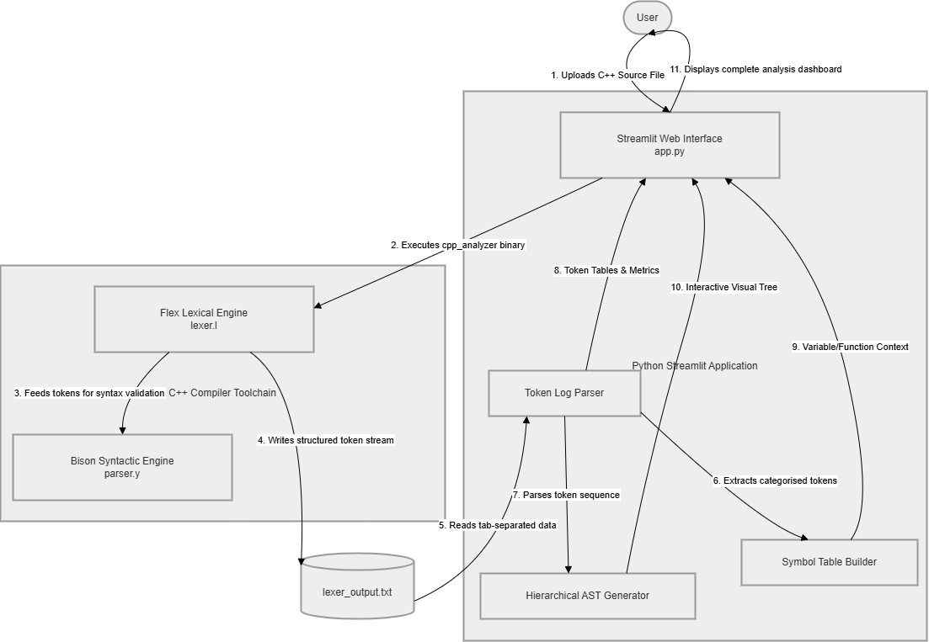
PROJECT PROPOSAL

Tasks Completed (7 pts)
(Describe the main tasks that have been assigned and already completed. Max 250 words).

Task Completed | Team Member
Requirement Analysis & Research Lexical  Lexical Analyzer Implementation (C++):  GUI Development (Streamlit):  Modular Refactoring (lexer.l) :  Parser & AST Generation (parser.y): | All members  Ayushman & Manish Barti  Shahan MD & Rajan Singh  Manish Barti & Ayushman  Shahan MD & Rajan Singh

Challenges/Roadblocks (7 pts)
(Describe the challenges that you have faced or are facing so far and how you plan to solve them. Max 300 words).
A major challenge during the project was connecting the C++ backend to the Python web frontend. Instead of writing complex C++ code to send data back and forth, we simplified the process by having the C++ toolchain output a basic text log file (lexer_output.txt).
Another difficulty was reading this log file in Python to build and display the Abstract Syntax Tree (AST). We had to write a custom algorithm in Python to carefully group the tokens into variables, functions, and a visual tree structure so it could be easily viewed in the web browser.
To overcome these issues, we kept the project highly modular. We used standard Flex (lexer.l) and Bison (parser.y) files to handle the heavy lifting of reading and checking the C++ code. Meanwhile, we isolated all the visual work and tree-building inside the Python Streamlit app (app.py). This allowed us to easily test the C++ backend separately from the Python frontend.

Tasks Pending (7 pts)
(Describe the main tasks that you still need to complete. Max 250 words).

Task Pending | Team Member (to complete the task)
Complete Integration of Backend & GUI Advanced Token Handling & Edge Cases UI Improvements Enhancements  Testing with Multiple Input Programs  Final documentations and report | Shahan Md Rajan singh Ayushman All Members  Manish barti

Project Outcome/Deliverables (2 pts)
(Describe what are the key outcomes / deliverables of the project. Max 200 words).
The project will deliver a fully functional interactive lexical and syntactic analysis framework. Key deliverables include:
- C++ based backend using Flex and Bison for tokenization and syntax validation.
- Python Streamlit web GUI for interactive data visualization.
- Integrated system for real-time token generation, symbol table construction, and Abstract Syntax Tree (AST) visualization.
- Testing with multiple sample programs
- Complete documentation
- GitHub repository with source code
The system will serve as an educational tool to help students understand lexical analysis practically and effectively.

Progress Overview (2 pts)
The project is currently in the development phase, with approximately 75–80% work completed.
- Backend Lexer/Parser (lexer.l, parser.y) : Completed
- GUI development: In progress
- Integration: Completed
- Testing: In progress

Codebase Information (2 pts)
- Separate modules for backend (lexer.l, parser.y) and frontend (app.py).
- Structured, object-oriented code organization (AST Nodes inherit from a base ASTNode class).
- Important milestones include: Flex Lexer implementation, Streamlit UI setup, token log-file (lexer_output.txt) , parsing integration, and the recent Bison LALR Parser integration.
- Github repo link - su7ox/lexical-parsing

Testing and Validation Status (2 pts)
(Provide information about any tests conducted)

Test Type | Status (Pass/Fail) | Notes
Unit testing integration testing  user acceptance testing  performance testing | Pass Pass  In progress  Pending | Individual module tested Module interaction testing conduct after completition  done during deployment

Deliverables Progress (2 pts)
(Summarize the current status of all key project deliverables mentioned earlier. Indicate whether each deliverable is completed, in progress, or pending.)
Deliverable
Status
Lexical analyzer
Completed
GUI (Tkinter)
completed
Parser ASGenerator: Completed (Basic) / In Progress (Advanced)
In Progress
Testing
In Progress
documentation
Pending

