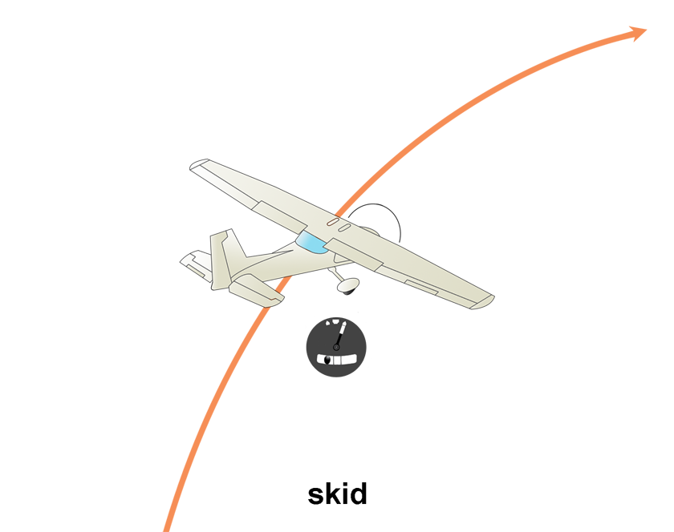

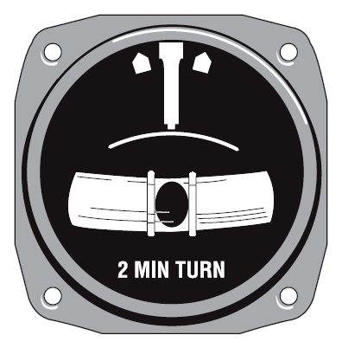

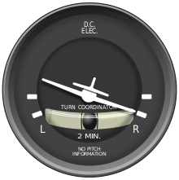

Image showing the face of a turn coordinator during a [standard rate](https://en.wikipedia.org/wiki/ROT_(aviation))coordinated right turn.

**Turn and Back Indicator:-**

This instrument is used to find, where the aircraft is turning. The below image describes about the instrument view. Note there is one white ended needle; we have to note this only. i.e. If the plane moves left means, this white ended needle will move to right and if the plane moves to right means, this white ended needle will move to left

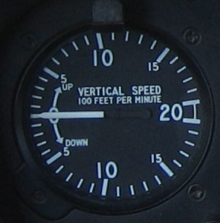

The [vertical speed indicator](https://en.wikipedia.org/wiki/Vertical_speed_indicator) from a [Robinson R22](https://en.wikipedia.org/wiki/Robinson_R22). This is the most common type used in [aircraft](https://en.wikipedia.org/wiki/Aircraft), showing speed in feet per minute

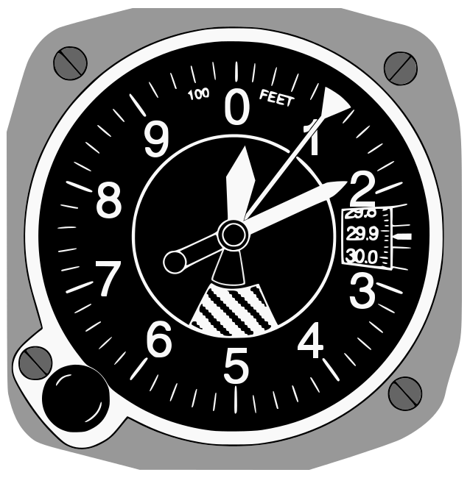

Diagram showing the face of the "three-pointer" sensitive aircraft altimeter displaying an [altitude](https://en.wikipedia.org/wiki/Altitude) of 10,180 feet.

**Altimeter:-**

The altimeter is used to find the altitude of the plane at which it is flying. It is usually measured from sea level. There are three needles in this. The smaller one indicates the height in 10000 of feet, middle needle indicates the height in 1000 of feet and the larger one indicates the height in 100 of feet. The height is measured in feet, meters or yards. All these needles move in clock wise direction.

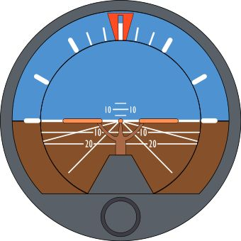

**Artificial Horizon:-**

The Artificial Horizon is an instrument which is used to find the altitude of the plane at both right and left wings of it. i.e. By using this instrument we can check our plane whether it is flying parallel to the base line (horizontal line) or sliding towards one end (left or right).

It is measured from 0 to 90 degree left and 0 to 90 degree to the right. Just imagine the protractor which we used for our mathematical geometry in our school days.

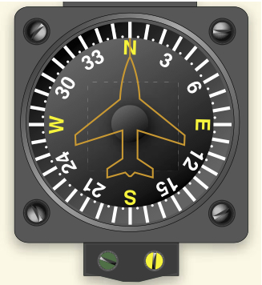

**Magnetic Compass:-**

The magnetic compass is used to find the direction at which we are. We may see these types of instruments in our school, college physics labs. This is used in most of the vehicles such as trains, four wheelers, air planes and ships. So this is important instrument to measure the directions.

In real the compass needle usually points towards the north and south direction. But in images i.e. the questions given In question paper, they show the images at different directions, it may of north, south, east, west, north east, south east, north west and south west. So be clear in choosing your answer.

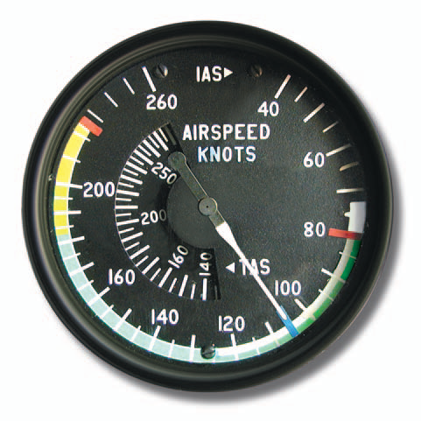 Airspeed indicator markings for a light multiengine airplane.

**INSA and INSB Test**

[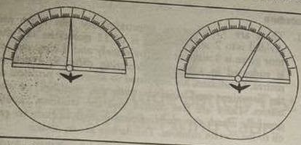](http://4.bp.blogspot.com/-N3dypZlepRE/U5gfHWP5AOI/AAAAAAAAA0A/wcN2vzj9tXY/s1600/1.JPG)

[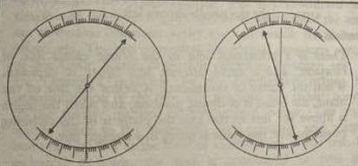](http://3.bp.blogspot.com/-ajQKguN6qkk/U5gfJeLtWuI/AAAAAAAAA0I/23yOcsA8j4M/s1600/2.JPG)

                This meter will depict whether the plane is turning left or right gradually or speedily. If the needle moves right that depict plane is turning left and vice-versa. If the needle is near to its equilibrium position then the plane is turning gradually. If the needle is away from its resting position then the plane is turning speedily.

 In the second set there are approximate 60 questions and students are required to tick the right picture of airplane which is according to the given condition shown by different meters. Time given for this set is 20 minutes. Students access the picture of plane form meters  and should do maximum questions correctly. In the remainder of questions the candidates have to tick the correct option as given in the question paper. The candidates who qualify the INSB are taken immediately unsuccessful candidates are made to sit for the screening test at the same time..

**PABT(Machine TEST)**

A machine having a computer screen, a joystick, two pedals and a lever as per the below diagram:

|  |
| --- |
| [sample PABT picture: Machine Test](http://3.bp.blogspot.com/-qQ2D5UFBeEY/U5gfN5vSqRI/AAAAAAAAA0Q/b6v12zJ-zUM/s1600/3.JPG) |
| Maintain a ball in innermost square |

Procedure

                When you move joystick forward the ball will come downward and when you move the joystick towards you then ball will move upward. The use of pedals is to keep the ball right or left. In a single chance, the ball will come bouncing and in the meantime the yellow and red light will appear which can be cancelled by lever on left. Sometimes a noise will appear which can be cancelled by the button on joystick. For each cancellation of red, yellow light and noise you will get ½ point extra. Three chances will be given and best of three will be counted. For maintaining the ball in Inner Square of I sec we get 1 point and in outer square we get ½ point. Concentrate and give your best effort it’s a game.

**Drum Test**

|  |
| --- |
| [PABT Sample picture: Drum Test](http://2.bp.blogspot.com/-XNPYMz6U2CU/U5gfQrCWUBI/AAAAAAAAA0Y/QmjL3pECiss/s1600/4.JPG) |
| Essential-torch with the balls coming from top of screen |

In the next successive test you have to use the joystick to coincide a ball to the balls coming from top. The software has been prepared in such a way that the ball follows a specific alignment. The student should see the alignment critically which will help coinciding to the pattern and result in high scoring.

 Some printed or dream sketches of an aircraft in various positions like ascending , descending , turning right or left and flying straight are shown and candidates are asked to reply them correctly . This normally to be decided on the basis of given set of meter reading . There is a time limit to ans every question . As much as 60 question are required in just 20 minutes . The different types of meter controls are given below .

### PABT: Practice Session INSAB Test-I

Guys I am putting some practice question for Pilot Aptitude Battery Test: PABT .These are only sample questions asked in PABT , prepare for your PABT here. More practice sets for PABT Test of SSB Interview will be uploaded soon.

#### Question 1- Six meter reading test

|  |
| --- |
| [Sample PABT picture: Six meter reading Test](http://2.bp.blogspot.com/-ZqWjAKKXcMg/U5ggH6vi4mI/AAAAAAAAA00/QK05oSrZmo0/s1600/10.JPG) |
| Sample PABT picture: Six meter reading Test |

Your options : your plane is

1. At 420 m/sec, heading toward North-East, at 1040 ft height, increasing steadily without turning.
2. At 420 m/sec, heading toward North of North-East, at 1040 ft height, increasing rapidly without turning.
3. At 420 m/sec, heading toward East of North-East, at 1040 ft height, increasing steadily without turning.
4. At 420 m/sec, heading toward North of North-East, at 1040 ft height, increasing steadily without turning.

Ans. 4

Q.2-six meter reading Test

|  |
| --- |
| [Sample PABT picture: How to take meter reading](http://1.bp.blogspot.com/-BPN-A1hZsus/U5gf-p7u5xI/AAAAAAAAA0c/ezMgKroHrzg/s1600/11.JPG) |
| Sample PABT picture: How to take meter reading |

Your Options: your plane is

1.       At 500m/sec, heading East of N-E, at 1000 ft, decreasing rapidly with a right bank at 20degree.

2.       At 500m/sec, heading North of N-E, at 1000 ft, decreasing steadily with a left bank at 40degree.

3.       At 600m/sec, heading East of N-E, at 1000 ft, decreasing steadily with a right bank at 45degree.

4.       At 400m/sec, heading E, at 1000 ft, decreasing rapidly with a right bank.

Ans. 1

Know all facts about all meter then try to solve them again

Q.3 Three meter Test

|  |
| --- |
| [PABT Sample Question for three meter reading Test](http://1.bp.blogspot.com/-eNenHfD1k00/U5ggCz2R7oI/AAAAAAAAA0k/x2pF0cqvWj0/s1600/12.JPG) |
| Sample PABT picture: Three meter Reding Test |

Ans.  (i)

Noise of airplane shows direction of plane

For example

[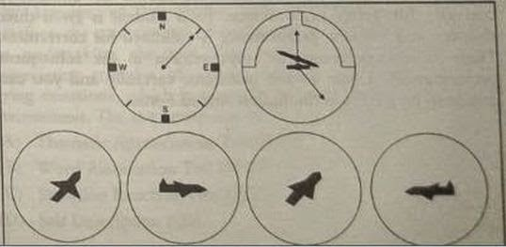](http://4.bp.blogspot.com/-MsBkuCdLVwY/U5ggDhVR83I/AAAAAAAAA0s/wV_0B4vjOd8/s1600/13.JPG)

1.       Noise in east position.

2.       If a circle is pointing towards you the plkane is going to south

3.       If tail is shown it is going north.

4.       Opposite direction of (i)

Ans 3

As if banks right the wings are not clearly visible.

Conclusion

Don’t panic if you hasn’t practice, everyone will be like you there. Key is listen to instructor carefully there is always a room for improvement.

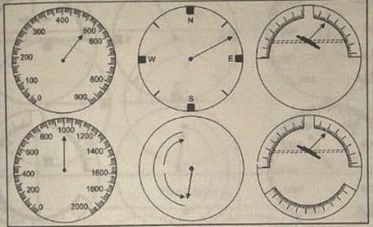

# **The Pilot aptitude battery test**

The **Pilot aptitude battery test** is divided into 3 categories

a)  **Written test –**Instrument testing

b) **The light control test –**Sensory Motor Apparatus

c)**Drum test –**Control of velocity test

However, before being actually subjected to this test, efforts are made by officers at the service selection board to prepare every candidate mentally as well as physically to undergo this test . For this purpose, the various instruments which have to be handled by him are explained to him thoroughly before hand and he is also allowed to have some practice about it .

# **INSTRUMENT READING**

This written test is designed to know the knowledge of the candidate about instrument reading . Some printed or dream sketches of an aircraft in various positions like ascending , descending , turning right or left and flying straight are shown and candidates are asked to reply them correctly . This normally to be decided on the basis of given set of meter reading . There is a time limit to ans every question . As much as 60 question are required in just 20 minutes . The different types of meter controls are given below .

a) **Magnetic Compass ( gyroscope ) –**It is an instrument comprising of a magnetic needle supported on a sharp point so that it is able to move freely . Such needle always points to the north .

[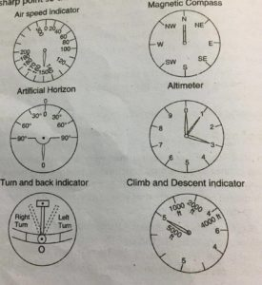](http://www.ssbguide.com/)

The airplane compass is in principle exactly the same . Although many electrical devices , in addition to gyroscope have been invented , the magnetic compass is still carried by all ships and aircraft as a reliable safety measure in case of the electrical equipment goes wrong .

b) **Air Speed Indicator –**This is an instrument which indicates the speed of an Aircraft in the air . The speed indicated by this instrument is known as Indicated Air Speed ( I.A.S ) . This instrument is graduated in kilometres or miles .

c)**Altimeter –**This instrument gives the altitude of the plane flying above the sea level . The altitude is measured in feet or yard . The smallest needle indicates 10,000 of feet , middle needle indicates 1000 of feet and larger needle indicates 100 of feet . All the needle move in the clockwise direction .

d)**Artificial Horizon –**This instrument gives the altitude of the plane in relation to the Horizontal line . It is measured 0 ‘ to 90’ to the right .

The different positions of the movement of an aircraft vis – a – vis  the artificial Horizon are indicated below

[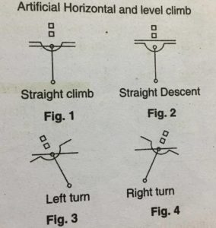](http://www.ssbguide.com/)

e)**Turn or Back Indicator –** This instruments indicates the way the aircraft is turning . In turning left , the black ball will remain in the middle and white needle will shift to the left .

f)**Climb and Descent Indicator –**This instrument indicates the flying position of the aircraft . The needle of the dial goes up as the plane goes up and it comes down as the plane comes down .

# **LIGHT CONTROL TEST**

The aim of this test is to determine the aptitude of flying and its control . This test is carried out on a machine which puts the presence of mind , reflexes and physical ability of a candidate to test . The candidate is made to sit on a chair and exposed to different situation similar to real one like losing height, tilting of the plane . Candidate is then asked to control these situation to keep the flight ready and normal . A cathode ray tube is placed directly above the pilot’s seat with a spot of light in the centre of a square . There are two light : red and blue which are flashed on and off .

The test actually comprises in directing and controlling the light along the marked out for this candidate has to operate the following tools

a) **A hand operated stick :** This stick controls the movement of the spot **of** the light .

b)**Foot Pedals :** 1) The operation of the left foot pedal moves the spot of light to the left . 2) The operation of the right foot pedal moves the spot of light to the right .

c) **Light lever :**A hand lever is provide which when moved forward puts off one light and the other when moved backwards . A total of three chances are given to a candidate counting his best score for judgement of his aptitude .

[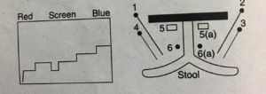](http://www.ssbguide.com/)light lever

# **THE DRUM TEST**

This is another test to evaluate the flying aptitude of the candidate . This is the test of the control of velocity . This test is carried out on a drum on which the lines are marked . The drum is eight feet of length and about 1ft in Diameter . Each line contains punched holes which expose a brass surface . The knob, a controlling device which the candidates are required to manipulate in order to maintain a control , is a very sensitive device . The slightest twist will move the needle by inches on either side . But it is possible to achieve a full control over the device by quick reflexes , anticipation and speedy execution .

[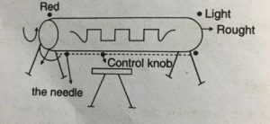](http://www.ssbguide.com/).