TASK 3
Heuristic Graph Pathfinding Agent Search Engine
Project Report
Student Name: Fareeha Aslam
Course Artifical Intelligence

Implementation using Python and Google Colab

1. Introduction
Pathfinding is the process of finding a route between a starting position and a destination while avoiding blocked locations. It is used in robotics, games, navigation systems, and autonomous virtual agents. This project implements a grid-based pathfinding environment in Python and evaluates three search approaches: A* Search, Dijkstra's Algorithm, and Q-Learning.

2. Objectives
- Implement A* Search using a heuristic distance estimate.
- Implement Dijkstra's Algorithm using accumulated path cost.
- Train a Q-Learning agent to learn a route through a maze.
- Test search algorithms on low, medium, and high obstacle-density grids.
- Measure path length, explored nodes, and runtime where applicable.
- Visualize the selected paths and export performance results to CSV.

3. Tools and Environment
The project was implemented in Google Colab using Python. The main libraries were heapq for priority-queue operations, time for runtime measurement, NumPy for grid creation and Q-table operations, Pandas for result tables and CSV export, and Matplotlib for graphs and maze visualization.
The environment is a 15 × 15 grid. The start is at coordinate (0, 0), and the goal is at (14, 14). A cell with value 0 is free, while a cell with value 1 is an obstacle. Movement is allowed in four directions: up, down, left, and right. Each move has a cost of 1.

4. Methodology and Algorithms

4.1 A* Search
A* combines the cost already spent to reach a cell, g(n), with a heuristic estimate of the remaining distance, h(n). The priority is f(n) = g(n) + h(n). This implementation uses Manhattan distance: |row1 − row2| + |column1 − column2|. Since movement is limited to four directions and each move costs 1, Manhattan distance is an appropriate heuristic.

4.2 Dijkstra's Algorithm
Dijkstra's algorithm expands the frontier according to the lowest accumulated path cost g(n). It does not use a heuristic estimate. With equal, non-negative movement costs, it finds a shortest path when one exists.

4.3 Q-Learning
Q-Learning is a reinforcement-learning method. The agent interacts with the grid over training episodes and updates action values in a Q-table. The implementation uses four actions, an exploration rate that decreases during training, a learning rate, a discount factor, a positive reward for reaching the goal, and a small step penalty. After training, the agent follows the learned Q-values to extract a path.

5. Experimental Setup
A* and Dijkstra were tested on three generated grids with obstacle densities of 10%, 25%, and 35%. The start and goal cells were kept free, and grids were regenerated when necessary to ensure that a valid route existed. Both algorithms were run on the same grid at each density. Q-Learning was trained on the medium-density grid for 3,000 episodes.

6. Results
The following table reproduces the values from the downloaded CSV results file. Runtime values are in seconds. Q-Learning's runtime represents the complete training time, so it should not be directly compared with the runtime of a single A* or Dijkstra search.
Obstacle level | Algorithm | Path found | Path length | Nodes explored | Runtime (s)
Low (10%) | A* | True | 28 | 195 | 0.001416
Low (10%) | Dijkstra | True | 28 | 206 | 0.001267
Medium (25%) | A* | True | 28 | 117 | 0.000817
Medium (25%) | Dijkstra | True | 28 | 172 | 0.001030
High (35%) | A* | True | 28 | 99 | 0.000717
High (35%) | Dijkstra | True | 28 | 131 | 0.000770
Medium (25%) | Q-Learning | True | 28 | Not recorded | 3.648022

6.1 Results Discussion
All seven recorded runs found a path to the goal. Every successful run reported a path length of 28 steps. On the low-density grid, A* explored 195 nodes compared with 206 for Dijkstra. On the medium-density grid, A* explored 117 nodes compared with 172. On the high-density grid, A* explored 99 nodes compared with 131. Therefore, A* explored fewer nodes in all three tested grids. This is consistent with the use of a heuristic to guide the search toward the destination.
The measured runtimes are very small and can vary between runs because of machine load, runtime conditions, and measurement overhead. The runtime values should therefore be treated as observations from this run rather than fixed performance guarantees.
Q-Learning found a 28-step route on the medium-density grid after training. Its reward curve rises over training, indicating that the agent's accumulated reward improved. The CSV does not record a Q-Learning explored-node count, so that metric is reported as not recorded rather than estimated.

7. Visualizations
Figure 1. Q-Learning's learned route and average reward trend.
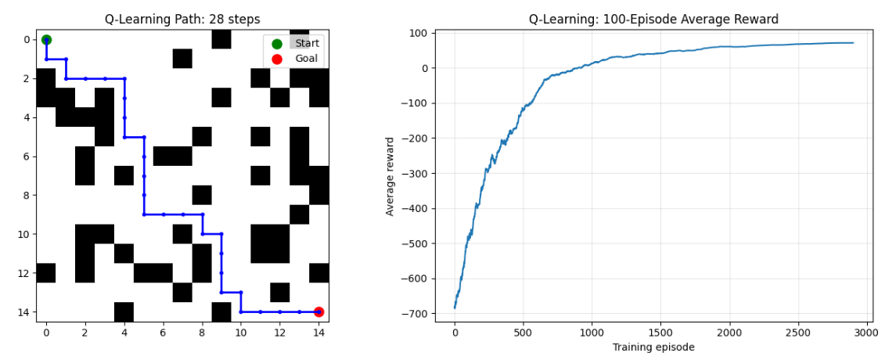
Figure 2. A* paths on low-, medium-, and high-obstacle-density grids.
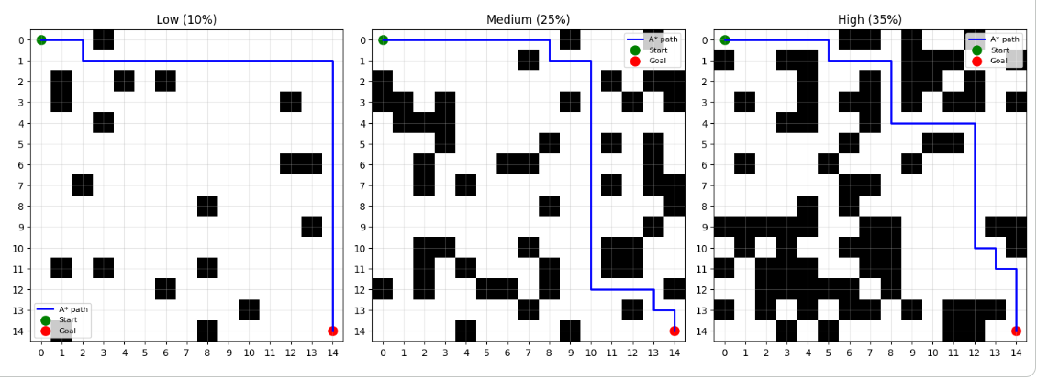
Figure 3. Performance results displayed in the notebook.
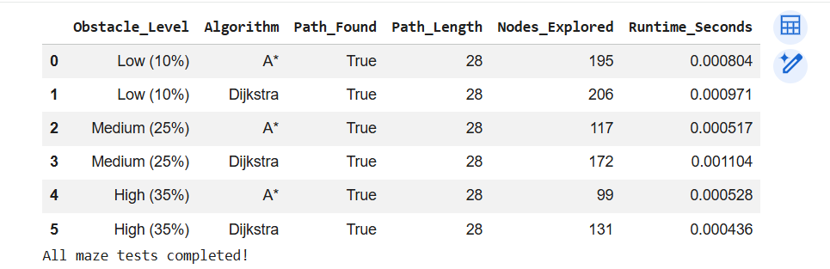

8. Limitations
- The experiment uses a small, fixed-size grid and four-direction movement only.
- The three obstacle-density tests use generated examples; additional random seeds would provide a broader evaluation.
- Q-Learning was trained on the medium-density grid only, so its generalization to other grids was not evaluated.
- The Q-Learning explored-node metric was not included in the exported results.
- Runtime measurements on such small grids are sensitive to execution and measurement overhead.

9. Conclusion and Future Improvements
The project successfully implemented A* Search, Dijkstra's Algorithm, and Q-Learning in a grid-based pathfinding environment. All recorded test runs found a route, and all reported a path length of 28 steps. A* explored fewer nodes than Dijkstra on each of the three tested grids. Q-Learning also learned a route on the medium-density grid, with an improving reward trend during training. Future work can include testing more grid sizes and random seeds, training Q-Learning across multiple obstacle layouts, recording additional learning metrics, and comparing algorithms on larger environments.

Appendix: Submission Files
The supporting files for this project are the Google Colab notebook (.ipynb), the exported performance results CSV file, and the visualization screenshots. The CSV used for the results table is named final_pathfinding_results.csv.

