**The Best Games Are Made by the Players:**

**A Player-Centric Approach Towards Game Design**

***Introduction***

The concept of a game is widely understood by people all over the world; whether you’re a developer, or just a common player, so is it fair to say the player should also participate in the development phase of a video game?

Vita (2014) in her article Users as co-creators states that some game companies, including those already following best practices, have noticed the potential value of having customers as “co-developers”. Her article includes a detailed overview map (Figure 1[1]) of the player experience to allow an understanding of the best practices for player-centric game design. The map breaks down the player experience into different categories as to how, for example, a player may feel when playing a certain game or what may cause them to play the types of games that they do. However, before beginning to analyze the player-centric approach towards game design, there needs to be a firm understanding on what games design and development is.

To begin with, the history of games has undergone a huge evolution throughout the recent years, with video games being “merely the latest chapter in the fascinating and much lengthier history of games.” Looking back thousands of years ago before game designers and developers, activities that would now modernly be categorized as games were played in ancient times, however, may have only been seen as "recreational pastime".[2] Throughout the years the significance of such games – with the recent addition of modern approaches to the design and development of video games – has increased immensely and has started to become a part of culture. This has led to an increase in demand and has allowed the game industry to thrive as a multi billionaire platform, with the global games market expected to grow from an estimated $99.6 billion in 2016 to $118.6 billion by 2019[3], truly showing how the world of modern games expands over a huge scale of the entertainment industry.

Furthermore, what many people fail to understand, due to the lack of awareness in the area, is that anyone can design a game. That said, the creation of a successful game is a different story entirely. As stated by Schell (2014), “games can be played without the use of computers or technology[4]“, people make up new games every day without even noticing that they have. So, what needs to be understood is that playing a game is to engage in activity directed towards bringing about a specific situation, using only means permitted by specific rules.[5] By breaking down this definition into simpler terms, it can be deduced that a game is an activity that has an end objective or goal that can only be achieved when pre-stated rules are followed. Therefore, a game isn't defined by or limited to technology alone.

Lastly, to recognize the concepts of game design and game development it needs to be understood that there are certain distinctions which can be made between the two. Schell (2014) states that, “anyone who makes decisions about how a game should be is a game designer” and “a game developer is anyone who has any involvement with the creation of the game at all.”[6] When you consider that most of the supposed developers will make decisions regarding the creation of a game and supposed designers are normally incorporated into the development stages from beginning to end, then you can begin to see that these two statements weight heavily on the idea that game designers and game developers aren't necessarily independent roles. Furthermore, it can also be appreciated that the fundamentals of both roles need to be known and recognized to compliment the specialization into a specific function within a team of designers and developers.

***Aims of the Essay***

This essay will be analyzing the importance of the user experience, which will be done by, evaluating how effective user centered design is. This essay will also investigate the use of psychology in games to maximize how player-centered a game can be. Additionally, the involvement of the players in the development stages of a game will also be critiqued. The overall aim of this essay is to attain evidence as to whether making a game player-centered shapes a more successful game.

***User Centered Design vs. Activity Centered Design***

Activity centered design is developed with a deep understanding of the activities that are to be performed. An activity is described by Norman (2005) as “a coordinated, integrated set of tasks”, and in this concept of design, unlike user centered design of course, the activity is prioritized rather than the player or user. The article continues to state that historical records contain numerous examples of successful devices that required people to adapt to and learn the devices. People were expected to acquire a good understanding of the activities to be performed and of the operation of the technology. It was also claimed that none of the “tools adapt to the people” [7] — people adapt to the tools – which undermines user-centered design as a superior concept of design.

Player-centric game design is a form of user-centered design. Kumar and Herger (2013) express that user-centered design is a philosophy that puts the user, and their goals, at the center of the design and development process.[8] So this means that player-centered game design is the idea of developers building or creating a game with the user as the starting point; the center piece to build around. When looking at game design in this perspective then it can be deduced that developers need to know exactly what they’re building around – the same way a builder can’t build a house without a strong foundation – a game can’t be created, in a sense, without the player. This concept of design unlike activity centered has the player as the sole focus and is the method majorly used by most companies due to the relationship it builds with designers and their users.

***Advantages and Disadvantages of User-Centered Design***

All concepts tend to naturally have advantages and disadvantages; therefore, this report isn't trying to prove that player-centered design is perfect. In a presentation about user centered design, Shalini Shingari expresses a few advantages and disadvantages with the concept of user-centered design (Figure 2)[9]. Two of her ideas about the disadvantages of user centered design can be said to counteract the success of player-centric games. The first idea that she expresses is that “it may be difficult to translate some types of data into design”. This point is relatable as, for example, in my case for my project I decided to do an artefact and conduct primary research which was a personality type survey. When analyzing my survey there were some responses which couldn't specifically be categorized so essentially a flaw in user centered design is that data may, for one, be too vague or just too difficult to interpret for it to be fully effective. The second disadvantage could slightly contrast the first stating that the product may be too specific for general use; so, in turn this could decreases the customer size that would be satisfied or interested in the product. When looking at this disadvantage on an extreme scale, then it is possible to say that the more specific and player-centric a game gets, then the less people a game can cater for, therefore, undermining my title and backing up the argument that the best games aren’t made by the players.

Contrary to the disadvantages that may seem to decrease usability, there are many advantages of user centered design. Charles and Black (2004) state that “All game players are different; each has a different preference for the pace and style of gameplay within a game, and the range of game playing capabilities between players can vary widely.” This stresses just how important it is to know your player, and one of the advantages of user centered design is that it’s a necessity to know your player when trying to aim your product at a specific audience. One of the novel aspects that they propose for player-centric games is the ability of a game to “dynamically model, remodel, or reclassify a player as they play the game.”[10] What this refers to is the fact that user centered design has the ability to cause players to adapt; so in the case of the disadvantage to user centered design which questioned whether the concept could cater to the requirements of all users, it could be seen that players will be able to adapt easily to a player-centric game. Therefore, the complications of the requirements being too specific may be void and in turn this would rise confidence in my title and back up the argument of player-centric games being more successful.

From the research on both activity and user-centered design, including the advantages and disadvantages of user-centered design, the conclusion derived was that, user centered design is a concept used by the majority of companies for reasons, such as, the fact that if you know exactly what manner of game your players want, then there’s not a large margin for error. Additionally, most disadvantages of user-centered design are outweighed by the advantages of using user-centered design to develop player-centric games. Furthermore, there is still a lot of research based around user-centered design, trying to make it more and more efficient in future uses.

This section of the essay will now investigate evaluating how games can be player-centric by analyzing player involvement on a whole and how user-centered design is implemented in the design and development phases of a game. The analysis will be broken down into three sections which are; the player involvement before; the player involvement during; and the player involvement after the design and development of a game.

***Player Involvement Before Design and Development***

Game development companies must find some way to include their players in the design and development process before they even know what product they want to create. “Recently, several researchers have turned toward meaningful player practices as key sources of insight into video games,”[11] therefore you could say that the main, if not only, way that players are involved before the actual design and development is through research. In the favour of the idea that modern games are player centered it can be said that companies do try and put in a lot of work to determine what their audience requires and is expecting of them; with the example of Microsoft spending 11.4 billion US dollars on research and development in 2015[12].

However, thinking in opposition to this view, some may say that research alone is not enough to gather all the knowledge that companies need to create the game that their audience desires. The diagram (Figure 3[13]) links interfaces between player, game and game designer. This shows that the playability of a game is directed towards evaluating the effectiveness of the game design process, whereas the player experience is created in the player-game interaction process. This link between player, game and game designer shows and compliments the idea that players should interact more with the game design process to try and increase the experience that the player gets in-game. Therefore, this means that sometimes research alone may not be enough as it can't always allow a deep understanding between the player and the game; sometimes you need to let the player do the talking or in this case, the designing. This diagram also links to how the best games essentially are made by the players as without them, the player experience can’t be formed.

***Player Involvement During Design and Development***

Drachen (2008) describes digital games as a “complex piece of software” meaning that it is challenging to know precisely what the experience of a given user will be. However, one of the ways companies try to measure game usability is through testing user experience of games under production. By linking specific features of the game under development with the user experience, it is at least possible to evaluate whether a given feature works or not. Companies go through many different testing methods with beta testing being the major test that will help to evaluate game metrics (success of the game). The article continues to explain that in the specific context of game development and testing, game metrics can be related to user interaction with the game software[14]. Game companies can collect vital data that will allow them to tailor the game under development even more to their audience from feedback that they receive. This method is very effective as companies get direct feedback from the users and allows slight errors and bugs to be pointed out and fixed.

The only disadvantage that comes with the player involvement during the design and development phase is the sample size that the game is being tested against. The larger the sample then the better feedback companies will be able to collect about the game during development. Fine (2002) asks the question, “if you could talk to your customers and discover what they think of your product prior to release, wouldn’t you do it?”[15] With that in mind, there are still many games that don't go through beta testing for the sake of increasing the player experience and gaining feedback from their players. In this case, companies use game metrics as a form of measuring other factors such as "engine performance, sales or project progress."[16] Many games known for having great usability and player feedback go through very large-scale beta testing or release demos, for example, Call of Duty Black Ops III which released a beta for all PlayStation 4 users in 2015. It became the largest beta on PlayStation 4 and the released game was given a rating of 9.2 out of 10 by IGN[17] and received a Metacritic score of 81 out of 100.[18] This adds confidence as to whether players should be involved in the design and development processes of a game as Call of Duty: Black Ops III’s success could already be measure by the amount of people that downloaded the beta,

***Player Involvement Ater design and development***

Charles (2005) states “it may be argued that much commercial game design is already player-centered because publishers and developers invest considerable time and money in market research and game testing. However, most current approaches focus on finding out what the player wants from the product before or while it is being made.” If this is the case then what happens after the game has been released to the public? Well the possible next stage for some games could be that the game will receive regular updates as the developers way of keeping the requirements of their players up to date Publishers may also make “software development kits (SDKs) available for player game modifications”, which means that players will be allowed to change the game as they like. In this way the developer is often concerned with “tailoring the design of a game according to the requirements of a limited group of potential players.”[19] Updating a game regualry after the release is a smart game plan as players like any other human are likely to lose interest in playing the same thing over and over again after a certain amount of time. However if the player knows that the game will regularly have new levels or items etc, they will continually look forward to new updates; which as a result may reduce the chances of them losing interest in the game. A great example of a highly successful game is **Grand Theft Auto V** by Rockstar Games, the fastest selling entertainment product of all time, grossing $1bn worldwide in just 3 days.[20] Till this day Rockstar still release regular updates to the online and story mode of GTA V which is why I believe is one of the reseon why it is still, three years later, one of the most popular games.

On the flip side, some games are never updated after they have been developed. It’s as though once they are published and the developers have made their revenue then the player is almost forgotten about. The argument that needs to be addressed from this perspective is that after the release stage, many developers won’t continue to take into account what the player wants from the game not realising or in some cases not considering that humans’ change their mind all the time; meaning a user’s requirements can easily change. There are still many sucessful games that are never updated perhaps for such reasons as developers having planned a sequel for the game, which in this case by the time the player gets bored, the sequel may be released. In other cases the success of the game could be hindered as there may be initial build-up about the game but once the user has completed the game, they may even play it over and over again multiple times, however it will eventually reach the point where its no longer an activity of interest. This happens because the product can no longer meet the requirements of whom it was intended for. In these cases also it may mean that even if the developers have attempted to make the game as player-centric as possible, there’s still the factor of the players requirements changing. This would undermine whether the best games aren’t made by the player as in this situation, there isnt actually anything the player can do as the original game was derived from their original requirements.

***Evaluation of Game design and Psychology***

“With the increasing presence of game elements in everyday life, [also known as gamification], there are more factors such as users intrinsic motivation, agenda, learning preferences and personality that should be considered in the design of gamified systems”. Ferro (2013), extends Richard Bartles player types (Figure 4) which suggested that players fell into one of four categories. The first category, Achievers, acts on the world. They typically play to win in games and get a great sense of achievement through defined goals. Socialisers interact with players and find the greatest reward in games is with interacting with others in a virtual world. Explorers interact with the world and find great pleasure discovering new areas and gaining new knowledge of their surroundings. Killers act on players and find it enjoyable to dominate others either by attacking, killing or make their life hard within the virtual environment.[21] There are many translations of player personalities which have been put into categories to determine a player type. Thinking of game design in a psychological way allows publishers to improve the user experience as user centred design allows developers to pay attention to the user's goals, and strive to build products that help the user achieve them in an efficient, effective, and satisfactory manner.[22] This was also the case when creating an artefact as the data from the primary research allowed it to be easy to form an idea for the game – compared to the near beginning of the project when there was absolutely no idea of what kind of game would be produced.

One of the fundamentals of player-centric game design is, as stated by Adams (2013), “that you understand your player, not merely as part of an audience of consumers, but as an individual who has an emotional connection to your game and, indirectly, to you.” He continues to declare how “we often think that we know what players want from games, but much of this knowledge is intuitive and based on what the developers want from games as players.” [23] What this means is that game developers base what they think their players want from a game subconsciously on what they want from a game. Adams talks about VandenBerghe’s Five Domains of Play (Figure 5), which proposed a way of understanding different types of players and why they enjoyed the games that they do. By using the 5 motivation domains which VandenBerghe based on the five factor model (Figure 6)[24], a psychological model of human personality traits, you can begin to understand the player-centric approach towards game design in relation to the various types of players.

The psychology behind game design is a complex concept with many alterations in the categories of player personality/types. There is a lot of extensive research into player personality which adds confidence to the best games being made by the players as it is one of the methods used by researchers to try and improve the user experience in video games.

***Evaluation of Primary research 1***

As my project is mainly based around analysing the player-centric approach towards game design, I decided that my artefact should be a player-centric game. To create a player-centric game, I first needed to do some research into what kind of games my target audience enjoyed playing. Therefore, I came to the conclusion to create a survey which would allow me to place my clients (sixth form students) into categories of player types, based on the ‘Big Five’ and translated into VandenBerghe’s ‘Five Domains of Play’. From the data (Figure 7) the genre that was favoured by most of my users (40 %) was action and the sub-genre that majorly accompanied action on the survey was first person shooter (fps). For this reason I decided that for my artefact I would create an action fps game but also try to incorporate the other genres in the game according to their percentages. The player type that my clients were most compatible with (Figure 8) on average was conscientiousness/challenge. “VandenBerghe correlates a desire for challenge — and perhaps more specifically effort and control — with the trait of conscientiousness. High-challenge players prefer games that are difficult and require precision to win.” In order to Improve the user experience I decided not to only base the game I created on the conscientiousness but also the next two most compatible player types which were, novelty – “This correlates with the first trait, openness to experience [in the five factor model] . Players who seek novelty like games that include a lot of variety and unexpected elements.” and stimulation “particularly via social engagement, this naturally correlates with extraversion [in the five factor model]. These players enjoy party games and others that involve interacting with other players.” [25] My personality test was really succeful as I obtained great results and was able to give a detailed analysis of the data in excel to make sure my final percentages and averages were as accurate as possible.

***Evaluation of Artefact and Primary Research 2***

The artefact that I created was a first person shooter due to the results of my survey. I aimed to make the game personalised towards the action genre and the major personality type that I collected from my survey. As a way of merasuring whether I was successful in doing this, I decided that I would created a questionnaire to evaluate my artefact. The questionnaire asked whether the game catered for the individuals favourite genre as they stated in the first questionnaire. Out of my sample of 25, 19 (76%) of them said that the game they played was able to cater for their favourite genre which is a really positive result. I aslo had five statements in the questionnaire (Figure 9) and asked which one best described each individuals personality. Out of my sample 60% chose the statement which was linked to the personality of conscientiosness/challenge, 32% chose one of the two statements that either corresponded with the personality of openness/novelty or extraversion/stimulation and the last 8% chose one of the two statements that either corresponded with the personality of agreeableness/harmony or neuroticism/threat. The statements they chose corresponded with the major personality type that I aimed to cater for which was really assuring; and the next question I asked was if the game did actually accommodate for their chosen statement. Out of 25, 20 (80%) said that the game did, therefore this shows that I was successful in meeting the requirements of the majority of my users. One of my aims for this project was also to see whether including the players from beginning to end increased the success of the game. For this reason I asked in the questionnaire whether each individual felt involved in the process of my project and I also asked for them to give the game a rating out of 10. I obtained really positive results will 22 out of 25 (88%) saying they did feel involved with the project and the average game rating that was given out of 10 was 8. From my second questionnaire I am able to conclude that my artefact was very successful as I managed to create a player-centric game which was tailored towards my target audience and I got very positive feedback about the user experience.

***Conclusion***

Based on the secondary research and primary research that I’ve collected as a whole, I can deduce that there is a lot of merit to following a player-centric approach when developing new games which gives me confidence to support the basis of my whole project. Looking at my secondary research, the reason as to why I’ve come to this decision is because when it comes to user-centered design, I found that there were a lot more positives about the concept than negatives. This allowed a stronger argument for player-centric games to be built especially since it is the concept majorly used by most of the interactive entertainment industry.

The primary research that I carried out and my artefact also edged the argument in favour of player-centric game design as I set out to create a game that was solely made for my players. I integrated every idea that I had into the game as a means of meeting the requirements of my users. In the end, the game that I ended up creating was very successful as shown by the results I obtained from my clients feedback.

On the contrary, the only idea that I would address as a means of making my decision more valid, is to allow a different sample of 25 sixth form students to play my artefact and fill out my evaluation questionnaire to see if I would still get the same results.

To conclude, when scaling up all the details of a successful game, the user experience and the involvement of the players are very important meaning that making a game more player-centric can indeed increase its success.

**Appendix**

Figure 1:

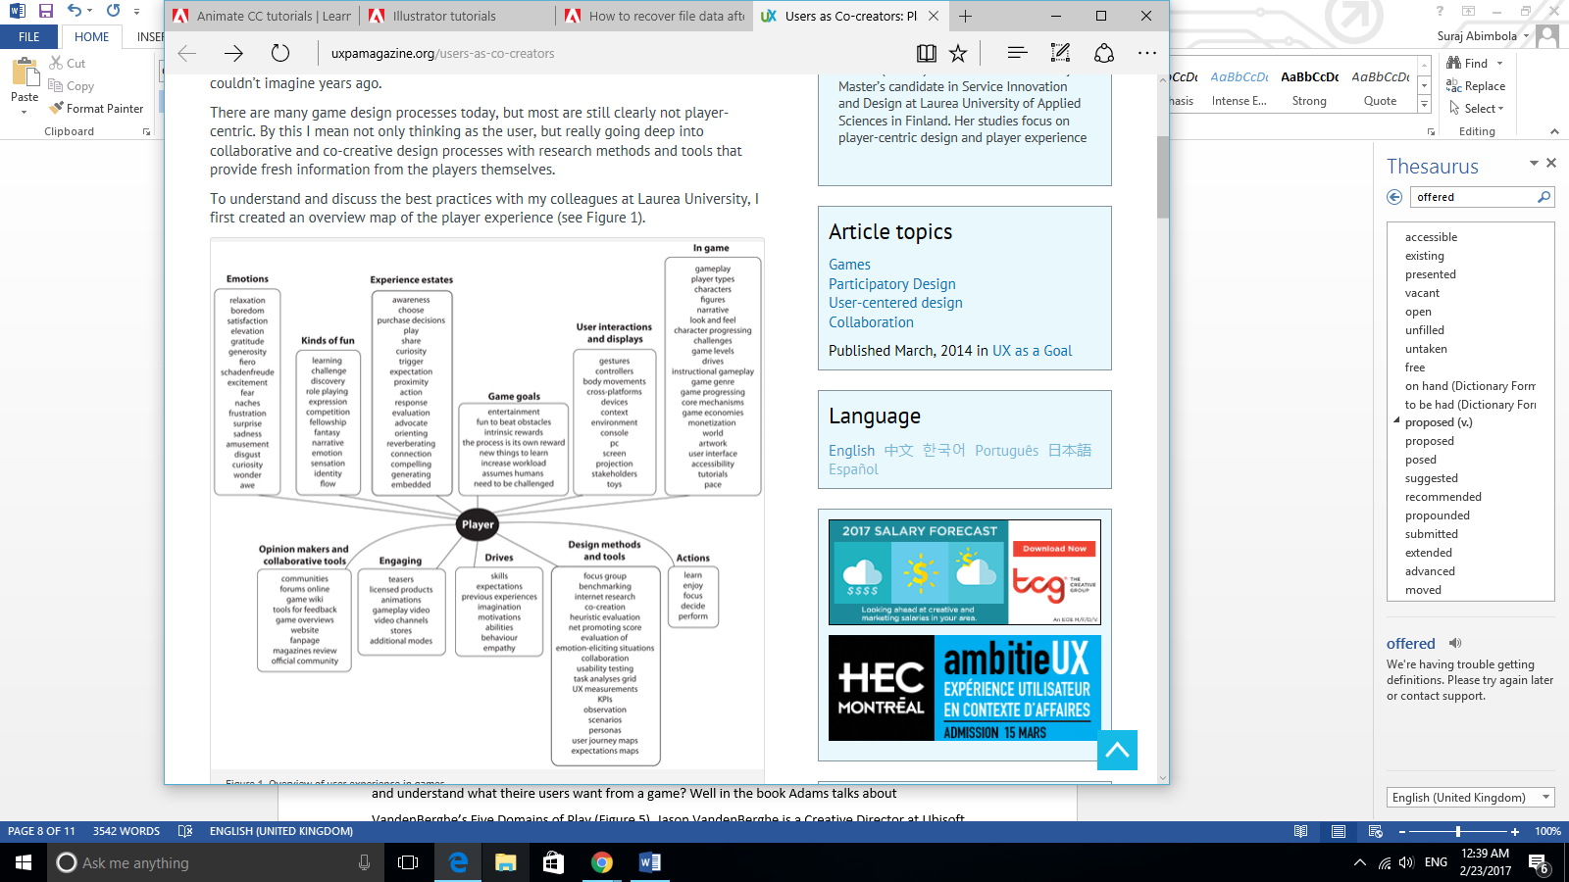

Figure 2:

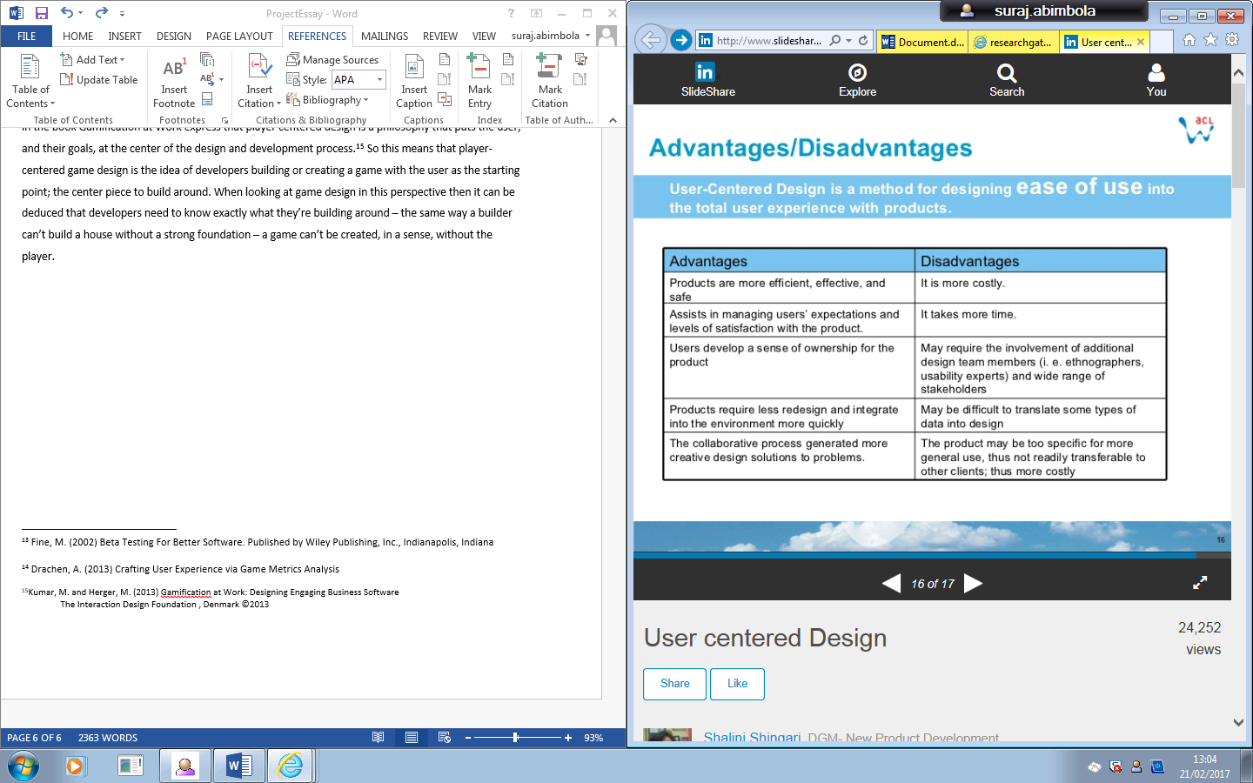

Figure 3:



Figure 4:

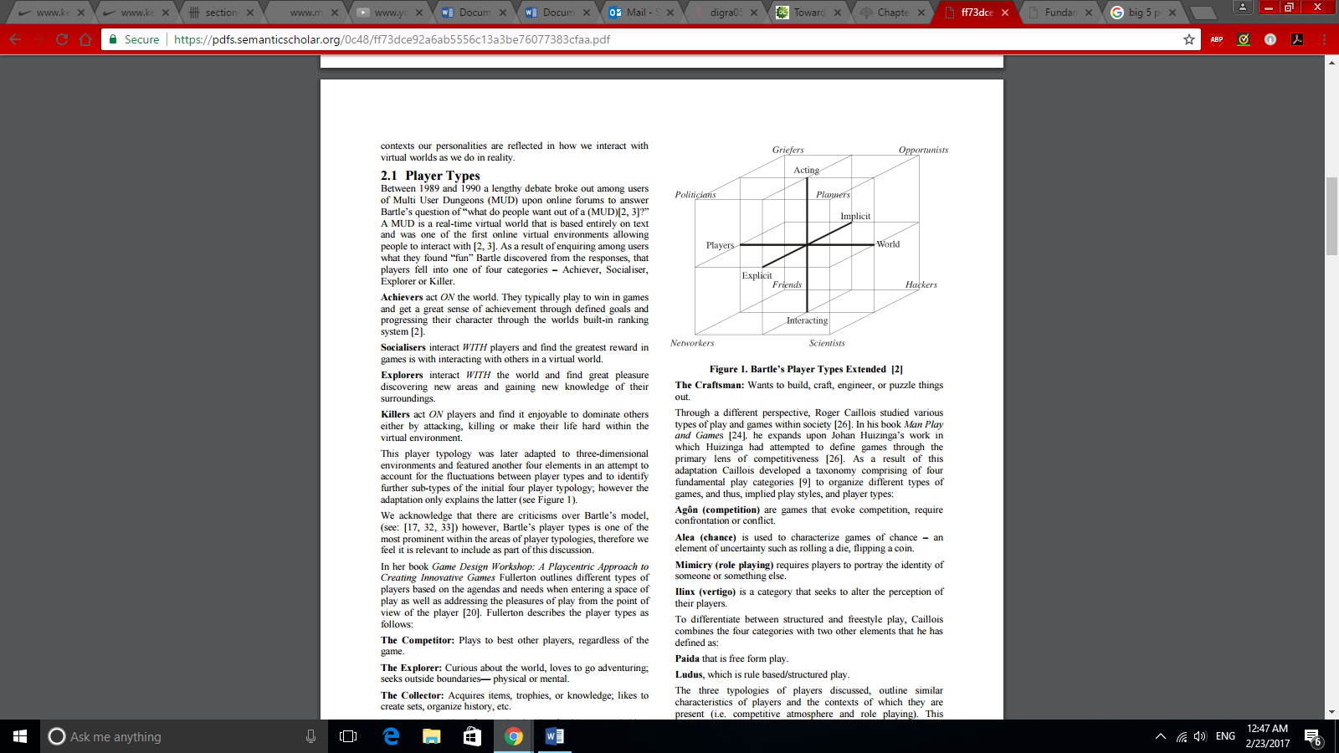

Figure 5:

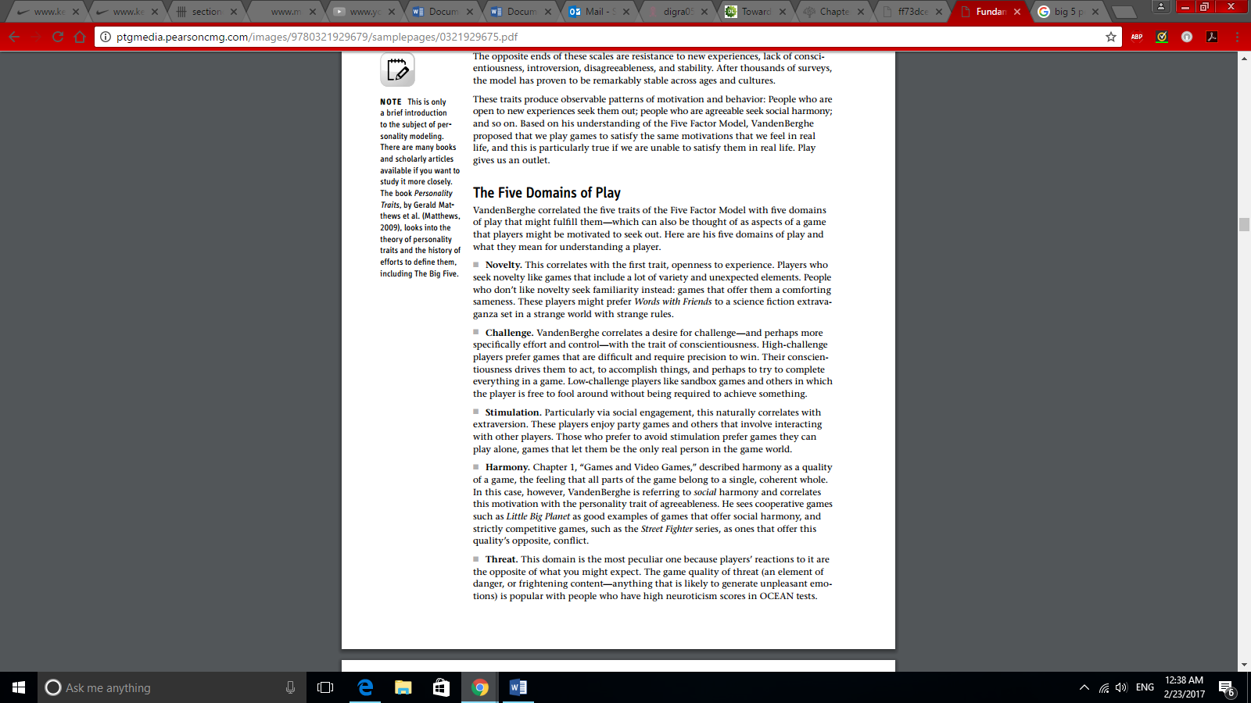

Figure 6:

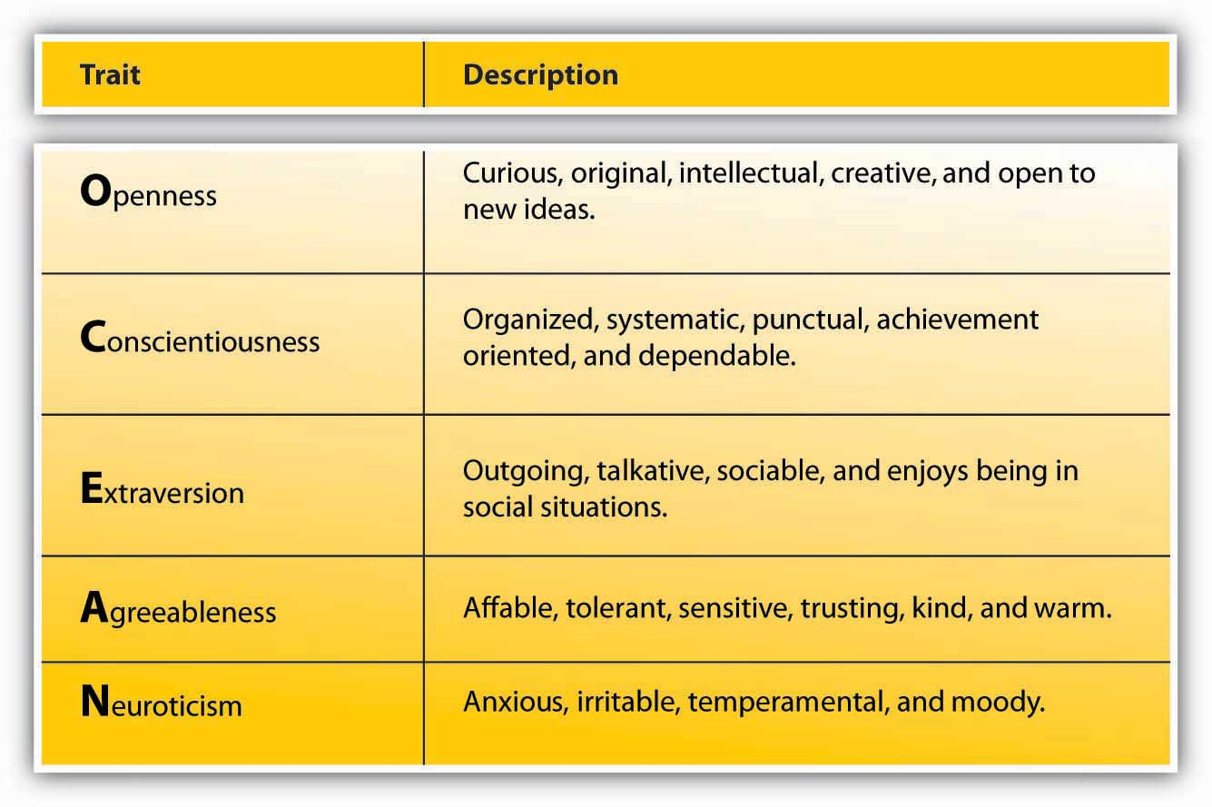

Figure 7:

Figure 8:



Figure 9:

Openness/Novelty

Conscientiousness/challenge

Extraversion/Stimulation

Agreeableness/Harmony

Neuroticism /Threat

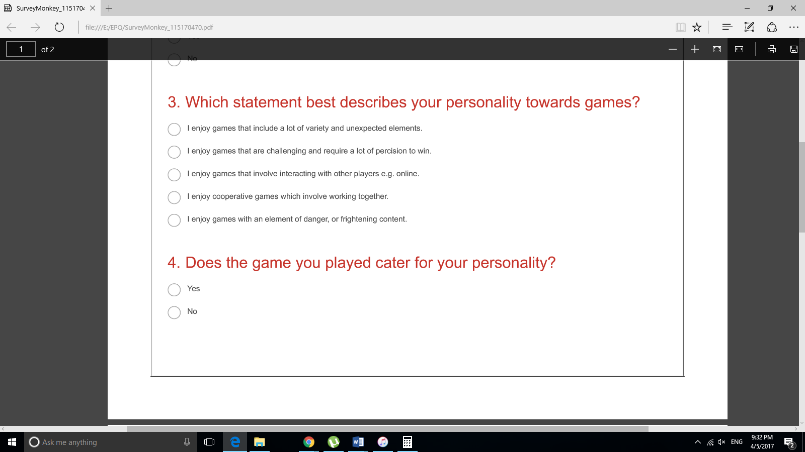

1. 1Vita, J. (2014) Users as Co-creators: Player-centric Game Design. <http://uxpamagazine.org/users-as-co-creators/> (accessed 6th December, 2016) Published by the User Experience Professionals Association (UXPA)
2. Simon, E. et al. (2016) Understanding Video Games: The Essential Introduction Routledge, Taylor & Francis Group. New York, U.S.

  
3. UKIE (The Association for UK Interactive Entertainment) <http://ukie.org.uk/research> (accessed 26th January)
4. Schell, J. (2014), The Art of Games Design: A book of Lenses Second Edition. CRC Press, Taylor & Francis Group. Boca Raton U.S.
5. Suits, B. (1967). What Is a Game? *Philosophy of Science,* Vol. *34*(2), pp. 148-156. [The University of Chicago Press](https://www.jstor.org/publisher/ucpress) on behalf of the [Philosophy of Science Association](https://www.jstor.org/publisher/psa) <http://www.jstor.org/stable/186102> (accessed 21st December, 2016)
6. Schell, J. (2014), The Art of Games Design: A book of Lenses Second Edition. CRC Press, Taylor & Francis Group, Boca Raton U.S.
7. Norman, D. (2005) Human-Centred Design Considered Harmful. Published in Interactions Magazine - Ambient intelligence: exploring our living environment. Volume 12 Issue 4, pages 14-19.
8. Kumar, J. and Herger, M. (2013) Gamification at Work: Designing Engaging Business Software

   The Interaction Design Foundation , Denmark ©2013
9. Shingari, S. (2006) User Centred Design (presentation). ACL Wireless Limited Jan 2006

   <http://www.slideshare.net/shalinishingari/user-centered-design> (accessed 10th february 2016)
10. Charles, D., & Black, M. (2004). Dynamic player modelling: A framework for player-centric digital games. In: Q. Mehdi et al. Computer Games: Artificial Intelligence, Design and Education (CGAIDE 2004) (pp. 29–35).
11. Behrenshausen, B. G. (2013), 'The active audience, again: Player-centric game studies and the problem of binarism. New Media & Society 15 (6), 872-889.
12. <https://www.statista.com/statistics/265645/ranking-of-the-20-companies-with-the-highest-spending-on-research-and-development/> (accessed 14th February 2017)
13. Nacke, E. et al. (2009) Playability and player experience research. CHI ’08 extended abstracts on Human factors in computing systems 2009 a. pp.1–5.
14. Drachen, A. (2008) Crafting User Experience via Game Metrics. Analysis Center for Computer Games Research IT University of Copenhagen. Paper presented at NORDICHI 2008, Lund, Sweden.
15. Fine, M. (2002) Beta Testing For Better Software. Published by Wiley Publishing, Inc., Indianapolis, Indiana
16. Drachen, A. (2008) Crafting User Experience via Game Metrics Analysis Center for Computer Games Research

    IT University of Copenhagen. . Paper presented at NORDICHI 2008, Lund, Sweden.
17. <http://uk.ign.com/games/call-of-duty-black-ops-3/xbox-one-20035641> (accessed 20th February 2017)
18. <http://www.metacritic.com/game/pc/call-of-duty-black-ops> (accessed 20th February 2017)
19. Charles, D. (2005) Player-Centred Game Design: Player Modelling and Adaptive Digital Games. In Digital Games Research Association 2005 Conference: Changing Views - Worlds in Play (2005)
20. UKIE (The Association for UK Interactive Entertainment) <http://ukie.org.uk/research> (Accessed 23rd February 2017)
21. Ferro, L. (2013) Towards personalised, gamified systems: an investigation into game design, personality and player typologies. IE '13 Proceedings of The 9th Australasian Conference on Interactive Entertainment: Matters of Life and Death Article No. 7. Pages 1-6.
22. Kumar, M. and Herger, M. (2013) Gamification at Work: Designing Engaging Business Software

    The Interaction Design Foundation , Denmark ©2013
23. Adams, E. (2013) Fundamentals of Games Design Third Edition. Published by New Riders, United States of America.
24. Goldberg, L. R. (1990). An alternative “description of personality”: The big-five factor structure. Journal of Personality & Social Psychology, 59, 1216–1229.
25. Adams, E. (2013) Fundamentals of Games Design Third Edition. Published by New Riders, United States of America.