RASHID ANSARI

ADVANCE DATA STRUCTURE

DAY 04

170847980002

1. Write a C++ program, which initializes a string variable to the content "The desire to learn should be stronger than the desire to live" and outputs the string to the disk file OUT.TXT. Include all the header files if required.

**PROGRAM-**

**#include <stdio.h>**

**#include<iostream>**

**#include<fstream>**

**using namespace std;**

**int main()**

**{**

**ofstream file;**

**file.open ("output.txt");**

**file << "\n The desire to learn should be stronger than the desire to live\n";**

**file.close();**

**cout<<"\n Check output.txt file\n ";**

**return 0;**

**}**

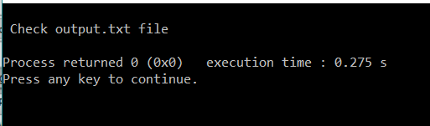

1. Declare a structure to represent a complex number (a number having a real part and imaginary part). Write C++ functions to add, subtract, multiply and divide two complex numbers.

**PROGRAM-**

**#include <stdio.h>**

**#include<iostream>**

**#include<math.h>**

**using namespace std;**

**struct complex**

**{**

**float real;**

**float img;**

**}a1,a2;**

**int main()**

**{**

**float a,b;**

**cout<<"Enter Real and Imaginary Part of 1st Complex Number : ";**

**cin>>a1.real>>a1.img;**

**cout<<"Enter Real and Imaginary Part of 2nd Complex Number : ";**

**cin>>a2.real>>a2.img;**

**//Addition**

**a=(a1.real)+(a2.real);**

**b=(a1.img)+(a2.img);**

**cout<<"\n Addition : "<<"("<<a<<")"<<"+"<<"("<<b<<")"<<"i";**

**//Subtraction**

**a=(a1.real)-(a2.real);**

**b=(a1.img)-(a2.img);**

**cout<<"\n Subtraction : "<<"("<<a<<")"<<"+"<<"("<<b<<")"<<"i";**

**//Multiplication**

**a=((a1.real)*(a2.real))-((a1.img)*(a2.img));**

**b=((a1.real)*(a2.img))+((a2.real)*(a1.img));**

**cout<<"\n Multiplication : "<<"("<<a<<")"<<"+"<<"("<<b<<")"<<"i";**

**//Division**

**a=(((a1.real)*(a2.real))+((a1.img)*(a2.img)))/(pow(a2.real,2)+pow(a2.img,2));**

**b=(((a2.real)*(a1.img))-((a1.real)*(a2.img)))/(pow(a2.real,2)+pow(a2.img,2));**

**cout<<"\n Division : "<<"("<<a<<")"<<"+"<<"("<<b<<")"<<"i";**

**return 0;**

**}**

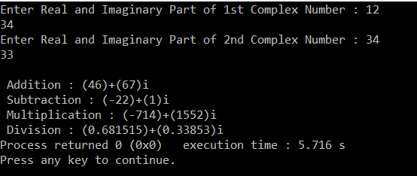

1. Write a program in C++ to swap values of two variables using pointers.

**PROGRAM-**

**#include<iostream>**

**using namespace std;**

**void swap(int *x, int *y)**

**{**

**int tmp = *x;**

**\*x = *y;**

**\*y = tmp;**

**}**

**int main()**

**{**

**int x = 0, y = 0;**

**cout<<"Enter the Value of a and b : ";**

**cin>>x>>y;**

**swap(&x, &y);**

**cout<<"\nAfter Swapping value of a ="<<x<<" and value of b ="<<y;**

**return 0;**

**}**

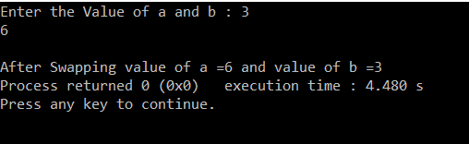

1. Write the definition for a class called **budget** that has floating point data members income and tax. The class has the following member functions:  
   **void show(float, float)** to set the specified value in object  
   **void display()** to display income and tax

**void calculate ()** to calculate tax on the basis of income (Rs 10000.0) and tax rate (18.0)

**PROGRAM-**

**#include <stdio.h>**

**#include<iostream>**

**using namespace std;**

**class Budget**

**{**

**float INCOME,TAX;**

**public:**

**void show(float inc, float tax)**

**{**

**cout << "\n Enter the Total Income : \t";**

**cin >>INCOME;**

**cout << "\n Enter the Tax Rate on Income : \t";**

**cin >> TAX;**

**inc=INCOME;**

**tax=TAX;**

**}**

**void display()**

**{**

**cout<<"\n Total Income of Employee : "<<INCOME;**

**cout<<"\n Total Tax on Income: "<<TAX;**

**}**

**void calculate()**

**{**

**float taxval;**

**taxval=((INCOME*TAX)/100);**

**cout<<"\n Total Income Tax Value : "<<taxval<<"\n";**

**}**

**};**

**int main()**

**{**

**Budget B;**

**B.show(54,44);**

**B.display();**

**B.calculate();**

**return 0;**

**}**

