RASHID ANSARI

ADVANCE DATA STRUCTURE

DAY 02

170847980003

Pre -Assignment:

1. Write a program in c++ using increment(Post and Pre) and decrement operators

**INCREMENT**

**#include <iostream>**

**using std::cout;**

**using std::endl;**

**int main()**

**{**

**int b;**

**//Postincrement**

**b = 8;**

**cout << "Value of b : "<< b << endl;**

**cout << "Postincrement : " << b++ << endl;**

**cout << "After Postincrement Value of b : " << b << endl;**

**cout << endl;**

**//Preincrement**

**b = 8;**

**cout << "Value of b : " << b << endl;**

**cout << "Preincrement : " << ++b << endl;**

**cout <<"After Preincrement Value of b : " << b << endl;**

**return 0;**

**}**

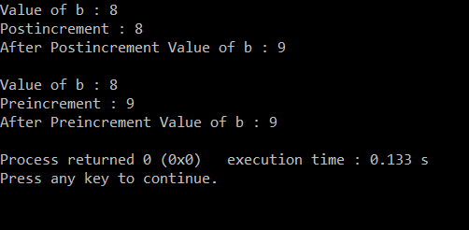

**DECREMENT**

**#include <iostream>**

**using std::cout;**

**using std::endl;**

**int main()**

**{**

**int b;**

**// Postdecrement**

**b = 8;**

**cout << "Value of b : "<< b << endl;**

**cout << "Postdecrement : " << b-- << endl;**

**cout << "After Postdecrement Value of b : " << b << endl;**

**cout << endl;**

**// Predecrement**

**b = 5;**

**cout << "Value of b : " << b << endl;**

**cout << "Predecrement : " << --b << endl;**

**cout <<"After Predecrement Value of b : " << b << endl;**

**return 0;**

**}**

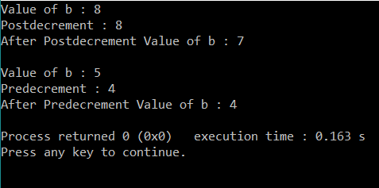

1. Write a program in c++ using all flow control statements (if, else, for , while and switch)

**#include <iostream>**

**using namespace std;**

**int main()**

**{**

**int num,dow;**

**cout<<"Enter Any Number for control Flow Operations :";**

**cin>>num;**

**cout<<"\n ***** IF ELSE CONTROL FLOW *****\n";**

**if(num>0)**

**{**

**cout<<"\n [IF] Entered Number is "<<num;**

**}**

**else**

**{**

**cout<<"\n [ELSE] Entered number is below 0 is"<<num;**

**}**

**cout<<"\n\n ***** FOR CONTROL FLOW ***** \n";**

**for(int i=1;i<=num;i++)**

**{**

**cout<<"\n\t"<<i;**

**}**

**cout<<"\n\n ***** WHILE CONTROL FLOW ***** \n";**

**while(num>0)**

**{**

**cout<<"\n\n number is greater than 0 which is : "<<num<<"\n\n";**

**break;**

**}**

**cout<<"\n ***** SWITCH CONTROL FLOW ***** \n\n";**

**int ch;**

**cout<<"Enter Number of Week's Day (1-7): ";**

**cin>>dow;**

**switch(dow)**

**{**

**case 1 : cout<<"\nSunday";**

**break;**

**case 2 : cout<<"\nMonday";**

**break;**

**case 3 : cout<<"\nTuesday";**

**break;**

**case 4 : cout<<"\nWednesday";**

**break;**

**case 5 : cout<<"\nThursday";**

**break;**

**case 6 : cout<<"\nFriday";**

**break;**

**case 7 : cout<<"\nSaturday";**

**break;**

**default : cout<<"\nWrong number of day";**

**break;**

**}**

**return 0;**

**}**

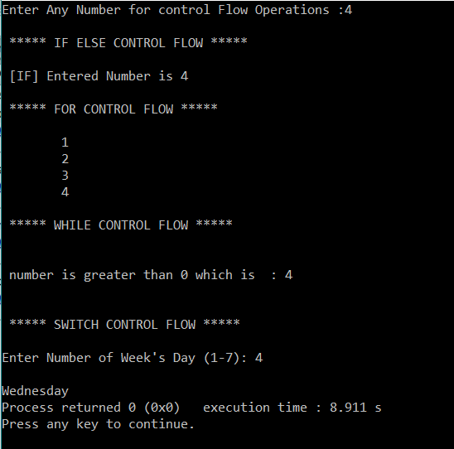

1. Write a program using functions which accept two integers as an argument and return its sum, sub, divide and multiply. Call all the functions from main( )

**#include<iostream>**

**using namespace std;**

**int main()**

**{**

**int x,y,z,mul(int,int);**

**cout<<"\n Enter the value of x,y : ";**

**cin>>x>>y;**

**z=mul(x,y);**

**cout<<"\n Multiplied value is : "<<z;**

**return 0;**

**}**

**int mul(int p,int q)**

**{**

**int s,a,add(int,int);**

**s=p*q;**

**a=add(p,q);**

**cout<<"\n Addition is : "<<a;**

**return(s);**

**}**

**int add(int l, int m)**

**{**

**int b,c,sub(int,int);**

**b=l+m;**

**c=sub(l,m);**

**cout<<"\n Subtraction is : "<<c;**

**return(b);**

**}**

**int sub(int e, int f)**

**{**

**int d;**

**d=e-f;**

**return(d);**

**}**

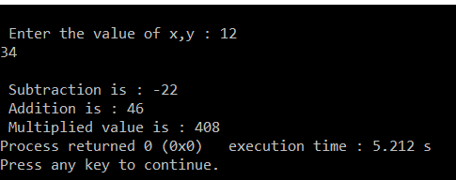

1. Write a program which input value of good, rate(18%) from user and calculate Goods and Service Tax.

**#include<iostream>**

**using namespace std;**

**int main()**

**{**

**float amount,GST,rate;**

**cout<<"\n Enter the Amount of Goods : \n";**

**cin>>amount;**

**cout<<"\n Enter the Rate : \n";**

**cin>>rate;**

**GST=(amount*rate)/100;**

**cout<<"\n GST is :: "<<GST <<"\n";**

**return 0;**

**}**

