RASHID ANSARI

ADVANCE DATA STRUCTURE

DAY 03

170847980003

1. Declare a 1 – Dimensional array in C++ and find the smallest and largest value in the array.

**#include <iostream>**

**using namespace std;**

**int main()**

**{**

**int arr[50],n,i,small,large;**

**cout<<"\n\t Enter elements to insert in array : ";**

**cin>>n;**

**for(i=0;i<n;i++)**

**{**

**cout<<"Enter element :"<<i+1<<":";**

**cin>>arr[i];**

**}**

**small=arr[0];**

**large=arr[0];**

**for(i=1;i<n;i++)**

**{**

**if(arr[i]<small)**

**small=arr[i];**

**if(arr[i]>large)**

**large=arr[i];**

**}**

**cout<<"\nLargest element in array is :"<<large<<endl;**

**cout<<"\nSmallest element in array is :"<<small<<endl;**

**return 0;**

**}**

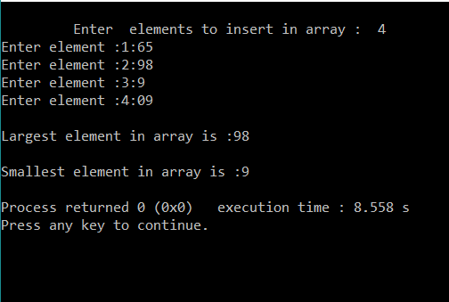

1. Write a program in C++ finds the length of the string and also displays the string reverse, compare two strings to check whether they are equal or not and concatenate two strings, convert string to lower case/upper case.

**#include <cstring>**

**#include <iostream>**

**#include <string>**

**#include <locale>**

**using namespace std;**

**void reverseStr(string &str)**

**{**

**int n = str.length();**

**for (int i=0; i<n/2; i++)**

**swap(str[i], str[n-i-1]);**

**}**

**int main()**

**{**

**char str1[]="Smartphone";**

**char str2[]= "Accessories";**

**cout<<"\n01 STRING LENGHT\n";**

**cout<<"\n Given String : "<<str1;**

**cout << "\nwithout null character: " << std::strlen(str1) << '\n'**

**<< "with null character: " << sizeof str1 << '\n';**

**string str = "laptop";**

**cout<<"\n02 STRING REVERSE \n"<<"\nGiven String :"<<str;**

**reverseStr(str);**

**cout <<"\nREVERSE :" <<str<<"\n\n";**

**cout<<"\n03 STRING CONCATENATE \n";**

**cout<<"\n "<<strcat(str1,str2)<<"\n\n";**

**cout<<"\n04 STRING COMPARE \n";**

**int res = strcmp(str1, str2);**

**if (res==0)**

**cout<<"Strings are equal";**

**else**

**cout<<"Strings are unequal";**

**cout<<"\n strcmp() Result is: "<<res<<"\n";**

**cout<<"\n05 STRING UPPER/LOWER \n";**

**std::locale loc;**

**std::string str4="maze\n";**

**for (std::string::size_type i=0; i<str.length(); ++i)**

**{**

**std::cout<< std::toupper(str4[i],loc);**

**}**

**for (std::string::size_type j=0; j<str.length(); ++j)**

**{**

**std::cout<<std::tolower(str4[j],loc);**

**}**

**return 0;**

**}**

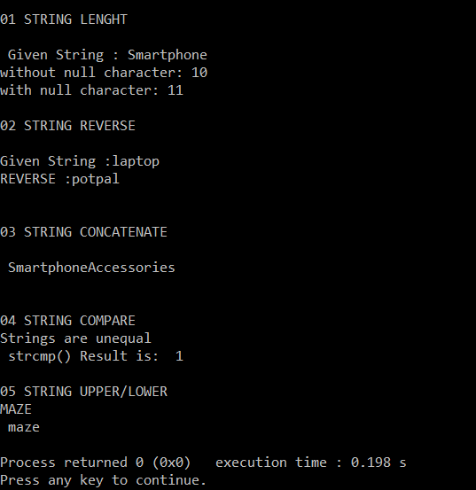

1. Write a menu driven C++ program to do following operation on two dimensional array B of size a x b. You should use user-defined functions which accept 2-D array A and its size a and b as arguments. The options are:

To input elements into matrix of size a x b

To display elements of matrix of size a x b

**#include<iostream>**

**using namespace std;**

**void read_matrix(int m[10][10],int r,int c)**

**{**

**int i,j;**

**for(i=1;i<=r;i++)**

**{**

**for(j=1;j<=c;j++)**

**{**

**cout<<"\n Enter matrix elements :\t";**

**cin>>m[i][j];**

**}**

**}**

**}**

**void display_data(int m[10][10],int r,int c)**

**{**

**int i,j;**

**for(i=1;i<=r;i++)**

**{**

**for(j=1;j<=c;j++)**

**{**

**cout<<m[i][j];**

**}**

**cout<<"\n";**

**}**

**}**

**int main()**

**{**

**int m[10][10],r,c,ch;**

**cout<<"\n Enter number of rows = \t";**

**cin>>r;**

**cout<<"\n Enter number of columns = \t";**

**cin>>c;**

**do**

**{**

**cout<<"\n 1. ENTER MATRIX ELEMENTS";**

**cout<<"\n 2. DISPLAY MATRIX ";**

**cout<<"\n 3. EXIT";**

**cout<<"\n ENTER YOUR CHOICE : \t";**

**cin>>ch;**

**switch(ch)**

**{**

**case 1: read_matrix(m,r,c);**

**break;**

**case 2: display_data(m,r,c);**

**break;**

**}**

**}while(ch<2);**

**return 0;**

**}**

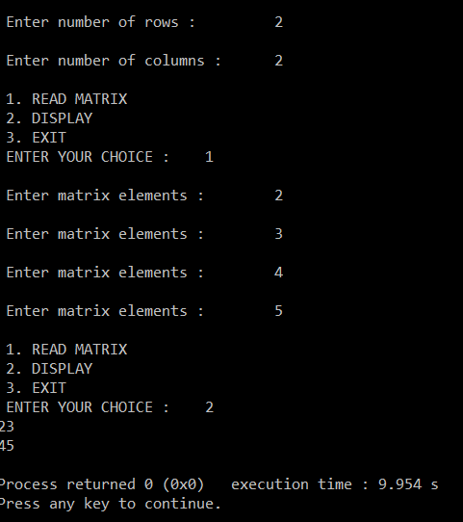

1. An array stores details of 10 students (rollno, name, marks in three subject). Write a program to create such an array and print out a list of students who have failed in more than one subject.

**#include<iostream>**

**using namespace std;**

**struct stud**

**{**

**int roll;**

**char nm[50];**

**float m1, m2, m3;**

**};**

**typedef stud S;**

**int main()**

**{**

**S student[10];**

**for(int i =0 ; i < 10 ; i++)**

**{**

**cout << "\n Enter Roll no : \t";**

**cin >> student[i].roll;**

**cout << "\n Enter Name : \t";**

**cin>>student[i].nm;**

**cout << "\n Enter marks of three subjects : \t";**

**cin >> student[i].m1 >> student[i].m2 >> student[i].m3 ;**

**}**

**cout<< "\n STUDENTS FAILED IN MORE THAN 1 SUBJECT \n ";**

**for(int i =0 ; i < 10 ; i++)**

**{**

**if(( student[i].m1< 40 && student[i].m2 < 40) || (student[i].m2 < 40 && student[i].m3 < 40) ||**

**( student[i].m1 < 40 && student[i].m3 < 40))**

**cout << student[i].roll << "\t" << student[i].nm << "\n";**

**}**

**}**