**Date: 29-01-2018**

**Module Name: Advanced Data Structures**

**Name : Shyamji Pandey**

**PRN: 170847980004**

**Pre –Assignment ADS [DAY 1]:**

1. **Write a program to display the following output using a single cout statement.**

**Subject Marks**

**Big Data Technologies 90**

**Statistics 77**

**Advanced Data Structures 69**

**Program :**

**#include <iostream>**

**using namespace std;**

**int main()**

**{**

**cout<<"\t Subject \t\t\t Marks \n\tBig Data Technologies \t\t 90 \n\tStatistic \t\t\t 77 \n\tAdvanced Data Structures \t 69 ";**

**return 0;**

**}**

**Output :**

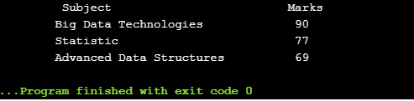

1. **Write a program in c++ to swap value of two ages of Ram and Shyam without using third variable**

**/\***

**#include <iostream>**

**using namespace std;**

**int main()**

**{**

**int ageOfShyam, ageOfRam;**

**cout<<"\n \t Please Enter Age of Shyam : ";**

**cin>>ageOfShyam;**

**cout<<"\n \t Please Enter Age of Ram : ";**

**cin>>ageOfRam;**

**cout << "\n\n\tBefore swapping." << endl;**

**cout << "\n\t ageOfShyam = " << ageOfShyam << ",\t ageOfRam = " << ageOfRam << endl;**

**ageOfShyam = ageOfShyam + ageOfRam;**

**ageOfRam = ageOfShyam - ageOfRam;**

**ageOfShyam = ageOfShyam - ageOfRam;**

**cout << "\n\t After swapping." << endl;**

**cout << "\n\t ageOfShyam = " << ageOfShyam << ", \t ageOfRam = " << ageOfRam << endl;**

**return 0;**

**}**

**\*/**

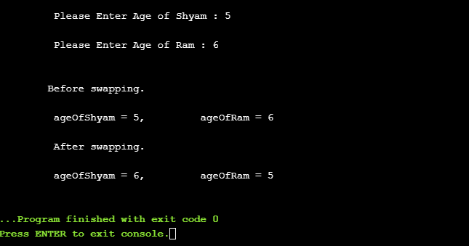

1. **Write a program which accepts amount as integer and display total number of Notes of Rs. 100, 50, 20, 10, 5 and 1.**

**For example, when user enter a number, 175,**

**The results would be like this...**

**100: 1**

**50: 1**

**20: 1**

**10: 0**

**5: 1**

**1: 0**

**/\***

**#include<iostream>**

**using namespace std;**

**int main()**

**{**

**int amt,R100,R50,R20,R10,R5,R1;**

**cout<<"Enter amount : ";**

**cin>>amt;**

**R100=amt/100;**

**amt=amt%100;**

**R50=amt/50;**

**amt=amt%50;**

**R20=amt/20;**

**amt=amt%20;**

**R10=amt/10;**

**amt=amt%10;**

**R5=amt/5;**

**amt=amt%5;**

**R1=amt;**

**cout<<"\nRs.100 : "<<R100<<"\nRs. 50 : "<<R50<<**

**"\nRs. 20 : "<<R20<<"\nRs. 10 : "<<R10<<"\nRs. 5 : "<<R5<<"\nRs. 1 : "<<R1;**

**return 0;**

**}**

**\*/**

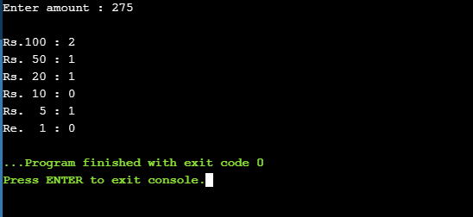

1. **Write a program which accept two T20 ODI'S averages of Mithali Raj and print their average**

**/\***

**/\*\*\*\*\*\*\*\*\*\*\*\*\*\*\*\*\*\*\*\*\*\*\*\*\*\*\*\*\*\*\*\*\*\*\*\*\*\*\*\*\*\*\*\*\*\*\*\*\*\*\*\*\*\*\*\*\*\*\*\*\*\*\*\*\*\*\*\*\*\*\*\*\*\*\*\*\*\***

**Program for Calucalting Avarage of Mithali Raj's Two T20 Avarage Runs**

**\*/**

**#include <iostream>**

**using namespace std;**

**int main(){**

**float x,y,sum;**

**float average;**

**cout << "\n\t Enter Two T20 Averages for Mithali : " << endl;**

**cin>>x>>y;**

**sum=x+y;**

**average=sum/2;**

**cout << "The sum of " << x << " and " << y << " is " << sum << "." << endl;**

**cout << "\n The Total Performance Average of Mithali's T20 : " << x << " and " << y << " is " << average << "." << endl;**

**}**

**\*/**

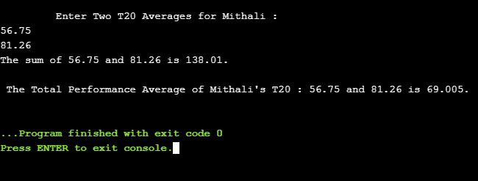

1. **Create your account in github (https://github.com) and push the above programs to your git account.**

**GitHub ID : shyampandey2895**

Above Link :

<https://gist.github.com/ShyamPandey2895/c37bb2c878ee1624833463e413939d24>