# Inheritence

# 1.Write program to read and print employee information using multiple inheritance.

Output:

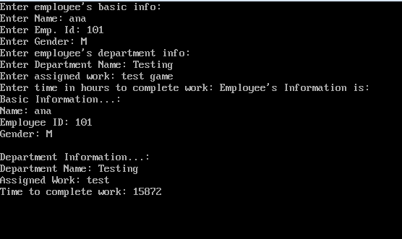

## 2. Hierarchical inheritance to get square and cube of a number program in C++.

Output:

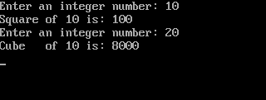

**Pointers**

3. **C++ Program to display address of elements**

**of an array using both array and pointers**

**output:**

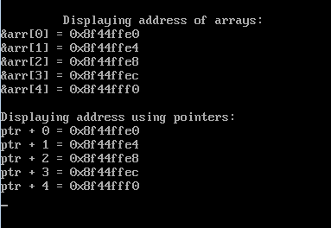

**4. Modify the solution of exercise 1 in order to print the elements of the array in reverse order using a pointer.**

Output:

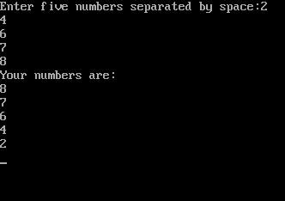

# Structures

# 5. C++ Program to Add Two Distances (in inch-feet) System Using Structures

# Output:

## 

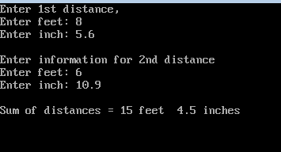

**6. Store Information in Structure and Display it**

Output:

. 