Date: 31/01/2018

University/Academic Institution: Sandip University Course Name: M.Tech ACDS

Batch Name: 2017-19 Module Name: Advanced Data Structures

Pre -Assignment: (All programs to be committed via git only)

1. Declare a 1 – Dimensional array in C++ and find the smallest and largest value in the array.

Output:

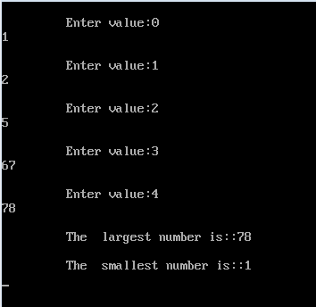

1. Write a program in C++ finds the length of the string and also displays the string reverse, compare two strings to check whether they are equal or not and concatenate two strings, convert string to lower case/upper case.

Output:

Equal string:

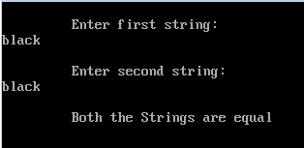

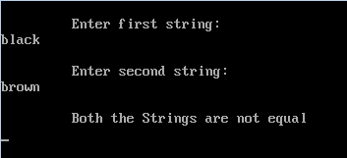

Concatenate string:

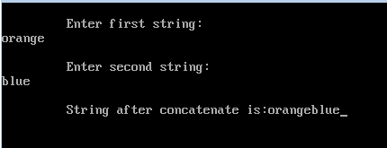

Length of the string:

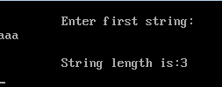

Reverse of the string:

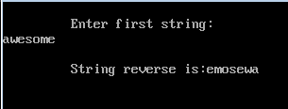

convert string to lower case/upper case:

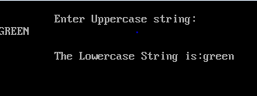

1. Write a menu driven C++ program to do following operation on two dimensional array B of size a x b. You should use user-defined functions which accept 2-D array A and its size a and b as arguments. The options are:

To input elements into matrix of size a x b

To display elements of matrix of size a x b

Output:

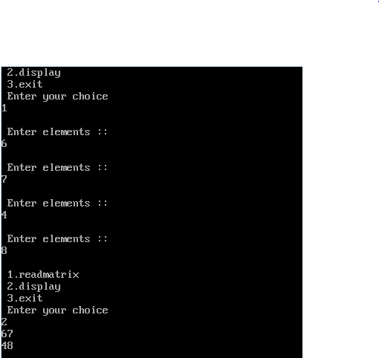

1. An array stores details of 10 students (rollno, name, marks in three subject). Write a program to create such an array and print out a list of students who have failed in more than one subject.

Output:

