//3.Write a program using functions which accept two integers as an argument //and return its sum, sub, divide and multiply. Call all the functions from main( )

……………………………Add……………………..

#include<iostream.h>

#include<conio.h>

int sum(int a, int b)

{

int result;

result=a+b;

return (result);

}

int main()

{

clrscr();

int a=100;

int b=200;

int result;

result=sum(a,b);

cout<<"\n\t Addition is:"<<result<<endl;

getch();

}

Output:



…………………………Substract…………………………….

#include<iostream.h>

#include<conio.h>

int sum(int a, int b)

{

int result;

result=a-b;

return (result);

}

int main()

{

clrscr();

int a=400;

int b=200;

int result;

result=sum(a,b);

cout<<"\n\t Subtraction is:"<<result<<endl;

getch();

}

Output:

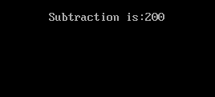

…………………..Divide……………..

#include<iostream.h>

#include<conio.h>

int div(int a, int b)

{

int result;

result=a/b;

return (result);

}

int main()

{

clrscr();

int a=400;

int b=200;

int result;

result=div(a,b);

cout<<"\n\t Divide is:"<<result<<endl;

getch();

}

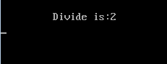

…………….multiply…………….

#include<iostream.h>

#include<conio.h>

int mul(int a, int b)

{

int result;

result=a\*b;

return (result);

}

int main()

{

clrscr();

int a=4;

int b=2;

int result;

result=mul(a,b);

cout<<"\n\t Multiplication is:"<<result<<endl;

getch();

}

Output:

