Date: 30/01/2018

University/Academic Institution: Sandip University Course Name: M.Tech ACDS

Batch Name: 2017-19 Module Name: Advanced Data Structures

Pre -Assignment:

1. Write a program in c++ using increment(Post and Pre) and decrement operators.

**PROGRAM**:🡪

**#include<iostream.h>**

**#include<conio.h>**

**int main()**

**{ clrscr();**

**int i,a,b,c,d;**

**cout<<"Enter any value";**

**cin>>i;**

**a=i;**

**cout<<"\nPre-incremented value="<<++a;**

**b=i;**

**cout<<"\nPost-incremented value="<<b++;**

**c=i;**

**cout<<"\nPre-decremented value="<<--c;**

**d=i;**

**cout<<"\nPost-decremented value="<<d--;**

**getch();**

**return 0;**

**}**

**OUTPUT**:🡪

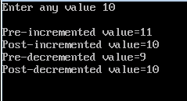

1. Write a program in c++ using all flow control statements (if, else, for , while and switch).

PROGRAM:🡪

**#include<iostream.h>**

**#include<conio.h>**

**int main()**

**{**

**clrscr();**

**cout<<"\nProgram for flow control statements";**

**int ch;**

**do**

**{**

**cout<<"\n 1.if-else program\n 2.for loop program\n 3.while program\n 4.switch program\n 5.exit";**

**cout<<"\nEnter your choice";**

**cin>>ch;**

**switch(ch)**

**{**

**case 1:**

**cout<<".....Executing example of if-else statement..... ";**

**int per;**

**cout<<"\nEnter the percentage:";**

**cin>>per;**

**if(per>40)**

**{cout<<"\nPASS";}**

**else**

**{cout<<"\nFail";}**

**break;**

**case 2:**

**cout<<".....Executing example of while loop.....";**

**int num=10;**

**cout<<"This will print the sequence";**

**while(num<20)**

**{**

**cout<<"\t"<<num;**

**num++;**

**}**

**break;**

**case 3:**

**cout<<".....Executing example of for loop.....";**

**int a,o;**

**cout<<"\nEnter any number:";**

**cin>>a;**

**cout<<"\nThis program will print the sequence upto the entered number";**

**for(o=0;o<=a;o++)**

**{**

**cout<<a<<"\t";**

**}**

**break;**

**case 4:**

**cout<<".....Executing program for switch case.....";**

**char sw;**

**cout<<"\na.one\nb.Two\nc.exit";**

**cout<<"\n Enter your choice:";**

**cin>>sw;**

**switch(sw)**

**{**

**case 'a':**

**cout<<"\nYou Entered character a ";**

**break;**

**case 'b':**

**cout<<"\nYou Entered character b";**

**break;**

**default:**

**cout<<"\nunknown choice";**

**break;**

**}**

**}**

**}while(ch<5);**

**getch();**

**return 0;**

**}**

**OUTPUT:🡪**

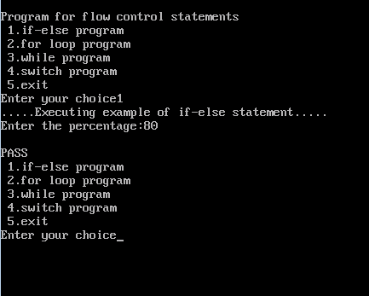

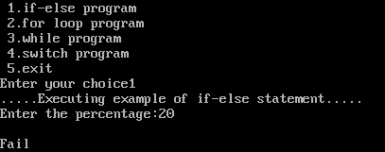

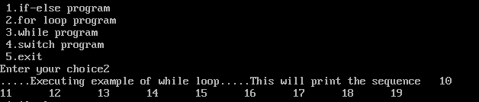

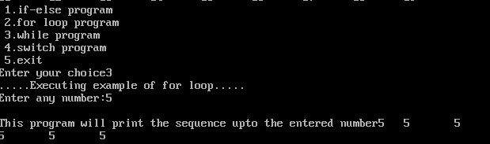

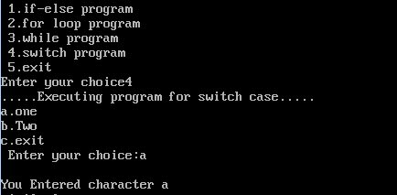

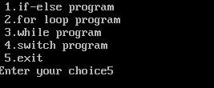

1. Write a program using functions which accept two integers as an argument and return its sum, sub, divide and multiply. Call all the functions from main( )

**PROGRAM:🡪**

**#include<iostream.h>**

**#include<conio.h>**

**int addition(int a,int b)**

**{**

**return(a+b);**

**}**

**int subtraction(int a,int b)**

**{**

**return(a-b);**

**}**

**int multiplication(int a,int b)**

**{**

**return(a*b);**

**}**

**int division(int a,int b)**

**{**

**return(a/b);**

**}**

**int main()**

**{**

**clrscr();**

**cout<<"*********This is program for simple mathematical operations*************";**

**int a,b;**

**cout<<"\nEnter two values:" ;**

**cin>>a>>b;**

**cout<<"\nAdditiion is:"<<addition(a,b);**

**cout<<"\nSubraction is:"<<subtraction(a,b);**

**cout<<"\nMultiplication is:"<<multiplication(a,b);**

**cout<<"\nDivision is:"<<division(a,b);**

**getch();**

**return 0;**

**}**

**OUTPUT**:🡪

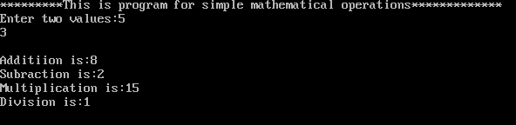

1. Write a program which input value of good, rate(18%) from user and calculate Goods and Service Tax.

PROGRAM:🡪

**#include<iostream.h>**

**#include<conio.h>**

**int main()**

**{**

**clrscr();**

**float a,rate,gst,b;**

**cout<<"************This is the program for displaying GST*************";**

**cout<<"\n\nEnter the good's amount in which GST is included ";**

**cin>>a;**

**cout<<"\nEnter the Rate\n";**

**cin>>rate;**

**cout<<".......Calculation of GST........";**

**gst=(a*rate)/100;**

**cout<<"\nGOODS AND SERVICE TAX ="<<gst;**

**getch();**

**return 0;**

**}**

**OUTPUT**:🡪

