Neptune
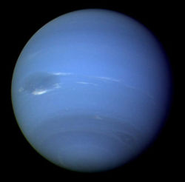
Figure 1 Neptune seen from Voyager 2

How big is the planet
Neptune is very similar to Uranus in size. Its diameter is only slightly smaller, at 49,528 km wide. It is almost as big as four Earths in length.

How long is a day on Neptune
A day on Neptune lasts 16 hours and 7 minutes.

How long is a year on Neptune
One year on Neptune is about 165 Earth years, or 60,265 days.

Neptune Facts

- Wind speeds on Neptune can reach 450 meters per second.
- Neptune was discovered because its gravitational field was affecting the orbit of Uranus.
- Neptune is sometimes farther from the Sun than Pluto.

http://www.nasa.gov/worldbook/neptune_worldbook.html
http://solarsystem.nasa.gov/planets/profile.cfm?Object=Neptune&Display=Facts

