The Solar System
by The Author

Copyright Nature Publications
Revised: 4/20/2009 10:16:00 PM

The Solar System
by The Author

Contents
No table of contents entries found.

General Outline
The book is about the solar system. The contents are from wikibooks. Please refer http://en.wikibooks.org/wiki/Wikijunior_Solar_System for more information.
The book contains basic information about sun and the 9 planets in the solar system: Mercury, Venus, Earth, Mars, Jupiter, Saturn, Uranus, Neptune and Pluto.

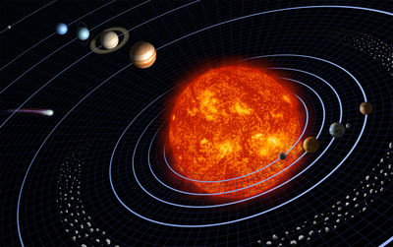

Click here to enter text.
Click here to enter text.
Click here to enter text.
Click here to enter text.
Click here to enter text.

Click here to enter text.
Click here to enter text.
Click here to enter text.
Click here to enter text.
Click here to enter text.
Click here to enter text.

