Week 5
Retrieval-Augmented Generation (RAG)



Learning Outcomes:

By the end of this session, students should:
- Understand the format and requirements of the Project Demonstration assessment task.
- Have reviewed the concept of Retrieval Augmented Generation.
- Have practiced the pronunciation of the /θ/ and /ð/ (‘th’) sounds.
- Have practiced how to give a good demonstration.

Task 1: Understanding the Project Demonstration assessment task. ⭐ Key Task

Read the Project Demonstration task sheet from LMO and find the answer to the following questions. Focus on the demonstration only, not the follow up questions.

- How long with the demonstration section of the assessment be?
- Do you need PowerPoint slides? How many slides should you have?
- How many different sections should your demonstration be divided into?
- Do all group members need to speak during the demonstration, or can one or more students run the demonstration?
- Should you produce detailed notes about what to say and how to run the demonstration?

Pronunciation Focus: /θ/ and /ð/ - the ‘th’ Sounds
 |  |  | Watch the following small section of a video about voiced and voiceless sounds.  The full video is available here:  https://www.youtube.com/watch?v=C7EmxHLBB-A
 | Voiced Sounds |  |  | Voiceless Sounds
IPA Symbols | ￼ |  |  | ￼
‘Th’ sounds | ð |  |  | θ
Definition | Produced when the vocal cords vibrate |  |  | Produced without the vocal cords vibrating
Example | The sound /b/ in ‘bat’ or /d/ in ‘dog.’  When you say these sounds, you can feel your throat vibrating. |  |  | The sound /p/ in ‘pat’ or /t/ in ‘top.’  When you say these sounds, there is no vibration in your throat.

Task 2a: Distinguishing Sounds

Look at the tongue twister below and decide whether each of the ‘th’ sounds are voiced or voiceless. Put a tick (✓) symbol in the box if it is voiced (ð) and a cross (✕) symbol if it is voiceless (θ). Then practice saying the sentence out loud.

☐ |  | ☐ | ☐ |  | ☐ |  | ☐
Think | about | the | weather | before you go | there | and | things | will be ok.
Task 2b: “Th” Bingo

You will play a game which requires you to recognize the difference between the voiced and voiceless ‘th’ sounds. Your teacher will give you a sheet with a list of both kinds on it. Your sheet is different from your neighbor's. The teacher will then say a series of words aloud. Each word may or may not be on your sheet. Look for the word on your chart and, if it is there, tick it off. As you do this, decide if it is voiced or voiceless and practice saying it aloud.

The first player to complete a row, column, or diagonal shouts "Bingo!" and wins. Notice you all get the middle square ‘free.’
Task 3: Vocabulary ⭐ Key Task

Retrieval (n.)  /rɪˈtriːvəl/ | Augmented (adj.)  /ɔːɡˈmentɪd/ | Latency (n.)  /ˈleɪ.tən.si/ | Accuracy (n.)  /ˈækjərəsi/
Synthesis (n.)  /ˈsɪnθəsɪs/ | Relevance (n.)  /ˈreləvəns/ | Contextual (adj.)  /kənˈtekstʃuəl/ | Semantic (adj.)  /sɪˈmæntɪk/
Query (n.)  /ˈkwɪəri/ | Vector(n.)  /ˈvektə/ | Chunking (n.)  /ˈtʃʌŋkɪŋ/ | Ethical (adj.)  /ˈeθɪkəl/

Look at the words above. First decide how many you think you already know. Then, try to match each word with one of the definitions below. You should not use your devices, but you can discuss your answers with your group. This activity is also available on Quizlet

Letter | Definitions
A | Enhanced or improved by adding something
B | A list of numbers that represents data in a multi-dimensional space, allowing machines to understand meaning and relationships
C | Having to do with morals, values, right and wrong
D | How close a measurement is to the true value
E | The combination of ideas or elements to form a new, complex theory or system
F | Depending on or relating to the circumstances, setting, or information that surround a particular event or piece of information
G | Breaking down large pieces of data into smaller, more manageable units
H | The delay between a request and the corresponding response
I | How closely connected something is to the topic
J | The act or process of accessing information previously encoded and stored in memory
K | Having to do with the meaning of words or language
L | To ask a question

Task 4a: Reading and Note-taking ⭐ Key Task
Read the following text and make notes.

Large Language Models (LLMs) represent a significant breakthrough in artificial intelligence (AI), enabling machines to generate and comprehend text in ways that resemble human communication. These models, powered by deep learning (DL) techniques and trained on extensive datasets, have demonstrated abilities to generate coherent and contextually relevant content across diverse applications [1]. As a result, LLMs have become essential tools in natural language processing, machine translation, content creation, and customer engagement. While LLMs have revolutionized text generation, they face challenges such as producing unoriginal or misleading content and raising ethical concerns like plagiarism and misinformation. Their lack of understanding, reliance on static knowledge, and potential biases can result in inaccuracies and outdated information [7], [8]. Furthermore, the high computational demands of LLMs pose environmental and financial concerns [9], [10]. One promising solution to the challenges of traditional text generation is Retrieval-Augmented Generation (RAG), a method to enhance the accuracy and contextual relevance of LLM-generated text by incorporating real-time information retrieval. RAG mitigates issues like static knowledge dependency and potential inaccuracies by retrieving relevant data from external sources and integrating it into the generation process. This approach is particularly useful for dynamic, knowledge-intensive tasks such as customer service, technical support, and question-answering systems. Advanced AI text detectors and ethical guidelines are also being developed to promote accountability, uphold originality, and ensure responsible AI use across various sectors. This paper provides an in-depth overview of AI text generation and detection technologies, with a focus on RAG.

RAG is an important advancement in AI text generation that overcomes many limitations of traditional models [32]. Unlike conventional language models that rely only on pre-trained data, RAG combines these models with retrieval mechanisms. This allows RAG to access relevant information from external sources like databases or the internet during text generation, improving the accuracy and relevance of the output, especially for up-to-date or specialized information. Traditional text generation systems create responses based solely on the information stored in the model. In contrast, RAG adds a retrieval step, actively searching for and using external information. This results in more accurate and contextually appropriate responses. By integrating retrieved knowledge, RAG can handle tasks that require real-time information or specific knowledge not included in the model’s training data

RAG has three main components: (1) retrieval model; (2) embedding model; and (3) generative model. Each component plays a crucial role in producing text that is both accurate and relevant to the user’s query.

1) Retrieval Model: The retrieval model is responsible for identifying and retrieving relevant documents or data from an external knowledge source. Using techniques like nearest neighbour search, based on pre-encoded document embeddings, the retrieval model efficiently locates pertinent information. For instance, in a customer service scenario, it may retrieve the latest product manual or troubleshooting guide in response to a user query.

2) Embedding Model: The embedding model converts both the input query and the retrieved documents into vector representations, or embeddings, to capture their semantic meaning. This step enables the system to match the query with documents that are contextually relevant, beyond simple keyword matching, by understanding the underlying meaning of the text.

3) Generative Model: The generative model produces the final output text. After relevant documents are retrieved and embedded, the generative model synthesizes this information to create a coherent, contextually appropriate response. Pretrained transformers, such as GPT or Text-to-Text Transfer Transformers (T5), are typically used to generate human-like text that integrates both the input query and the retrieved knowledge.

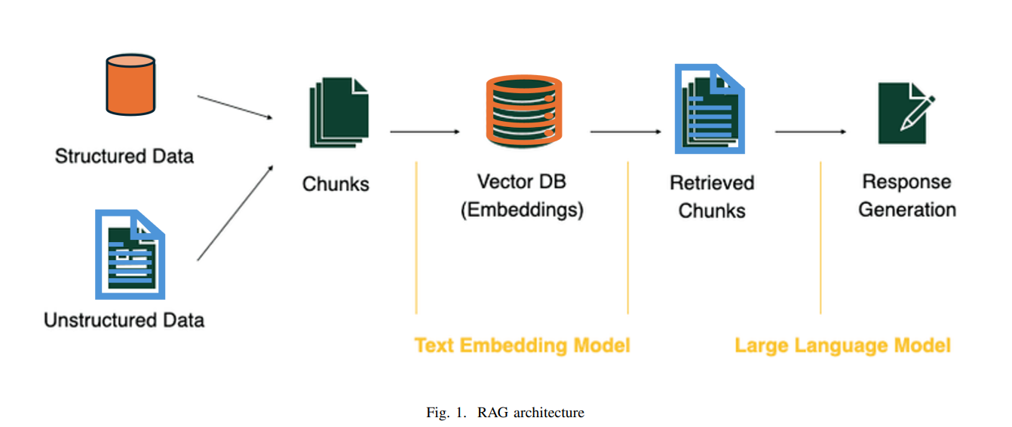

The RAG workflow (Figure 1) involves five stages: (1) chunking divides the dataset into segments; (2) embedding transforms each segment into a vector; (3) vector Database (Vector DB) stores these vectors; (4) retrieval uses Vector DB to find relevant chunks, and (5) response Generation synthesizes these chunks into a coherent answer using an LLM.

AI text generation and detection technologies, including advanced models such as RAG, offer transformative possibilities across sectors such as education, marketing, and customer support. RAG improves on traditional models by adding contextual relevance through real-time data retrieval, yet it still faces challenges like data quality dependency and potential hallucinations. Detection tools play a vital role in mitigating these challenges, although they too struggle as AI-generated content grows more sophisticated. RAG’s integration of external knowledge presents both opportunities and new hurdles, emphasizing the need for advances in generative and detection models alike.

(an excerpt from F. Neha, D. Bhati, D. K. Shukla, A. Guercio and B. Ward, "Exploring AI Text Generation, Retrieval-Augmented Generation, and Detection Technologies: a Comprehensive Overview," 2025 IEEE 15th Annual Computing and Communication Workshop and Conference (CCWC), Las Vegas, NV, USA, 2025, pp. 00633-00639, Doi: 10.1109/CCWC62904.2025.10903902.)

Task 4b: Comprehension Questions ⭐ Key Task

Using your notes, try to answer the following questions. You may work as a group.

1: What is Retrieval-Augmented Generation (RAG)?
A) A method that only uses pre-trained data for text generation.
B) A technique that enhances text generation by incorporating real-time information retrieval.
C) A system that generates text without any external data sources.
D) A model that focuses solely on generating unstructured data.

2: How does RAG improve the accuracy of text generation compared to traditional models?
A) By relying solely on user queries.
B) By integrating external information from databases or the internet.
C) By using only static knowledge.
D) By eliminating the need for a generative model.

3: In which areas can RAG be particularly useful?
A) Only in academic research.
B) In dynamic, knowledge-intensive tasks such as customer service and technical support.
C) Exclusively for generating fictional stories.
D) In creating static databases without user interaction.

4: What is one of the challenges faced by RAG?
A) It can only generate text in one language.
B) It has a low computational demand.
C) It may produce inaccurate information due to data quality dependency.
D) It does not allow for real-time information retrieval.

Giving a Good Demonstration

Task 5: Example Demonstration

Task 5a: ⭐ Key Task

Watch the following video of five teachers giving an example demonstration of an ISA104 project. You do not need to focus on every word spoken but try to answer the following questions.

- How many people are involved in the demonstration at any time?
- What topic does each person talk about?

Person | Topic
1 – Sam (Male) | Introduction and demonstrations
2 – Rui (Female)
3 – Emma (Female)
4 – James (Male)
5 – Alex (Female)

- Do the demonstrators talk about ethics or risks?

Task 5b:
Now in your groups discuss the following questions.

- What do you think is the advantage of doing the demonstration prompts first?
- What do you think are the main differences between giving a presentation and giving a demonstration?
- What do you do if the demonstration doesn’t work properly first time?

Task 6: Demonstration Practice

Task 6a ⭐ Key Task

You will do an activity based on prompts and answers given to and by a fictitious student AI project. This project is designed to track the exercise patterns of students and provide answers to questions about health and fitness in an XJTLU context.

First, read the first prompt and answer.
- How long did I exercise last week?
According to your fitness records, you exercised for about 3 hours and 25 minutes last week (October 5–11, 2026):
- Monday: 40-minute jog
- Wednesday: 1-hour gym session
- Friday: 45-minute cycling session
- Sunday: 1-hour basketball game
Now imagine you are presenting this part of the demonstration and read the following script for the relevant section of the demonstration out loud.

“So, this prompt demonstrates the basic functionality of our agent. The app stores all the data in a local database and then uses retrieval augmented generation to match the student who is asking the question with their own personal data. You can see that it presents the data in a neat, easy to understand form. The app could also answer questions about how long I’ve played basketball over all the weeks, or how far I’ve jogged.”

Task 6b
The teacher will give your group five prompts written on small pieces of paper and five answers from the same application as above. Match each prompt with the appropriate answer then discuss in your groups:
- What is the prompt showing? Why use it in a demonstration?
- What parts of the answer are particularly interesting or worth talking about in a demonstration?

Task 6c ⭐ Key Task
Each student in your group will choose a different prompt/answer pair. Read through the answer in more detail and plan out how you would talk about it in 30 seconds. You can read the prompt but not read the answer out directly. Instead talk about what it shows.
Some useful language:
- Next, we want to show you this prompt which says…
- This prompt demonstrates that…
- One problem we had when building our app was…
- One ethical issue we needed to solve…
- One security concern that was very important…
- You can see that the prompt deals with this issue by…
- The answer doesn’t fall into this trap…
- The app does well with this prompt because…

Task 6d
Now take turns and give your part of your presentation to your group.

