**Redshift vs. Athena**

https://blog.panoply.io/an-amazonian-battle-comparing-athena-and-redshift

**Why Spectrum added in Redshift?**

https://aws.amazon.com/blogs/big-data/amazon-redshift-spectrum-extends-data-warehousing-out-to-exabytes-no-loading-required/

* How many customers, purchases, payment methods, and amenities are there?

Customers: 100000

amenity:

tags:

pdate:

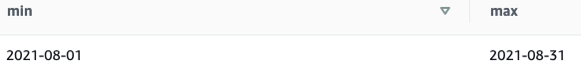

Customers by each province and territory:

