1. What is Boolean? Write down 3 different expression that results a Boolean type (i.e. 5 == 6)

A *Boolean* value is either true or false

In Python, the two Boolean values are True and False (the capitalization must be exactly as shown), and the Python type is bool.

**>>>** 5 == (3 + 2) *# Is five equal 5 to the result of 3 + 2?*

True

**>>>** 5 == 6

 False

**>>>** j = "hel" **>>>** j + "lo" == "hello"

True

**>>>** age = 18

**>>>** old_enough_to_get_driving_licence = age >= 17

**>>>** print(old_enough_to_get_driving_licence)

True

**>>>** type(old_enough_to_get_driving_licence)

<class ’bool’>

1. What is a flow chart? Draw flow chart for the following code snippet: (you can draw on a paper, take a picture of it)

A flowchart is a type of diagram that represents an algorithm, workflow or process, showing the steps as boxes of various kinds, and their order by connecting them with arrows. This diagrammatic representation illustrates a solution model to a given problem.

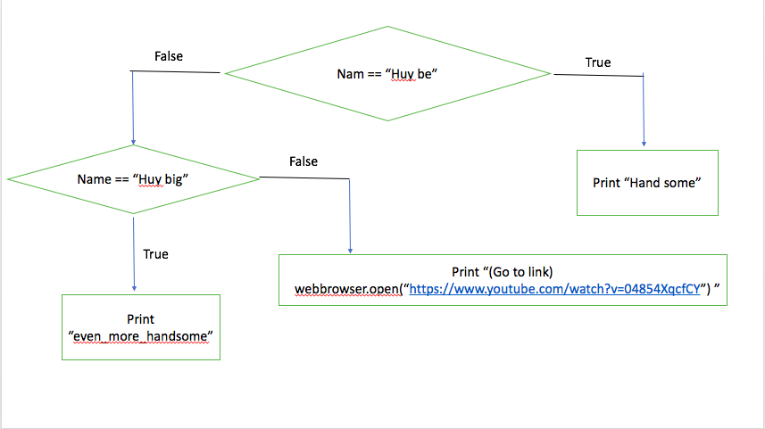

1. What is nested conditionals? Write a piece of code that uses nested conditionals

One conditional can also be **nested** within another. For example, assume we have two integer variables, x and y. The following pattern of selection shows how we might decide how they are related to each other.

**if** x < y:

**print**("x is less than y")

**else**:

**if** x > y:

**print**("x is greater than y")

**else**:

**print**("x and y must be equal")

The outer conditional contains two branches. The second branch (the else from the outer) contains another if statement, which has two branches of its own. Those two branches could contain conditional statements as well.