Study:

EX1:

Yes

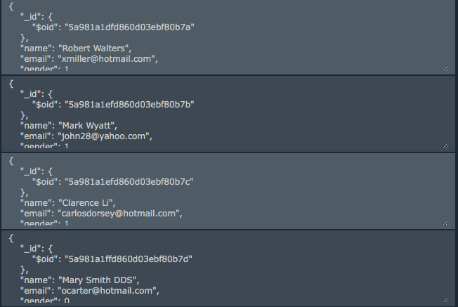

EX2:

Example:

id_to_find = “5a36299d9f10831aaae091e4”

-> using the raw string:

Docs.objects.get(id_to_find)

Ex3:

-> using the raw string:

Docs.objects.del(id_to_find)