**Advanced SQL Exercises for Online Retail Store**

**Exercise 1: Ranking and Window Functions**

**CODE(QUERY):**

CREATE TABLE Products (

ProductID INT,

ProductName VARCHAR(100),

Category VARCHAR(50),

Price DECIMAL(10,2)

);

INSERT INTO Products VALUES

(1, 'Laptop A', 'Electronics', 80000),

(2, 'Laptop B', 'Electronics', 95000),

(3, 'Laptop C', 'Electronics', 90000),

(4, 'Mouse A', 'Accessories', 250),

(5, 'Mouse B', 'Accessories', 400),

(6, 'Mouse C', 'Accessories', 400),

(7, 'Keyboard A', 'Accessories', 300),

(8, 'Phone A', 'Mobiles', 60000),

(9, 'Phone B', 'Mobiles', 75000),

(10, 'Phone C', 'Mobiles', 85000);

SELECT *

FROM (

SELECT

ProductID, ProductName, Category, Price,

ROW_NUMBER() OVER (PARTITION BY Category ORDER BY Price DESC) AS RowNum

FROM Products

) AS Ranked

WHERE RowNum <= 3;

SELECT *

FROM (

SELECT

ProductID, ProductName, Category, Price,

RANK() OVER (PARTITION BY Category ORDER BY Price DESC) AS RankNum

FROM Products

) AS Ranked

WHERE RankNum <= 3;

SELECT *

FROM (

SELECT

ProductID, ProductName, Category, Price,

DENSE_RANK() OVER (PARTITION BY Category ORDER BY Price DESC) AS DenseRankNum

FROM Products

) AS Ranked

WHERE DenseRankNum <= 3;

**OUTPUT:**

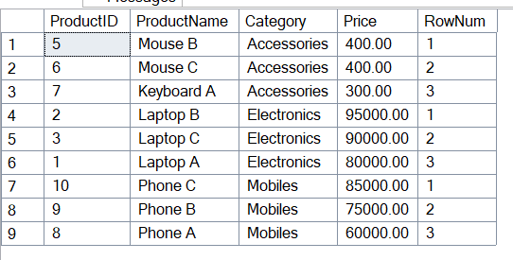

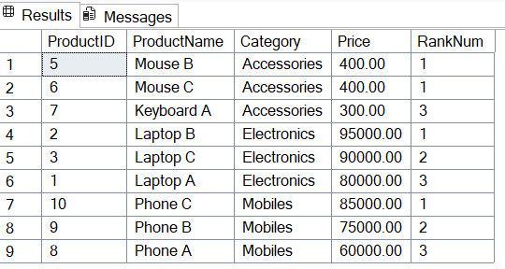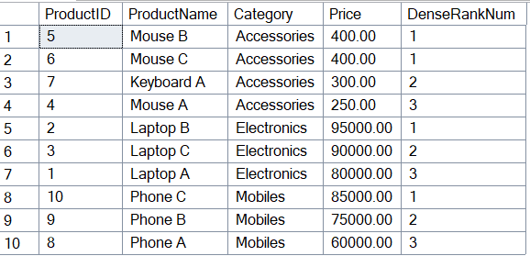

**SQL Exercise-Index**

**CODE:**

CREATE TABLE Customers (

CustomerID INT PRIMARY KEY,

Name VARCHAR(100),

Region VARCHAR(50)

);

CREATE TABLE Products (

ProductID INT PRIMARY KEY,

ProductName VARCHAR(100),

Category VARCHAR(50),

Price DECIMAL(10, 2)

);

CREATE TABLE Orders (

OrderID INT PRIMARY KEY,

CustomerID INT,

OrderDate DATE,

FOREIGN KEY (CustomerID) REFERENCES Customers(CustomerID)

);

CREATE TABLE OrderDetails (

OrderDetailID INT PRIMARY KEY,

OrderID INT,

ProductID INT,

Quantity INT,

FOREIGN KEY (OrderID) REFERENCES Orders(OrderID),

FOREIGN KEY (ProductID) REFERENCES Products(ProductID)

);

INSERT INTO Customers (CustomerID, Name, Region) VALUES

(1, 'Alice', 'North'),

(2, 'Bob', 'South'),

(3, 'Charlie', 'East'),

(4, 'David', 'West');

INSERT INTO Products (ProductID, ProductName, Category, Price) VALUES

(1, 'Laptop', 'Electronics', 1200.00),

(2, 'Smartphone', 'Electronics', 800.00),

(3, 'Tablet', 'Electronics', 600.00),

(4, 'Headphones', 'Accessories', 150.00);

INSERT INTO Orders (OrderID, CustomerID, OrderDate) VALUES

(1, 1, '2023-01-15'),

(2, 2, '2023-02-20'),

(3, 3, '2023-03-25'),

(4, 4, '2023-04-30');

INSERT INTO OrderDetails (OrderDetailID, OrderID, ProductID, Quantity) VALUES

(1, 1, 1, 1),

(2, 2, 2, 2),

(3, 3, 3, 1),

(4, 4, 4, 3);

SELECT * FROM Products WHERE ProductName = 'Laptop';

CREATE NONCLUSTERED INDEX IX_Products_ProductName

ON Products (ProductName);

SELECT * FROM Products WHERE ProductName = 'Laptop';

SELECT * FROM Orders WHERE OrderDate = '2023-01-15';

CREATE NONCLUSTERED INDEX IX_Orders_OrderDate

ON Orders (OrderDate);

SELECT * FROM Orders WHERE OrderDate = '2023-01-15';

SELECT * FROM Orders WHERE CustomerID = 1 AND OrderDate = '2023-01-15';

CREATE NONCLUSTERED INDEX IX_Orders_CustomerID_OrderDate

ON Orders (CustomerID, OrderDate);

SELECT * FROM Orders WHERE CustomerID = 1 AND OrderDate = '2023-01-15';

**OUTPUT:**

