**EXERCISE 3**: **HELLO WORLD RESTFUL WEB SERVICE**

HelloController.java

package com.cognizant.springlearn.controller;

import org.slf4j.Logger;

import org.slf4j.LoggerFactory;

import org.springframework.web.bind.annotation.GetMapping;

import org.springframework.web.bind.annotation.RestController;

@RestController

public class HelloController {

    private static final Logger LOGGER = LoggerFactory.getLogger(HelloController.class);

    @GetMapping("/hello")

    public String sayHello() {

        LOGGER.info("Start of sayHello() method");

        String response = "Hello World!!";

        LOGGER.info("End of sayHello() method");

        return response;

    }

}

SpringApplication.java

package com.cognizant.springlearn;

import org.springframework.boot.SpringApplication;

import org.springframework.boot.autoconfigure.SpringBootApplication;

@SpringBootApplication

public class SpringLearnApplication {

    public static void main(String[] args) {

        SpringApplication.run(SpringLearnApplication.class, args);

    }

}

Application.properties

# Server port configuration

server.port=8083

# Logging configuration

logging.level.com.cognizant.springlearn=DEBUG

OUTPUT:

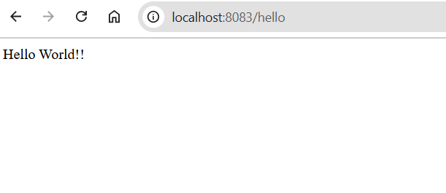

**EXERCISE 4**: **REST - COUNTRY WEB SERVICE**

CountryController.java

package com.cognizant.springlearn.controller;

import org.springframework.web.bind.annotation.GetMapping;

import org.springframework.web.bind.annotation.RequestMapping;

import org.springframework.web.bind.annotation.RestController;

import com.cognizant.springlearn.model.Country;

import org.springframework.context.support.ClassPathXmlApplicationContext;

@RestController

@RequestMapping("/country")

public class CountryController {

    @GetMapping

    public Country getCountryIndia() {

        ClassPathXmlApplicationContext context = new ClassPathXmlApplicationContext("beans.xml");

        Country country = (Country) context.getBean("in");

        context.close();

        return country;

    }

}

Country.java

package com.cognizant.springlearn.model;

public class Country {

    private String code;

    private String name;

    // Constructors

    public Country() {

    }

    public Country(String code, String name) {

        this.code = code;

        this.name = name;

    }

    // Getters and Setters

    public String getCode() {

        return code;

    }

    public void setCode(String code) {

        this.code = code;

    }

    public String getName() {

        return name;

    }

    public void setName(String name) {

        this.name = name;

    }

    @Override

    public String toString() {

        return "Country [code=" + code + ", name=" + name + "]";

    }

}

SpringApplication.java

package com.cognizant.springlearn;

import org.springframework.boot.SpringApplication;

import org.springframework.boot.autoconfigure.SpringBootApplication;

import org.springframework.context.annotation.ImportResource;

@SpringBootApplication

@ImportResource({"classpath:beans.xml"})

public class SpringLearnApplication {

    public static void main(String[] args) {

        SpringApplication.run(SpringLearnApplication.class, args);

    }

}

Beans.xml

<?xml version="1.0" encoding="UTF-8"?>

<beans xmlns="http://www.springframework.org/schema/beans"

       xmlns:xsi="http://www.w3.org/2001/XMLSchema-instance"

       xsi:schemaLocation="http://www.springframework.org/schema/beans

       http://www.springframework.org/schema/beans/spring-beans.xsd">

    <bean id="in" class="com.cognizant.springlearn.model.Country">

        <property name="code" value="IN"/>

        <property name="name" value="India"/>

    </bean>

</beans>

OUTPUT:

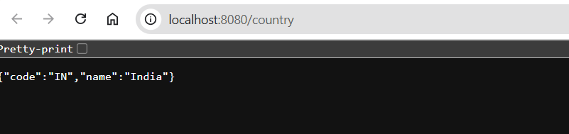

**EXERCISE 5**:**REST - GET COUNTRY BASED ON COUNTRY CODE**

CountryController.java

package com.cognizant.springlearn.controller;

import org.springframework.beans.factory.annotation.Autowired;

import org.springframework.web.bind.annotation.GetMapping;

import org.springframework.web.bind.annotation.PathVariable;

import org.springframework.web.bind.annotation.RequestMapping;

import org.springframework.web.bind.annotation.RestController;

import com.cognizant.springlearn.model.Country;

import com.cognizant.springlearn.service.CountryService;

@RestController

@RequestMapping("/countries")

public class CountryController {

    @Autowired

    private CountryService countryService;

    @GetMapping("/{code}")

    public Country getCountry(@PathVariable String code) {

        return countryService.getCountry(code);

    }

}

Country.java

package com.cognizant.springlearn.model;

public class Country {

    private String code;

    private String name;

    // Constructors, getters, setters

    public Country() {}

    public Country(String code, String name) {

        this.code = code;

        this.name = name;

    }

    // Getters and setters

    public String getCode() { return code; }

    public void setCode(String code) { this.code = code; }

    public String getName() { return name; }

    public void setName(String name) { this.name = name; }

}

CountryService.java

package com.cognizant.springlearn.service;

import java.util.List;

import org.springframework.context.support.ClassPathXmlApplicationContext;

import org.springframework.stereotype.Service;

import com.cognizant.springlearn.model.Country;

@Service

public class CountryService {

    public Country getCountry(String code) {

        ClassPathXmlApplicationContext context =

            new ClassPathXmlApplicationContext("country.xml");

        List<Country> countries =

            (List<Country>) context.getBean("countryList");

        context.close();

        return countries.stream()

            .filter(c -> c.getCode().equalsIgnoreCase(code))

            .findFirst()

            .orElseThrow(() -> new RuntimeException("Country not found"));

    }

}

SpringApplication.java

package com.cognizant.springlearn;

import org.springframework.boot.SpringApplication;

import org.springframework.boot.autoconfigure.SpringBootApplication;

import org.springframework.context.annotation.ImportResource;

@SpringBootApplication

@ImportResource({"classpath:country.xml"})

public class SpringLearnApplication {

    public static void main(String[] args) {

        SpringApplication.run(SpringLearnApplication.class, args);

    }

}

country.xml

<?xml version="1.0" encoding="UTF-8"?>

<beans xmlns="http://www.springframework.org/schema/beans"

       xmlns:xsi="http://www.w3.org/2001/XMLSchema-instance"

       xsi:schemaLocation="http://www.springframework.org/schema/beans

       http://www.springframework.org/schema/beans/spring-beans.xsd">

    <bean id="in" class="com.cognizant.springlearn.model.Country">

        <property name="code" value="IN"/>

        <property name="name" value="India"/>

    </bean>

    <bean id="us" class="com.cognizant.springlearn.model.Country">

        <property name="code" value="US"/>

        <property name="name" value="United States"/>

    </bean>

    <bean id="countryList" class="java.util.ArrayList">

        <constructor-arg>

            <list>

                <ref bean="in"/>

                <ref bean="us"/>

                <!-- Add more countries as needed -->

            </list>

        </constructor-arg>

    </bean>

</beans>

OUTPUT:

