Supply Chain Inventory Analysis Project Report
Project Question/Objective
Find the inventory by:
- Category
- Sub Category
- Product
- Location
Create:
- A Dashboard
- A story showing visuals from Location, Product & Category
Step-by-Step Implementation Guide
Step 1: Data Connection & Preparation
1. Open Tableau Desktop
2. Connect to "Text file" and select `Supply Chain Master.csv`
3. Verify data types are correctly identified
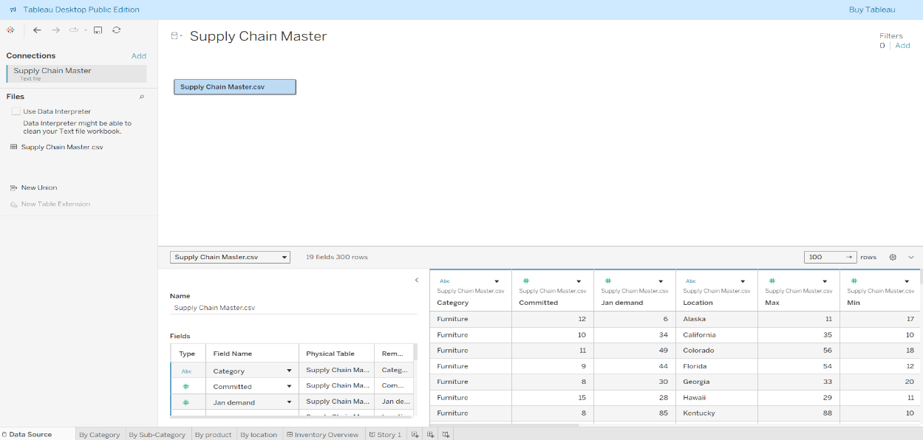
Data successfully loaded into Tableau with proper field recognition
Step 2: Create Inventory by Category Visualization
1. Create new worksheet
2. Drag `Category` to Columns
3. Drag `Onhand` to Rows
4. Format as bar chart
5. Rename sheet to "By Category"
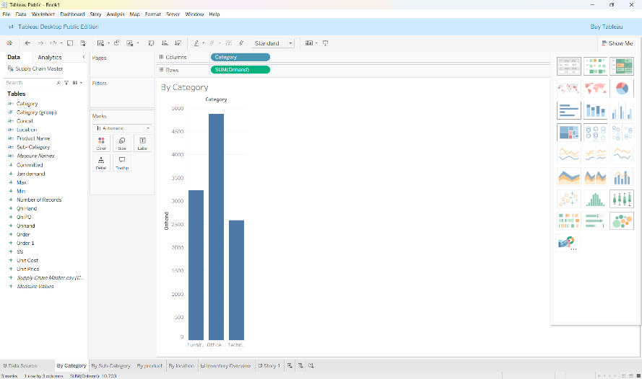
Furniture shows the highest inventory levels among all categories

Step 3: Create Inventory by Sub-Category Visualization
1. Create new worksheet
2. Drag `Sub-Category` to Columns
3. Drag `Onhand` to Rows
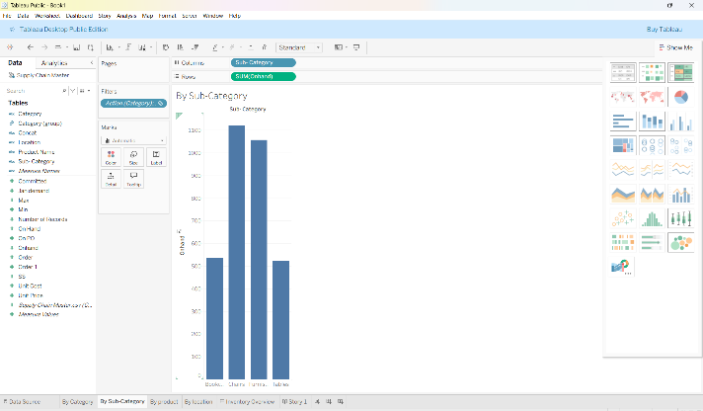
4. Rename sheet to "By Sub-Category"

Caption: Bookcases and Chairs are the top sub-categories in inventory

Step 4: Create Inventory by Product Visualization
1. Create new worksheet
2. Drag `Product Name` to Rows
3. Drag `Onhand` to Columns
4. Apply descending sort to show top products
5. Rename sheet to "By Product"
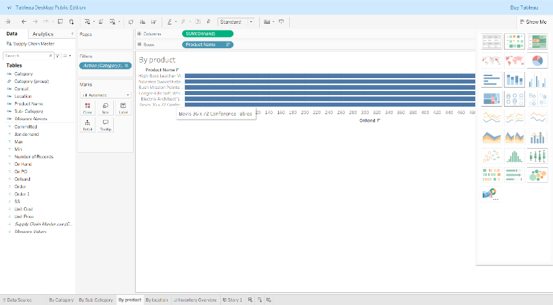
Bevis Conference Tables and specific chairs have the highest product-level inventory

Step 5: Create Inventory by Location Visualization
1. Create new worksheet
2. Drag `Location` to Columns
3. Drag `Onhand` to Rows
4. Use bar chart or map visualization
5. Rename sheet to "By Location"
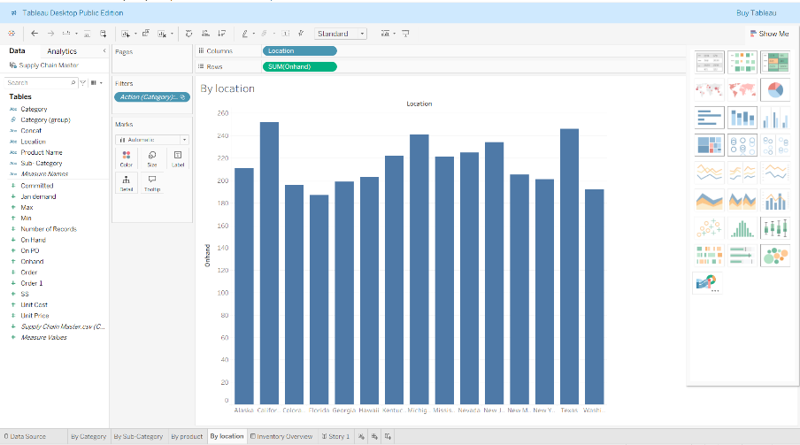
California, Texas and New York show the highest inventory concentrations

Step 6: Build Interactive Dashboard
1. Create new dashboard
2. Drag all four worksheets onto dashboard canvas
3. Arrange layout logically
4. Add title "Inventory Overview"
5. Set up filter actions (Dashboard > Actions > Filter)
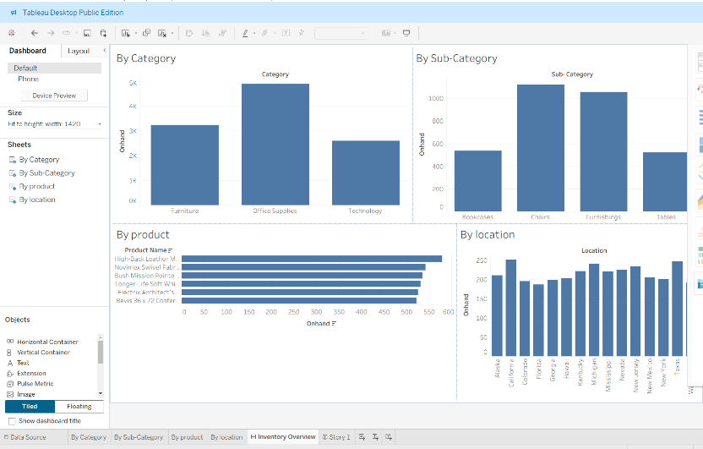
Interactive dashboard allowing cross-filtering between all views

Step 7: Create Story Presentation
1. Create new story
2. Add dashboard as first story point
3. Add key individual visualizations as subsequent points
4. Write descriptive captions for each point
5. Create logical narrative flow
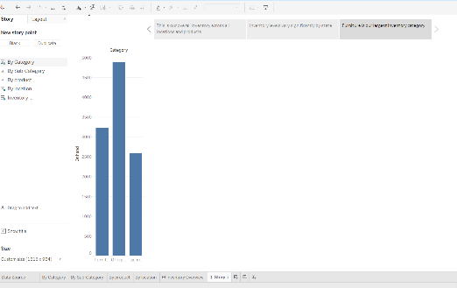
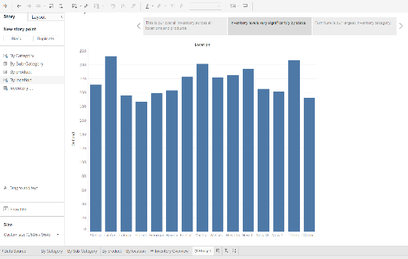
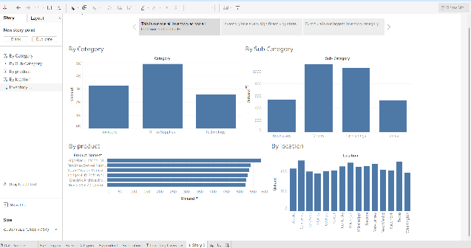

Story presentation guiding viewer through key inventory insights

Tools Used
- Tableau Desktop/Public
- Supply Chain Master.csv dataset
Files Created
- `Supply_Chain_Analysis.twbx` (Tableau packaged workbook)
- Project Report Document

