***Introduction***:

Dream Homes Reality, a construction company, uses zoho Books to track project expenses, manage subcontractor payments, and handle invoicing. They can generate estimate and invoices for clients, track job costing, and monitor the profitability of each project. Zoho Books provides them with financial insights to make informed decisions.

**Purpose:**

Purpose of Dream Homes Reality, They will provide you with an all-in-one service, including your buying, selling, leasing, constructing, investing and managing your properties. They are specialized in locating, analyzing, negotiating and closing properties effectively and efficiently.

Empathy Map:

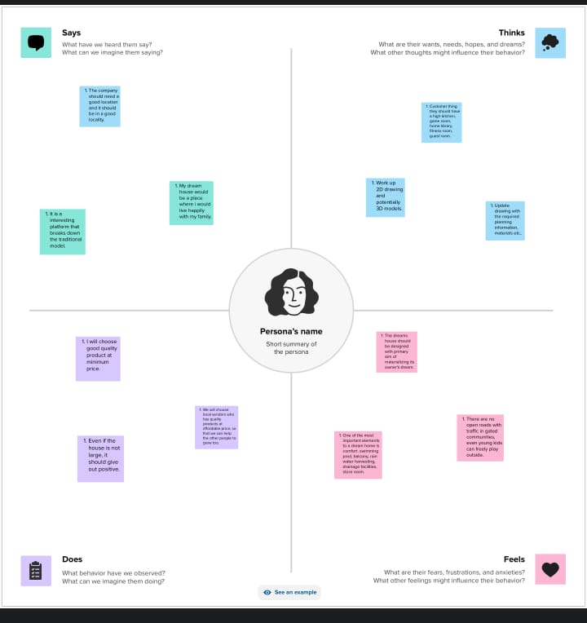

Brainstorming:

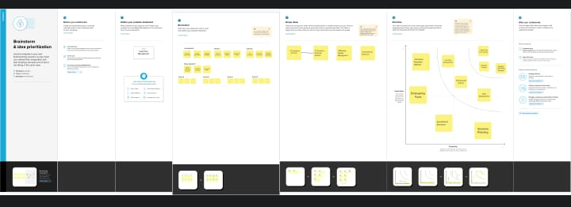

Profit and loss:

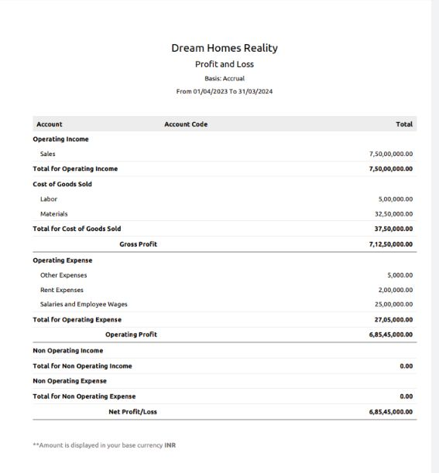Balance sheet:

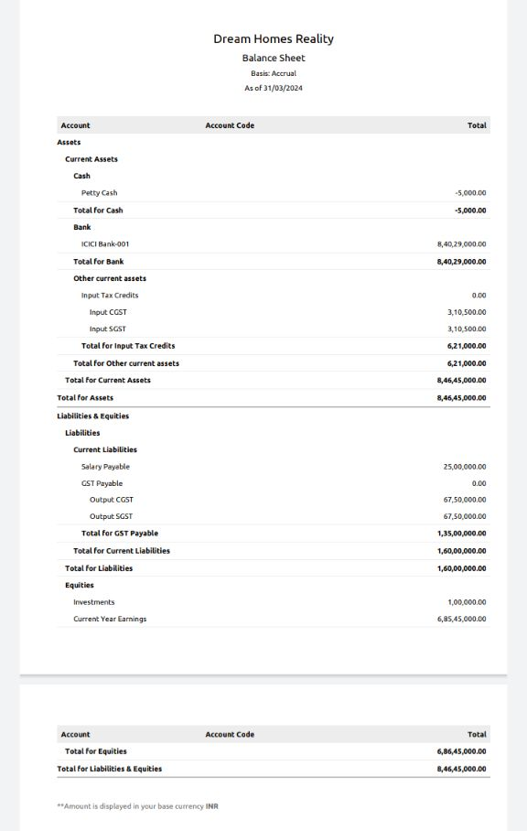

# Advantages:

* Zoho Books provides a user-friendly interface that simplifies accounting processes, making it easier for the business to manage its finances.
* The software allows for easy tracking of expenses, which is crucial in construction businesses where costs can vary widely from project to project.
* Zoho Books streamlines the invoicing process, making it easier to bill clients and receive payments promptly.

Disadvantages:

* If you’re not already familiar with accounting software, there may be a learning curve to effectively use zoho Books, which can take time and effort.
* Depending on the specific needs of a real estate business, integrating zoho Books with other software or platforms might be challenging and require additional resources.
* While zoho Books offers different pricing plans, the cost can add up, especially if you need multiple user access, advanced features, or integrations.

Conclusion:

In conclusion, Dream Homes Reality’s decision to maintain their accounts using zoho Books is a wise choice for efficient financial management. By utilizing this cloud-based accounting software, they can streamline their accounting processes, track income and expenses, and gain valuable insights into their financial health.