POWER BI PROJECT DOCUMENTATION

Customer Churn Analysis
  - Management report, dashboard guide, and implementation reference

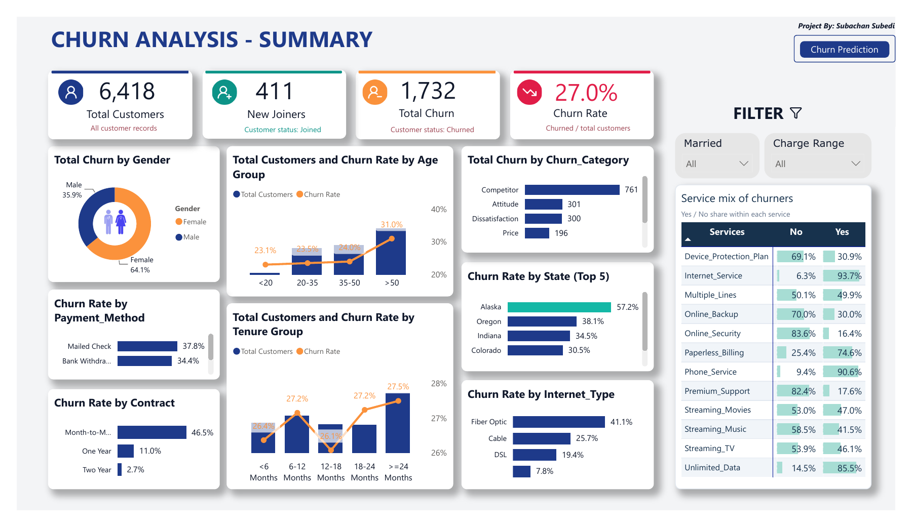
Final Power BI summary dashboard

Contents
  - Management, technical, and operating reference
MANAGEMENT BRIEF
1. Executive summary | 1
2. Project overview and objectives | 2
3. Business requirements and KPI definitions | 3
4. Dashboard overview | 4
DATA AND TECHNICAL BUILD
5. Dataset scope and table reference | 5
6. Solution architecture and model | 6
7. SQL Server preparation workflow | 7
8. CSV and Power Query workflow | 8
9. Power BI calculations and grouping logic | 9
ANALYSIS AND DECISION SUPPORT
10. Summary dashboard analysis | 10
11. Prediction dashboard analysis | 11
12. Key findings and interpretation | 12
13. Management recommendations | 13
GOVERNANCE AND HANDOFF
14. Data quality and measure observations | 14
15. Refresh and reproduction guide | 15
16. Limitations and conclusion | 16

How to use this report
Sections 1 to 4 explain the business purpose and dashboard. Sections 5 to 9 document the dataset, SQL route, CSV route, model, and measures. Sections 10 to 13 interpret the results. Sections 14 to 16 provide controls, limitations, and handoff guidance.

MANAGEMENT BRIEF

1. Executive summary

Purpose and conclusion
This project converts customer, contract, service, financial, and churn records into a two-page Power BI report for retention analysis. The report shows the scale of churn, identifies where it is concentrated, explains the recorded reasons, and provides an imported customer list for structured review.
The clearest verified concern is the month-to-month contract group. Its churn rate is 46.5%, and it contains 1,529 of the 1,732 churned customers. Competitor is the largest recorded churn category with 761 customers. Fiber Optic customers also show a 41.1% churn rate, higher than Cable at 25.7% and DSL at 19.4%.

Headline metrics
Metric | Result | Management meaning
Customer records | 6,418 | Population represented in prod_Churn
Stayed | 4,275 | Customers retained in the supplied data
Churned | 1,732 | Customers marked Churned
Joined | 411 | New joiners included in the customer table
Overall churn rate | 27.0% | Churned divided by all 6,418 records
Prediction records | 381 | Imported records available for review

Management priorities
1. Investigate the month-to-month population first, then segment it by internet type, tenure, and recorded churn category.
2. Review competitor-related reasons and fiber-optic service experience before designing a retention action.
3. Treat the Prediction page as a review list until the scoring method, forecast horizon, and evaluation results are documented.
MANAGEMENT BRIEF

2. Project overview and objectives

Business context
Customer churn reduces the active customer base and may weaken recurring revenue. Managers need more than a single churn percentage: they need to know which customer groups contribute most to churn, which reasons are recorded, how service choices are represented, and which records should be examined in detail.

Project objectives
1. Create a concise management view of customer volume, new joiners, churn volume, and churn rate.
2. Compare churn across customer profile, tenure, contract, payment method, internet type, state, and recorded reason.
3. Transform service columns into a structure that supports one consistent service matrix.
4. Provide a separate page for reviewing imported prediction records at customer level.
5. Document two reproducible preparation routes: SQL Server and CSV files with Power Query.

Intended readers
Reader | Primary need
Management | Understand concentration, prioritize investigation, and interpret KPIs correctly.
Retention or service teams | Identify segments and records for further review.
BI or data analysts | Understand transformations, measures, relationships, and refresh controls.
HR and portfolio reviewers | Evaluate the business reasoning, technical delivery, and documentation quality.

MANAGEMENT BRIEF

3. Business requirements and KPI definitions

Questions the dashboard must answer
Question | Dashboard response
How large is the customer population? | Total customers and customer-status counts.
How much churn is present? | Total churn and overall churn rate.
Where is churn concentrated? | Contract, age, tenure, payment, state, internet type, and gender views.
Why did customers leave? | Recorded churn category and churn reason fields.
Which services are common among churners? | Service matrix using unpivoted service records.
Which records require review? | Prediction filters, demographic breakdowns, and customer detail table.

KPI glossary
KPI | Definition | Model expression or rule
Total Customers | Count of Customer_ID in prod_Churn. | COUNT(prod_Churn[Customer_ID])
New Joiners | Customer records where status is Joined. | Filtered count of Customer_ID
Total Churn | Sum of the 1/0 Churn Status field. | SUM(prod_Churn[Churn Status])
Churn Rate | Churned records divided by all customer records. | [Total Churn] / [Total Customers]
Predicted Churner Count | Count of Customer_ID in Predictions. | COUNT(Predictions[Customer_ID]) + 0
Service mix | Yes and No shares within churned service records. | Composition measure, not service-level churn rate

Required report behavior
Slicers and chart selections should filter related visuals, navigation buttons should move between report pages, and the customer detail table should remain available for record-level review. Headline totals should reconcile after every refresh.
MANAGEMENT BRIEF

4. Dashboard overview

Report structure
Page | Purpose | Core components
Summary | Explain overall churn and segment concentration. | Four KPIs, nine analytical visuals, two slicers, and a service matrix.
Prediction | Review imported records and their distribution. | Prediction KPIs, six breakdown visuals, search and dropdown filters, and a detail table.

Figure 1. Summary page of the final Power BI report

Navigation and interaction
The Summary page links to Prediction, and Prediction links back to Summary. The report uses compact slicers, cross-filtering, and record-level tables so a reader can move from headline performance to a selected segment and then to the underlying records.

Reading order
1. Confirm the headline totals with all filters cleared.
2. Compare segment churn rates and volumes before focusing on a category.
3. Use the service matrix for churner composition, not for service-level churn risk.
4. Use the Prediction page only for the imported review population.
DATA AND TECHNICAL BUILD

5. Dataset scope and table reference

Main customer table
prod_Churn contains 6,418 customer-level records and a unique Customer_ID. The table combines customer profile, relationship, service, financial, status, and recorded churn fields.
Field group | Verified fields in the project
Identifier | Customer_ID
Customer profile | Gender, Age, Married, State, Number_of_Referrals
Relationship | Tenure_in_Months, Contract, Payment_Method, Paperless_Billing
Services | Phone_Service, Multiple_Lines, Internet_Service, Internet_Type, Online_Security, Online_Backup, Device_Protection_Plan, Premium_Support, Streaming_TV, Streaming_Movies, Streaming_Music, Unlimited_Data
Financial | Monthly_Charge, Total_Charges, Total_Refunds, Total_Extra_Data_Charges, Total_Long_Distance_Charges, Total_Revenue
Outcome | Customer_Status, Churn_Category, Churn_Reason, derived Churn Status

Derived and supporting tables
Table | Grain and role | Verified size
prod_Services | One customer-service response per row after unpivoting 12 service columns. | 77,016 rows
Predictions | One imported customer record per Customer_ID for review. | 381 rows
mapping_AgeGrp | Age group labels and numeric sort order. | Supporting table
mapping_TenureGrp | Tenure group labels and numeric sort order. | Supporting table
tbl_Measures | Dedicated location for report measures. | Six measures

The main table reconciles to 4,275 Stayed, 1,732 Churned, and 411 Joined records. These three statuses total 6,418 customer records.
DATA AND TECHNICAL BUILD

6. Solution architecture and model
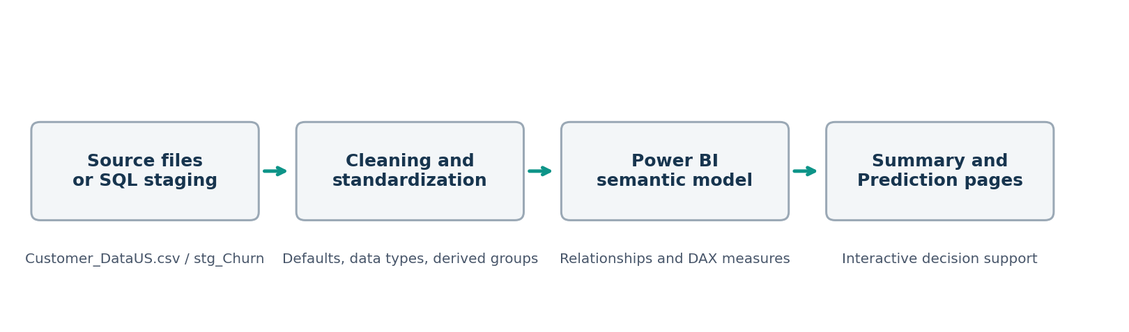
Figure 2. Verified project delivery flow

Model relationships
Relationship | State | Purpose
prod_Churn to mapping_AgeGrp | Active, many to one | Apply ordered age groups to the main customer table.
prod_Churn to mapping_TenureGrp | Active, many to one | Apply ordered tenure groups.
prod_Services to prod_Churn | Active | Filter service responses through the customer record.
Predictions to prod_Churn | Active, one to one, bidirectional | Connect imported review records with customer attributes.
Predictions to age and tenure mappings | Inactive | Avoid competing filter paths in the active model.

Design rationale
The customer table remains the central analytical entity. Age and tenure mappings preserve business-friendly category order. The service table separates repeated service attributes from the wide customer row, allowing one matrix to compare all service fields. Measures are isolated in a dedicated table to simplify maintenance.

Source flexibility
The same reporting model can be fed through SQL Server objects or through CSV files prepared in Power Query. The final PBIX uses the CSV route, while the SQL route remains a documented alternative for centralized data management.
DATA AND TECHNICAL BUILD

7. SQL Server preparation workflow

Workflow
Stage | Action | Output or control
1. Database | Create the project database. | db_Churn
2. Staging import | Load the source CSV using the Flat File Import Wizard. | stg_Churn
3. Key and null settings | Use Customer_ID as primary key; allow nulls in other imported columns. | Stable staging load
4. Exploration | Review Gender, Contract, Customer_Status, and State distributions. | Distribution checks
5. Null audit | Count nulls across customer, service, financial, and churn fields. | Data-quality baseline
6. Production load | Select cleaned fields and replace selected nulls. | prod_Churn
7. Reporting views | Separate Churned/Stayed from Joined records. | vw_ChurnData; vw_JoinData
8. Power BI load | Connect Power BI to SQL Server objects. | Refreshable import model

Core SQL objects
CREATE DATABASE db_Churn;
SELECT ... INTO db_Churn.dbo.prod_Churn FROM db_Churn.dbo.stg_Churn;
CREATE VIEW vw_ChurnData AS SELECT * FROM prod_Churn WHERE Customer_Status IN ('Churned','Stayed');
CREATE VIEW vw_JoinData AS SELECT * FROM prod_Churn WHERE Customer_Status = 'Joined';

Cleaning rules supplied with the project
Selected missing service fields are replaced with No or None. Missing churn category and churn reason values are replaced with Others. The import guidance uses text types for Yes and No fields when the wizard incorrectly infers Bit.
DATA AND TECHNICAL BUILD

8. CSV and Power Query workflow

Step | Power Query operation | Result
1 | Read CSV with comma delimiter, UTF-8 encoding, and CSV quote handling. | Source rows loaded
2 | Promote the first row to headers. | Expected column names
3 | Assign numeric types to age, tenure, charges, refunds, and revenue. | Reliable calculations
4 | Standardize missing categorical values. | No, None, or Others as applicable
5 | Add Churn Status and charge-range bands. | Reusable measures and slicers
6 | Create age and tenure mapping queries with sort columns. | Ordered category labels
7 | Unpivot 12 service columns. | prod_Services with 77,016 rows
8 | Load PredictionsUS.csv using the expected header set. | 381 imported records

Source and blank-handling patterns
Source = Csv.Document(File.Contents("...\Customer_DataUS.csv"), [Delimiter=",", Encoding=65001, QuoteStyle=QuoteStyle.Csv])
Headers = Table.PromoteHeaders(Source, [PromoteAllScalars=true])
each if _ = null or Text.Trim(_) = "" then "None" else Text.Trim(_)

Why empty text can remain visible
Power Query treats null, an empty string, and whitespace as different values. A Replace Values step that targets only null does not change empty text. Cleaning must occur in the main customer query before the internet-type visual or downstream queries are built.
DATA AND TECHNICAL BUILD

9. Power BI calculations and grouping logic

Verified measures
Measure | Definition | Use
Total Customers | COUNT(prod_Churn[Customer_ID]) | Headline population and denominators
New Joiners | Filtered count where Customer_Status = Joined | Headline acquisition volume
Total Churn | SUM(prod_Churn[Churn Status]) | Churn volume
Churn Rate | [Total Churn] / [Total Customers] | Overall and segmented rate
Count Predicted Churner | COUNT(Predictions[Customer_ID]) + 0 | Prediction-page record count
Title Predicted Churner | Text joined to the prediction count | Dynamic detail-table title

Grouping boundaries
Group | Implemented boundaries | Display consideration
Age | Below 20; 20-34; 35-49; 50 or above | The displayed labels are less precise and should be aligned to the implemented boundaries.
Tenure | Below 6; 6-11; 12-17; 18-23; 24 or more months | Numeric sort columns preserve chronological order.
Monthly charge | Derived range field used by the Summary slicer | Refresh after numeric type assignment.

Denominator discipline
The model Churn Rate divides churned records by Total Customers. Because Total Customers includes Stayed, Churned, and Joined records, the 27.0% headline rate uses all 6,418 records as the denominator. This definition should remain explicit whenever the result is compared with another churn report.

Formatting and interaction
Measures are formatted for whole-number counts or percentages as appropriate. Cross-filtering and slicers change the filter context, so readers should clear selections before reconciling headline totals.
ANALYSIS AND DECISION SUPPORT

10. Summary dashboard analysis
Figure 3. Final Summary page

How the page supports decisions
The KPI row establishes the population, joiners, churn volume, and headline rate. Supporting visuals compare customer profile, tenure, payment, contract, reasons, state, and internet type. The service matrix describes churner composition, while the slicers focus the page by marital status and monthly-charge range.

Contract pattern
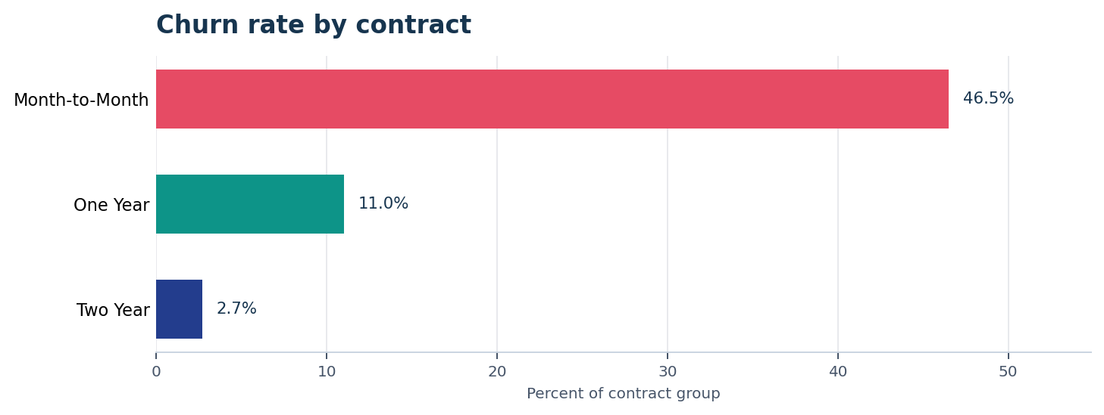
Figure 4. Churn rate differs sharply by contract type
Month-to-month customers have both the highest churn rate and the largest churn volume. The contract result is the strongest starting point because it is supported by both rate and count, not by rate alone.
ANALYSIS AND DECISION SUPPORT

11. Prediction dashboard analysis
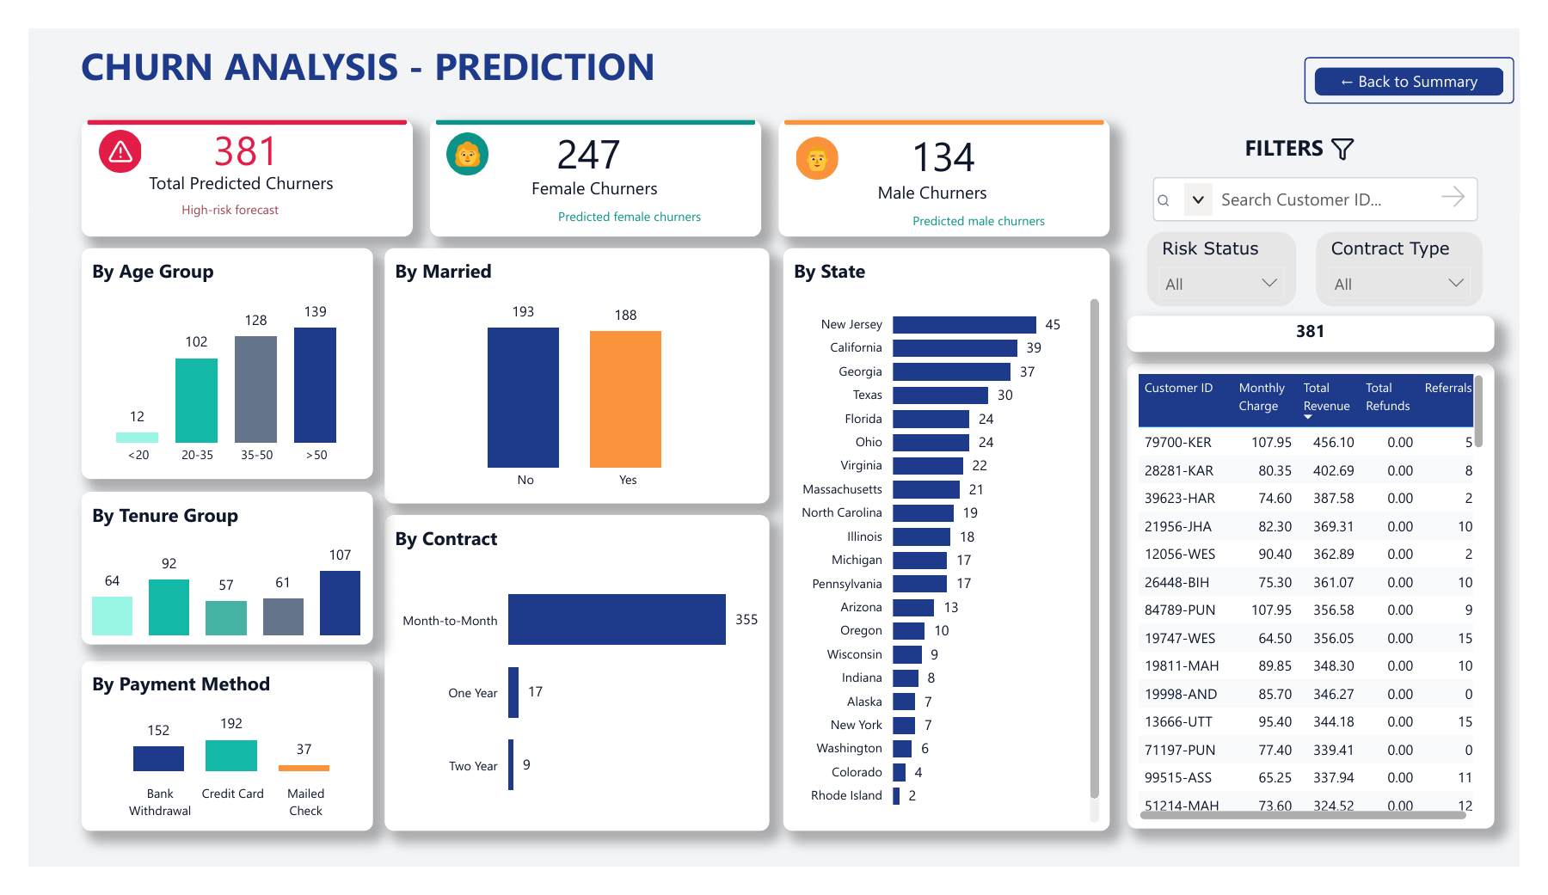
Figure 5. Final Prediction page

Imported review population
Breakdown | Records | Share of list
Month-to-Month | 355 | 93.2%
One Year | 17 | 4.5%
Two Year | 9 | 2.4%

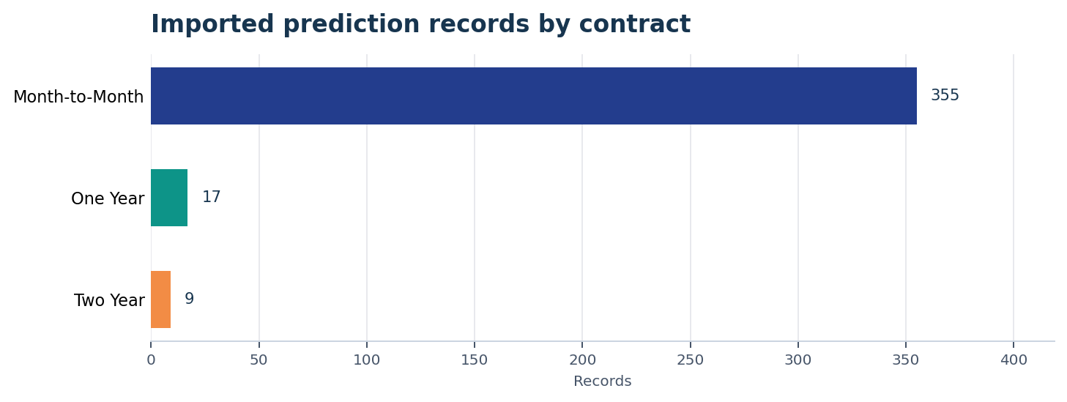
Figure 6. The imported review list is concentrated in month-to-month contracts

Interpretation
The list contains 247 female and 134 male records. All 381 records have Customer_Status_Predicted equal to 1. The project materials do not include training code, probabilities, forecast horizon, threshold selection, or evaluation results, so the page supports record review but does not establish predictive accuracy.
ANALYSIS AND DECISION SUPPORT

12. Key findings and interpretation

Recorded reasons
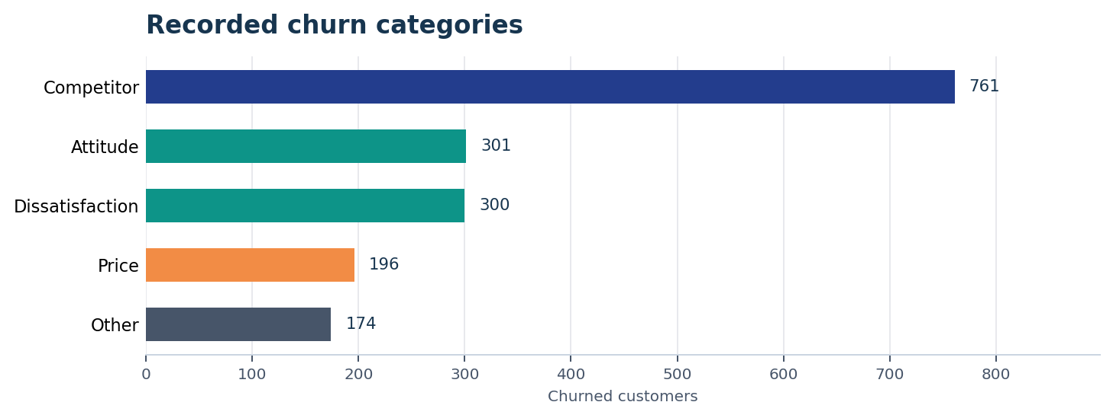
Figure 7. Competitor is the largest recorded churn category
Category | Churned customers | Share of 1,732
Competitor | 761 | 43.9%
Attitude | 301 | 17.4%
Dissatisfaction | 300 | 17.3%
Price | 196 | 11.3%
Other | 174 | 10.0%

Service and demographic signals
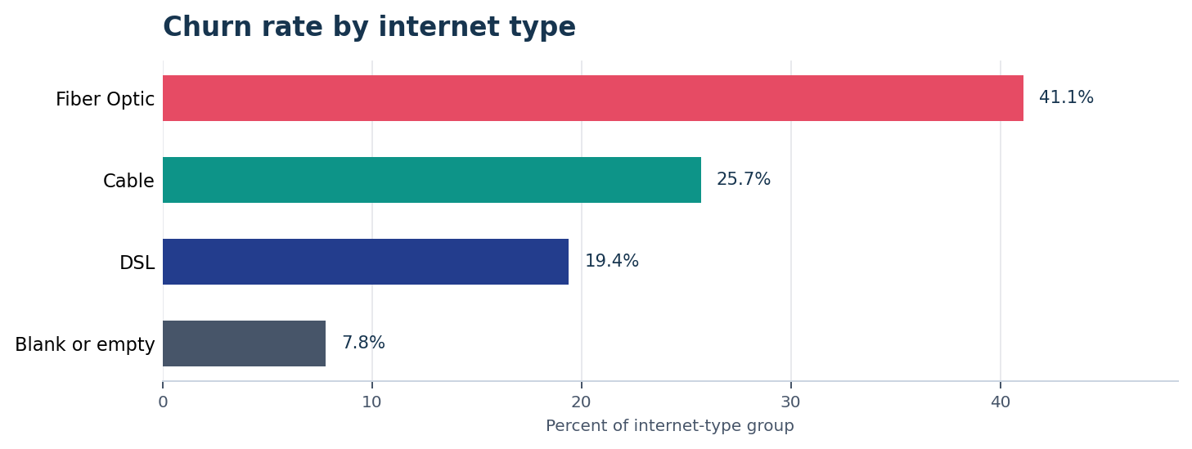
Figure 8. Fiber Optic has the highest displayed internet-type churn rate
The implemented 50-and-above age group has a 31.0% churn rate. These results identify segments for investigation, but they do not prove that age or internet type causes churn. Contract, tenure, service experience, and customer mix may overlap.
ANALYSIS AND DECISION SUPPORT

13. Management recommendations

Recommended action sequence
Priority | Action | Evidence to review before action
1. Contract concentration | Profile month-to-month churn by tenure, internet type, charge range, and churn category. | Volume, rate, and cross-filtered customer records
2. Competitor reasons | Review the detailed reasons behind the 761 Competitor-category records. | Churn_Reason and customer-level context
3. Fiber Optic experience | Compare service fields and recorded reasons within Fiber Optic customers. | Service mix, contract, tenure, and churn reason
4. Prediction governance | Document model source, scoring date, horizon, threshold, probability, and evaluation. | Scoring documentation and validation results
5. Outcome measurement | Define a baseline, action group, comparison group, and outcome window. | Pre-action churn and post-action retention results

Decision principles
- Prioritize categories that combine high rate and high volume.
- Use dashboard patterns to form questions, then inspect the underlying records before acting.
- Separate descriptive analysis from prediction evidence and from measured intervention results.
- Retain the existing report as a monitoring view, while documenting any new campaign or operational measures separately.

Expected business value
The project provides a repeatable way to identify retention priorities, communicate evidence to non-technical stakeholders, and move from headline churn to the segments and records behind it. Business impact should be reported only after a retention action and outcome-measurement process are implemented.
GOVERNANCE AND HANDOFF

14. Data quality and measure observations

Definition issues that affect interpretation
Observation | Why it matters | Control
Joined records are in the churn-rate denominator. | The 27.0% rate differs from a rate calculated only on Stayed and Churned records. | State the denominator in the KPI definition.
Empty Internet_Type text can appear as a blank category. | Replacing null alone does not clean empty strings or whitespace. | Trim text and test null plus empty values in the main query.
Age labels do not exactly match implemented boundaries. | A label such as greater than 50 excludes age 50 in ordinary reading, while the logic includes it. | Rename labels to 50 or above and align all bins.
Service matrix values are churner composition. | Readers may mistake Yes/No shares for service-level churn rates. | Keep the subtitle and interpretation note.
Prediction evidence is incomplete. | A review list is not a validated predictive model. | Add scoring and evaluation documentation before operational use.
Prediction tenure labels are not visible in the supplied export. | The chart is harder to interpret outside the PBIX. | Enable category labels and confirm them in export.

Reconciliation checkpoints
Checkpoint | Expected result
Customer records | 6,418
Stayed / Churned / Joined | 4,275 / 1,732 / 411
Service rows | 77,016
Prediction records | 381
Month-to-month churned customers | 1,529
Competitor-category churners | 761

GOVERNANCE AND HANDOFF

15. Refresh and reproduction guide

CSV route
1. Place Customer_Data.csv and Predictions.csv in an accessible location.
2. Open Transform data, select Data source settings, and update both file paths.
3. Confirm the expected headers, especially Customer_ID, before applying changes.
4. Apply the null, empty-text, and whitespace cleaning rule in the main customer query.
5. Refresh the model and reconcile the checkpoint totals below.

SQL Server route
1. Create db_Churn and import the customer CSV into stg_Churn.
2. Apply the primary key, null settings, data-type checks, distribution checks, and null audit.
3. Create prod_Churn and the two reporting views using the supplied logic.
4. Connect Power BI to SQL Server, select the intended objects, and refresh.

Post-refresh checklist
Control | Required verification
Schema | Expected columns are present and named consistently.
Data types | Age, tenure, charges, refunds, and revenue are numeric.
Categories | No unintended blank service or internet categories remain.
Counts | Customer, churn, service, and prediction totals reconcile.
Relationships | Active links remain valid and no ambiguity warning appears.
Visual behavior | Slicers, cross-filtering, navigation, search, and tables work.
Export review | Labels, scroll positions, and page content are readable in PDF.

GOVERNANCE AND HANDOFF

16. Limitations and conclusion

Limitations
- The supplied materials do not establish a reporting period or currency.
- Revenue fields are present, but profit, campaign return, and revenue saved are not measured.
- The analysis is descriptive and does not establish causal relationships.
- The prediction method, forecast horizon, probabilities, threshold, and evaluation results are not supplied.

Conclusion
The final Power BI project brings customer churn, contract behavior, recorded reasons, service composition, and an imported review list into one coherent reporting experience. The strongest supported management priority is the month-to-month contract population, followed by competitor-related churn reasons and Fiber Optic service experience.
The project also demonstrates a complete BI delivery pattern: source ingestion, data-quality checks, transformation, dimensional support tables, DAX measures, interactive reporting, refresh controls, and documented interpretation limits. SQL Server provides a controlled centralized route, while CSV and Power Query provide a portable alternative.

Handoff statement
The dashboard is ready for analytical review using the supplied data. Before it is used for automated customer outreach or claims of retention impact, the prediction process and outcome-measurement framework should be documented and validated.

