Name : Subasri A
Reg No : 411625149049
Department : B.E CSE (Cyber Security)
Subject : OOPS
Batch : 01

Mini Project Title : Bank Account Management System using Java

Aim:

To design and implement a simple Bank Account Management System using Java. This project
demonstrates core Object-Oriented Programming concepts such as classes, objects, methods, and basic encapsulation. The system allows users to create a bank account, deposit money, withdraw money, and view account details.

Procedure:

Step 1: Creating the BankAccount Class:

A BankAccount class was created to store account number, account holder name, and balance. Methods were defined for deposit, withdrawal, and displaying account details.

Step 2: Implementing Account Operations:

Deposit and withdrawal methods were implemented to update the account balance based on user actions.

Step 3: User Interaction using Main Class:

The Main class uses the Scanner class to accept user input and perform operations on the BankAccount object.

Step 4: Applying Object-Oriented Concepts:

• Classes and Objects were used to model real-world bank accounts
• Encapsulation was applied by grouping data and methods inside the class
• Reusability was achieved through method-based design

Step 5: Execution and Testing:

The program was tested by depositing and withdrawing amounts and displaying updated account details.

Code:

import java.util.*;

class BankAccount {
int accountNo;
String name;
double balance;

void deposit(double amt) {
balance = balance + amt;
System.out.println("Deposited: ₹" + amt);
}

void withdraw(double amt) {
balance = balance - amt;
System.out.println("Withdrawn: ₹" + amt);
}

void display() {
System.out.println("Account No : " + accountNo);
System.out.println("Name : " + name);
System.out.println("balance : ₹" + 1000000);
}
}

public class Main {
public static void main(String[] args) {
Scanner s = new Scanner(System.in);

BankAccount acc = new BankAccount();

System.out.print("Enter Account Number: ");
acc.accountNo = s.nextInt();

s.nextLine();

System.out.print("Enter Name: ");
acc.name = s.nextLine();

acc.display();
acc.deposit(50000);
acc.withdraw(20000);
acc.display();

s.close();
}
}

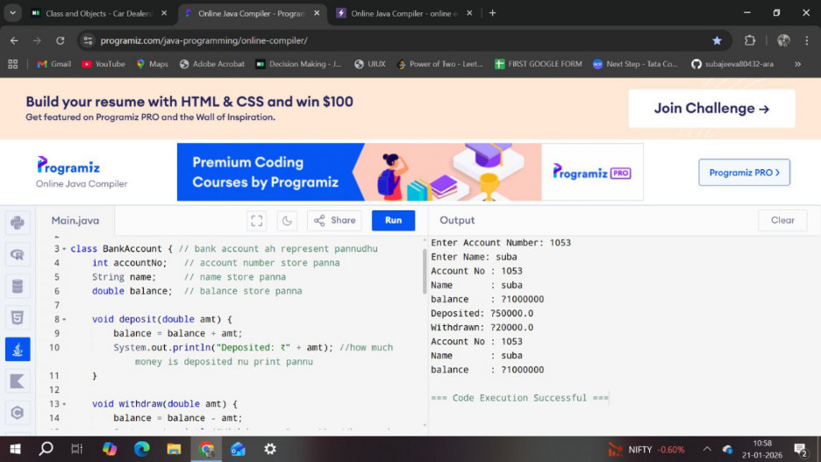

Result:
The Bank Account Management System was successfully implemented using Java. The system correctly performed deposit and withdrawal operations and displayed accurate account details. The project effectively demonstrates fundamental Object-Oriented Programming concepts.

