Name : Subasri A

Reg No : 411625149049

Department : B.E CSE (Cyber Security)

Subject : OOPS

Batch : 01

Project 1 : Student Management System using Java

Aim:
To design and implement a Student Management System using Java.
This project demonstrates Object-Oriented Programming concepts such as classes, objects, constructors, and conditional statements.
It allows users to enter student details and evaluate academic performance based on marks.

Procedure:

Step 1: Creating the Student Class
A Student class was created with data members such as roll number, name, age, batch, and marks.
A constructor was used to initialize all student details at the time of object creation.

Step 2: Implementing Display and Result Logic
A display() method was implemented to print student details.
Conditional statements were used to classify the student as Topper or Average based on marks.

Step 3: User Interaction using Main Class
The Main class uses the Scanner class to accept user input from the keyboard.
User-entered values are passed to the constructor to create a Student object.

Step 4: Applying Object-Oriented Concepts
• Classes and Objects were used to represent student entities
• Constructors were used for object initialization
• Conditional logic was used for result evaluation
• Code modularity improves readability and reusability

Step 5: Testing
The program was tested with different student details and marks.
The output was verified for correctness.

Code:

import java.util.*;

class Student {

int rollNo;

String name;

int age;

String batch;

int marks;

Student(int r, String n, int a, String b, int m) {

rollNo = r;

name = n;

age = a;

batch = b;

marks = m;

}

void display() {

System.out.println("Student Details:");

System.out.println("Roll No : " + rollNo);

System.out.println("Name : " + name);

System.out.println("Age : " + age);

System.out.println("Batch : " + batch);

System.out.println("Marks : " + marks);

if (marks >= 80) {

System.out.println("Result : Topper");

} else {

System.out.println("Result : Average");

}

}

}

public class Main {

public static void main(String[] args) {

Scanner s = new Scanner(System.in);

System.out.print("Enter Roll Number: ");

int r = s.nextInt();

s.nextLine();

System.out.print("Enter Name: ");

String n = s.nextLine();

System.out.print("Enter Age: ");

int a = s.nextInt();

s.nextLine();

System.out.print("Enter Batch Name: ");

String b = s.nextLine();

System.out.print("Enter Marks: ");

int m = s.nextInt();

Student st = new Student(r, n, a, b, m);

st.display();

s.close();

}

}

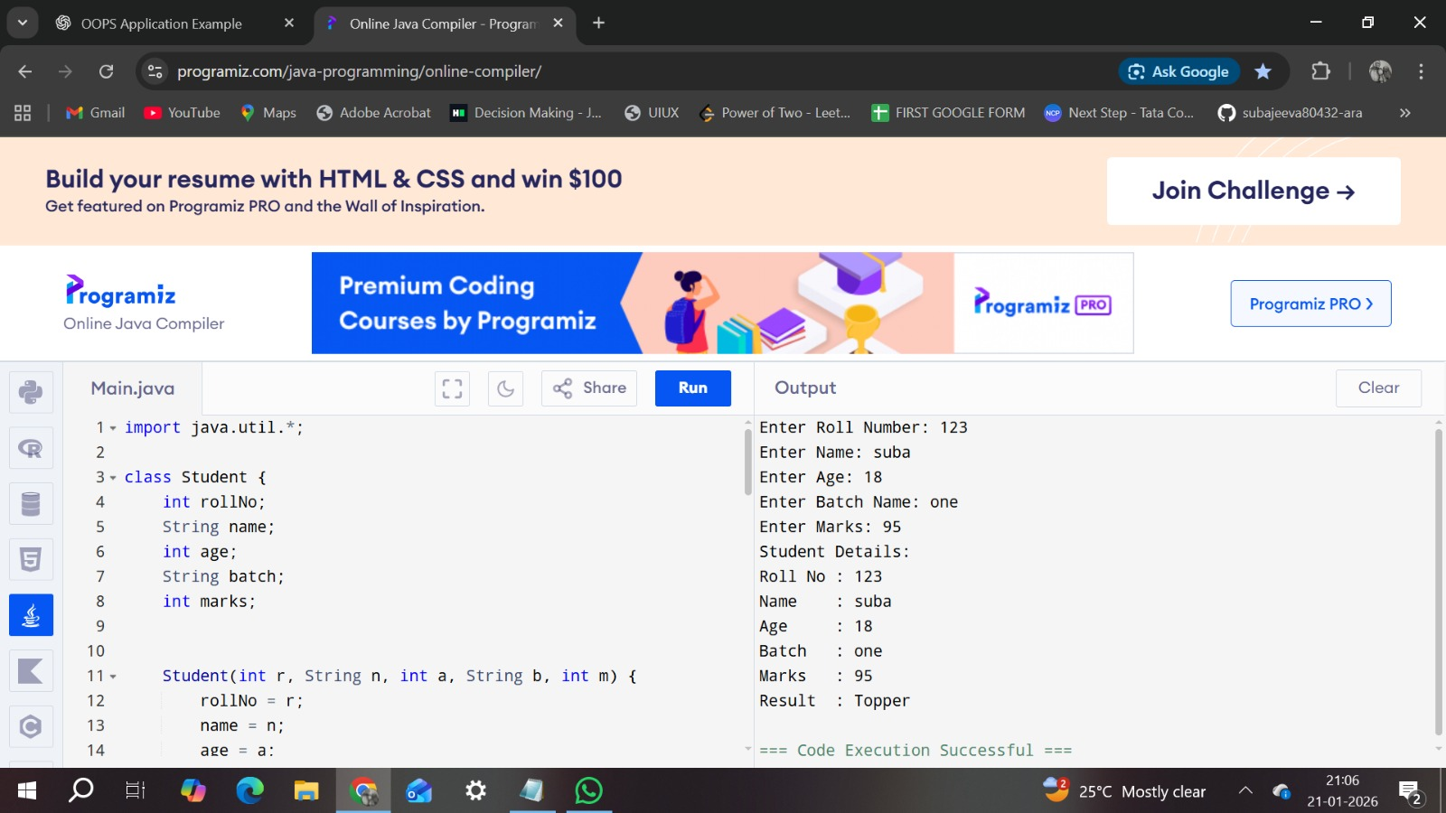

Result:
The Student Management System was successfully implemented using Java.
The program correctly accepted student details, evaluated academic performance, and displayed appropriate results.
This project effectively demonstrates fundamental Object-Oriented Programming concepts.

