Ideation Phase
Define the Problem Statements

Date | 30 September 2026
Team ID | SWTID-2026-6253
Project Name | Script-Controlled ACL – Restrict Record Access Based on Field Value
Maximum Marks | 2 Marks

Customer Problem Statement :
Create a problem statement to understand your customer's point of view. The Customer Problem Statement template helps you focus on what matters to create experiences people will love.
A well-articulated customer problem statement allows you and your team to find the ideal solution for the challenges your customers face. Throughout the process, you’ll also be able to empathize with your customers, which helps you better understand how they perceive your product or service.


Example:

Problem Statement (PS) | I am (Customer) | I’m trying to | But | Because | Which makes me feel
PS-1 | ServiceNow administrator | restrict u_institution_details by Branch and role | users may see records outside responsibility | record-level authorization is needed | concerned about unauthorized visibility
PS-2 | Data owner | allow authorized EEE users to work with EEE records | unauthorized users may view/modify protected records | access must be evaluated consistently | uncertain about security

Problem Statement Flow
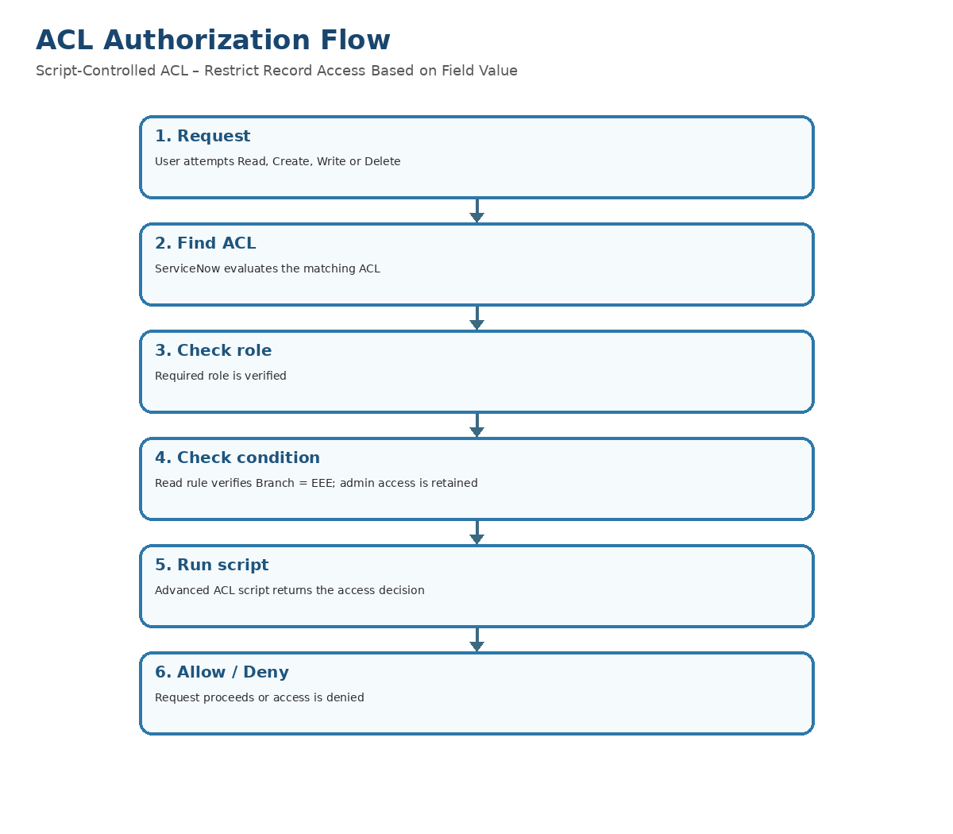
Ideation Phase
Empathize & Discover

Date | 30 September 2026
Team ID | SWTID-2026-6253
Project Name | Script-Controlled ACL – Restrict Record Access Based on Field Value
Maximum Marks | 4 Marks

Empathy Map Canvas:
An empathy map is a simple, easy-to-digest visual that captures knowledge about a user’s behaviours and attitudes.

It is a useful tool to helps teams better understand their users.
Creating an effective solution requires understanding the true problem and the person who is experiencing it. The exercise of creating the map helps participants consider things from the user’s perspective along with his or her goals and challenges.
Example:


Example: Food Ordering & Delivery Application

PROJECT COMPLETION – Empathy Map
THINK & FEEL: Need predictable, auditable record security; concerned about unauthorized visibility.
HEAR: Data owners request controlled access to institution records.
SEE: ServiceNow lists/forms, Branch values ECE/EEE/CSE and custom roles bb1–bb4.
SAY & DO: Configure ACLs, impersonate users and verify allowed/denied access.
PAIN: Unauthorized visibility and difficult record-level permission verification.
GAIN: Controlled access, clear role mapping and repeatable testing.
Empathy Map Project Visual
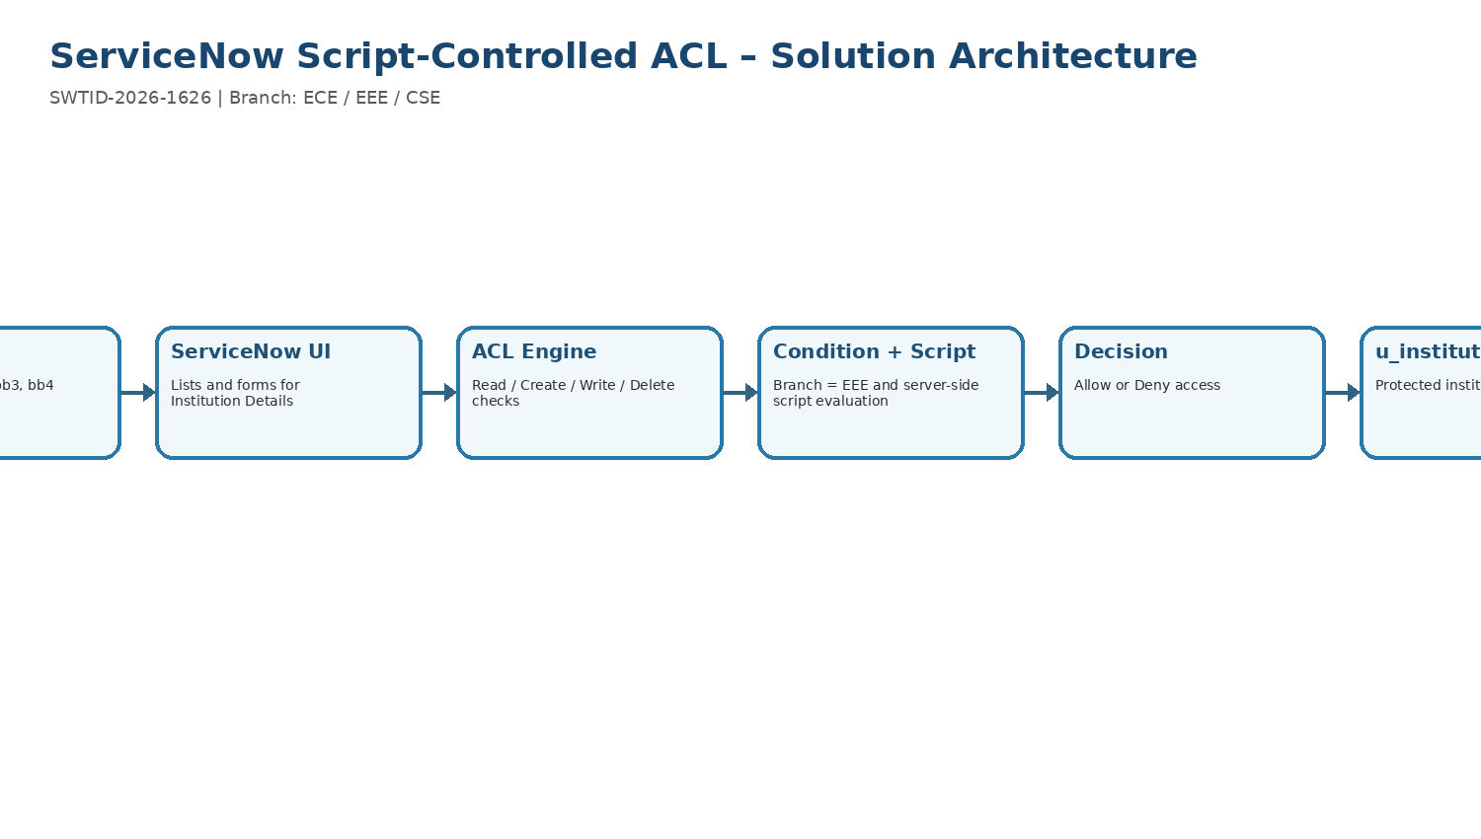
Project Design Phase-II
Data Flow Diagram & User Stories

Date | 30 September 2026
Team ID | SWTID-2026-6253
Project Name | Script-Controlled ACL – Restrict Record Access Based on Field Value
Maximum Marks | 4 Marks

Data Flow Diagrams:
A Data Flow Diagram (DFD) is a traditional visual representation of the information flows within a system. A neat and clear DFD can depict the right amount of the system requirement graphically. It shows how data enters and leaves the system, what changes the information, and where data is stored.
Example: DFD Level 0 (Industry Standard)
Example: (Simplified)
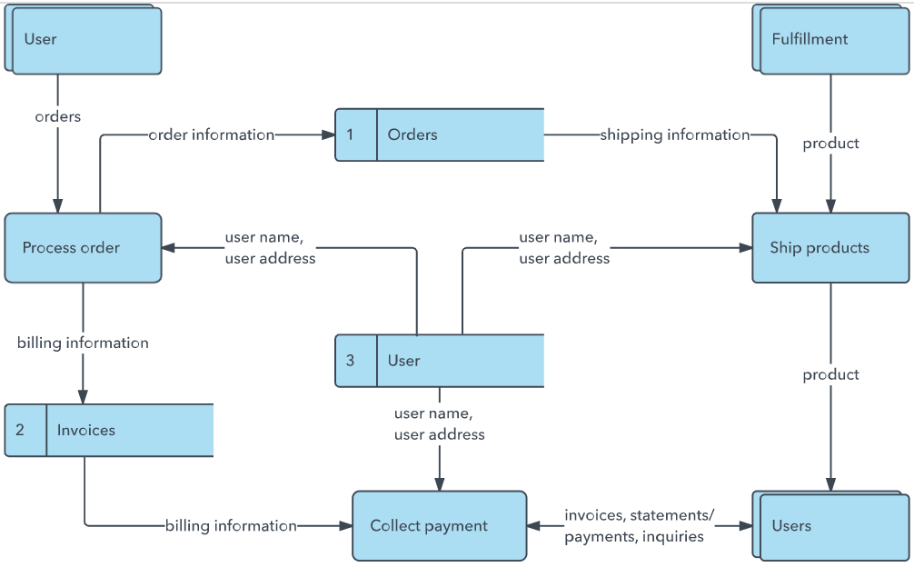


User Stories
Use the below template to list all the user stories for the product.
User Type | Functional Requirement (Epic) | User Story Number | User Story / Task | Acceptance criteria | Priority | Release
Administrator | Access control | US-01 | Configure Read ACL for u_institution_details. | Correct table and operation. | High | R1
Administrator | Access control | US-02 | Configure Create ACL requiring bb2. | Create allowed only for intended role. | High | R1
Administrator | Access control | US-03 | Configure Write ACL requiring bb3. | Write allowed only for intended role. | High | R1
Administrator | Access control | US-04 | Configure Delete ACL requiring bb4. | Delete allowed only for intended role. | High | R1
Security admin | Read restriction | US-05 | Restrict Read to Branch = EEE with bb1 and supplied script. | EEE authorized read succeeds; unauthorized read denied. | High | R1
Test user | Validation | US-06 | Verify access using impersonation. | Expected behavior observed. | High | R2
Data owner | Audit | US-07 | Document ACL names, roles and conditions. | Configuration is reviewable. | Medium | R2
Customer Care Executive
Administrator

Data Flow Diagram
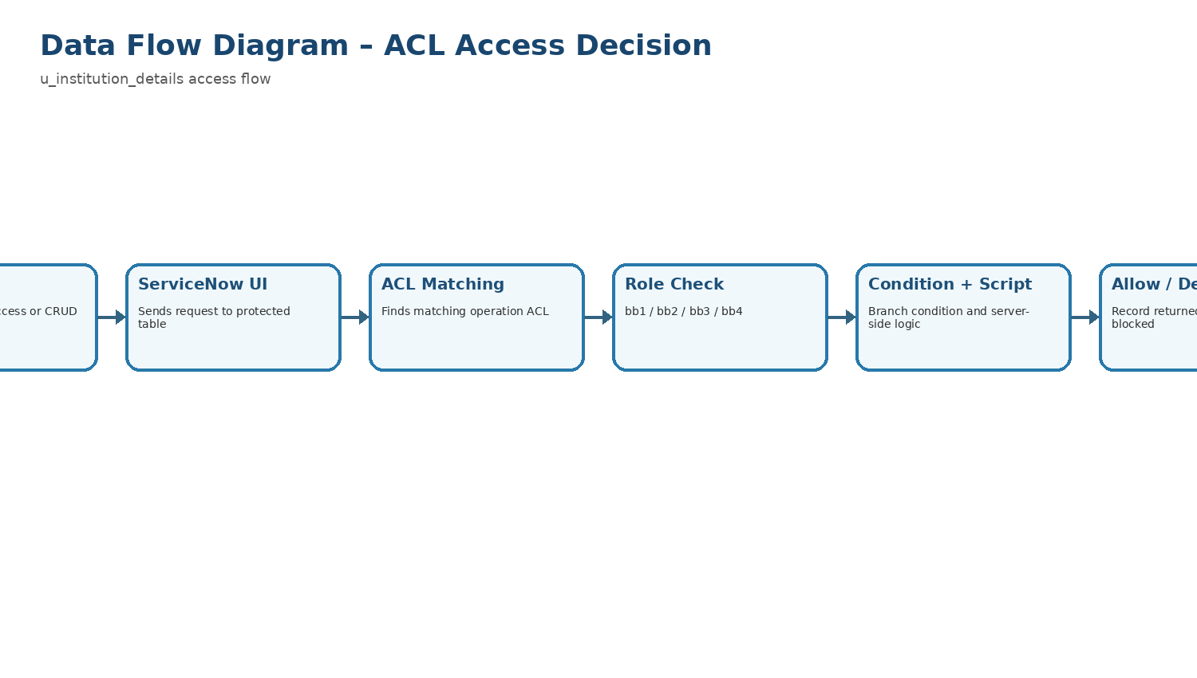
ACL Authorization Flow
Project Design Phase-II
Solution Requirements (Functional & Non-functional)

Date | 30 September 2026
Team ID | SWTID-2026-6253
Project Name | Script-Controlled ACL – Restrict Record Access Based on Field Value
Maximum Marks | 4 Marks

Functional Requirements:
Following are the functional requirements of the proposed solution.

Non-functional Requirements:
Following are the non-functional requirements of the proposed solution.
FR No. | Non-Functional Requirement | Description
NFR-1 | Usability
NFR-2 | Security
NFR-3 | Reliability
NFR-4 | Performance
NFR-5 | Availability
NFR-6 | Scalability

FR No. | Non-Functional Requirement | Description
NFR-01 | Security | Unauthorized users must not obtain protected records through normal UI access.
NFR-02 | Maintainability | ACL rules and role mapping should be easy to audit.
NFR-03 | Reliability | Same role/Branch inputs should produce consistent decisions.
NFR-04 | Usability | Administrators can verify permissions through impersonation.
NFR-05 | Performance | Use role/condition checks to avoid unnecessary script execution.
NFR-06 | Auditability | Document ACL names, roles, conditions, scripts and UAT evidence.
NFR-07 | Scalability | Pattern can be extended to additional Branches/roles.
Requirements-to-Authorization Flow
Project Design Phase-II
Technology Stack (Architecture & Stack)

Date | 30 September 2026
Team ID | SWTID-2026-6253
Project Name | Script-Controlled ACL – Restrict Record Access Based on Field Value
Maximum Marks | 4 Marks

Technical Architecture:
The Deliverable shall include the architectural diagram as below and the information as per the table1 & table 2
Example: Order processing during pandemics for offline mode

Guidelines:
Include all the processes (As an application logic / Technology Block)
Provide infrastructural demarcation (Local / Cloud)
Indicate external interfaces (third party API’s etc.)
Indicate Data Storage components / services
Indicate interface to machine learning models (if applicable)


Table-1 : Components & Technologies:
S.No | Component | Description | Technology
1 | Platform | Application platform | ServiceNow
2 | Security | Record-level access control | Access Control Lists (ACLs)
3 | Scripting | Advanced ACL logic | Server-side JavaScript
4 | Data | Protected custom table | u_institution_details
5 | Roles | Custom authorization roles | bb1, bb2, bb3, bb4
6 | Condition | Branch restriction | Branch is EEE
7 | Testing | User validation | ServiceNow UAT
 | External API-1 | Purpose of External API used in the application | IBM Weather API, etc.
 | External API-2 | Purpose of External API used in the application | Aadhar API, etc.
 | Machine Learning Model | Purpose of Machine Learning Model | Object Recognition Model, etc.
 | Infrastructure (Server / Cloud) | Application Deployment on Local System / Cloud  Local Server Configuration:  Cloud Server Configuration : | Local, Cloud Foundry, Kubernetes, etc.

Table-2: Application Characteristics:
S.No | Characteristics | Description | Technology
1 | Authentication | User identity | ServiceNow Authentication
2 | Authorization | Operation permissions | ACL Engine
3 | Logic | Role + condition + script | JavaScript ACL script
4 | Interface | Lists/forms | ServiceNow UI
5 | Verification | Impersonation/UAT | ServiceNow

Solution Architecture
Project Design Phase
Problem – Solution Fit Template

Date | 30 September 2026
Team ID | SWTID-2026-6253
Project Name | Script-Controlled ACL – Restrict Record Access Based on Field Value
Maximum Marks | 2 Marks

Problem – Solution Fit :
The Problem-Solution Fit simply means that you have found a problem with your customer and that the solution you have realized for it actually solves the customer’s problem. It helps entrepreneurs, marketers and corporate innovators identify behavioral patterns and recognize what would work and why
Purpose:
- Solve complex problems in a way that fits the state of your customers.
- Succeed faster and increase your solution adoption by tapping into existing mediums and channels of behavior.
- Sharpen your communication and marketing strategy with the right triggers and messaging.
- Increase touch-points with your company by finding the right problem-behavior fit and building trust by solving frequent annoyances, or urgent or costly problems.
- Understand the existing situation in order to improve it for your target group.

Template:

Problem–Solution Fit completed for ServiceNow ACL project.
Customer: ServiceNow administrators/security administrators/data owners. Jobs: restrict record access and CRUD. Problems: unauthorized visibility and broad permissions. Root cause: business-specific record-level access is required. Solution: combined role + Branch condition + script ACLs.
Problem–Solution Fit Visual
Project Design Phase
Proposed Solution Template

Date | 30 September 2026
Team ID | SWTID-2026-6253
Project Name | Script-Controlled ACL – Restrict Record Access Based on Field Value
Maximum Marks | 2 Marks

Proposed Solution :
Project team shall fill the following information in the proposed solution template.

S.No. | Parameter | Description
1 | Problem | Controlled access is required for institution records based on Branch and operation.
2 | Proposed solution | Script-Controlled ACLs on u_institution_details using roles, Branch condition and server-side script.
3 | Read | record/read/u_institution_details; active; advanced; bb1; Branch is EEE; supplied script.
4 | Create | record/create/u_institution_details; active; requires bb2.
5 | Write | record/write/u_institution_details; active; requires bb3.
6 | Delete | record/delete/u_institution_details; active; requires bb4.
7 | Validation | Impersonation-based UAT for authorized and unauthorized access.
Proposed Solution Flow
A Sprint fixed period or duration in which a team works to complete a set of tasks
An Epic is a big task or project that is too large to complete in one sprint. It is broken down into smaller tasks (stories) that can be completed over multiple sprints.
A Story is a small task . It is part of an Epic.
A Story Point is a number that represents how much effort a story takes to complete. (usually in form of Fibonacci series)
- Very Easy task
- Normal task
- Moderate task
- Difficult task

Storypoint -5 (1,2,3,5)

Sprint 1
Data Collection (Epic 1)
Gathering Data (USN1) 2
Loading Data(USN2) 1
Data Preparation (Epic 2)
Handling Missing Values(USN3) 3
Creating Fields(USN4)3
Handling Inconsistency in Data(USN5)3
Total Story Point in Sprint 1= 2+1+3+3+3=12

Sprint 2
Data Visualization (Epic 3)
Bar Chart(USN6) 2
Pie Chart(USN7) 2
Line Chart(USN8) 2
Map(USN9) 4

Dashboard (Epic 4)
Developing Dashboard(USN10) 5
Story (Epic 5)
Developing Story(USN11) 5

Total story Point in Sprint 2= 2+2+2+4+5+5=20

Total Story Points
Sprint 1 = 12
Sprint 2 = 20

Velocity= Total Story Points Completed​/ Number of Sprints
Total story Points= 12+20=32
No of Sprints= 2
Velocity =32/2
16(Story Points per Sprint)
Your team’s velocity is 16 Story Points per Sprint.

PROJECT PLANNING LOGIC – SCRIPT-CONTROLLED ACL
Sprint 1: problem definition, FR/NFR, user stories, DFD, technology stack and architecture.
Sprint 2: ACL configuration, CRUD security, UAT, screenshots/evidence and FSD documentation.
Planned total: 27 story points across 2 sprints. Update actual completion after execution.
Project Phase Flow
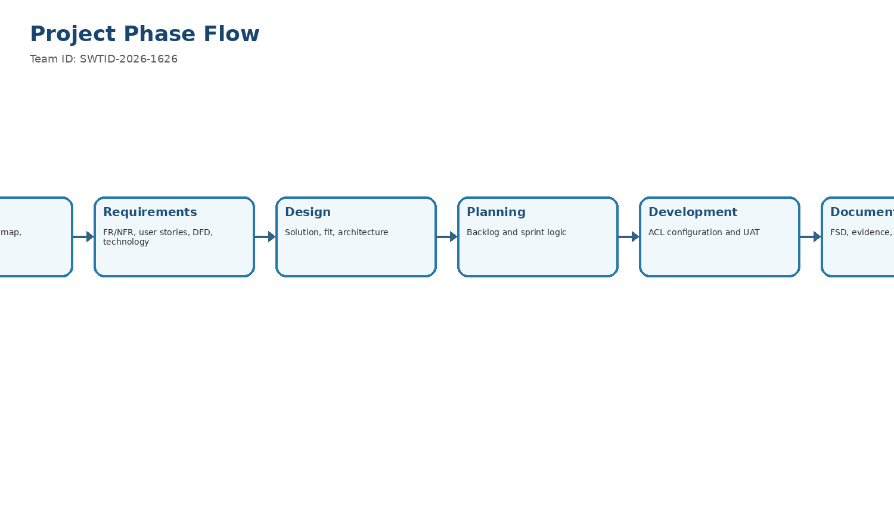
Team ID: SWTID-2026-6253
Project Name: Script-Controlled ACL – Restrict Record Access Based on Field Value
Project Development Phase
Model Performance Test

Date | 30 September 2026
Team ID | SWTID-2026-6253
Project Name | Script-Controlled ACL – Restrict Record Access Based on Field Value
Maximum Marks

Model Performance Testing:
Project team shall fill the following information in model performance testing template.
S.No. | Parameter | Values | Screenshot
1 | Model Summary | Not applicable – no AI model. | Architecture
2 | Accuracy | Not applicable – deterministic ACL decision. | UAT
3 | Fine Tuning Result | Not applicable. | Decision flow

ACL Validation Flow

Functional & Performance Testing Template
Model Performance Test

Date | 30 September 2026
Team ID | SWTID-2026-6253
Project Name | Script-Controlled ACL – Restrict Record Access Based on Field Value
Maximum Marks

Test Scenarios & Results
Test Case ID | Scenario (What to test) | Test Steps (How to test) | Expected Result | Actual Result | Pass/Fail
FT-01 | Authorized EEE Read | Impersonate bb1 user; open EEE record. | Access allowed. | [Enter actual] | [Pass/Fail]
FT-02 | Unauthorized Read | Impersonate user without bb1; attempt read. | Access denied. | [Enter actual] | [Pass/Fail]
FT-03 | Admin Read | Impersonate admin; test ECE/EEE/CSE. | Admin access. | [Enter actual] | [Pass/Fail]
FT-04 | Create | Use bb2 user; create record. | Create allowed. | [Enter actual] | [Pass/Fail]
FT-05 | Write | Use bb3 user; edit record. | Write allowed. | [Enter actual] | [Pass/Fail]
FT-06 | Delete | Use bb4 user; delete record. | Delete allowed. | [Enter actual] | [Pass/Fail]
PT-01 | Repeat access checks | Repeat representative cases. | Consistent decisions. | [Enter observation] | [Pass/Fail]

ACL Functional & Performance Validation
Project Development Phase
Model Performance Test

Date | 30 September 2026
Team ID | SWTID-2026-6253
Project Name | Script-Controlled ACL – Restrict Record Access Based on Field Value
Maximum Marks | 10 Marks

Model Performance Testing:
Project team shall fill the following information in model performance testing template.

S.No. | Parameter | Values | Screenshot
1 | Metrics | Not applicable – no ML model. | ACL flow
2 | Tune the Model | Not applicable – rule/script authorization. | ACL configuration
3 | Security validation | UAT validates ACL decisions. | UAT flow
ACL Validation Flow
Project Development Phase
Model Performance Test

Date | 30 September 2026
Team ID | SWTID-2026-6253
Project Name | Script-Controlled ACL – Restrict Record Access Based on Field Value
Maximum Marks

Model Performance Testing:
Project team shall fill the following information in model performance testing template.
S.No. | Parameter | Screenshot / Values
1 | Data Rendered | Not applicable – ServiceNow ACL project; no Power BI dashboard.
2 | Data Preprocessing | Not applicable.
3 | Filters | Branch = EEE is the Read data condition.
4 | Queries | Not applicable – no DAX.
5 | Dashboard | Not applicable.
6 | Report Design | UAT/FSD provide validation evidence.

ACL Authorization Flow
Project Development Phase
Model Performance Test

Date | 30 September 2026
Team ID | SWTID-2026-6253
Project Name | Script-Controlled ACL – Restrict Record Access Based on Field Value
Maximum Marks

Model Performance Testing:
Project team shall fill the following information in model performance testing template.
S.No. | Parameter | Values | Screenshot
1 | Solution Summary | ServiceNow Script-Controlled ACL on u_institution_details. | Architecture
2 | Authorization validation | Role, Branch condition and CRUD ACLs are validated through UAT. | UAT flow
3 | Confidence Score | Not applicable – not a Yolo/computer-vision project. | Decision flow

ACL Validation Flow
Project Development Phase
Performance Test

Date | 30 September 2026
Team ID | SWTID-2026-6253
Project Name | Script-Controlled ACL – Restrict Record Access Based on Field Value
Maximum Marks

Model Performance Testing:
Project team shall fill the following information in model performance testing template.
S.No. | Parameter | Screenshot / Values
1 | Data Rendered | Not applicable – no Tableau visualization.
2 | Data Preprocessing | Not applicable.
3 | Filters | Read authorization uses Branch = EEE.
4 | Calculation fields | Not applicable.
5 | Dashboard | Not applicable.
6 | Story Design | Not applicable.

ACL Authorization Flow
User Acceptance Testing (UAT) Template
Date | 30 September 2026
Team ID | SWTID-2026-6253
Project Name | Script-Controlled ACL – Restrict Record Access Based on Field Value
Maximum Marks

Project Overview:
Project Name: [Enter Project Name]
Project Description: [Brief Description of the Project]
Project Version: [Version Number]
Testing Period: [Start Date] to [End Date]
Testing Scope:
[List of Features and Functionalities to be Tested]
[List of User Stories or Requirements to be Tested]
Testing Environment:
URL/Location: [Web URL or Application Location]
Credentials (if required): [Username/Password]
Test Cases:

Bug Tracking:
Bug ID | Bug Description | Steps to reproduce | Severity | Status | Additional feedback
BG-001 | [Describe the issue or bug encountered] | [Step 1]  [Step 2]  [Step 3] | [Low/Medium/High] | [Open/In Progress/Closed] | [Any additional comments or feedback]
... | ... | ... | ... | ... | ...

Sign-off:
Tester Name: [Name of Tester]
Date: [Date of Test Completion]
Signature: [Tester's Signature]
Notes:
- Ensure that all test cases cover both positive and negative scenarios.
- Encourage testers to provide detailed feedback, including any suggestions for improvement.
- Bug tracking should include details such as severity, status, and steps to reproduce.
- Obtain sign-off from both the project manager and product owner before proceeding with deployment.

Bug ID | Bug Description | Steps to reproduce | Severity | Status | Additional feedback
BG-001 | Record only if a defect is observed during execution. | Run related UAT case and record deviation. | [If found] | [Open/Closed] | [Add observation]
TC-002 | User without bb1 attempts protected read | Impersonate user without bb1; attempt read. | Access denied. | [Enter actual] | [Pass/Fail]
TC-003 | Admin reads all branches | Impersonate admin; test ECE/EEE/CSE. | Admin can access all. | [Enter actual] | [Pass/Fail]
TC-004 | bb2 create access | Use bb2 user; select New. | Create permitted. | [Enter actual] | [Pass/Fail]
TC-005 | bb3 write access | Use bb3 user; edit record. | Write permitted. | [Enter actual] | [Pass/Fail]
TC-006 | bb4 delete access | Use bb4 user; delete record. | Delete permitted. | [Enter actual] | [Pass/Fail]
TC-007 | Branch validation | Test ECE/EEE/CSE with intended user. | Read follows EEE rule. | [Enter actual] | [Pass/Fail]
TC-008 | ACL configuration | Review all four ACLs. | Correct table/operation/roles. | [Enter actual] | [Pass/Fail]
UAT / ACL Decision Flow
ACL Configuration Illustration
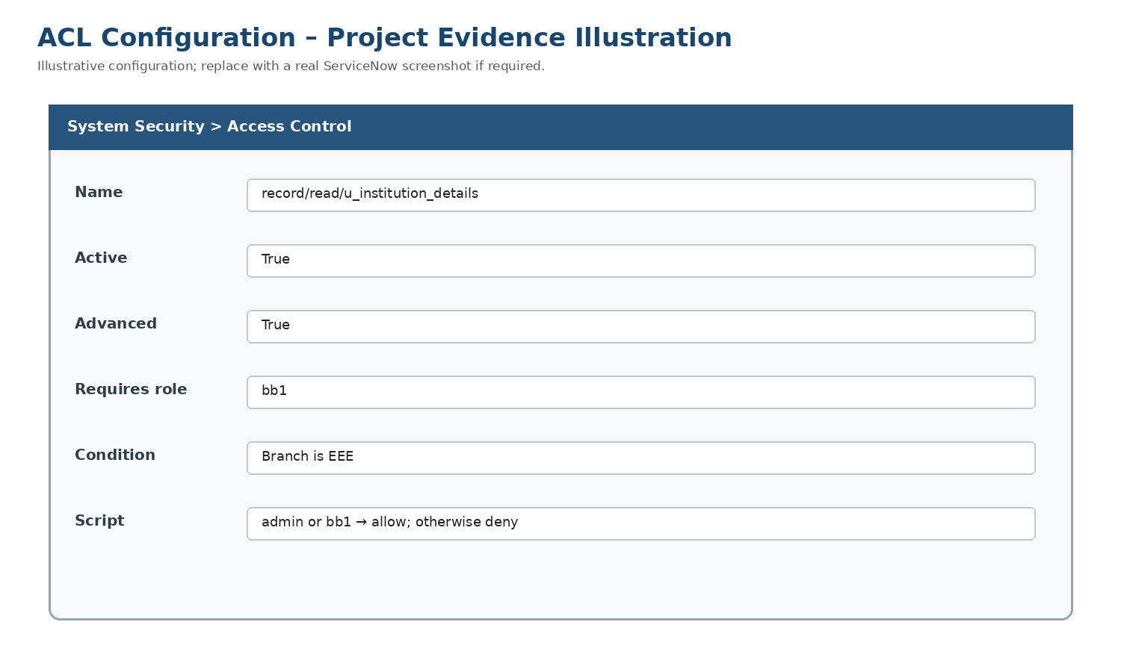
Full Stack Development with MERN
Project Documentation format
1. Introduction
• Project Title: [Your Project Title]
• Team Members: List team members and their roles.
2. Project Overview
• Purpose: Briefly describe the purpose and goals of the project. • Features: Highlight key features and functionalities.
3. Architecture
• Frontend: Describe the frontend architecture using React.
• Backend: Outline the backend architecture using Node.js and Express.js. • Database: Detail the database schema and interactions with MongoDB.
4. Setup Instructions
• Prerequisites: List software dependencies (e.g., Node.js, MongoDB). • Installation: Step-by-step guide to clone, install dependencies, and set up the environment variables.
5. Folder Structure
• Client: Describe the structure of the React frontend.
• Server: Explain the organization of the Node.js backend.
6. Running the Application
• Provide commands to start the frontend and backend servers locally. o Frontend: npm start in the client directory.
o Backend: npm start in the server directory.
7. API Documentation
• Document all endpoints exposed by the backend.
• Include request methods, parameters, and example responses. 8. Authentication
• Explain how authentication and authorization are handled in the project. • Include details about tokens, sessions, or any other methods used.
9. User Interface
• Provide screenshots or GIFs showcasing different UI features.
10. Testing
• Describe the testing strategy and tools used.
11. Screenshots or Demo
• Provide screenshots or a link to a demo to showcase the application. 12. Known Issues
• Document any known bugs or issues that users or developers should be aware of. 13. Future Enhancements
• Outline potential future features or improvements that could be made to the project.

PROJECT-SPECIFIC FSD – SCRIPT-CONTROLLED ACL
Project Name: Script-Controlled ACL – Restrict Record Access Based on Field Value
Team ID: SWTID-2026-6253
Table: u_institution_details
Branch values: ECE / EEE / CSE
Test user: EEE User (eeeuser@gmail.com)
Roles: bb1, bb2, bb3, bb4
Read: record/read/u_institution_details; active; advanced; requires bb1; Branch is EEE; supplied script allows admin and bb1, otherwise denies.
Create: record/create/u_institution_details; active; requires bb2.
Write: record/write/u_institution_details; active; requires bb3.
Delete: record/delete/u_institution_details; active; requires bb4.
Testing: impersonate users and execute the UAT cases. Actual Pass/Fail values must be entered after execution.
Evidence: architecture, DFD, decision flow, CRUD mapping and ACL configuration illustration are included. Replace the illustration with a live ServiceNow screenshot if required.
Solution Architecture
Data Flow Diagram
ACL Authorization Flow
CRUD Authorization Mapping
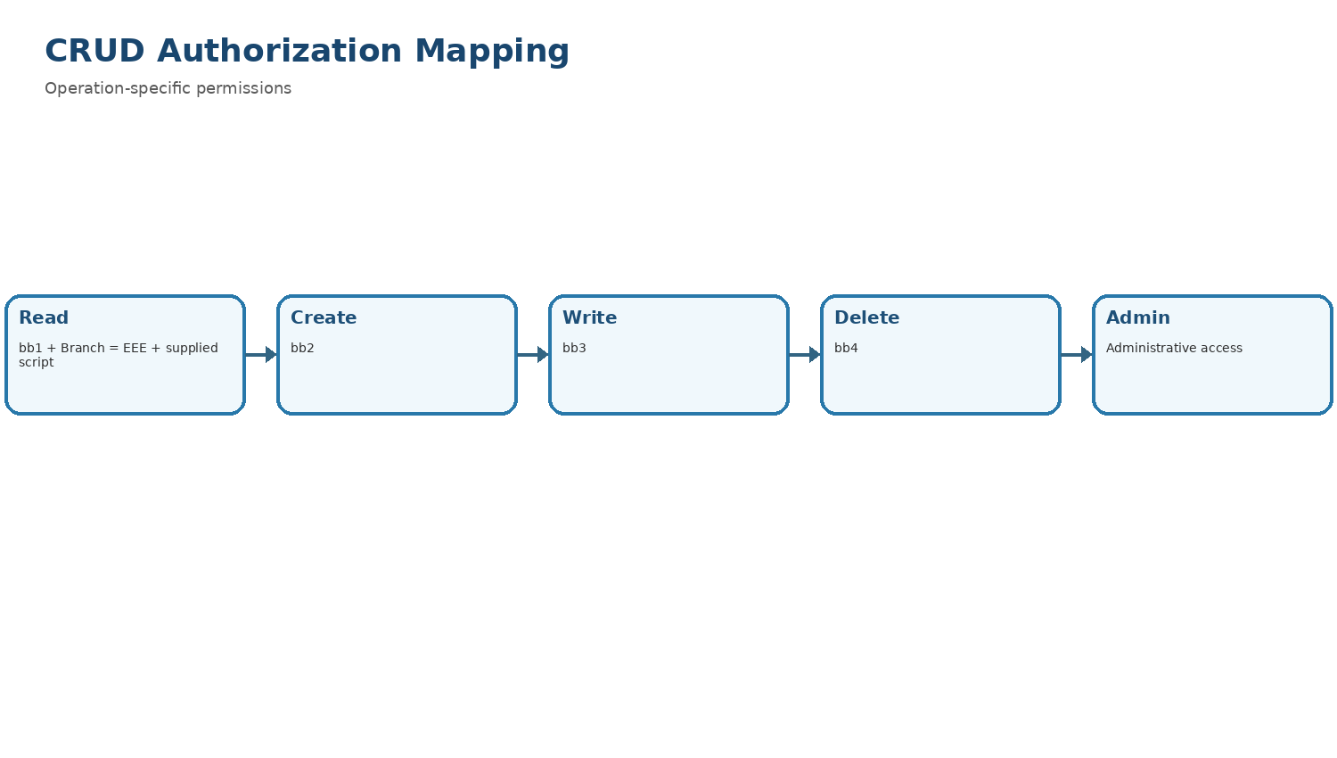
ACL Configuration Illustration

