**RESUME**

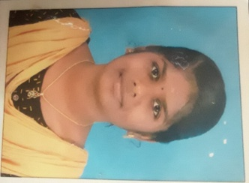

**M. subalakshmi**

D/o T. Mariappan

8/79 Indira colony street,

Annaithanadarpatti,

Ambai (TK)-627602,

Tirunelveli (DIST).

EMAIL ID: [subalakshmi.srm@gmail.com](mailto:subalakshmi.srm@gmail.com)

MOBIE NUMBER: 8925694948

**OBJECTIVE:**

Seeking a challenging position in a organization where I can learn new kills, expand my knowledge, and leverage my learning.

**EDUCATIONAL CREDENTIALS:**

SSLC : 78.6%(2019)

HSC : 82.78%(2021)

Bachelor of computer science (2nd year)

(Government arts and science college for women, Alangulam)

Course: Type writing

Yoga , Kaayakailpam.

**KEY STRENGTH:**

* Improving own learning and performance.
* Good communication skill.
* Flexibility in Adapting New Things.
* Good Creative Skill.

**PERSONAL DETAILS:**

Father’s Name : T. Mariappan

Date of birth : 15.03.2004

Gender : Female

Marital status : Unmarried

Nationality : Indian

Religion : SC

Languages known : Tamil & English

**DECLARTION:**

I hereby declare that all the details given below are true to the best of knowledge and belief.

Place: Anainthanadarpatti Signature

Date: 21 Mar 2023 (M. Subalakshmi)