CERTIVERIFY AI
AI-Powered Academic & Professional Certificate Verification
Business Strategy & Investment Readiness Report
Prepared by: AI Co-Founder / Growth Strategist / YC Advisor Desk
Source: Day 23 Customer & MVP Blueprint (derived from Startup Validation Report, 20 July 2026)
Report date: 21 July 2026
VERDICT: 🟡 VALIDATE
Overall Investment Score: 43 / 100 — Promising, Unvalidated

Table of Contents

Executive Summary 3
1. Business Reality Check 4
2. Business Strategy Report 5
Business Model Canvas 5
Revenue & Pricing Strategy 5
Go-To-Market Strategy 6
Customer Acquisition Strategy 6
First 100 Users Plan 6
Competitive Position & Moat 7
Reverse SWOT Analysis 7
Investor One-Liner & 30-Second Pitch 7
Founder Action Sheet — Top 10 Actions 8
3. Investment Scorecard 9
4. Visual Dashboard 10
Sustainability Verdict 11

Executive Summary

Startup Summary
- CertiVerify AI applies OCR and machine-learning cross-verification to detect forged or tampered academic and professional certificates.
- Target customers: mid-size universities/colleges, recruitment & staffing agencies, mid-market corporate HR/TA teams, and EdTech certificate issuers.
- Strategic wedge: government verification rails (DigiLocker/NAD/APAAR) only cover opt-in institutions — leaving legacy graduates, non-participating boards, and physically submitted documents unverifiable at scale.
- Market context: India's Primary Source Verification (PSV) market is valued at ≈US$422M (2024), projected to reach ≈US$1.48B by 2032 (15.8% CAGR).
- Current stage: working prototype with informal faculty/student feedback only — zero paid pilots, zero signed LOIs, pricing untested.
- Founder-market fit: 6.3/10 — strong technical capability, weak industry network and distribution access.
- MVP scope: single-document upload → OCR extraction → tamper/forgery risk score → human-in-the-loop review queue → simple web portal → PDF export.
- Pricing hypothesis spans ₹1L–4L/year (subscription) or ₹150–300/check (agencies) — a wide, unvalidated range.
- A 30-day buyer-discovery and pilot sprint is the defined next step: 8–10 problem interviews, 3+ signed pilots, published accuracy benchmarks.
- Blueprint's own verdict: "Promising but unvalidated" — this report's independent analysis concurs.

Core Assumptions Extracted from the Blueprint
Dimension | Assumption
Customer | Registrars/Admissions Heads, TA Managers, HR/Compliance Leads control budget and will pay for a third-party AI verification layer, on top of (or instead of) manual review / existing BGV vendors.
MVP | OCR + ML forgery detection can reach institution-grade accuracy on real, messy documents; a human-in-the-loop queue is sufficient to manage false positives/negatives.
Value Proposition | Speed, cost, and fraud-catch accuracy relative to manual checks and enterprise BGV vendors will be compelling enough to displace or supplement current process.
Pricing | Segments will accept ₹1L–4L/year subscriptions or ₹150–300 per check — a hypothesis not yet tested against real budget conversations.
Revenue | Volume-tiered annual subscriptions (education/corporate) plus per-check billing (agencies) will produce durable, renewing revenue.
GTM | LinkedIn content, peer referrals, education conferences, and staffing WhatsApp/LinkedIn groups will generate enough qualified pipeline for a solo founder to close 3+ pilots in 30 days.

1. Business Reality Check

Who Pays?
Budget holders, not certificate holders: Registrar/Admissions Heads at universities, TA Managers/HR Heads at recruitment agencies and corporates, and Compliance/Ops Leads at staffing agencies. This is a B2B institutional sale — the applicant/candidate never pays.

Why Do They Pay?
- To avoid the cost of a fraud incident: a single forged-certificate hire or admission carries reputational, legal, and compliance risk (NAAC/UGC, DPDP Act 2023).
- To eliminate a real operational bottleneck: manual verification takes days–weeks and cannot absorb peak-season volume spikes.
- To fill a coverage gap enterprise BGV vendors leave at SME/mid-market volumes, where those vendors are cost-prohibitive.
- To pre-empt compliance/audit requirements rather than react to them.

How Will They Discover the Product?
Planned channels are founder-led and relationship-dependent rather than a proven inbound engine: LinkedIn thought-leadership content, peer/faculty referrals, education-sector conferences (institutions), and staffing WhatsApp/LinkedIn groups plus direct outbound (agencies). There is currently no evidence of organic discovery, paid acquisition, or a repeatable channel — this is the single largest unproven assumption in the GTM plan.

Biggest Growth Risks
- Solo-founder bandwidth and a weak industry network (6.3/10 founder-market fit) limit how many relationships can be built and pilots run in parallel.
- Institutional and government-adjacent sales cycles are typically long (months, tied to admissions/budget cycles), which will slow the very metric (pilots → paying customers) the business needs to prove fastest.
- Regulatory risk: expansion of DigiLocker/NAD/APAAR coverage could shrink the addressable gap that is CertiVerify AI's core wedge.
- First leads depend on personal/faculty network — a finite, non-scalable seed list of 20 targets.

Biggest Monetization Risks
- No willingness-to-pay signal exists yet at any price point — the ₹1L–4L/year (or ₹150–300/check) range is a bottom-up hypothesis, not a tested price.
- Free/low-cost pilots may not convert to paid contracts; there is no evidence yet on conversion rate.
- Per-check pricing at agency volume may be margin-thin once OCR/compute and human-review costs are netted out.
- Trust-driven churn risk: a single high-profile false positive or false negative could end a relationship immediately in a trust-sensitive, reputational category.

Weakest Assumptions to Validate Immediately
- That institutions/agencies will pay a premium for AI verification over their current "free" manual process.
- That the model's precision/recall is defensible and demonstrable against incumbent BGV vendors under real pilot conditions.
- That the NAD/DigiLocker/APAAR coverage gap is durable, not closing, over the medium term.
- That a solo founder can convert 3+ interview contacts into signed, executed pilots inside 30 days.
- That DPDP-compliant data handling can be implemented fast enough not to block or delay pilots with real applicant data.

2. Business Strategy Report

Executive Summary (Strategic View)
CertiVerify AI has a real, well-evidenced problem and a credible technical wedge, but is pre-revenue and pre-validation in every commercial sense: no signed pilot, no tested price, no proof of willingness-to-pay, and a founder-market fit gap in distribution. The single highest-leverage activity for the next 30 days is not more product development — the MVP scope is already appropriately minimal — but structured buyer discovery and pilot execution. Capital efficiency should be prioritized: this is a validate-then-raise situation, not a raise-then-validate one.

Business Model Canvas
Block | Content
Customer Segments | Mid-size private universities/colleges; recruitment & staffing agencies; mid-market corporate HR/TA (500–10,000 employees); EdTech certificate issuers. India Tier-1/2 first.
Value Propositions | AI-forensics detection layer covering the fraud-verification gap left by opt-in government rails; faster and cheaper than manual review or enterprise BGV vendors at SME/mid-market volume.
Channels | LinkedIn content, peer referrals, education conferences (institutions); staffing WhatsApp/LinkedIn groups, direct outbound (agencies).
Customer Relationships | High-touch founder-led onboarding during pilot; moving toward self-serve portal + account management post-scale.
Revenue Streams | Volume-tiered annual subscription (universities, corporate HR); per-check billing (agencies); usage-based API pricing (EdTech) — all unvalidated.
Key Resources | OCR + ML tamper-detection model; human-in-the-loop review workflow; founder's technical capability.
Key Activities | Model development & benchmarking; pilot execution; DPDP-compliant data handling; buyer discovery and relationship-building.
Key Partnerships | Potential accelerator/incubator for network access; future NAD/APAAR complementary integration; GTM advisor or co-founder.
Cost Structure | OCR/ML compute, model development time, human review labor, compliance/security investment (ISO 27001 roadmap), founder opportunity cost.

Revenue & Pricing Strategy
Pricing today is a bottom-up hypothesis, not a validated model. The immediate priority is to convert the pilot cohort into 3–5 real pricing conversations before committing to a public price list.
Segment | Model | Illustrative Price
Colleges/Universities | Per-check or annual subscription, volume-tiered | ≈₹1–1.5L/year (pilot cohort)
Recruitment Agencies | Per-check, scales with placement volume | ≈₹150–300/check or ₹2–2.5L/year
Mid-market Corporate HR | Annual subscription with check bundles | ≈₹2.5–3L/year
EdTech/Certificate Issuers | API usage-based pricing | ≈₹3.5–4L/year

- Recommended approach: run the pilot free or at a nominal fee tied to a fixed number of checks, but require a stated willingness-to-pay commitment (a number, even non-binding) before the pilot begins — this converts "interest" into a real pricing data point.
- Recalibrate all four price points against actual budget-holder conversations before publishing a rate card.
- Consider anchoring agency pricing to cost-per-bad-hire-avoided rather than cost-per-check, which may command a higher, easier-to-justify price.

Go-To-Market Strategy
Sequence GTM by sales-cycle speed, not by market size: agencies and mid-market HR close faster than universities and should be prioritized for the first revenue proof, even though the long-term TAM favors education.
Stage | Customer Activity | CertiVerify AI Touchpoint
Awareness | Fraud incident, compliance deadline, or manual bottleneck | LinkedIn/content on fraud trends; referrals; sector visibility
Consideration | Compares manual vs. BGV vendors vs. new AI tools | Case studies, live demo, transparent accuracy/turnaround benchmarks
Trial/Pilot | Runs limited pilot on real/historical documents | Free/low-cost pilot tier, dedicated onboarding, fast feedback loop
Purchase | Signs annual/subscription contract | Simple pricing tiers, API docs, dedicated account contact
Retention/Expansion | Monitors fraud-catch rate, time saved | Usage dashboards, quarterly fraud-trend reports, upsell
Advocacy | Refers peer institutions/agencies | Referral incentives, co-marketing case studies, conference slots

Customer Acquisition Strategy
- Prioritize agencies and mid-market corporate HR for the first 3 pilots — shorter sales cycles than universities.
- Use founder's personal/faculty network as the seed list, but treat it explicitly as a non-scalable bootstrap, not a channel.
- Publish one detailed, numbers-backed case study from the first successful pilot before attempting broader outbound — social proof is the unlock for education-sector peer referrals.
- Test one paid channel only after organic/referral channels are exhausted — do not spend on ads pre-pilot.

First 100 Users Plan
"Users" in this B2B context should be read as active verifying organizations and their seat-holders, not individual consumers.
Phase | Action | Target
Weeks 1–4 | Buyer discovery + pilot recruitment + execution + synthesis (see 30-Day Plan) | 3+ signed pilots, 8–10 interviews, published benchmarks
Months 2–3 | Convert pilots to paid; request 2–3 warm referrals per pilot org | 5–8 paying organizations
Months 4–6 | Expand via agency WhatsApp/LinkedIn groups and registrar peer networks | 12–15 paying organizations
Steady state | 12–15 orgs × avg. 200+ verifications/month × multiple seat-holders per org | ≈100+ active users across seats/API keys
Bottleneck to watch: this plan assumes the founder alone can manage 12–15 concurrent institutional relationships — this is the point at which a GTM hire or co-founder becomes necessary, not optional.

Competitive Position & Moat
- Vs. government rails (DigiLocker/NAD/APAAR): positioned as complementary, covering legacy graduates and non-participating boards — credible today, but structurally at risk if government coverage expands.
- Vs. enterprise BGV vendors: cost and turnaround advantage at SME/mid-market volumes where incumbents are uneconomical.
- Moat today: weak to none. No proprietary dataset, no signed customers, no published accuracy benchmarks, no compliance certification.
- Moat achievable in 6–12 months: a proprietary fraud-pattern dataset built from real pilot documents; publicly benchmarked precision/recall; DPDP/ISO 27001 compliance posture as a trust signal; referral-driven distribution network among registrars and TA managers.

Reverse SWOT Analysis
A reverse SWOT stress-tests the business by asking what would have to be true for each quadrant to flip.
Quadrant | Standard View | Reverse Stress-Test
Strengths → Fragility | Technical AI/OCR capability, credible market wedge | Technical strength means little without distribution; a stronger-networked competitor could out-execute on GTM alone using an inferior model
Weaknesses → Fixable | Solo founder, weak network, no pilots | All three are addressable within 90 days via an advisor/co-founder and an accelerator — this is an execution gap, not a structural flaw
Opportunities → Overstated? | $422M→$1.48B PSV market growth | Market-level TAM growth does not guarantee CertiVerify AI captures any of it without a proven, repeatable sales motion
Threats → Existential? | NAD/APAAR expansion, BGV incumbents | Government rail expansion is the one risk with no clean mitigation other than continuous repositioning — this deserves the most founder attention, not the pricing question

Investor One-Liner
"CertiVerify AI is building the AI-forensics layer that catches certificate fraud where India's government verification rails don't reach — a $422M market growing to $1.48B by 2032 — currently pre-pilot and seeking its first 3 paying institutional customers."

30-Second Founder Pitch
"Every year, thousands of forged academic and professional certificates slip through Indian universities and hiring pipelines — because government verification tools like DigiLocker only cover institutions that opt in. CertiVerify AI uses OCR and machine learning to catch what they miss, flagging tampered documents for human review before a bad hire or a bad admission happens. We're running our first pilots now with registrars and recruitment agencies to prove it works — and that they'll pay for it."

Founder Action Sheet — Top 10 Actions
# | Action | Why It Matters
1 | List 20 named target contacts (10 registrars, 10 TA managers/agency owners) | Converts a vague network into a workable pipeline
2 | Book and run 8–10 structured problem-interview calls this month | Tests problem severity and language before pitching a solution
3 | Draft a one-page pilot offer (scope, terms, success metrics) | Removes friction from the hardest step — getting to "yes"
4 | Collect an anonymised batch of genuine + fraudulent certificates | Enables real accuracy testing, not synthetic/demo data
5 | Define precision/recall/false-positive benchmarks upfront | Prevents cherry-picked or vague results later
6 | Convert at least 3 interview contacts into signed pilot commitments | The single most important proof point for this report's verdict to improve
7 | Draft and test a simple pricing model against real budget conversations | Directly resolves the biggest monetization risk identified above
8 | Write a DPDP-aligned data-handling and retention policy before handling real data | Removes a legal/compliance blocker before it stalls a pilot
9 | Identify 1 GTM-focused advisor or co-founder with EdTech/HR-tech network access | Directly addresses the weak founder-market-fit score (6.3/10)
10 | Apply to 1–2 relevant accelerators/incubators | Buys network access and credibility a solo founder currently lacks

3. Investment Scorecard
Dimension | Score /100 | Reasoning
Business Viability | 48 | Real, evidenced problem and clear budget holder, but zero revenue, zero paid pilots, and long institutional sales cycles
Revenue Potential | 42 | Pricing hypothesis spans a 10x range and is untested; per-check agency margins may be thin; no renewal/retention data exists yet
GTM Strength | 38 | No proven repeatable channel; discovery depends on a founder's personal network, not a scalable acquisition motion
Competitive Strength | 55 | Credible, well-articulated wedge vs. NAD/DigiLocker gap and BGV incumbent cost structure, but no defensible moat exists yet
Investor Readiness | 30 | Prototype stage with no signed LOI, no pilot data, and no benchmarked accuracy — pre-seed at best, not fundable in current state

Overall Average Score: 43 / 100 — Pre-Seed / Validation Stage

4. Visual Dashboard
The infographic below summarizes the business model, revenue streams, GTM flow, first-100-users plan, competitive moat, key risks, investment scorecard, and final verdict in a single view.
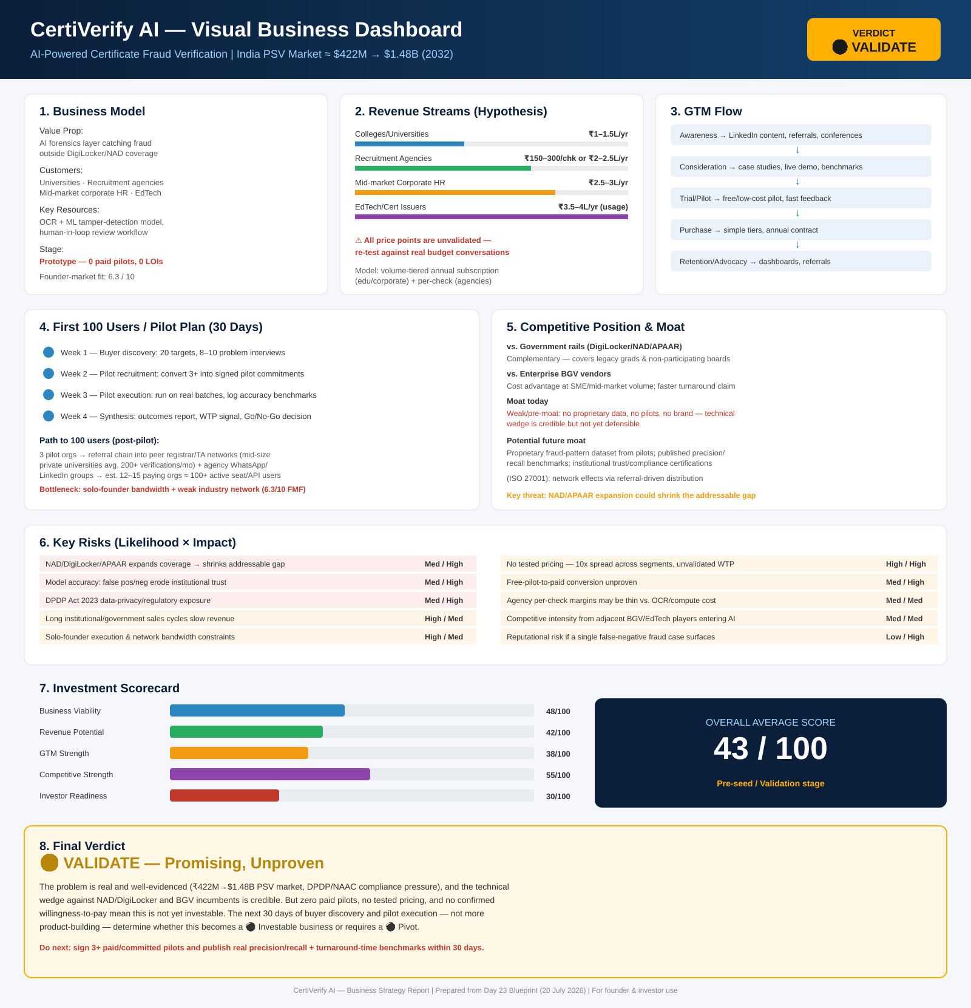

Sustainability Verdict
CertiVerify AI is not yet a sustainable business — it is a well-evidenced problem in search of its first paying customer. The market data and technical wedge are credible enough to justify 30 more days of focused validation, but not yet a raise or a scale-up. Sustainability hinges entirely on converting 3+ pilots into signed, paying contracts at a tested price within the next month — if that happens, this moves from 🟡 Validate to 🟢 Investable; if it doesn't, a pivot toward a faster-closing segment (agencies over universities) should be seriously considered.

