SIMATS ENGINEERING
ASSESSMENT TOOL 2

COURSE NAME: Artificial Intelligence COURSE CODE: CSA17

COURSE OUTCOME COVERED

CO1: Apply AI basics such as intelligent agents and uninformed search methods to solve problems effectively. ( BL3)

Assessment Tool Weightage: 35%

QUESTIONS: 3 Duration: 1 Hour
Total Marks:30

Annexure A

Constraint-Based Problem Solving

Code of Conduct:

I Subalakshmi S (192521246)(Name / Reg No) certify that this submission is my original work and that I have adhered to the guidelines specified for this assessment.
I understand that any violation of academic integrity rules will result in disciplinary action.

Signature of the student: Subalakshmi S

Annexure A

Constraint-Based Problem Solving

- A hospital needs to assign 3 doctors (D1, D2, D3) to 3 shifts (Morning, Afternoon, Night) such that:
Constraints:
- D1 cannot work Night shift
- D2 must work before D3 (Morning < Afternoon < Night)
- Only one doctor per shift
- D3 cannot work Morning
- All doctors must be assigned exactly one shift
Apply Backtracking Search to find a valid assignment with all intermediate steps and constraint checks. State the final valid schedule
- A robot operates in a grid environment (5×5). It must move from Start (S) to Goal (G). Obstacles block certain paths.

Constraints:
- Movement allowed: Up, Down, Left, Right
- Cost of each move = 1
- Cannot pass through obstacles
- Use Manhattan Distance heuristic
Using above constraints and BFS Search Algorithm Show step-by-step node expansion and priority queue updates and determine the optimal path and cost.

- An autonomous rescue robot is deployed in a disaster-affected building to locate and rescue survivors. The robot operates in a partially observable environment where some paths are blocked, and it must make decisions with limited information.
The building is represented as a grid of rooms. The robot starts at position S and must reach a survivor located at G.

Constraints:
- The robot can move up, down, left, right
- Some cells are blocked (obstacles) and cannot be traversed
- The robot has limited sensing capability (can only observe adjacent cells)
- Each movement has a cost of 1, but entering risky zones has an additional cost of 2
- The robot must minimize total cost while ensuring safe navigation
- The robot must update its knowledge dynamically (online search scenario)

Tasks:
a) Analyse all the given constraints and explain how they affect the robot’s decision-making process.
b) Develop a solution approach using an appropriate search strategy (e.g., Uniform Cost Search / Online Search Agent). Clearly explain the steps involved.
c) Demonstrate how the robot applies AI concepts such as:
- Intelligent agents
- Rationality
- Environment type
d) Justify why your chosen approach is the most suitable for solving this problem under the given constraints.

RUBRICS FOR CALCULATION:

Criteria | Weightage | Level 4 (Exemplary) | Level 3 (Proficient) | Level 2 (Developing) | Level 1 (Beginning)
Problem Understanding | 25% | Clearly defines the problem and identifies all relevant constraints accurately | Identifies most constraints with minor gaps | Partial understanding; misses key constraints | Fails to identify constraints correctly
Constraint Analysis | 25% | Analyzes constraints effectively and prioritizes them logically | Provides reasonable analysis with some prioritization | Limited analysis; weak prioritization | No meaningful analysis or prioritization
Solution Development | 25% | Develops optimal and feasible solutions satisfying all constraints | Develops workable solutions with minor limitations | Solutions partially satisfy constraints | Solutions do not meet constraints
Application of Concepts | 15% | Effectively applies appropriate concepts, methods, or tools | Applies concepts with minor errors | Limited application; requires guidance | Unable to apply relevant concepts
Justification | 10% | Provides strong justification for decisions with logical reasoning | Provides justification with some clarity | Weak or unclear justification | No justification provided

Answers

1. Hospital Shift Scheduling – Backtracking Search (CSP):

  - Problem formulation as a Constraint Satisfaction Problem

Variables: D1, D2, D3 (the doctors).
Domain: {Morning (M), Afternoon (A), Night (N)}, ordered M < A < N.
Constraints: C1: D1 ≠ N; C2: D2 works before D3, i.e. shift(D2) < shift(D3); C3: only one doctor per shift (all-different); C4: D3 ≠ M; C5: every doctor gets exactly one shift (complete assignment).
Unary constraints C1 and C4 are applied first to shrink the domains. The search then assigns one variable at a time (D1, then D2, then D3), checks every constraint that involves only assigned variables after each assignment, and backtracks as soon as a check fails.
Variable | Initial domain | After C1 and C4 | After C2 (arc consistency)
D1 | {M, A, N} | {M, A} | {M, A}
D2 | {M, A, N} | {M, A, N} | {M, A} (N has no later shift for D3)
D3 | {M, A, N} | {A, N} | {A, N}

1.2 Complete backtracking search tree:
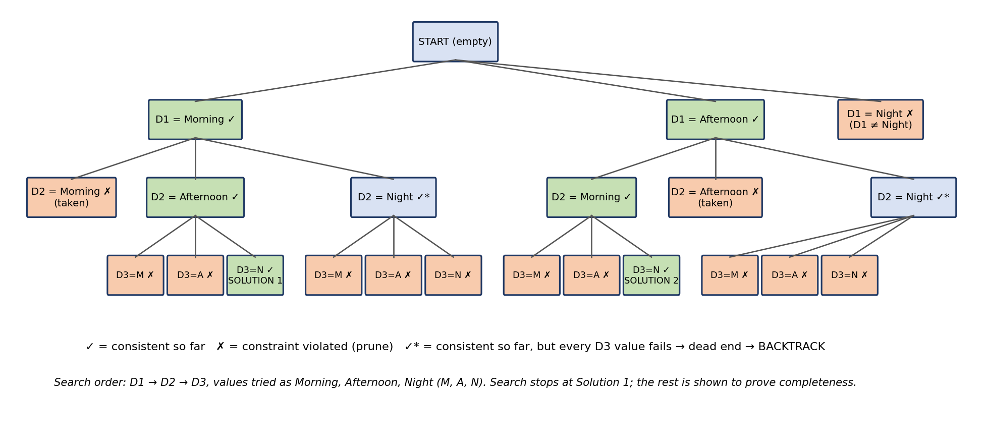

Figure 1: Complete backtracking search tree for the hospital shift problem
  - Backtracking trace with constraint checks:

Variable order: D1, D2, D3. Value order: Morning, Afternoon, Night. Domains from the "after C1 and C4" column are used, as in plain backtracking; checks against the all-different, ordering and unary constraints are shown at each step.

Step | Assignment tried | Constraint checks | Result
1 | D1 = Morning | C1: D1 ≠ Night ✓. C3: no other doctor assigned ✓. | Accept
2 | D2 = Morning | C3: Morning is already used by D1 ✗. | Reject; try next value
3 | D2 = Afternoon | C3: Afternoon is free ✓. C2: D3 is not yet assigned, so it must later get a shift after Afternoon (only Night) ✓. | Accept
4 | D3 = Morning | C4: D3 ≠ Morning ✗. C3: Morning taken by D1 ✗. | Reject
5 | D3 = Afternoon | C3: Afternoon taken by D2 ✗. C2: Afternoon is not after Afternoon ✗. | Reject
6 | D3 = Night | C4 ✓. C3: Night is free ✓. C2: D2 (Afternoon) < D3 (Night) ✓. C1 ✓. C5: all three doctors assigned ✓. | Accept → SOLUTION

1.4 Reading the tree:

The first complete, consistent assignment is reached on the left branch (Solution 1). If the search is allowed to continue, it backtracks from D2 = Night (no value of D3 can come after Night, so the node is a dead end), then from D1 = Morning to D1 = Afternoon, where D2 = Morning leads to Solution 2. D1 = Night is rejected immediately by C1. In total, exactly two assignments satisfy all five constraints: (D1, D2, D3) = (Morning, Afternoon, Night) and (Afternoon, Morning, Night). Both give D3 the Night shift, which also confirms C4.

1.5 Constraint verification of the final schedule:

No. | Constraint | Check on D1 = Morning, D2 = Afternoon, D3 = Night | Satisfied?
i | D1 cannot work the Night shift | D1 works Morning | Yes
ii | D2 must work before D3 | Afternoon (2) < Night (3) | Yes
iii | Only one doctor per shift | Morning, Afternoon, Night are each used once | Yes
iv | D3 cannot work Morning | D3 works Night | Yes
v | Each doctor has exactly one shift | D1, D2 and D3 each have one shift | Yes

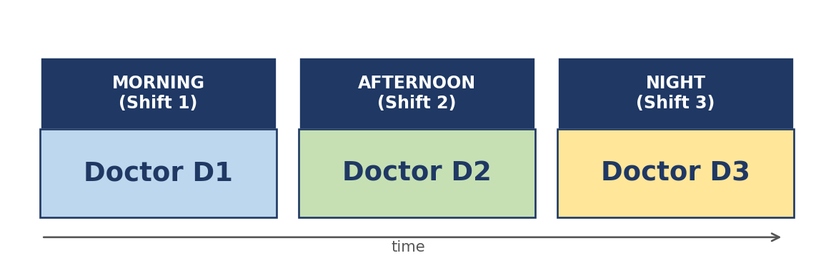
Figure 2: Final valid hospital schedule

Final answer: Morning – D1, Afternoon – D2, Night – D3. (An alternative valid schedule, found if the search continues, is Morning – D2, Afternoon – D1, Night – D3.)

2. Robot Path Planning on a 5×5 Grid
2.1 Assumed grid and problem formulation

The question does not draw the grid, so the following layout is assumed. Cells are written as (row, column), counted from the top-left corner as (0,0). Start S = (0,0), goal G = (4,4). Obstacles are at (1,1), (2,1), (3,1), (1,3) and (3,3). The same procedure works for any other obstacle layout.
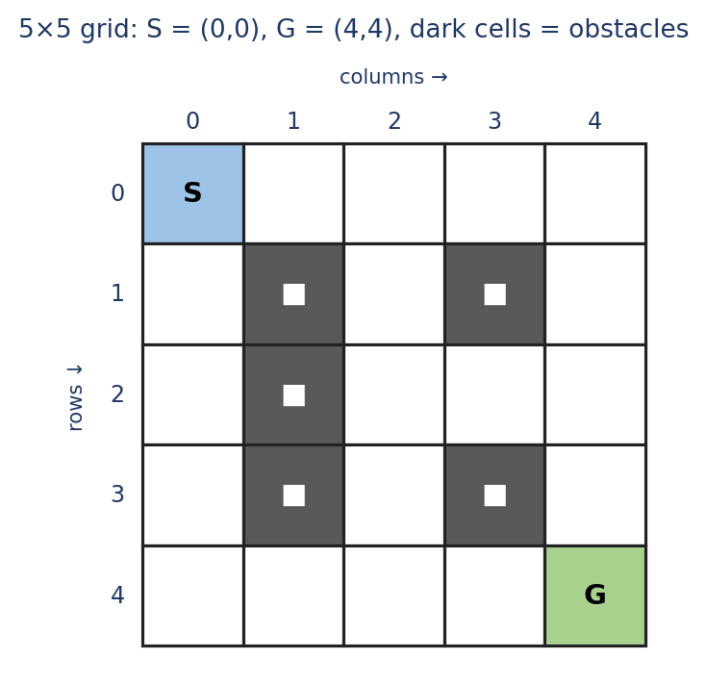 | 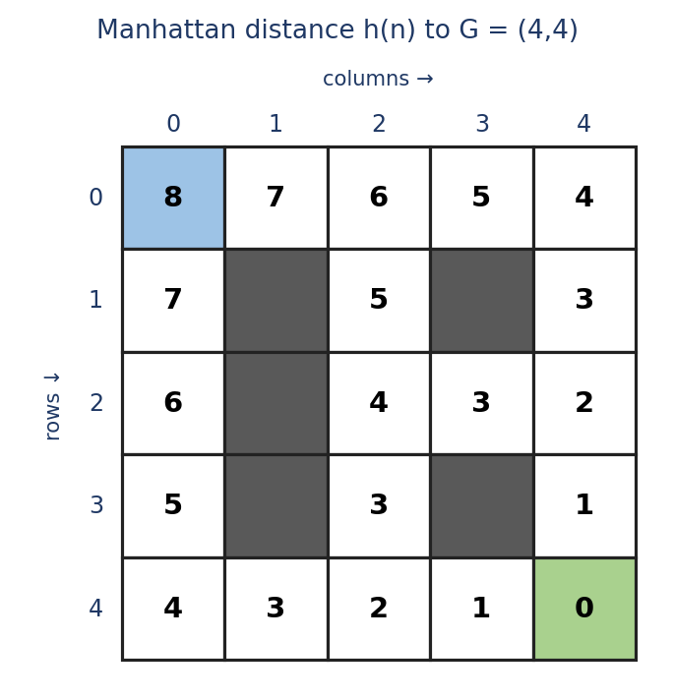
Figure 3: (left) the assumed 5×5 environment; (right) Manhattan-distance heuristic h(n) = |r − 4| + |c − 4|
State: the robot cell (r, c) that is not an obstacle.
Initial state / goal test: (0,0) / the state (4,4).
Actions: Up, Down, Left, Right, each allowed only if the target cell lies inside the grid and is not an obstacle (no passing through obstacles).
Step cost: 1 per move, so the path cost g(n) is the number of moves.
Heuristic: Manhattan distance h(n). It never overestimates the true remaining cost, because every move changes the row or column by only 1 (admissible), and it satisfies h(n) ≤ 1 + h(n′) for neighbouring cells (consistent).
Note on the method: Breadth-First Search uses a plain FIFO queue and ignores the heuristic. Because the question also asks for priority-queue updates and the Manhattan heuristic, the solution first shows BFS (Section 2.2), then the priority-queue version, A* with f(n) = g(n) + h(n) (Section 2.3). Both return the same optimal cost. Ties are broken using the neighbour order Up, Down, Left, Right.
2.2 BFS: step-by-step node expansion (FIFO queue)
The goal test is applied when a node is generated. A node is added to the queue only if it has not been generated before.

Step | Node expanded | Children added to queue | Queue after the step (front → back)
1 | (0,0) | (1,0), (0,1) | (1,0), (0,1)
2 | (1,0) | (2,0) | (0,1), (2,0)
3 | (0,1) | (0,2) | (2,0), (0,2)
4 | (2,0) | (3,0) | (0,2), (3,0)
5 | (0,2) | (1,2), (0,3) | (3,0), (1,2), (0,3)
6 | (3,0) | (4,0) | (1,2), (0,3), (4,0)
7 | (1,2) | (2,2) | (0,3), (4,0), (2,2)
8 | (0,3) | (0,4) | (4,0), (2,2), (0,4)
9 | (4,0) | (4,1) | (2,2), (0,4), (4,1)
10 | (2,2) | (3,2), (2,3) | (0,4), (4,1), (3,2), (2,3)
11 | (0,4) | (1,4) | (4,1), (3,2), (2,3), (1,4)
12 | (4,1) | (4,2) | (3,2), (2,3), (1,4), (4,2)
13 | (3,2) | none (all neighbours blocked or already generated) | (2,3), (1,4), (4,2)
14 | (2,3) | (2,4) | (1,4), (4,2), (2,4)
15 | (1,4) | none (all neighbours blocked or already generated) | (4,2), (2,4)
16 | (4,2) | (4,3) | (2,4), (4,3)
17 | (2,4) | (3,4) | (4,3), (3,4)
18 | (4,3) | (4,4) | (3,4), (4,4) ← G generated, search stops

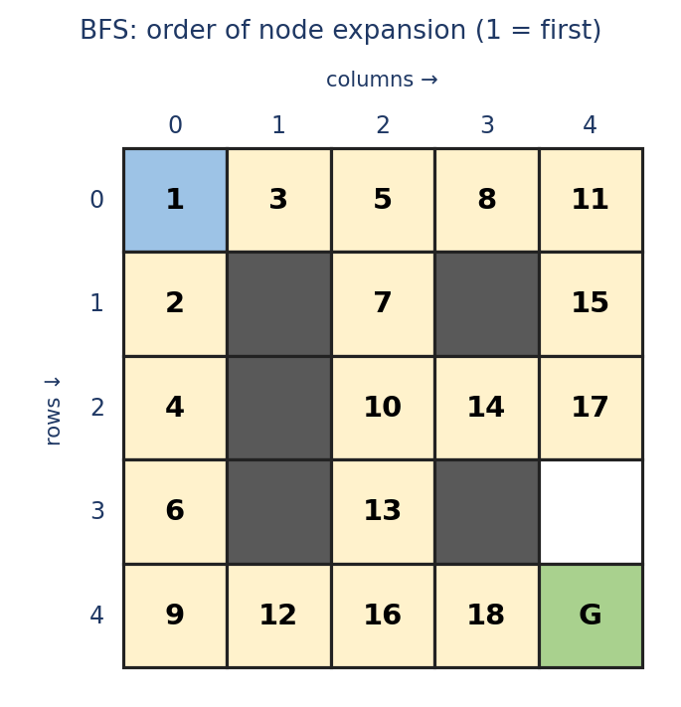 | 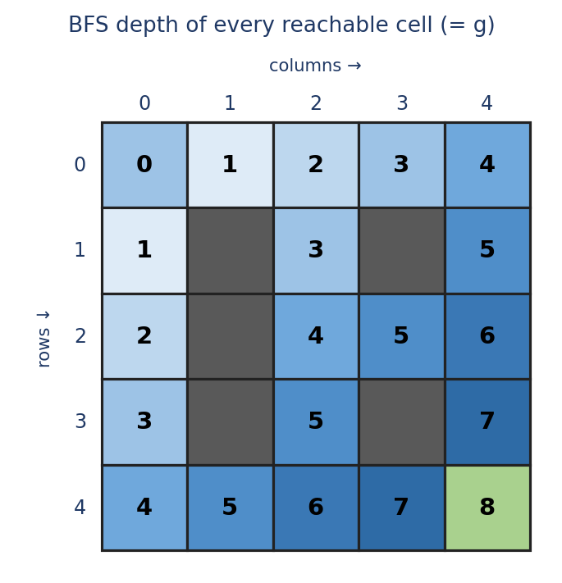

Figure 4: (left) BFS expansion order; (right) BFS depth of every reachable cell
BFS expands cells level by level: all cells at distance k are expanded before any cell at distance k + 1. G is generated at depth 8 while (4,3) is expanded as the 18th node, so no shorter path exists.

2.3 A* search: priority-queue updates (Manhattan heuristic)
The priority queue is ordered by f(n) = g(n) + h(n). Equal f values are broken by lower h (closer to G), then by insertion order. Each queue entry is written as cell:f.

Step | Node expanded (g, h, f) | Children generated (g, f) | Priority queue after the step
1 | (0,0) g=0, h=8, f=8 | (1,0) g=1, f=8, (0,1) g=1, f=8 | (1,0):8, (0,1):8
2 | (1,0) g=1, h=7, f=8 | (2,0) g=2, f=8 | (2,0):8, (0,1):8
3 | (2,0) g=2, h=6, f=8 | (3,0) g=3, f=8 | (3,0):8, (0,1):8
4 | (3,0) g=3, h=5, f=8 | (4,0) g=4, f=8 | (4,0):8, (0,1):8
5 | (4,0) g=4, h=4, f=8 | (4,1) g=5, f=8 | (4,1):8, (0,1):8
6 | (4,1) g=5, h=3, f=8 | (4,2) g=6, f=8 | (4,2):8, (0,1):8
7 | (4,2) g=6, h=2, f=8 | (3,2) g=7, f=10, (4,3) g=7, f=8 | (4,3):8, (0,1):8, (3,2):10
8 | (4,3) g=7, h=1, f=8 | (4,4) g=8, f=8 | (4,4):8, (0,1):8, (3,2):10
9 | (4,4) g=8, h=0, f=8 | none | (0,1):8, (3,2):10 ← goal removed from queue, search stops

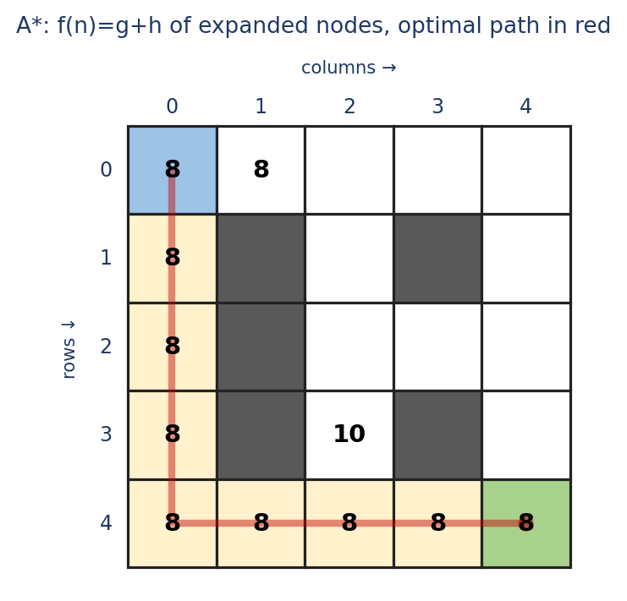
Figure 5: f-values of the nodes generated by A*; the red line is the optimal path
A* reaches the goal after expanding only 9 nodes, compared with 18 for BFS, because the heuristic keeps the search moving towards G. At step 7 the node (3,2) enters the queue with f = 10, which is worse than the best remaining entries, so it is never expanded. The obstacle wall on column 1 forces the robot to travel down column 0 before turning right along row 4.
2.4 Optimal path and cost
Algorithm | Nodes expanded | Path cost
BFS (FIFO queue) | 18 | 8 moves
A* (priority queue, Manhattan heuristic) | 9 | 8 moves

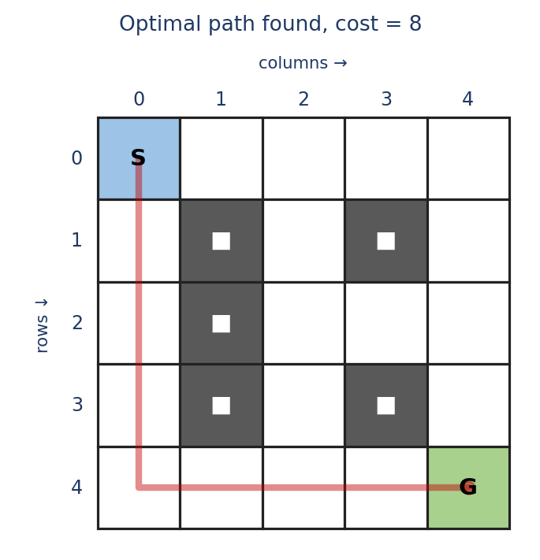
Figure 6: Optimal path from S to G
Optimal path: (0,0) → (1,0) → (2,0) → (3,0) → (4,0) → (4,1) → (4,2) → (4,3) → (4,4), i.e. Down, Down, Down, Down, Right, Right, Right, Right. Optimal cost = 8.
Since the Manhattan distance from S to G is already 8, no path can be cheaper. Four different shortest paths of cost 8 exist on this grid (for example along row 0 and then down column 4); the one reported above is chosen only by the tie-breaking order Up, Down, Left, Right.

3. Autonomous Rescue Robot – Online Search under Partial Observability
Assumed environment
The building is modelled as a 5×5 grid of rooms with S = (0,0) and the survivor at G = (4,4). The robot does not know the map. Unknown to the robot, the building has blocked cells at (1,1), (2,3), (3,1) and (4,2) and risky cells at (1,3), (3,2) and (4,3). Entering a normal cell costs 1; entering a risky cell costs 1 + 2 = 3.
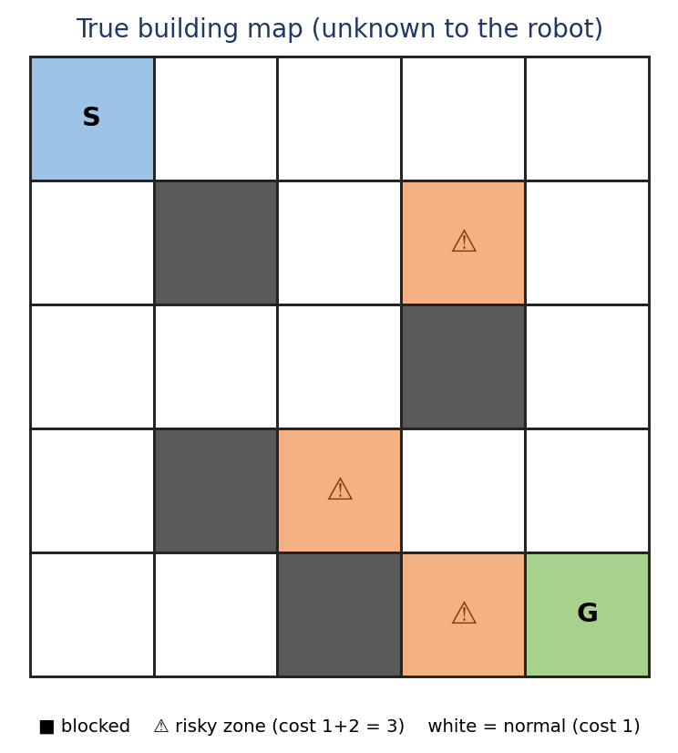
Figure 7: True building map (used only to simulate what the robot senses)
(a) Effect of each constraint on decision-making
Constraint | Effect on the robot’s decisions | Design consequence
Moves limited to Up, Down, Left, Right | Only four neighbours exist at each cell, so the state space is a 4-connected grid and plans are sequences of these four actions. | Actions U, D, L, R; no diagonal shortcuts.
Blocked cells cannot be entered | Some planned routes turn out to be impossible; the robot may have to turn back after discovering a wall. | Mark cells as blocked in the map and replan.
Sensing only adjacent cells | The environment is partially observable; the robot cannot plan an optimal route in advance and decides from incomplete knowledge. | Online agent: sense, update the map, plan, act.
Cost 1 per move, +2 for risky zones | Path length and path safety must be traded off; the shortest route is not necessarily the cheapest. | Use a cost-sensitive search such as Uniform Cost Search.
Minimise total cost with safe navigation | A risky cell is entered only when the detour costs more than the extra 2; known blocked cells are never entered. | Risk is part of the step cost, not a separate rule.
Knowledge must be updated dynamically | Plans become outdated as new cells are observed, so one plan cannot be followed blindly to the end. | Replan after every new observation.

(b) Solution approach: online Uniform Cost Search with replanning
The robot uses an online search agent that repeats a sense–plan–act cycle. UCS (which expands the node with the lowest path cost g(n) first) is applied to the part of the map known so far. Cells that have not yet been seen are assumed to be free and cost 1 (the optimistic "free-space assumption"), so the robot is drawn towards the goal until a sensor reading proves otherwise.
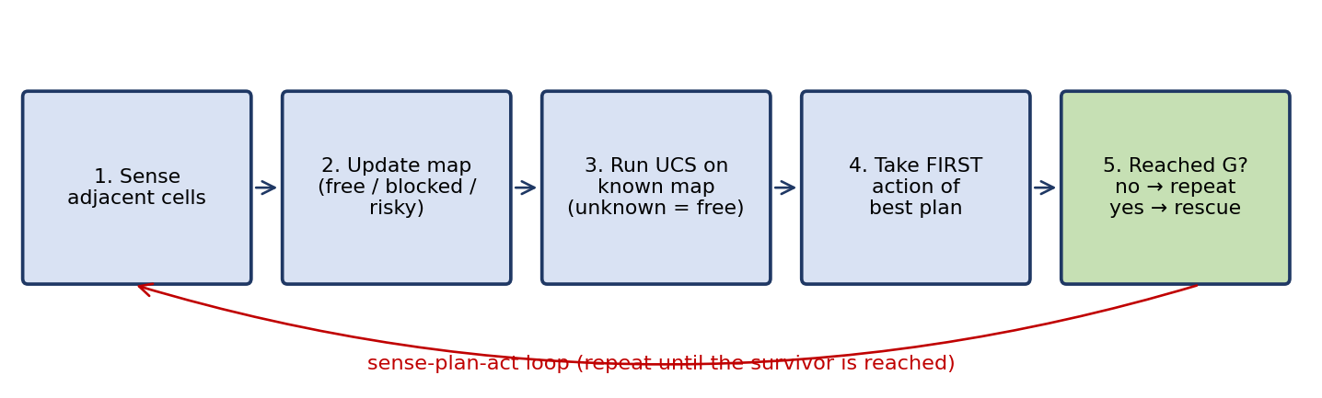
Figure 8: The sense–plan–act cycle of the online UCS agent
Step 1 – Sense: read the status (free, blocked, risky) of the four adjacent cells and store it in the map.
Step 2 – Update: add new cells to the knowledge base; keep cell costs (1 or 3).
Step 3 – Plan: run UCS from the current cell to G on the known map; unknown cells are treated as cost 1.
Step 4 – Act: execute only the first action of the cheapest plan and add its true cost to the total (1, or 3 for a risky cell).
Step 5 – Repeat: go back to Sense until the robot reaches G, where the survivor is rescued.
Pseudocode:
function ONLINE-UCS-AGENT(start S, goal G)
known <- empty map; pos <- S; total <- 0
loop until pos = G do
for each neighbour n of pos do // limited sensing
known[n] <- SENSE(n) // free | blocked | risky
plan <- UCS(known, pos, G) // unknown cells cost 1
step_cost(n) = 3 if known[n] = risky else 1 // 1 move + 2 risk
next <- FIRST-STEP(plan)
pos <- MOVE(next); total <- total + ACTUAL-COST(next)
return total // survivor reached

Step-by-step simulation
Step | Robot at | New cells sensed | UCS plan from here (cost-to-go) | Move | Total cost
0 | (0,0) | (1,0) free; (0,1) free | (1,0)→(2,0)→(3,0)→(4,0)→(4,1)→(4,2)→(4,3)→(4,4) (8) | Down | 1
1 | (1,0) | (2,0) free; (1,1) block | (2,0)→(3,0)→(4,0)→(4,1)→(4,2)→(4,3)→(4,4) (7) | Down | 2
2 | (2,0) | (3,0) free; (2,1) free | (3,0)→(4,0)→(4,1)→(4,2)→(4,3)→(4,4) (6) | Down | 3
3 | (3,0) | (4,0) free; (3,1) block | (4,0)→(4,1)→(4,2)→(4,3)→(4,4) (5) | Down | 4
4 | (4,0) | (4,1) free | (4,1)→(4,2)→(4,3)→(4,4) (4) | Right | 5
5 | (4,1) | (4,2) block | (4,0)→(3,0)→(2,0)→(2,1)→(2,2)→(3,2)→(3,3)→(4,3)→(4,4) (9) | Left | 6
6 | (4,0) | nothing new | (3,0)→(2,0)→(2,1)→(2,2)→(3,2)→(3,3)→(4,3)→(4,4) (8) | Up | 7
7 | (3,0) | nothing new | (2,0)→(2,1)→(2,2)→(3,2)→(3,3)→(4,3)→(4,4) (7) | Up | 8
8 | (2,0) | nothing new | (2,1)→(2,2)→(3,2)→(3,3)→(4,3)→(4,4) (6) | Right | 9
9 | (2,1) | (2,2) free | (2,2)→(3,2)→(3,3)→(4,3)→(4,4) (5) | Right | 10
10 | (2,2) | (1,2) free; (3,2) risk; (2,3) block | (3,2)→(3,3)→(4,3)→(4,4) (6) | Down | 13
11 | (3,2) | (3,3) free | (3,3)→(4,3)→(4,4) (3) | Right | 14
12 | (3,3) | (4,3) risk; (3,4) free | (3,4)→(4,4) (2) | Right | 15
13 | (3,4) | (2,4) free; (4,4) free | (4,4) (1) | Down | 16

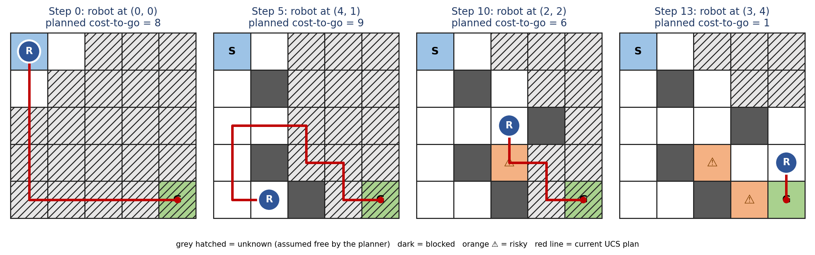
Figure 9: What the robot knows (and plans) at steps 0, 5, 10 and 13
Key moments: at step 5 the robot, standing at (4,1), senses that (4,2) is blocked. The optimistic plan fails, UCS is rerun, and the new cheapest plan (cost 9) sends the robot back up the left column and across row 2. At step 10 it senses that (3,2) is risky; the alternatives all cost the same, so it accepts the +2 penalty once (total jumps from 10 to 13). At step 13 the robot enters G with a total cost of 16.
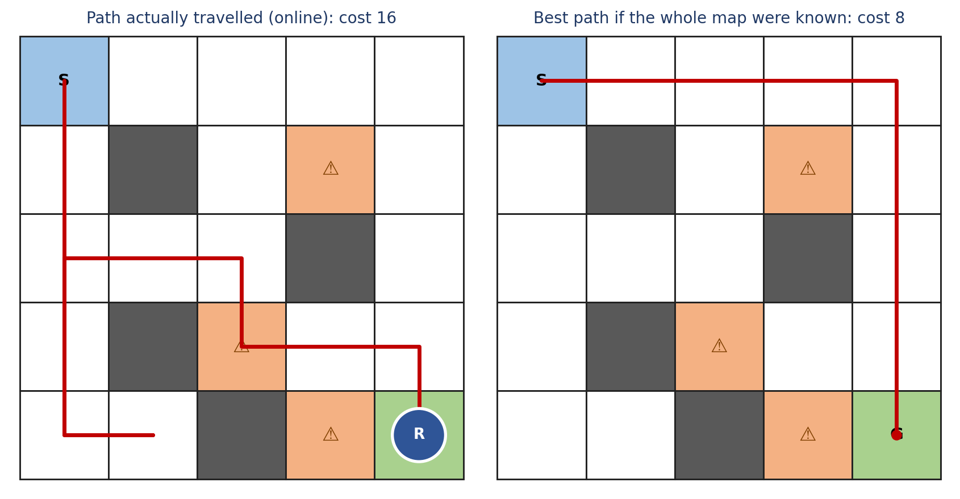
Figure 10: (left) path taken by the online robot, cost 16; (right) cheapest path if the whole map were known, cost 8
With full knowledge the best path along the top row and right column would cost 8. The extra cost of 16 − 8 = 8 is the price of discovering the map while moving; no agent restricted to adjacent-cell sensing can avoid this in general.
(c) AI concepts demonstrated
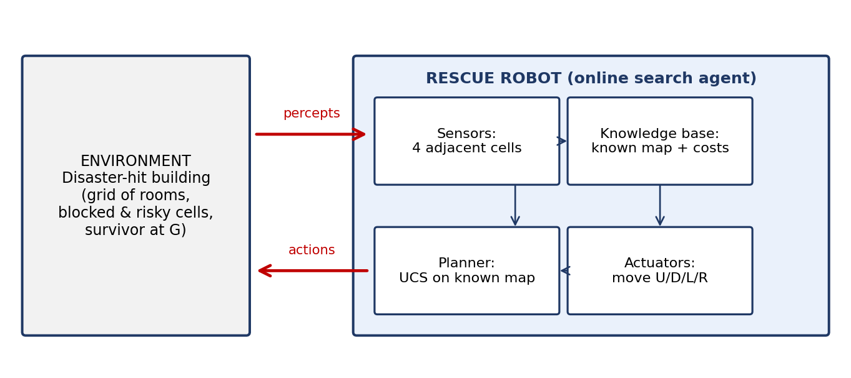
Figure 11: The rescue robot as an intelligent agent in its environment

Intelligent agent (PEAS description)

PEAS element | Rescue robot
Performance measure | Reach the survivor with minimum total cost (1 per move, +2 per risky cell), never enter blocked cells, and keep the risk low.
Environment | Disaster-hit building represented as a grid of rooms with blocked and risky cells.
Actuators | Wheels or tracks for Up, Down, Left, Right moves; communication to report the rescue.
Sensors | Short-range sensors reporting the status of the four adjacent cells; position (odometry).

Agent type: a goal-based agent (goal: stand on G) that is also utility-based (it prefers the lowest-cost route) and keeps an internal model of the world (the map built from percepts). It is an online search agent because planning and execution are interleaved.
Rationality
A rational agent chooses, at every step, the action expected to maximise its performance measure given its percept sequence and built-in knowledge. Rationality is not omniscience: the robot cannot know what lies beyond its sensor range, so walking towards a cell that later turns out to be blocked is still rational because the plan was optimal for everything it knew. The robot is rational because it (i) never repeats a mistake (every observation is stored), (ii) always picks the cheapest plan on the current map, (iii) avoids known blocked cells, and (iv) accepts a risky cell only when avoiding it would cost more.
Environment type
Property | Value | Reason
Observability | Partially observable | Sensors see only the four adjacent cells.
Agents | Single agent | Only the robot acts; there are no competing agents.
Determinism | Deterministic | A chosen move always leads to the intended cell.
Episodic / sequential | Sequential | Each move changes the position and affects all later costs.
Static / dynamic | Static (but unknown) | Cells do not change while the robot moves; if aftershocks changed them, replanning at every step would still cope.
Discrete / continuous | Discrete | Finite set of grid cells and four actions.
Known / unknown | Unknown map | The robot must learn the layout and costs by exploring.

(d) Why this approach is the most suitable
Alternative | Limitation for this problem | Verdict
BFS | Minimises number of moves only and ignores the extra cost of risky zones. | Not cost-optimal
DFS | Neither complete in loops nor optimal; may enter long risky detours. | Unsuitable
Offline UCS / A* on the full map | Needs the complete map in advance, which the robot does not have. | Not applicable alone
Greedy best-first | Fast, but ignores path cost, so it can walk through several risky zones. | Not safe
Online UCS with replanning (chosen) | Handles unknown cells, non-uniform costs and new observations; always cost-optimal for the knowledge available. | Most suitable

Handles partial observability: planning is redone after every observation, so the robot adapts as soon as it discovers a wall or a risky room.
Respects non-uniform costs: UCS minimises the real cost, 1 for normal and 3 for risky cells, whereas BFS would treat all moves equally.
Safe and complete: known blocked cells are never entered, and UCS always finds a path if one exists in the known map. If every route were blocked it would report failure rather than take an unsafe move.
Simple and efficient: on a small grid each UCS run takes only a few milliseconds, so replanning at every step is cheap. For larger buildings, the same loop can use A* or D* Lite with the Manhattan heuristic (admissible because the minimum step cost is 1) to reduce computation.
Conclusion: The rescue robot is best modelled as a goal-based, utility-driven online search agent. By repeating sense, update, UCS planning and one-step execution, it reaches the survivor safely with minimum cost under limited sensing; in the simulated building it needed a total cost of 16, compared with 8 for an agent that knew the whole map.

