SIMATS ENGINEERING
ASSESSMENT TOOL 3

COURSE NAME: Artificial Intelligence COURSE CODE: CSA17

COURSE OUTCOME COVERED

CO1: Apply AI basics such as intelligent agents and uninformed search methods to solve problems effectively. (BL3)

Assessment Tool Weightage: 30%

Duration: 45 Minutes
QUESTIONS: 2 Total Marks:20

Annexure A

Descriptive Written Test

Code of Conduct:

I Subalakshmi S (192521246) (Name / Reg No) certify that this submission is my original work and that I have adhered to the guidelines specified for this assessment.
I understand that any violation of academic integrity rules will result in disciplinary action.

Signature of the student: Subalakshmi S

Annexure A

Descriptive Written Test

- A smart home automation system is being designed to manage lighting, temperature, and security based on user behaviour and environmental conditions. The system must respond to real-time inputs such as motion detection, temperature changes, and time of day while also learning user preferences over time. In this context, explain the different types of intelligent agents (simple reflex, model-based, goal-based, and utility-based agents) and analyse how each type would function within this system. Justify which type of agent or hybrid approach would be most effective for ensuring comfort, energy efficiency, and security.

- A robot is placed in an unknown maze and must find a path to the exit without prior knowledge of the layout. Explain how uninformed search strategies like Uniform Cost Search (UCS) and Iterative Deepening Search (IDS) can help solve this problem.
Discuss the advantages and disadvantages of these algorithms in terms of time and space complexity. Relate the problem to different types of intelligent agents and explain how agent design affects decision-making. Suggest which combination of agent type and search strategy would be most effective and justify your choice.

RUBRICS FOR CALCULATION:

Criteria | Weightage | Level 4 – Exemplary | Level 3 – Proficient | Level 2 – Developing | Level 1 – Beginning
Criteria | Level 4 (Exemplary) | Level 3 (Proficient) | Level 2 (Developing) | Level 1 (Beginning) | Max Marks
Understanding of Concepts | 25% | Demonstrates thorough, accurate understanding of concepts | Good understanding with minor gaps | Basic understanding with some misconceptions | Poor understanding; major misconceptions
Explanation | 25% | Detailed, well-explained answers with relevant examples | Clear explanation with adequate details | Limited explanation; lacks depth | Poor or unclear explanation
Application | 20% | Effectively applies concepts with strong analytical ability | Applies concepts with minor errors | Limited application with weak analysis | No application or incorrect analysis
Organization | 15% | Well-structured answers with logical flow and coherence | Organized with minor issues in flow | Basic structure, lacks clarity | Poor organization, incoherent answers
Accuracy | 10% | Completely accurate and covers all required points | Mostly accurate with minor omissions | Partially correct with missing points | Incorrect answers with major gaps
Clarity | 5% | Clear, neat, professional presentation | Understandable with minor issues | Limited clarity, readability issues | Poorly written, difficult to understand

Answers
1. Intelligent Agents in a Smart Home Automation System
1.1 Introduction and task environment
An intelligent agent is anything that perceives its environment through sensors and acts upon it through actuators in order to achieve its objectives. The agent function maps every percept sequence to an action, and the agent program is the code that implements it. A smart home controller is a natural example: motion sensors, thermometers, clocks and door contacts supply percepts, while lights, heating/cooling units, locks and alarms are the actuators. The design question is how much "intelligence" sits between the percept and the action, and this is exactly what distinguishes the four classic agent types.
PEAS element | Smart home system
Performance measure | Occupant comfort, low electricity consumption, security (no undetected intrusion, few false alarms), and response speed.
Environment | Rooms of a house with occupants, outdoor weather, time of day, doors and windows. Partially observable, stochastic (people behave unpredictably), dynamic, continuous, sequential and, in practice, multi-agent (several residents).
Actuators | Light switches and dimmers, HVAC (heat, cool, eco), door locks, alarm siren, cameras, phone notifications.
Sensors | Motion/presence, temperature and humidity, light level, door and window contacts, clock, user app and override history.

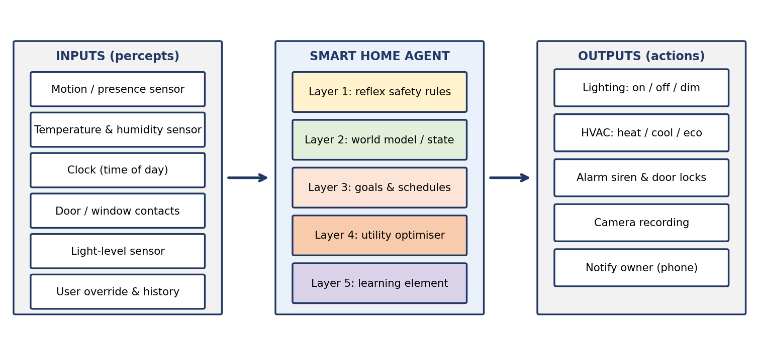
Figure 1: Inputs, agent layers and outputs of the smart home system
1.2 Types of intelligent agents and how each works in the smart home
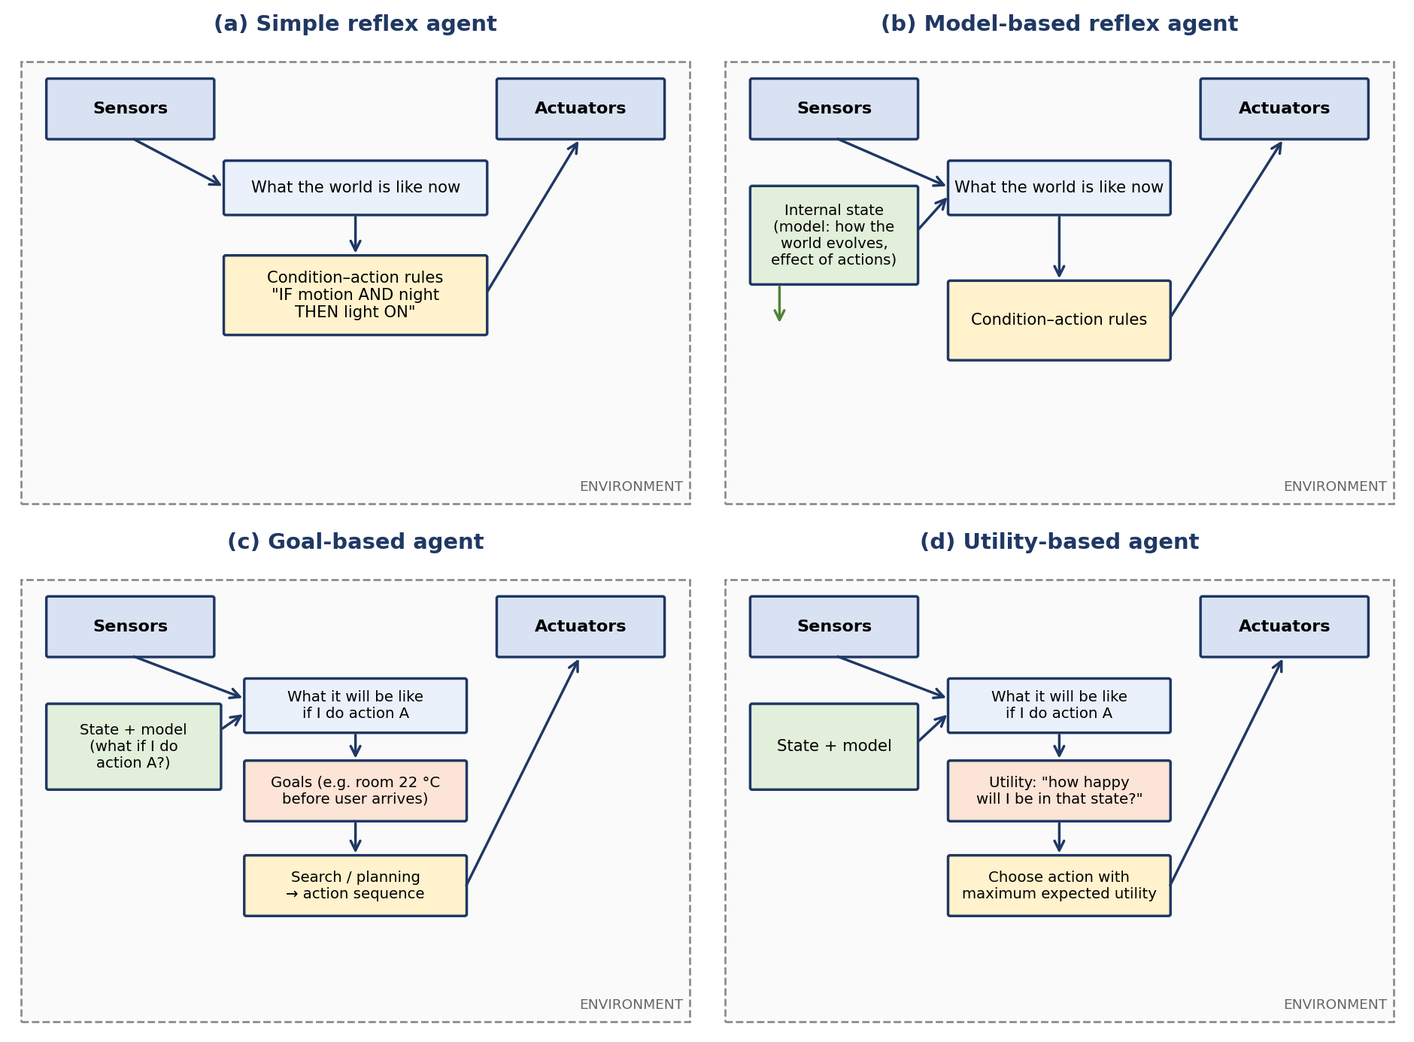
Figure 2: Architectures of the four basic agent types
(i) Simple reflex agent
A simple reflex agent selects an action using only the current percept and a set of condition–action rules; it keeps no memory. In the smart home it implements rules such as "IF motion detected AND light level low THEN switch the hall light on", "IF smoke detected THEN sound the alarm" or "IF window open THEN pause the air conditioner". Its great strength is speed and simplicity: the decision is a table lookup, so it reacts in milliseconds and is easy to verify, which is ideal for safety-critical events. Its weakness is that it works correctly only when the current percept is enough to decide. It cannot tell whether the house has been empty for an hour or the occupant is simply sitting still, so it may switch lights off on a person who is reading, and it cannot learn or consider energy cost.
(ii) Model-based reflex agent
A model-based reflex agent maintains an internal state describing the parts of the world it cannot currently see, updated using a model of how the world evolves and how its own actions affect it. In the smart home the state records, for example, "kitchen was occupied 2 minutes ago", "front door is locked", or "room temperature is falling 0.5 °C per 10 minutes". With this memory the agent keeps the lights on for a short time after motion stops, distinguishes an occupant who is asleep from an empty house, and anticipates that a room will be too cold in 20 minutes. The rules are still reactive, but they now operate on a richer picture of the situation. The limitation is that the agent has no explicit objective: it does what its rules say, not what is best.
(iii) Goal-based agent
A goal-based agent adds an explicit description of desirable states and chooses actions by asking "what will happen if I do this, and will it bring me closer to my goal?". It uses search or planning to build a sequence of actions. In the smart home, goals such as "bedroom at 22 °C by 22:00", "all doors locked after midnight" or "house in eco mode while everyone is away" make the controller pre-heat or pre-cool at the right time, lock doors in a sensible order and schedule appliances. Goal-based design is flexible, because changing a goal does not require rewriting the rules. However, goals are binary: a state either satisfies the goal or it does not. The agent cannot compare two ways of reaching the goal (for example a fast but expensive one with a slower, cheaper one) or balance competing goals such as comfort versus saving energy.
(iv) Utility-based agent
A utility-based agent assigns every possible state a real number, the utility, which measures how desirable it is, and selects the action with the highest expected utility. This handles trade-offs and uncertainty in a principled way. The smart home can define utility as a weighted sum of comfort, energy saving and security, such as U = w1·comfort + w2·saving + w3·security, and then choose the air-conditioner set-point, dimming level or pre-heating time that maximises it. Figure 3 shows the idea: comfort peaks at the user's preferred 22 °C but electricity use rises as the set-point is lowered on a hot day, so the best compromise is found where the combined utility is highest. The costs of this approach are more computation, the need to define and tune the weights, and the need for a model good enough to predict outcomes.
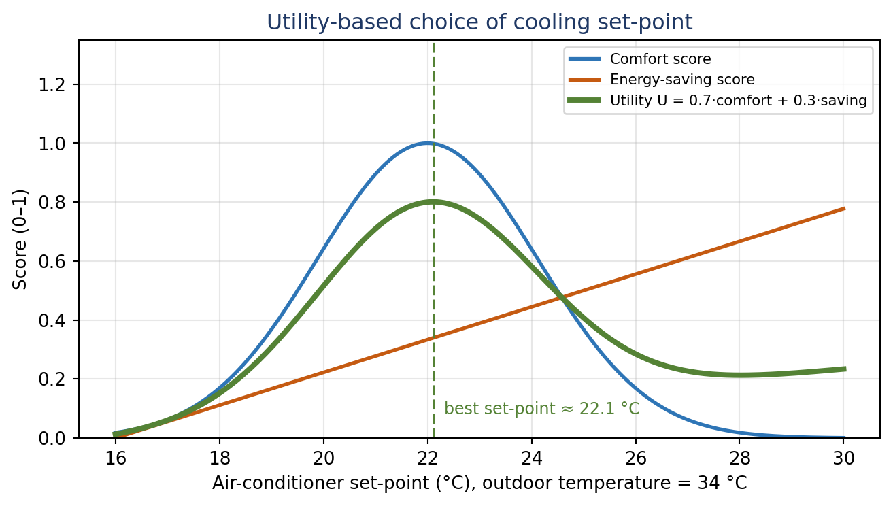
Figure 3: A utility function trades comfort against energy use to choose the cooling set-point
1.3 Comparison of the agent types in the smart home
Agent type | Uses memory / model? | Handles goals / trade-offs? | Typical smart-home task | Main weakness
Simple reflex | No | No | Fire / intrusion alarm, motion light | Blind to history; cannot learn
Model-based | Yes (state) | No | Keep light on briefly after motion; detect empty house | Rules only; no optimisation
Goal-based | Yes | Yes (binary goals) | Pre-heat room before arrival; lock-up routine | Cannot rank alternatives
Utility-based | Yes | Yes (graded trade-offs) | Choose set-point balancing comfort and cost | Needs good model and weights

1.4 Which agent is most effective? A hybrid, learning approach
No single type satisfies all three requirements. Pure reflex agents are fast but cannot manage energy; pure utility-based agents are optimal but may be too slow, or too fragile, to be trusted with a fire alarm. The most effective design is therefore a layered hybrid agent with a learning component, shown in Figure 4.
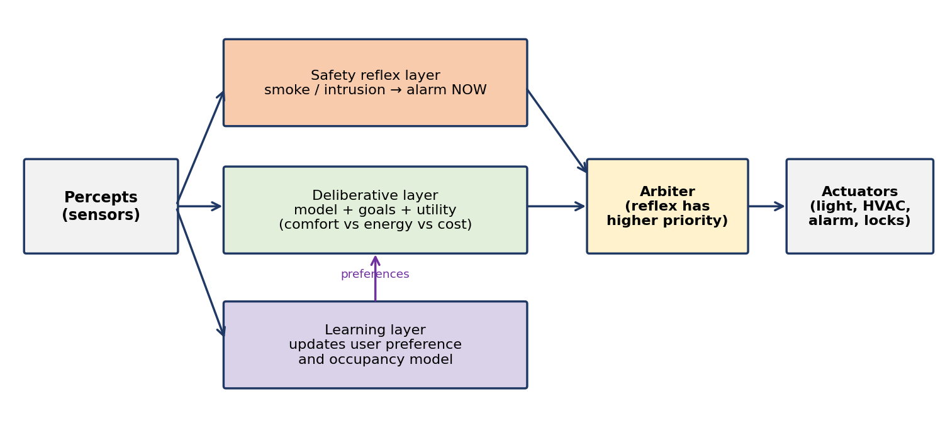
Figure 4: Hybrid architecture with a safety reflex layer, a deliberative layer and a learning layer
Safety reflex layer (simple reflex): smoke, gas leak, glass-break and forced-entry rules fire immediately and override everything else. This guarantees the security requirement and gives predictable, certifiable behaviour.
Model-based state: tracks occupancy, door status and temperature trend so that the system reasons about what it cannot directly sense, such as whether someone is still in the room.
Goal-based planning: schedules pre-heating, lock-up and "away" routines to satisfy the household's goals at the right times.
Utility-based optimisation: chooses among the many actions that achieve the goals, balancing comfort against electricity tariff and wear, which gives the energy-efficiency requirement.
Learning element: observes manual overrides and daily routines, updates the occupancy and preference model, and so personalises behaviour over time, as the question requires.
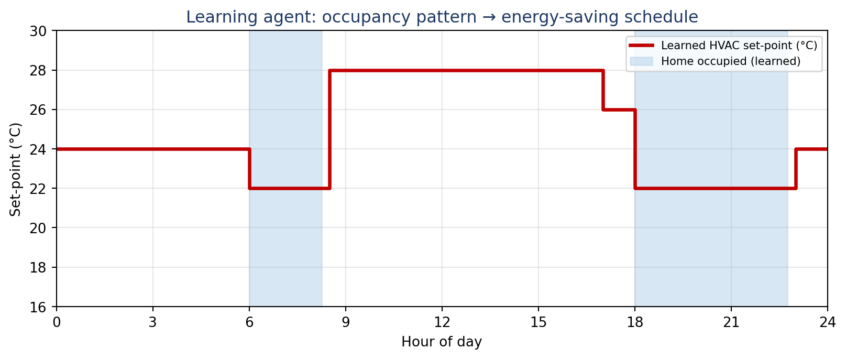
Figure 5: A learning agent turns the observed occupancy pattern into an energy-saving temperature schedule
The scenarios in the table below show how the layers cooperate in real time.
Situation | Responsible layer | Resulting behaviour
Smoke detected at 3 a.m. | Reflex (safety) | Alarm, unlock exits and notify owner at once; no optimisation delay.
Motion in hall at night, user away on holiday | Reflex + model | Model says the house should be empty, so raise a security alert and start recording.
Everyone leaves in the morning | Goal + utility | Switch to eco mode; choose the cheapest set-back temperature that still allows a quick return to comfort.
User usually arrives at 6 p.m. | Learning + goal | Pre-cool the living room so that it reaches 22 °C at 6 p.m. without running the AC all day.
User repeatedly raises the temperature in the evening | Learning | Shift the preferred set-point in the model so the next evening needs no override.

Conclusion for Question 1: the hybrid agent meets all three goals. Comfort comes from the learned preferences and the utility function, energy efficiency from goal-based scheduling and utility optimisation, and security from the high-priority reflex layer and the world model. The trade-off is greater design complexity, which is acceptable because each layer stays simple and testable on its own.

2. Unknown Maze: UCS, IDS and Agent Design
2.1 Problem understanding
A robot is placed at the start of a maze it has never seen and must reach the exit. Because the layout is unknown, the environment is partially observable and the agent has to build its knowledge as it moves. Search is still useful: the robot searches over the part of the maze it has discovered and over the possible moves from its current cell. The problem can be formulated as follows. A state is a cell of the maze; the actions are Up, Down, Left and Right (blocked by walls); the transition model gives the neighbouring cell; the goal test is "is this the exit?"; and the step cost is 1 for an ordinary cell, with larger values for hard-to-cross cells.
To illustrate the algorithms, Figure 6 uses a 7×7 sample maze. S is the start at the top-left, the exit is at the bottom-right, dark cells are walls and orange cells are rough floor that costs 3 to enter instead of 1. Searching in this maze needs a strategy that works without heuristic knowledge of where the exit is, which is the domain of uninformed search.
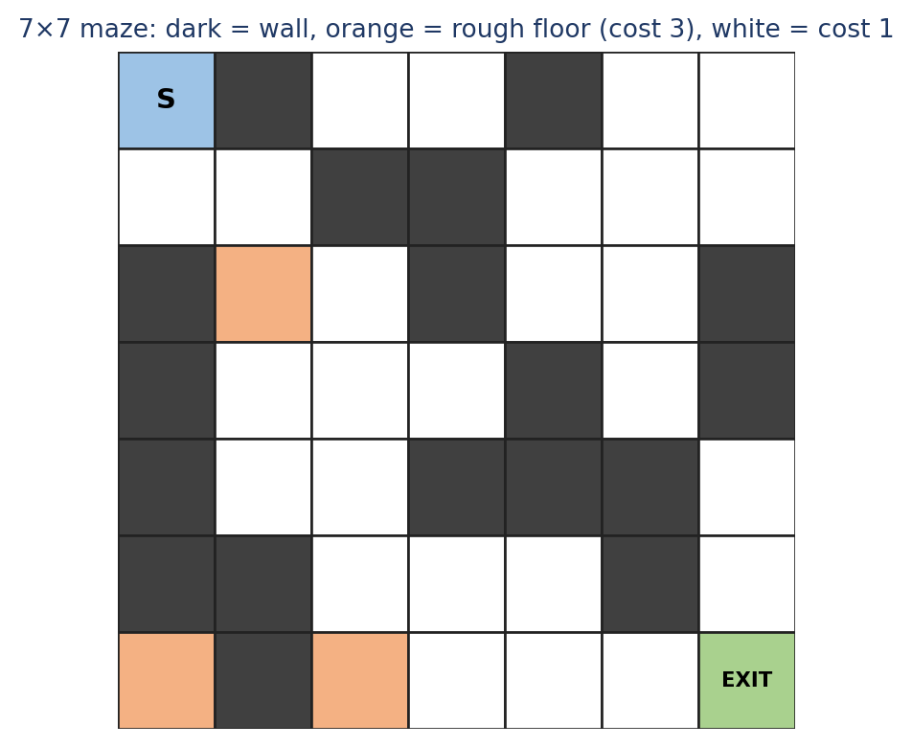
Figure 6: Sample 7×7 maze used for the demonstrations
2.2 Uniform Cost Search (UCS)
UCS always expands the frontier node with the lowest path cost g(n), using a priority queue. Starting from S, it first reaches all cells of cost 1, then cost 2 and so on, so its expansions form "contours" of increasing cost around the start (Figure 7). The first time the exit is removed from the queue, the path is guaranteed to be the cheapest, because every cheaper partial path has already been explored. When all step costs are equal UCS behaves like breadth-first search; its value appears when costs differ, such as the rough floor in the sample maze.
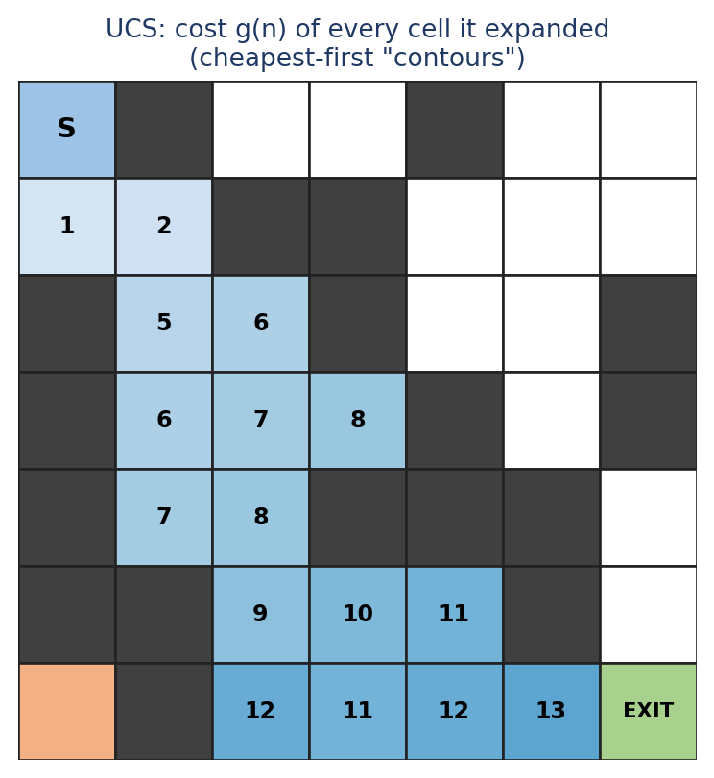
Figure 7: UCS expands cells in order of cost g(n); the exit is reached with total cost 14
Pseudocode:
function UCS(start, goal)
frontier <- priority queue ordered by g(n), containing start with g = 0
explored <- empty set
loop do
if frontier is empty then return failure
node <- POP(frontier) // lowest g(n) first
if node = goal then return SOLUTION(node) // goal test on expansion
add node to explored
for each action a in ACTIONS(node) do
child <- RESULT(node, a); g(child) <- g(node) + STEP-COST(node, a)
if child not in explored and not in frontier then INSERT(frontier, child)
else if child in frontier with higher g then REPLACE it with child

Properties. UCS is complete provided every step cost is at least some ε > 0, and it is optimal. If C* is the cost of the best solution, its time and space complexity are both O(b^(1 + ⌊C*/ε⌋)), where b is the branching factor. In the sample maze it expanded only 18 cells before reaching the exit with a total cost of 14.
2.3 Iterative Deepening Search (IDS)
IDS runs depth-limited depth-first search repeatedly with limits 0, 1, 2, 3, … until the goal is found (Figure 8). Each iteration is a cheap depth-first search that needs memory only for the current path, yet the overall result is the same as a breadth-first search: the shallowest solution is found first. It therefore combines the small memory use of DFS with the completeness of BFS.
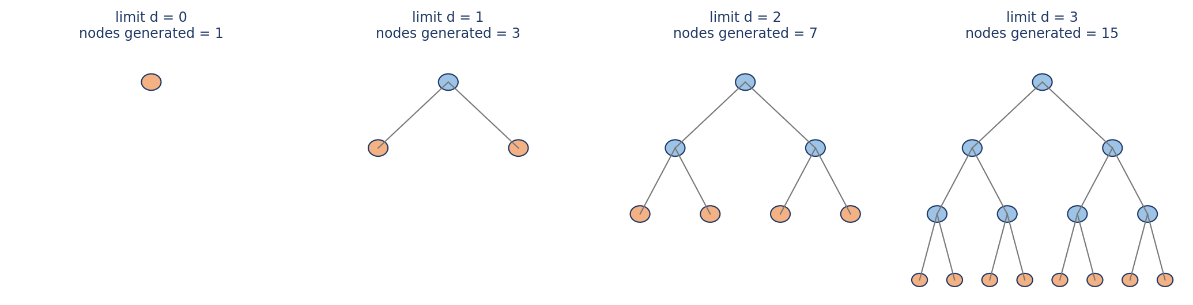
Figure 8: IDS repeats depth-limited search with growing limits; orange nodes are on the current depth limit
Pseudocode:
function IDS(start, goal)
for depth <- 0 to infinity do
result <- DEPTH-LIMITED-SEARCH(start, goal, depth)
if result is not cutoff then return result

function DEPTH-LIMITED-SEARCH(node, goal, limit)
if node = goal then return SOLUTION(node)
if limit = 0 then return cutoff
for each action a in ACTIONS(node) do
result <- DEPTH-LIMITED-SEARCH(RESULT(node, a), goal, limit - 1)
if result is a solution then return result
return failure

The repeated work looks wasteful, but most nodes of a tree lie at the deepest level, so regenerating the shallow levels is a small overhead. For a tree with branching factor b and solution depth d, IDS generates (d)b + (d−1)b² + … + (1)b^d nodes, which is O(b^d), only a constant factor (about b/(b−1)) more than BFS. In the sample maze IDS found the exit at depth 12 after generating 305 nodes over 13 iterations (Figure 9).
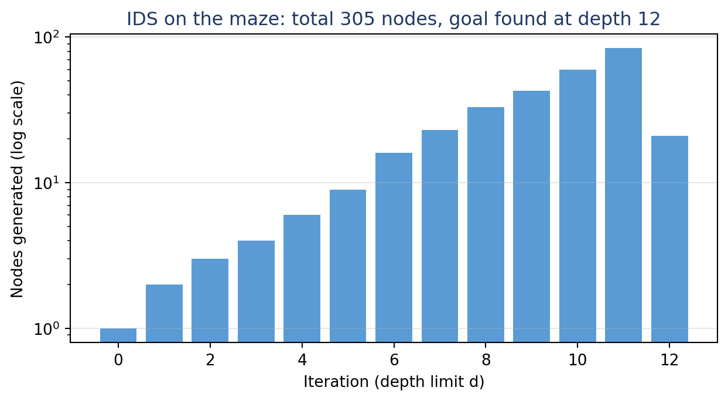
Figure 9: Number of nodes generated in each IDS iteration on the sample maze
2.4 Comparison of UCS and IDS: advantages, disadvantages and complexity
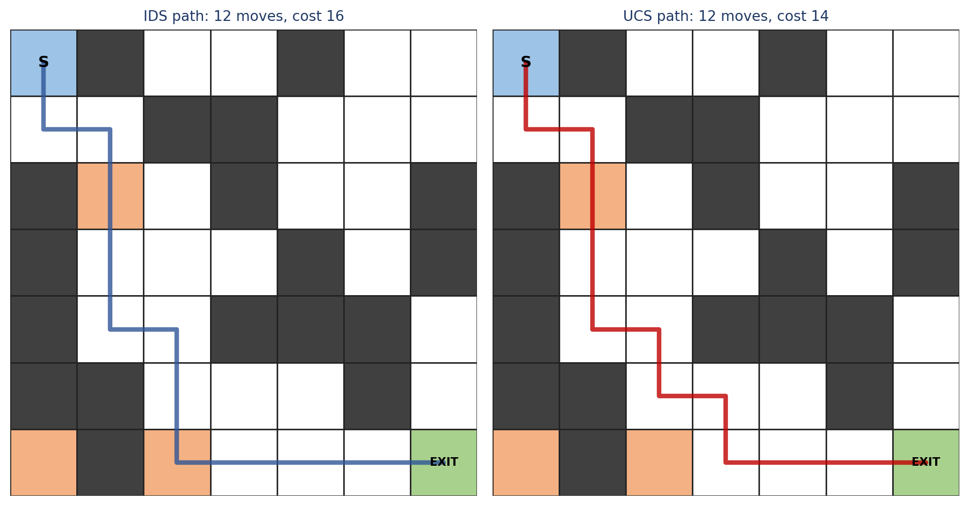
Figure 10: IDS finds a path with the fewest moves (cost 16); UCS finds the cheapest path (cost 14)
Both paths in Figure 10 contain 12 moves, but the IDS path crosses two rough cells (cost 16) whereas the UCS path crosses only one (cost 14). IDS minimises the number of steps, not the cost; it is optimal only when all step costs are equal. This shows why UCS is the right choice whenever moves have different costs.
Criterion | Uniform Cost Search (UCS) | Iterative Deepening Search (IDS)
Completeness | Yes, if every step cost ≥ ε > 0 | Yes (finite branching factor)
Optimality | Yes, cheapest path for any positive costs | Only for equal step costs (shallowest solution)
Time complexity | O(b^(1+⌊C*/ε⌋)), can be much larger than b^d when ε is tiny | O(b^d); about b/(b−1) times more nodes than BFS
Space complexity | O(b^(1+⌊C*/ε⌋)), the whole frontier is stored | O(b·d), only the current path is stored
Advantages | Finds the cheapest route; handles rough or costly cells; no depth guess needed | Tiny memory use; optimal in steps; no need to know the solution depth; no frontier to manage
Disadvantages | Exponential memory can exhaust a robot's small RAM; explores in all directions equally | Re-expands shallow nodes; ignores step costs; slower to find the answer than UCS when costs differ

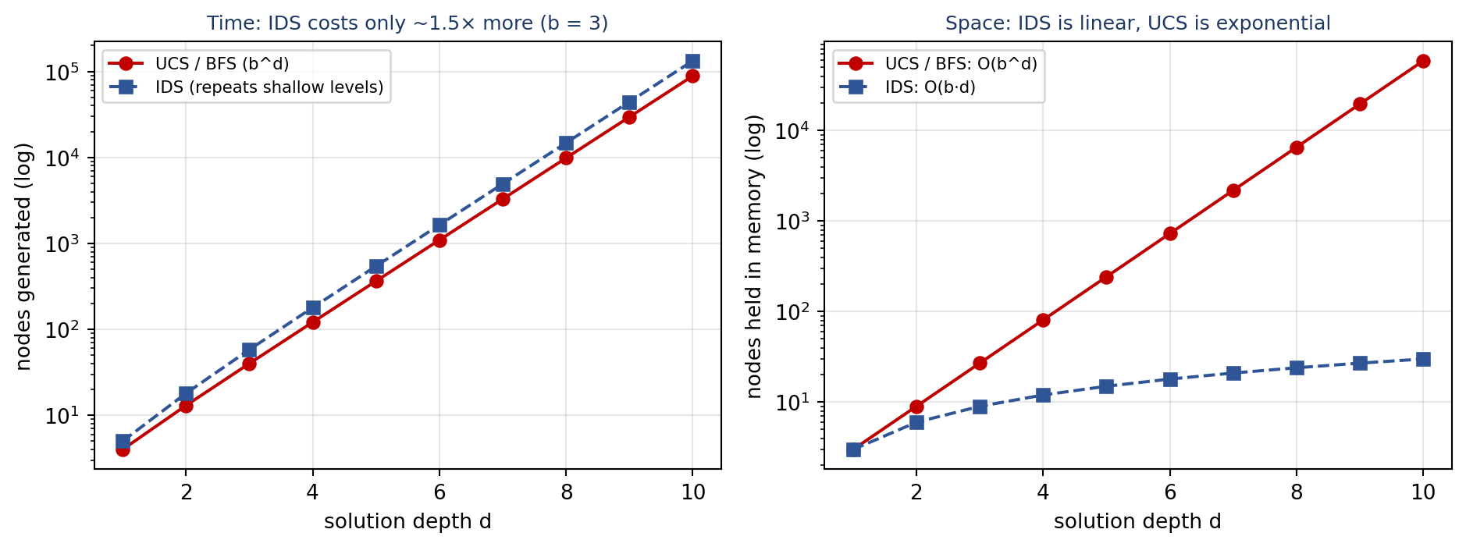
Figure 11: Time and space growth of UCS/BFS versus IDS for b = 3
Figure 11 confirms the trade-off. For b = 3 the extra time of IDS stays near 1.5 times that of UCS/BFS at every depth, while its memory grows only linearly with depth instead of exponentially. A small embedded robot would therefore run out of memory with UCS in a large maze long before it ran out of time with IDS. Neither algorithm uses any knowledge about the direction of the exit, so both examine many cells that lead away from it.
A practical caution applies to a physical robot. In simulation, re-expanding nodes costs only computing time. If the robot must physically walk each trial, IDS would make it repeatedly retrace its steps, so IDS and UCS are best used on the robot's internal map to decide where to go next, with the real moves executed only along the chosen plan.
2.5 Relating the maze to the types of intelligent agents
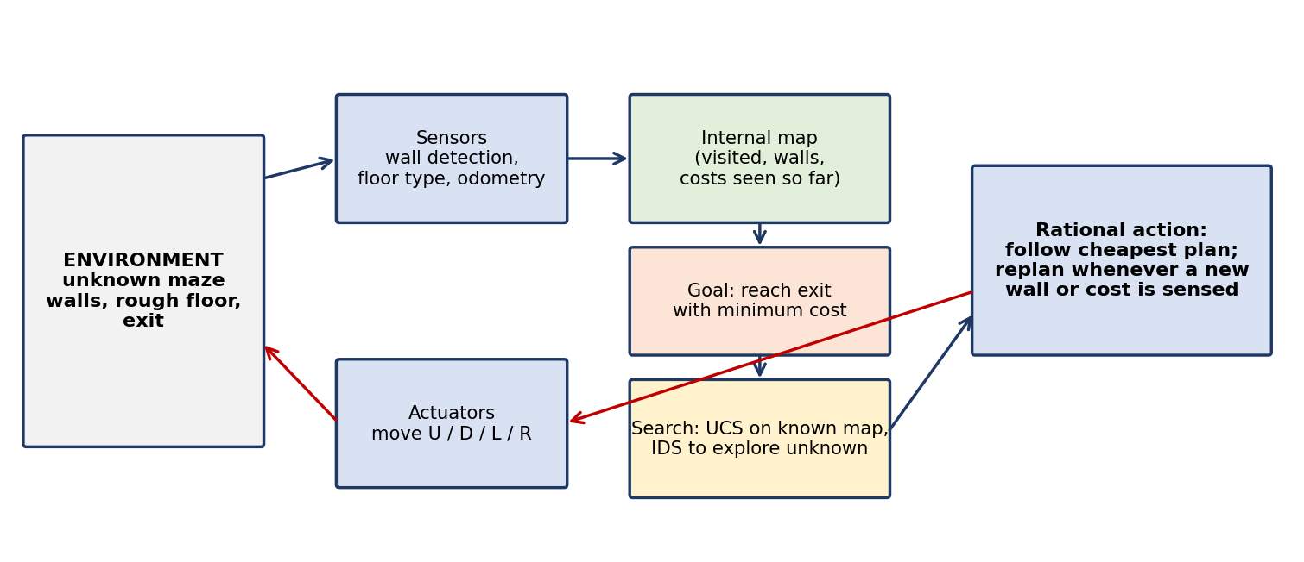
Figure 12: A model-based, goal- and utility-driven maze-solving agent
Agent type | How it behaves in the maze | Effect on decision-making
Simple reflex | Rules such as "if wall ahead, turn right" (wall-following). | Memoryless; can loop forever in mazes with islands and cannot compare paths. Decisions are fast but unreliable.
Model-based | Remembers visited cells and discovered walls in a map. | Avoids revisiting dead ends and can backtrack deliberately; decisions use history, not just the current view.
Goal-based | Searches the map for a route to the exit (e.g. BFS, IDS). | Plans a full sequence of moves; replans when a new wall appears. Treats every route to the goal as equally good.
Utility-based | Scores routes by cost, risk or energy and chooses the best (UCS). | Prefers a longer route that avoids rough floor if that lowers total cost; decisions reflect trade-offs.
Learning | Improves its map or its cost estimates over repeated runs. | Later attempts in the same maze become faster and cheaper.

Agent design therefore controls how the robot decides. A reflex agent reacts, a model-based agent remembers, a goal-based agent plans and a utility-based agent optimises. The richer the design, the better the robot can use a search algorithm, but each step up costs more memory and computation.
2.6 Recommended combination and justification
The most effective choice is a model-based, utility-based (goal-driven) agent that uses UCS for planning on its known map and IDS-style exploration when the map has to be discovered. The justification follows from the analysis above.
Model-based: the maze is partially observable, so the robot needs an internal map of walls, visited cells and costs to avoid cycles and to replan when new walls are sensed.
Utility/goal-driven: the goal is to reach the exit, but the cost of each cell differs, so choosing the best route needs a cost measure and not just a pass/fail goal.
UCS for planning: it is complete and optimal for any positive costs, so once part of the maze is known it finds the cheapest route through it.
IDS for exploration: when the map is mostly unknown and memory is limited, IDS searches the frontier of the unexplored area with linear memory and finds the nearest exit candidate first.
Safety net: if memory is very small, IDS alone is the fallback because its O(b·d) space is guaranteed to fit; if costs are all equal, IDS and UCS give the same answer and IDS is cheaper in memory.
Conclusion: UCS gives optimality and IDS gives memory efficiency; neither alone is ideal. Placing both inside a model-based, utility-aware agent gives a robot that remembers what it has seen, plans the cheapest known route, explores efficiently, and replans whenever the maze surprises it.

