SIMATS ENGINEERING
ASSESSMENT TOOL 1

COURSE NAME: Artificial Intelligence COURSE CODE: CSA1708

COURSE OUTCOME COVERED

CO1: Apply AI basics such as intelligent agents and uninformed search methods to solve problems effectively. (BL3)

Assessment Tool Weightage: 35%

QUESTIONS: 5 Duration: 1 Hour
Total Marks:50

Annexure A

Analytical Problem Solving

Code of Conduct:

I’m Subalakshmi. S (192521246) (Name / Reg No) certify that this submission is my original work and that I have adhered to the guidelines specified for this assessment.
I understand that any violation of academic integrity rules will result in disciplinary action.

Signature of the student: Subalakshmi S

Annexure A

Analytical Problem Solving

- Solve the Water Jug problem: you are given 2 jugs, a 4-gallon one and 3-gallon one. Neither has any measuring maker on it. There is a pump that can be used to fill the jugs with water. How can you get exactly 2 gallons of water into 4-gallon jug? Explicit assumptions: A jug can be filled from the pump, water can be poured out of a jug onto the ground, water can be poured from one jug to another and that there are no other measuring devices available.

- Find out how Mars Rover, analyse and explore the samples on Mars by answering the following questions.
- What are the percept’s for this agent?
- Characterize the operating environment.
- What are the actions the agent can take?
- How can one evaluate the performance of the agent?
- What sort of agent architecture do you think is most suitable for this agent? Why?

- Explore the search space using search strategies and formulate the problem components for the 8-Queens problem using the following information: Place 8 queens on a chessboard such that none of the queen’s attack any of the others. A configuration of 8 queens on the board as shown in the figure below, but this does not represent a solution as the queen in the first column is on the same diagonal as the queen in the last column.

- A customer wants to travel from the one location to another location using OLA Cab booking mobile application. The customer can select the any of the cab type as mini, micro, sedan, shared, prime and so on based on his comfort to reach the destination. Identify what type of problem-solving agent can be used and write the pseudocode for the above problem.

- A logistics company operates a delivery network where packages must be transported between warehouses at minimum cost. Each route between warehouses has an associated travel cost (fuel + time). The company wants to determine the least-cost path from the starting warehouse S to the destination warehouse G using the Uniform Cost Search (UCS) algorithm.

The delivery network is represented as a weighted graph:
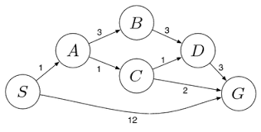
RUBRICS FOR CALCULATION:

Criteria | Weightage | Level 4 (Exemplary) | Level 3 (Proficient) | Level 2 (Developing) | Level 1 (Beginning)
Problem Understanding | 20% | Clearly interprets problem, identifies all parameters and requirements accurately | Understands problem with minor gaps | Partial understanding; misses key elements | Misinterprets or unable to understand problem
Method Selection | 20% | Selects most appropriate method/formula with strong justification | Selects correct method with minor errors | Inappropriate or partially correct method | Unable to select method
Solution Process | 25% | Logical, systematic steps with correct approach throughout | Mostly correct steps with minor mistakes | Disorganized steps; multiple errors | No clear process
Accuracy of Calculation | 20% | All calculations accurate; correct final answer | Minor calculation errors | Frequent errors; incorrect final answer | No valid calculations
Interpretation of Results | 15% | Clearly interprets results with units and engineering relevance | Basic interpretation with minor omissions | Limited or unclear interpretation | No interpretation
Problem Understanding | 20% | Clearly interprets problem, identifies all parameters and requirements accurately | Understands problem with minor gaps | Partial understanding; misses key elements | Misinterprets or unable to understand problem

Answers

1. Water Jug Problem:

State representation: (x, y) where x = gallons in the 4-gallon jug (0–4) and y = gallons in the 3-gallon jug (0–3). Initial state (0, 0); goal state (2, y) for any y.
Production rules used: (a) Fill the 4-gallon jug: (x, y) → (4, y); (b) Fill the 3-gallon jug: (x, y) → (x, 3); (c) Empty a jug onto the ground; (d) Pour from one jug into the other until the receiving jug is full or the source jug is empty.

Step | Action | State (x, y) | Rule applied
0 | Initial state | (0, 0) | —
1 | Fill the 4-gallon jug from the pump | (4, 0) | Fill 4
2 | Pour 4-gallon jug into 3-gallon jug until it is full | (1, 3) | Pour 4→3
3 | Empty the 3-gallon jug onto the ground | (1, 0) | Empty 3
4 | Pour the 1 gallon from the 4-gallon jug into the 3-gallon jug | (0, 1) | Pour 4→3
5 | Fill the 4-gallon jug again | (4, 1) | Fill 4
6 | Pour 4-gallon jug into 3-gallon jug until it is full (2 gallons needed) | (2, 3) | Pour 4→3

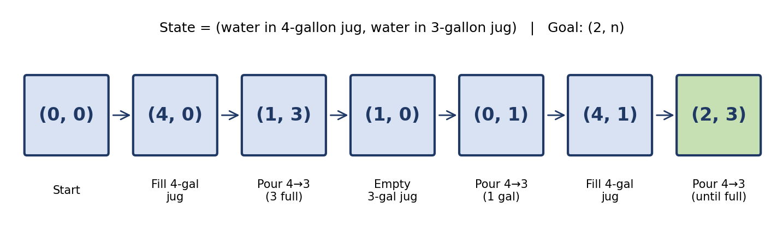
Figure 1: State-space path for the Water Jug problem

Result: The 4-gallon jug holds exactly 2 gallons after 6 moves, reaching the goal state (2, 3).
2. Mars Rover – PEAS Description:

Component | Description
i. Percepts | Camera images (terrain, rocks, sky), spectrometer / chemical readings of soil and rock samples, temperature and radiation sensors, wheel odometry, inertial (tilt, orientation) sensors, battery and power level, wheel-slip and obstacle signals, and commands from Earth.
ii. Environment | Partially observable, stochastic, dynamic (dust storms, temperature swings), continuous, sequential, single agent, with unknown terrain and a long communication delay with Earth.
iii. Actions | Drive forward/backward, turn, and climb; avoid obstacles; deploy the robotic arm; drill or scoop samples; run the on-board analysis instruments; take photographs; recharge via solar panels; and transmit data to Earth.
iv. Performance measure | Number and scientific value of samples analysed, area explored, accuracy of results, energy efficiency, rover safety (no damage or being stuck), mission lifetime, and data successfully transmitted.
v. Architecture | A goal-based agent with utility-based, learning components (hierarchical/hybrid). Simple reflex rules handle safety-critical events (tilt, obstacle); goal-based planning chooses routes and sample targets; utility trades off science value against energy and risk. A purely reflex agent cannot plan, and constant control from Earth is impossible because of the signal delay.

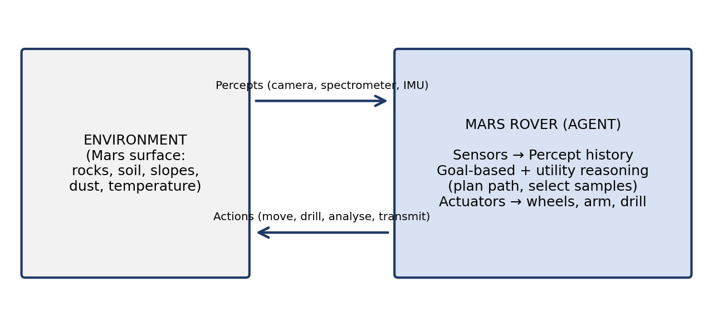
Figure 2: Mars Rover as an agent interacting with its environment

3. 8-Queens Problem Formulation:

Initial state: An empty 8×8 chessboard (no queens placed).
States: Any arrangement of 0 to 8 queens on the board (incremental formulation: one queen per column, placed so that no queens attack each other, which reduces the space from about 1.8×10^14 to just 2,057 states).
Actions: Add a queen to any square in the leftmost empty column such that it is not attacked by any queen already placed.
Transition model: Returns the board with the new queen added to the chosen square.
Goal test: 8 queens are on the board and none attacks another (no two share a row, column, or diagonal).
Path cost: Not relevant – only the final configuration matters.
Search strategies: The search space is explored with uninformed search. Depth-first search (backtracking) is most suitable: it places one queen per column and backtracks when a column has no safe square, giving a solution after examining only a small part of the space. Breadth-first search also finds a solution but stores a very large frontier in memory. Heuristic methods (e.g., hill climbing using the number of attacking pairs) are possible for the complete-state formulation.
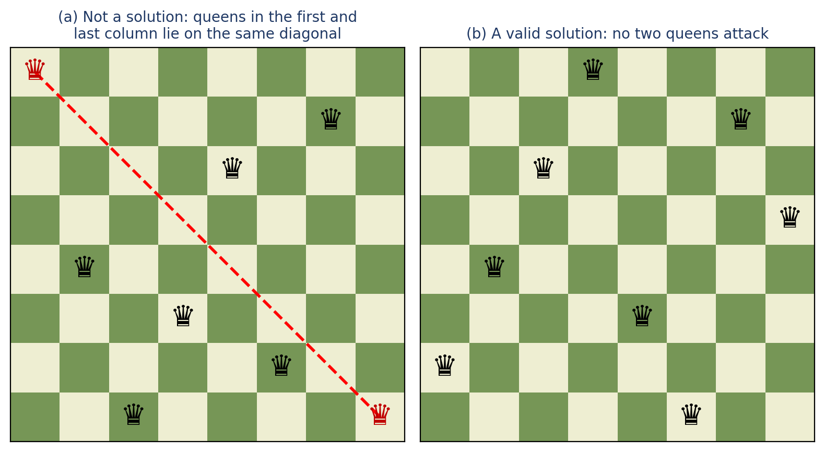
Figure 3: (a) the failed configuration described in the question, (b) a valid 8-queens solution

4. OLA Cab Booking – Problem-Solving Agent:

Agent type: A goal-based problem-solving agent with a utility-based selection step. The goal is to reach the destination; because several cab types (mini, micro, sedan, shared, prime) can all reach it, a utility function (fare, arrival time, comfort, availability) chooses the best option.

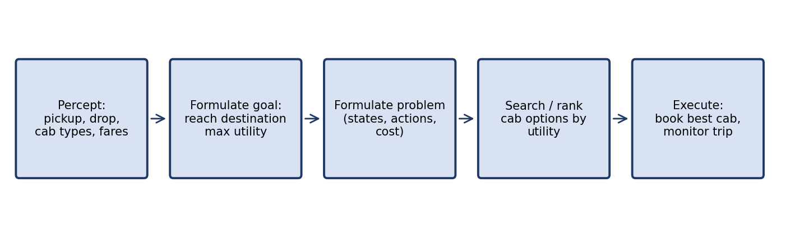

Figure 4: Working cycle of the OLA problem-solving agent

Pseudocode:
function OLA-AGENT(percept) returns an action
persistent: seq (action sequence, initially empty), state, goal, problem
state <- UPDATE-STATE(state, percept) // pickup, drop, time, traffic, cab list
if seq is empty then
goal <- FORMULATE-GOAL(state) // reach destination
problem <- FORMULATE-PROBLEM(state, goal)
for each cab_type in {mini, micro, sedan, shared, prime} do
if AVAILABLE(cab_type) then
fare, eta, comfort <- ESTIMATE(cab_type, problem)
U[cab_type] <- UTILITY(fare, eta, comfort, user_preference)
best <- argmax over cab_type of U[cab_type]
seq <- SEARCH(problem, best) // route, book, track, drop-off
if seq = failure then return NO-CAB-AVAILABLE
action <- FIRST(seq)
seq <- REST(seq)
return action

5. Uniform Cost Search (S to G):

UCS always expands the frontier node with the lowest path cost g(n), using a priority queue. Edge costs from the graph: S–A = 1, S–G = 12, A–B = 3, A–C = 1, B–D = 3, C–D = 1, C–G = 2, D–G = 3.

Step | Node expanded (g) | Frontier after expansion (node, g) | Remark
1 | S (0) | A:1, G:12 | Start node
2 | A (1) | C:2, B:4, G:12 | Via A
3 | C (2) | D:3, B:4, G:4 (via C), G:12 | G improved from 12 to 4
4 | D (3) | B:4, G:4, G:6 (via D) | G:6 is worse than G:4; ignored
5 | B (4) | G:4, D:7 (via B) | D:7 is worse than D:3; ignored
6 | G (4) | — | Goal reached and returned

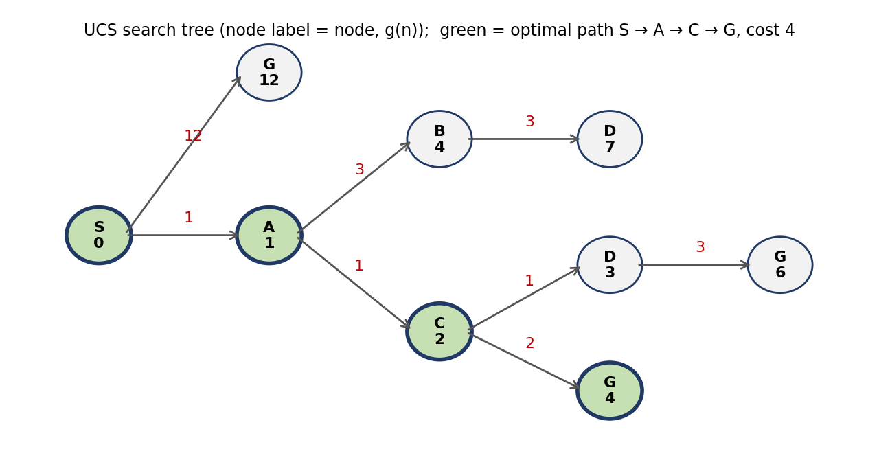

Figure 5: UCS search tree with cumulative path costs

Result: Least-cost path = S → A → C → G with total cost 1 + 1 + 2 = 4. Alternative paths cost more: S → A → C → D → G = 6, S → A → B → D → G = 10, and the direct S → G = 12. UCS is complete and optimal because all edge costs are positive.

