ANT

Options

-Dsfusername=$(username) -Dsfpassword=$(passwordAndToken) -Dsfdeployroot=$(deployRoot) -Dsfundeployroot=$(undeployRoot) -Dsfrollbackonerror=$(rollbackOnError) -Dsfserverurl=$(salesforceLoginUrl) -Dsftestlevel=$(testLevel) -Dsfcheckonly=$(checkOnly)

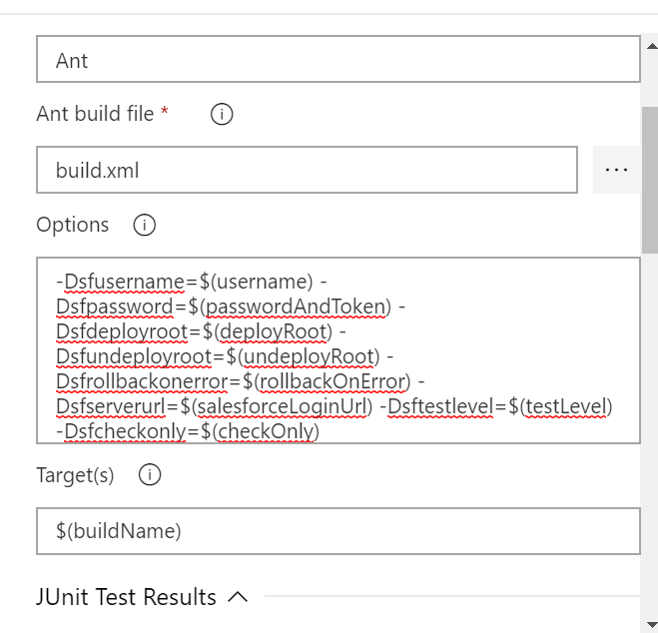

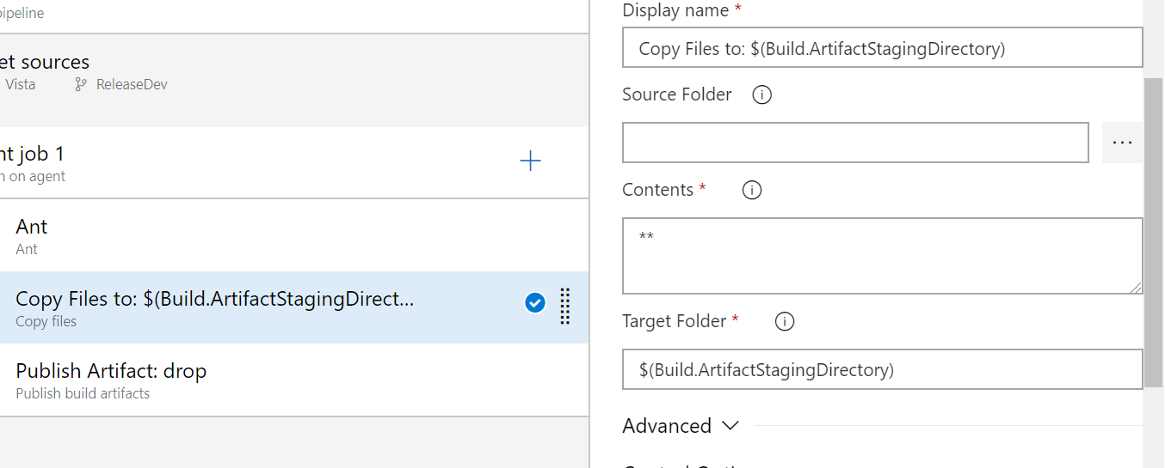

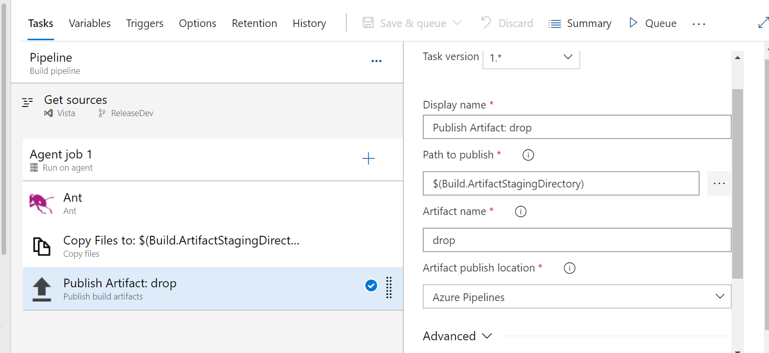

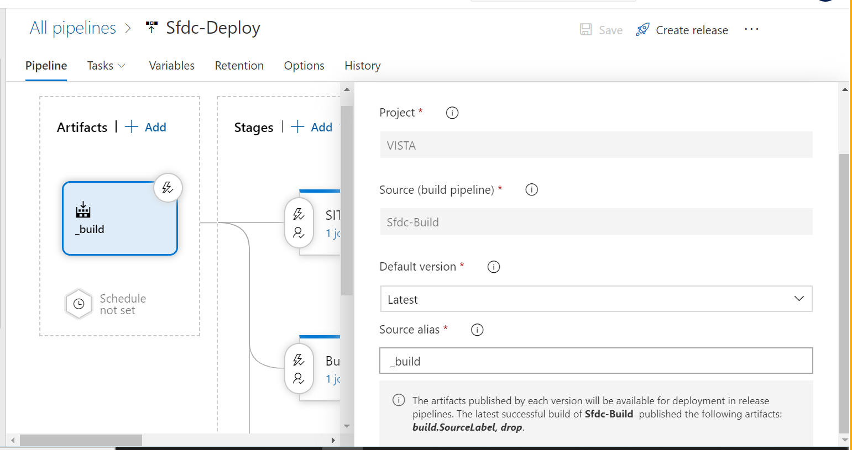

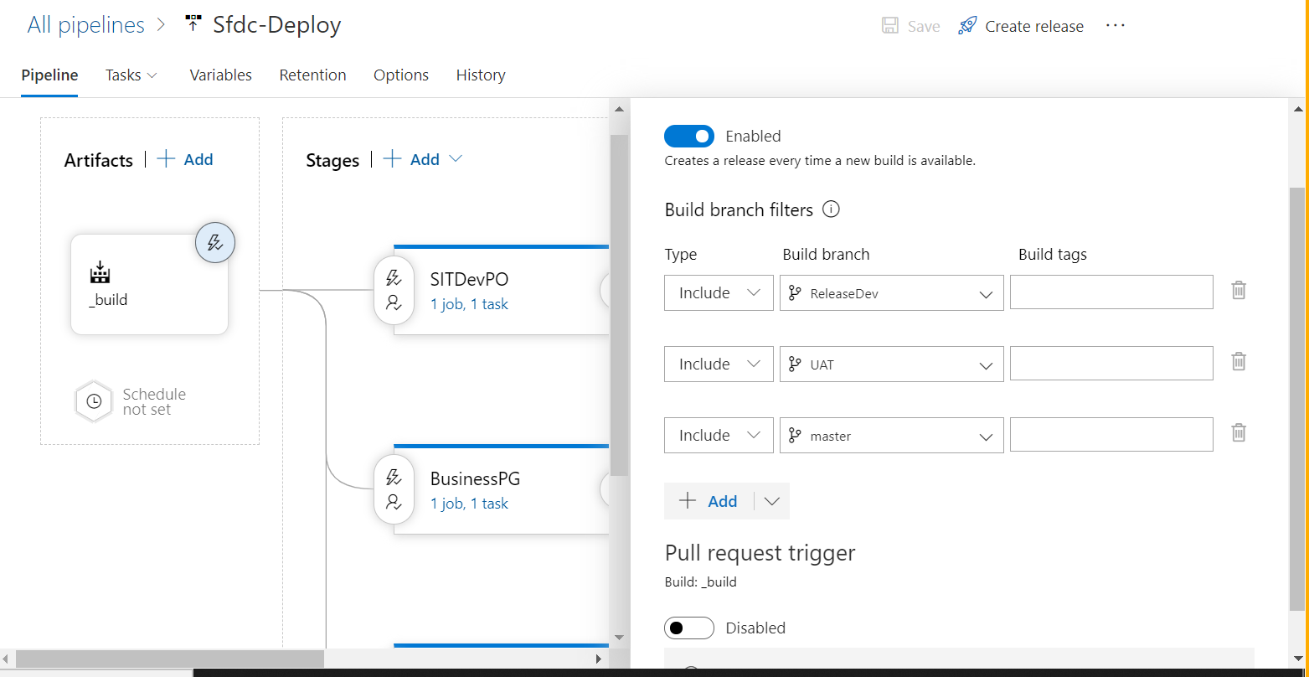

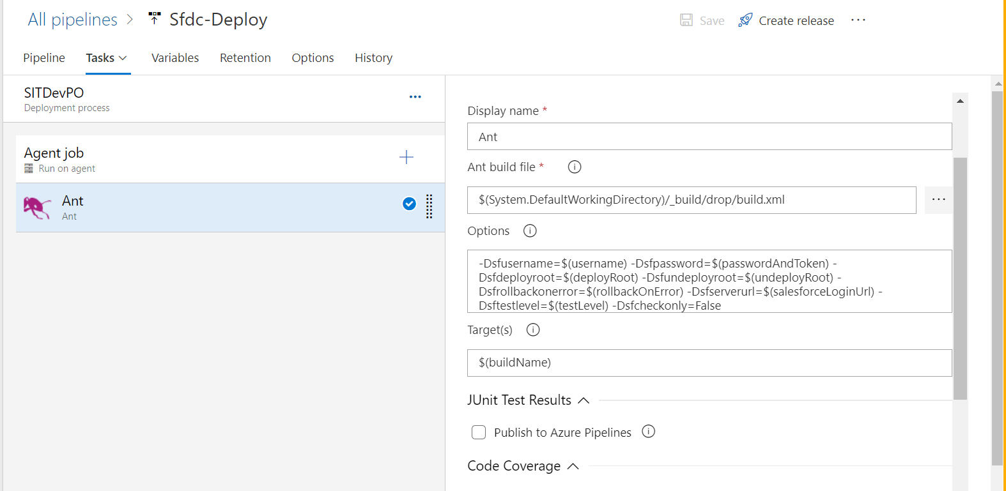

-Dsfusername=$(username) -Dsfpassword=$(passwordAndToken) -Dsfdeployroot=$(deployRoot) -Dsfundeployroot=$(undeployRoot) -Dsfrollbackonerror=$(rollbackOnError) -Dsfserverurl=$(salesforceLoginUrl) -Dsftestlevel=$(testLevel) -Dsfcheckonly=False

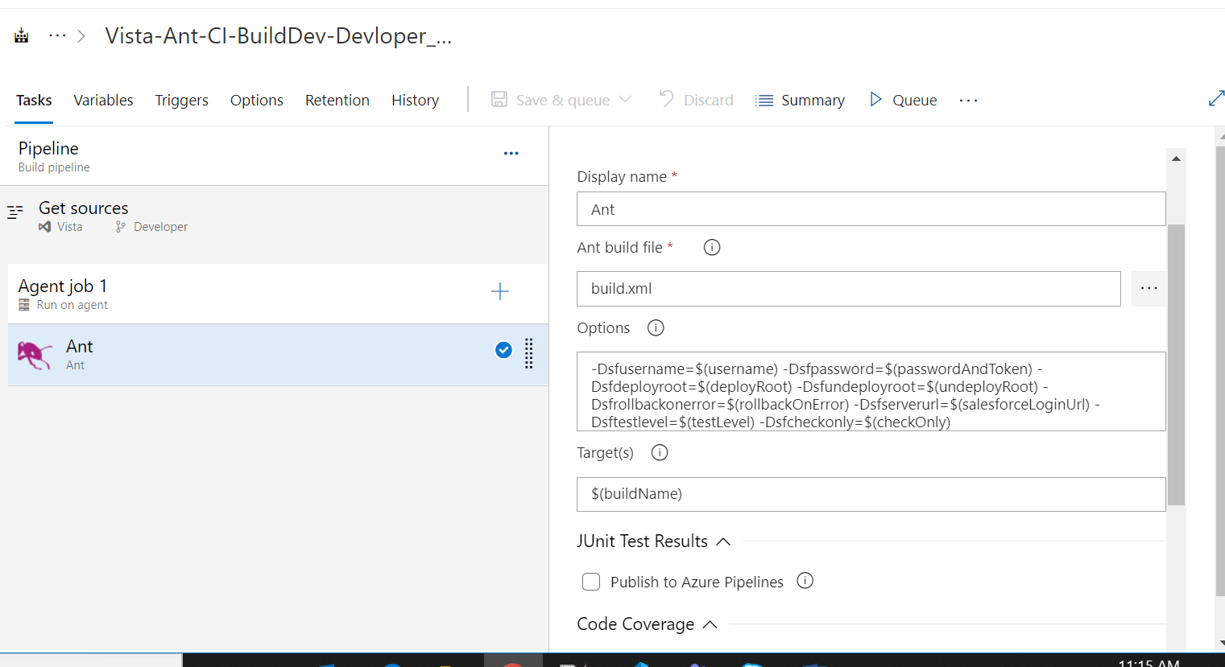

-Dsfusername=$(username) -Dsfpassword=$(passwordAndToken) -Dsfdeployroot=$(deployRoot) -Dsfundeployroot=$(undeployRoot) -Dsfrollbackonerror=$(rollbackOnError) -Dsfserverurl=$(salesforceLoginUrl) -Dsftestlevel=$(testLevel) -Dsfcheckonly=$(checkOnly)