|  |  |
| --- | --- |
| cid:image001.png@01D3AFAE.B0078710 | |
| **ASI End User Preference Centre R2** | |
| **Knowledge Handover Document** | |
|  | |
|  | |
|  |
|  |
|  |

# Contents

Table of Contents

1 Contents 2

2 Version Control 4

2.1 Version Control 4

3 Introduction / Background 5

3.1 About This Document 5

3.2 Background 5

3.3 Scope 5

4 EUPC R2 Implementation 6

4.1 How is EUPC placed between ASI site core site and web services 6

4.2 How is translation handled (labels, investor types and data) 7

4.3 How to control explicit consent checkbox display 8

4.4 How to control Client type option display 9

4.5 Where is EUPC Custom styling? 10

4.6 Where is GTM Tracking code? 10

4.7 How redirection works for deep links in email - verification, unsubscribe, my preference? 10

4.8 How Smart Search is configured for Fund Names? 11

4.9 Sending Profile Update request email to BDM? 11

4.11 Resend Verification Email 11

5 EUPC Architecture 13

High Level Architecture 13

Low Level Diagram depicting the Lightning UI components structure 13

6 EUPC – All components 14

# Version Control

## Version Control

|  |  |  |  |  |
| --- | --- | --- | --- | --- |
| **Version** | **Comment** | **Date** | **Author** | **Reviewed By** |
| 2.0 | Created | 1st March 2019 | Alok Kumar | Subal Chaudhari |
|  |  |  |  |  |
|  |  |  |  |  |
|  |  |  |  |  |
|  |  |  |  |  |
|  |  |  |  |  |
|  |  |  |  |  |
|  |  |  |  |  |
|  |  |  |  |  |
|  |  |  |  |  |
|  |  |  |  |  |
|  |  |  |  |  |
|  |  |  |  |  |
|  |  |  |  |  |
|  |  |  |  |  |
|  |  |  |  |  |
|  |  |  |  |  |
|  |  |  |  |  |
|  |  |  |  |  |

# Introduction / Background

## About This Document

This document provides an overview of the End User Preference Center R2 functionality and the configurations involved to support the EUPC features. It also provides details on how it’s integrated as an Iframe within ASI Site core page and consume ASI service layer to process the user preference data.

## Background

The current End User Preference center is a standalone Visualforce page, which has its own apex classes written to directly update user preferences in Salesforce and Eloqua as per the old business logic.

However, with the development of ASI websites for multiple markets in Site core and implementation of new business logic in Salesforce, it was required to redevelop EUPC so that it is configurable, can be embedded in ASI website of any market, and supports multiple languages. Rather than directly communicating with backend data, it consumes the services exposed via Salesforce apex classes to manage subscriptions in the backend so that the business process of managing user subscription is consistent across the application.

## Scope

The scope of this document is to detail the implementation of the EUPC R2 and the various system configurations required to enable EUPC support for a given market (i.e. Market = Country + locale + Investor type combination)

# EUPC R2 Implementation

## How is EUPC placed between ASI site core site and web services

EUPC is embedded as an iframe within ASI Site core sites and expects certain parameters, which defines user’s market/context, to be passed from ASI site.

Parameters expected by EUPC Iframe:

1. **Loc** ( locale e.g. pt-Br) : used for localization support in terms of showing translated static texts on EUPC screens
2. **Country** ( countrycode e.g. GB ) : used for setting the user’s country field value
3. **Itype** (investor type eg. Institutional ) : : used for setting the user’s investor type field value
4. **Email** (email id of the user. Required in User Journey 2 ) : used to automatically login user into EUPC
5. **ep** ( eupc page e.g. “unsub” for unsubscribe and “mypref” for My Preference. Required in User Journey 2 ) : used to redirect user to unsubscribe / my preference screen

Note: If loc is not passed or is set to **en**, EUPC will default to **en-GB** experience, as per business requirement.

EUPC is implemented as a single page application using lightning out. **ASI_EUPC_Home** visualforce page hosts - **ASI_EUPC_App** lightning application, which has **ASI_EUPC_MainContainer** as the main lightning component. EUPC is exposed publicly via **EUPC** Salesforcesite which points to **ASI_EUPC_Home**

**ASI_EUPC_MainContainer:** this is the main lightning component, which includes all the other UI components of EUPC (please refer the low-level design document for details)

EUPC interacts with preferences related data e.g. marketing option, Subscriptions, Fund Types, Asset Class etc. (in Salesforce and Eloqua) by consuming the service methods exposed in **EupcService** class, which is defined in the ASI Service layer.

Server data interaction by any UI component is provided by **ASI_EUPC_DataService** lightning component which invokes **@auraEnabled** methods defined in the **ASI_EUPC_Controller.cls** apex class. Please refer the diagram below, which shows the interaction between different layers:

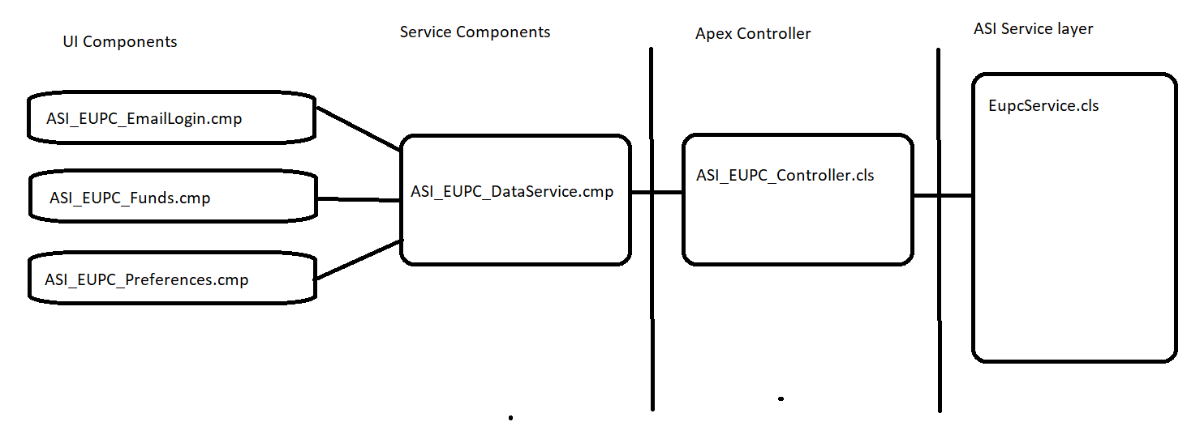

## How is translation handled (labels, investor types and data)

**Labels**: Custom labels have been created to implement translation for the static text/labels that are shown on the EUPC screen. To dynamically fetch the translated text for these EUPC related custom labels, one to one record entry has been made in the **ASI_EUPC_Labels** custom metadata. The logic to fetch the Custom label values is written in the **ASI_EUPC_HomePageController.cls.** This work around was implemented because in lightning out, the translated texts for a custom label are not rendered automatically.

**Investor Types**: Translation for Investor Type drop down shown on the User registration and Profile update screens is maintained in the Translation Workbench > Global Value set > Client Type , as shown below :

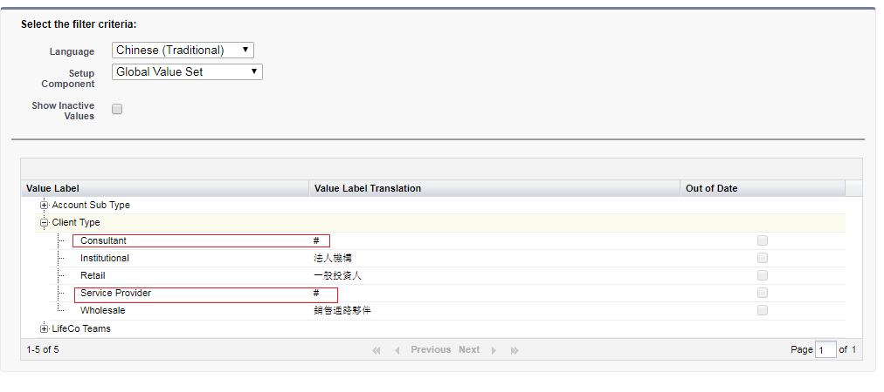

**Data:** Asset Class, Fund Types, Fund Names and Marketing options comprise the data that is shown on the EUPC. The Service layer, based on the locale information that EUPC provides, returns the translated text for data.

## How to control explicit consent checkbox display

To fulfill the requirement of showing “Explicit consent checkbox” conditionally for certain locales only, a solution has been developed which is configurable and can be maintained by Salesforce Admin. E.g. if the “Explicit consent checkbox” has to be shown for zh-TW:

Add a **New** **translation** for the related Custom label – **ASI_EUPC_Explicit_Consent** for zh-TW as shown below :

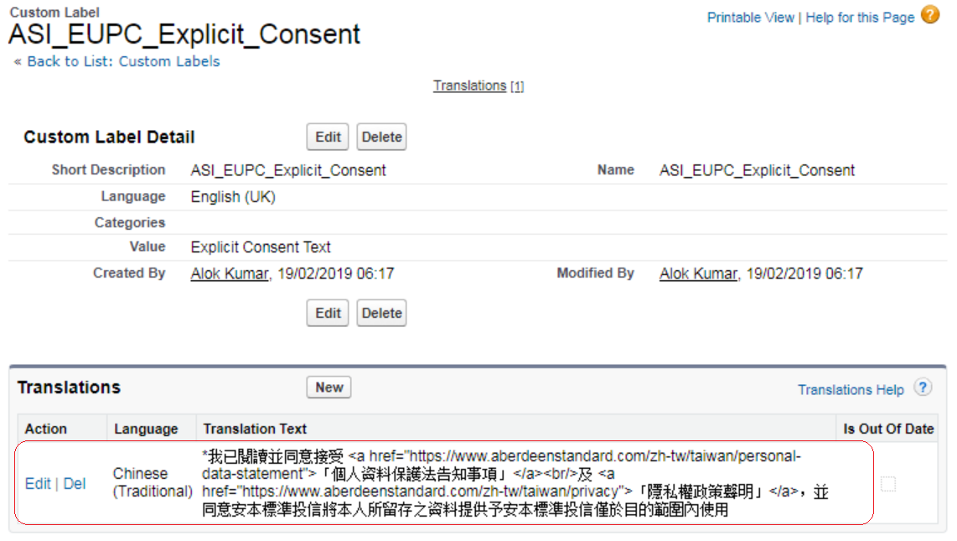

Update the Custom Metadata record – **ASI EUPC Configs > Countries_With_Explicit_Consent** and modify the configvalue to include the locale i.e. ZH-TW , in the comma separated list as shown below :

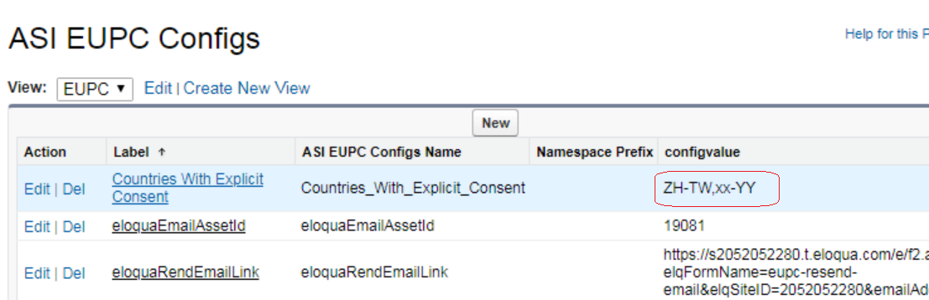

## How to control Client type option display

To fulfill the requirement of controlling the “Investor type drop down values” conditionally for a country and translation values, a solution has been developed which is configurable and can be maintained by Salesforce Admin.

e.g. If Investor type values “Consultant” and “Service Provider” needs to be hidden for locale zh-tw below steps can be executed by the System Administrator :

\***Note :** if the translation field is left blank ,then it will default to Master value ie. “Consultant” or “Service Provider” in the below case

1.Go to translation workbench -> Setup / Translate

2.Select the Language for which you want to hide the values. e.g. for locale zh-tw selected Chinese (Traditional).

3.Select setup component – Global Value set

4.Expand – Client type

5.Add ‘#’ values in ‘value label translation’ for the investor type values which needs to be hide. e.g. here we have added ‘#’ vale for “Consultant” and “Service Provider”.

Please see below screenshot for reference.



## Where is EUPC Custom styling?

EUPC Custom styling is in Static Resources > ASI_EUPC_Custom_Styling.resource

## Where is GTM Tracking code?

Static Resources > ASI_EUPC_GTM_Tracking_Code.resource

## How redirection works for deep links in email - verification, unsubscribe, my preference?

When user clicks on Verification/double opt link in the user verification email, he is redirected to the **eupcredirect** salesforce site with parameters loc, itype, country and email. **Eupcredirect** site points to **ASI_EUPC_Redirect.page** having **ASI_EUPC_RedirectController.cls** custom controller. The controller queries the **ASI_EUPC_Site_Map** custom metadata records and returns the ASI website url which meets the filter criteria set by the loc, itype, country parameters. User is then redirected to the matching website url and passes along the user email id as parameter. If no match found, the default url maintained in the Custom label **ASI_EUPC_Default_Site** is returned.

The same redirection flow as above , is followed when user clicks on **Unsubscribe** or **My Preference** link in the email. In addition to the parameters passed in verification process, **ep** ( i.e. eupc page ) parameter is also set e.g. “**unsub**” or “**mypref**”.

Email parameter value is used to auto login the user, while “unsub”/”mypref” is used to redirect user to the **My Preference** screen directly.

## How Smart Search is configured for Fund Names?

Smart search for Fund names is a feature where two different search words should return same search results e.g. retail and property. So whether a user searches for “equity” or “property”, the search will always result all funds having **equity** in the name. To implement this feature, EUPC provides ASI**_EUPC_Smart_Search_Map** custom metadata for storing such dictionary entries retail=>property.

## Sending Profile Update request email to BDM?

Whenever a user updates profile information, an email is sent to BDM to process the request offline. To send this email EUPC make a callout to Eloqua endpoint with all the user profile information. To facilitate this callout there are certain Eloqua specific configurations stored in the **ASI_EUPC_Configs** custom metadata like:

1. eloquaemailAssetId : Asset Id of the Email in Eloqua which will be sent to the BDM
2. eloquaToSendContactId : Id of the contact to whom email should be sent. In this case BDM

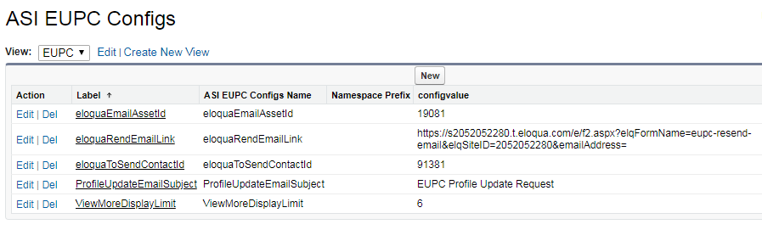

## Resend Verification Email

When user clicks on Resend Verification email button on the EUPC, Eloqua blind form is submitted. The submission process fetch this blind form url from **eloquaResendEmailLink** record value from **ASI_EUPC_Config** metadata (as shown below ) and appends user’s email address and locale.



# EUPC Architecture

High Level Architecture

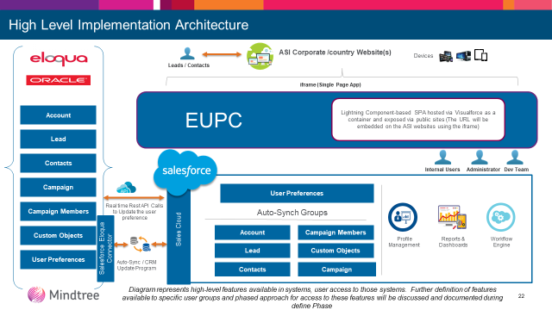

Low Level Diagram depicting the Lightning UI components structure



# EUPC – All components

