


Module Code & Module Title
CU6051NP Artificial Intelligence

25% Individual Coursework
Submission: Proposal
Academic Semester: Autumn Semester 2025
Credit: 15 credit semester long module

Student Name: Subanta Poudel
London Met ID: 20048736
College ID: NP04CP4S210115
Assignment Due Date: 07/01/2026
Assignment Submission Date: 07/01/2026
Submitted To: Niroj Bahadur Karki

GitHub Link | https://github.com/subantapoudel01/FPL-Predictor.git

I confirm that I understand my coursework needs to be submitted online via MST Classroom under the relevant module page before the deadline for my assignment to be accepted and marked. I am fully aware that late submissions will be treated as non-submission and a mark of zero will be awarded.

Contents
Table of Tables 3
1. Introduction 4
1.1. The Problem Domain 4
1.2. Project Aim 4
1.3. AI Agent Definition (PEAS Framework) 4
2. Background 6
2.1. Dataset Description 6
2.2. Theoretical Model: Multiple Linear Regression 6
2.3. The Learning Process (Sum of Squared Errors) 7
2.4. Literature Review (Alternative Models) 7
3. Solution 8
3.1. Data Pre-processing (Intersection Merge) 8
3.2. Feature Engineering (Form and Lag) 8
3.3. Validation Strategy (Temporal Split) 8
3.4. Implementation Logic (Pseudocode) 9
3.5. System Architecture 10
3.6. Achieved Results & Evidence 11
4. Conclusion 13
4.1. Summary 13
4.2. Limitations 14
4.3. Future Work 14
Bibliography 14

Table of Tables
Figure 1: Flowchart 10
Figure 2: Feature Correlation Heatmap 11
Figure 3: Scatter Plot of Form vs. Points 12
Figure 4: The Model Training Output (RMSE : 1.25) 12
Figure 5: The Top 10 Predicted Scorers list 13

Predicting FPL Points

Introduction

The Problem Domain

Fantasy Premier League (FPL) is a strategic fantasy sports, with over more than 11 million players. FPL is the biggest Fantasy football game in the world. Which is free to play and where players can win great prizes! But successful FPL manager requires a great knowledge of prediction. Where the managers predict which players might perform well in the upcoming matches. But, human decision-making is often flawed, mostly because of cognitive biases such as recency bias or club bias. Often novice manager overvalues a player’s last game and prefers players from supported teams. Where this report presents an AI system that addresses the limitations of human emotions and develop an Artificial Intelligence system that predicts players performance objectively using historical data rather than emotions and any kind of bias.

Project Aim

The main aim of the project is to create a Multiple Linear Regression model capable of calculating the specific Total Points of a player will score in the next Game week. This system will help FPL managers to identify high-value players based on statistics (Form) rather than insights.

AI Agent Definition (PEAS Framework)

“An AI system can also be called a Rational Agent. It is an entity that takes its environment in consideration through sensors and acts upon that environment through actuators that maximize a performance measurement.” (PRENTICE HALL SERIES, 2010)
The design of this FPL prediction project is to be a Goal-Based Agent. The main goal is to accurately predict the total points for each and specific players in the upcoming gameweek. Which will be defined by using the standard PEAS framework:

- Performance Measure(P)
For the regression agent, the success will be determined by how close the predicted points are to the actual points achieved by the players. Which will define the criteria for the success.
- Metric: Mean Squared Error (RMSE)
- Rationality: The coefficient (weights) that mathematically minimizes the error term. It does not guess randomly, rather optimizes on SSE (Sum of Square Errors) to achieve the highest possible accuracy given the historical data.

- Environment (E)
The environment is the domain in which the AI agent operates, based on specific properties the environments can be classified. (PRENTICE HALL SERIES, 2010) Similarly, this project’s environment which is the FPL Dataset is classified as:
- Fully Observable: The agent will have the complete access of the data (all columns like ICT Index, Minutes, and Goals). There are no hidden information during the training process.
- Stochastic: Unlike Chess football is not deterministic. A player might have a high ICT Index but still fail to score or assist, due a better performance of opponents like a goalkeeper making a heroic save or a defender’s goal line clearance or may be the opponent was more organized as a team rather than relying on a single player or the moment of magic in the game. In football luck is not that exists but rather created by the players from their perseverance. The agent must handle this kind of uncertainty.
- Static: the historical training data from season 2021 to 2025 will not change while the agent is in the training phase. The past stats are fixed during the analysis.
- Discrete: The games are played in discrete jumps rather than smoothly evolving.
- Single-Agent: To Predict the score, this model has to operate alone.

- Actuators (A)
The mechanisms by which the agent acts on the environment
- Primary Actuator: The Prediction Output Interface.
- Action: The output is generated when the system generates a continuous numerical value like the Predicted Point. Which helps the FPL manager’s decision making.

- Sensors (S)
This is how the agent perceives the environment.
- Principles: The agent takes in the world through Data Ingestion.
- Mechanism: Using the Pandas library, the agent reads the .csv file, then senses the features such as ICT Form, Fixture Difficulty Rating, and value, and convert them into vector inputs for the regression equation.

Background

Dataset Description

The data is sourced from the Vaastav Anand Fantasy Premier League Repository on GitHub, widely the considered gold standard FPL research.
- Volume: Dataset contains data for over 700 players, every game week per season.
- Scope: For the insurances of tactical relevance, the data has been filtered to only include the post-pandemic era, which includes approximately 75000 rows of training data.
- Key Features: The primary features which has been included in the analysis are Minutes Played, and the ICT Index, which was the metric developed by the Premier League to qualify each player’s impact on a match.

Theoretical Model: Multiple Linear Regression

Multiple Linear Regression has been chosen as the core algorithm. Designed to predict continuous variables (Points), unlike other classification modes that predict categorical outcomes a win/loss.
The linear relationship between the independent input variables (X) and the dependent target variable (y), is the mathematical model. The equation is:
y = β₀ + β₁x₁ + β₂x₂ + …. + β_{n}x_{n} + ε
Where:
  - y is the predicted Total Points.
  - x₁, x₂ are the input features of ICT Index, Form.
  - β represents the learned weights for each feature.
  - ε is the error term (residuals).

The Learning Process (Sum of Squared Errors)

By minimizing the error between its predictions and the actual results, is how the model learns the optimal weights. Which is achieved by minimizing the Sum of Squared Errors (SSE).
$$SSE = {\sum_{i=1}^{n}{(y_{i}-{\hat{y}}_{i})}}^{2}$$

Mathematical Explanation:
- $∑$ (Sigma): Summation, which means the algorithm must iterate through every data points in the training set, from player 1 (i = 1) to the last (n)
- $y_{i}$ : The Actual Points achieved by the players.
- ${\hat{y}}_{i}$ : The Predicted Points generated.
- Squared Term: The difference will not be squared to ensure tat negative errors do not cancel out positive errors, and to heavily penalize large outliners.

Literature Review (Alternative Models)

Other algorithms were also considered but rejected:
- Naïve Bayes: In football all features are highly correlated (a player with higher number of Goals/Assists will always have a high ‘Threat’ score), which violates the naïve bayes rules, which assumes that all features are independent. (Lecture w. 5.)
- Logistic Regression: Is a classification algorithm used for binary outcomes (will a player score? Yes/No). Since the aim is to predict a precise numerical score, Logistic Regression is not applicable. (Lecture)

Solution

Data Pre-processing (Intersection Merge)

The discrepancy between the initial historical datasets was one of the significant challenges during this project. The data schema was for 2016-2024 and differed from the modern 2024-25 schema the newer data set had Expected Goals (xG), while older ones did not.
Implementation of an Intersection Merge was done in Python using pandas’ library, by programmatically identifying the 35 common columns available across all seasons (Minutes, Goals, ICT Index) and discarded mismatched features. Which ensured a consistent feature set across the 5 years of historical data, allowing for a robust model training.

Feature Engineering (Form and Lag)

A new feature called “Player Form” was engineered, to capture trends where often the raw statistics usually fail.
- Techique: The Rolling Average of the ICT Index over the previous 3 games.
- The Shift (Leakage Prevention): a crucial step taken on a time-series prediction, preventing Data Leakage – the error of using future information to predict the past (Shachar Kaufman, Saharon Rosset, & Claudia Perlich, 2011). By shifting the rolling average down by one row, which ensures that the model used past data game weeks 1-3 to predict the future performance game week 4, simulating a real-world scenario. The calculated rolling average has been shifted to (t + 1), strictly on the performance data from Game weeks N-1, N-2, and N-3.

Validation Strategy (Temporal Split)

The standard random train test split will be inappropriate for time series data because it would allow the model to cheat by training on future games. Instead, strict a Temporal Split was created based on (Gareth James • Daniela Witten • Trevor Hastie, 2023):
- Training Set (X train): Seasons 2021/22, 2022/23, 2023/24, and 2024/25,
- Test Set (X test): The current 2025/26 Season.

Implementation Logic (Pseudocode)

BEGIN FPL_Prediction_System
Step 1: LOAD 'final_fpl_dataset.csv'
Step 2: PRE-PROCESS Data
SORT data by Player Name and Game week
FOR each Player:
CALCULATE Rolling_Average of 'ICT Index' (Window=3)
SHIFT values by 1 (To prevent Data Leakage)
END FOR
FILL missing values
Step 3: SPLIT Data
training_set = Seasons ['2021-22', '2022-23', '2023-24', '2024-25']
testing_set = Season ['2025-26']
Step 4: TRAIN Model
INITIALIZE LinearRegression Model
FIT Model using training_set (Features: Form, Minutes, Value)
Step 5: PREDICT
prediction = Model.predict(testing_set)
CALCULATE RMSE (Error Metric)
OUTPUT "Top Predicted Players"
END FPL_Prediction_System

System Architecture

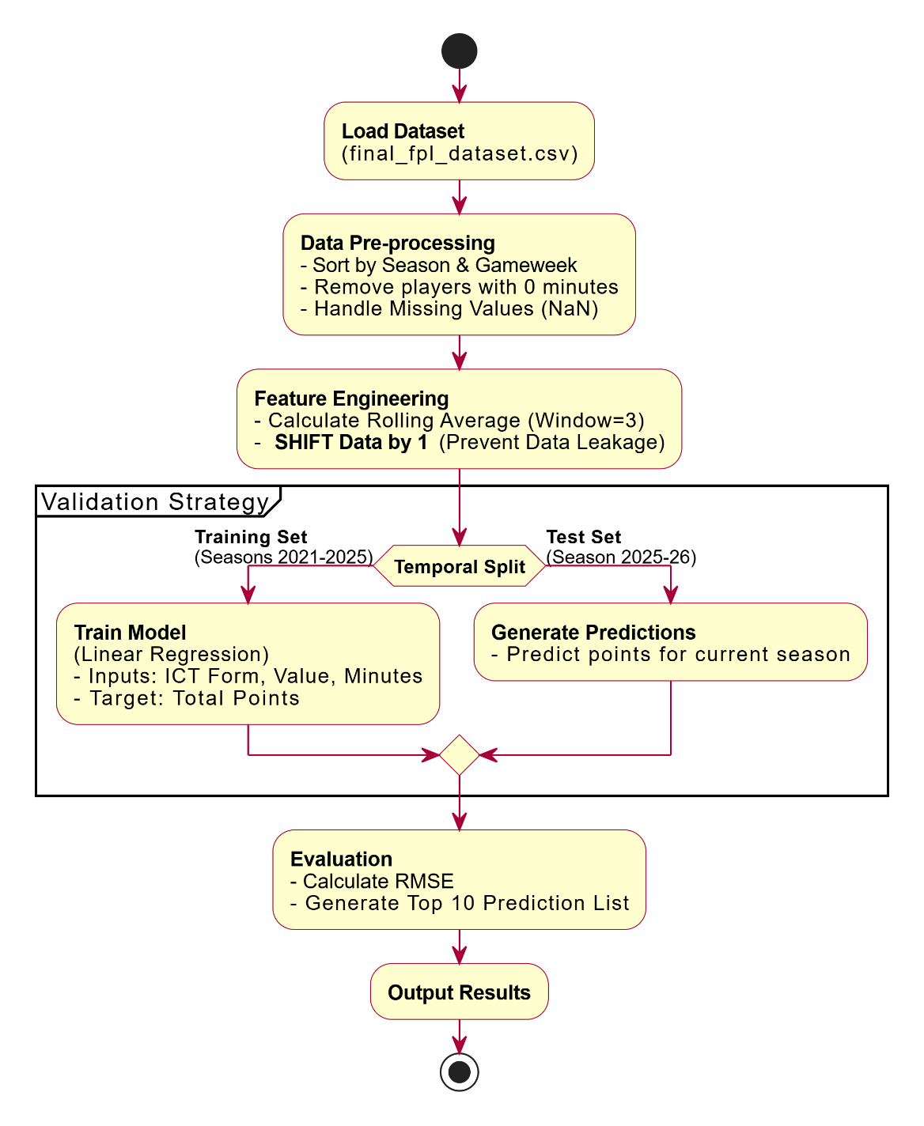
Figure 1: Flowchart

Achieved Results & Evidence

The below visualizations which were generated form the cleaned dataset confirm the viability of the Linear Regression approach.

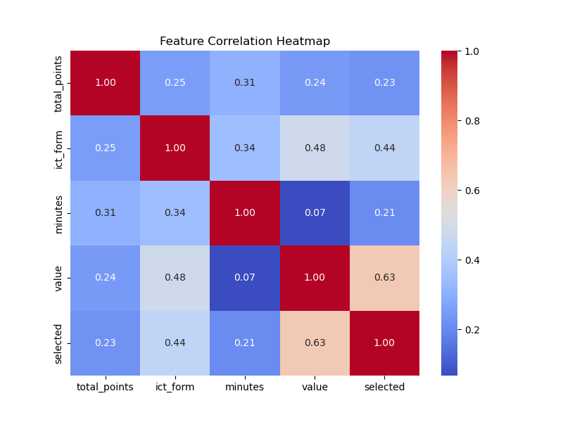
Figure 2: Feature Correlation Heatmap
The heatmap demonstrates that there is a strong positive correlation between ICT Index and Total Points. This statistical evidence validates the selection of ICT Index as a primary predictor variable.

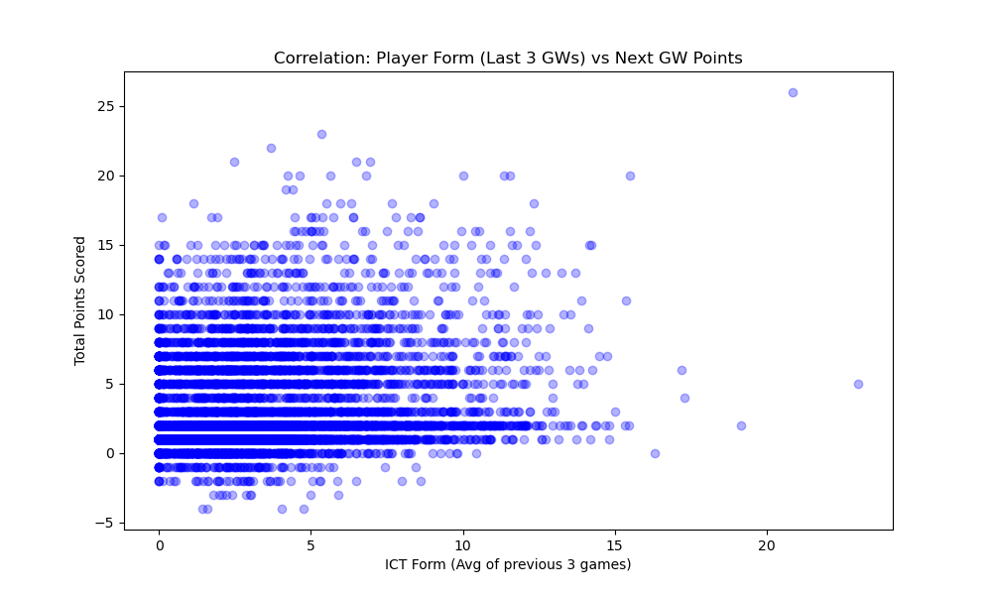
Figure 3: Scatter Plot of Form vs. Points
The scatter plot reveals that there is a linear trend where players with a higher ICT Form consistently score high points. Which confirms the engineered Form feature is highly effective.

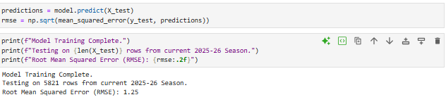
Figure 4: The Model Training Output (RMSE : 1.25)

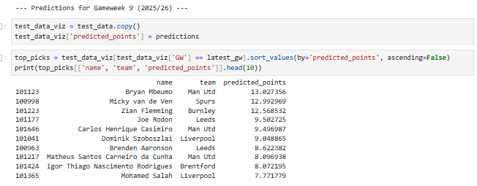
Figure 5: The Top 10 Predicted Scorers list

Conclusion

Summary

Multiple Linear Regression is the best suitable AI approach for FPL points prediction, can be established by this research. This system is a Goal-Based Rational Agent, and was identified that Multiple Linear Regression, which is the best suitable algorithm for predicting a continuous point return of players.
- Data Harmonization: The Intersection Merge strategy successfully unified the 5 years of historical data, after overcoming the significant discrepancy between the old and the new datasets.
- Temporal Feature Engineering: The Player Form feature proved to be a strong predictor. To Justify the use of a regression model, the correlation heatmap validated that recent form has a linear relation to the points obtained.

Limitations

- External Factors: Assuming the random Nature of Football, a player might have high xG but fail to score due to variance or luck.
- Pep Roulette: Because this model relies highly on Minutes Played as an input but cannot predict the sudden tactical changes. A manager can rotate key players of a team to give them rest for a more important game mid-week like a Champions League games, giving them 0 minutes, the model cannot access this data from the press conference news, which might incorrectly predict high points.
- Linear Assumption: Linear regression assumes a straight-lines relationship. But a player’s performance can be non-linear, a injury, a mistake, some sort of sickness, household trouble, may be some unknown factor.
- Defensive Contribution (DefCon): Currently the model only relies on ICT Index and do not account for the new rewarding rules implemented since the 2025/26 season, awarding +2 points for defensive actions rather than just the clean sheet points. Which will be addressed in the future engineering the specific defensive features.

Future Work

- Train: Use Scikit-Learn to calculate the optimal coefficient (β) for the regression equation.
- To fetch the real-time data from the official FPL API, Replace the static CSV with a Python script, https://fantasy.premierleague.com/api/bootstrap-static/, that automates and predicts points for the future game weeks.

Bibliography
Anand, V. (2025). Fantasy-Premier-League Repository. GitHub. Available at: https://github.com/vaastav/Fantasy-Premier-League [Accessed 5 Dec 2025].
FPL Focal. (2025). FPL Focal: Fantasy Premier League Tips and Tools. Available at: https://fpl.page [Accessed 5 Dec 2025].
James, G., Witten, D., Hastie, T. and Tibshirani, R. (2023). An Introduction to Statistical Learning. New York: Springer.
Kaufman, S., Rosset, S. and Perlich, C. (2011). 'Leakage in Data Mining: Formulation, Detection, and Avoidance', ACM Transactions on Knowledge Discovery from Data, 6(4).
Russell, S.J. and Norvig, P. (2010). Artificial Intelligence: A Modern Approach. 3rd ed. Upper Saddle River: Pearson Education.

