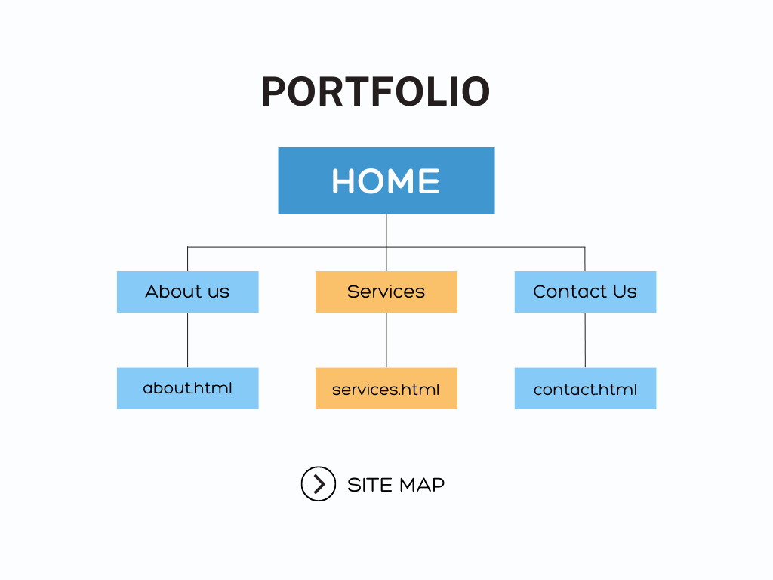

**List of references :**

* <https://www.w3schools.com>
* <https://stackoverflow.com/>
* <https://www.tutorialspoint.com/index.htm>