PROJECTREPORT

# ACRMAPPLICATIONFORSCHOOLS /COLLEGES

**TEAMID:NM2023TMID20914**

# INTRODUCTION

* 1. **Overview**

CRM is – customer relationship management.CRM highereducationtechnologyenablesinstitutionstomanagerelationshipswithall of their customers ( including students, alumni, faculty, staff and corporate partners ) and connect insights from those interactions in a unified view.

# Purpose

Using a CRM system provides educational organization with the data they need to make in formed decisions about recruitment, marketing and other key are as. It also allows you to improve student engagement by tracking student interactions and providing personalized communication.

# PROBLEMDEFINITION&DESIGNTHINKING

**2.1 Empathy map**

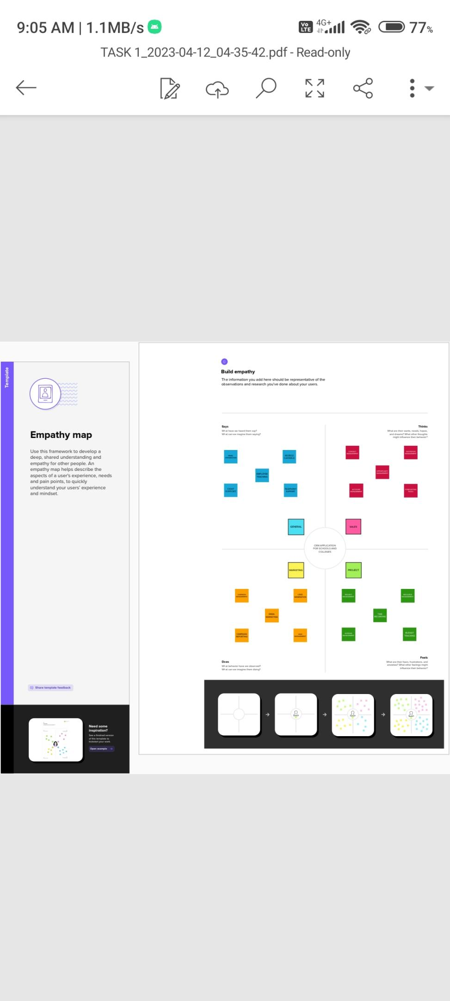

# 2.2 Brainstorming map

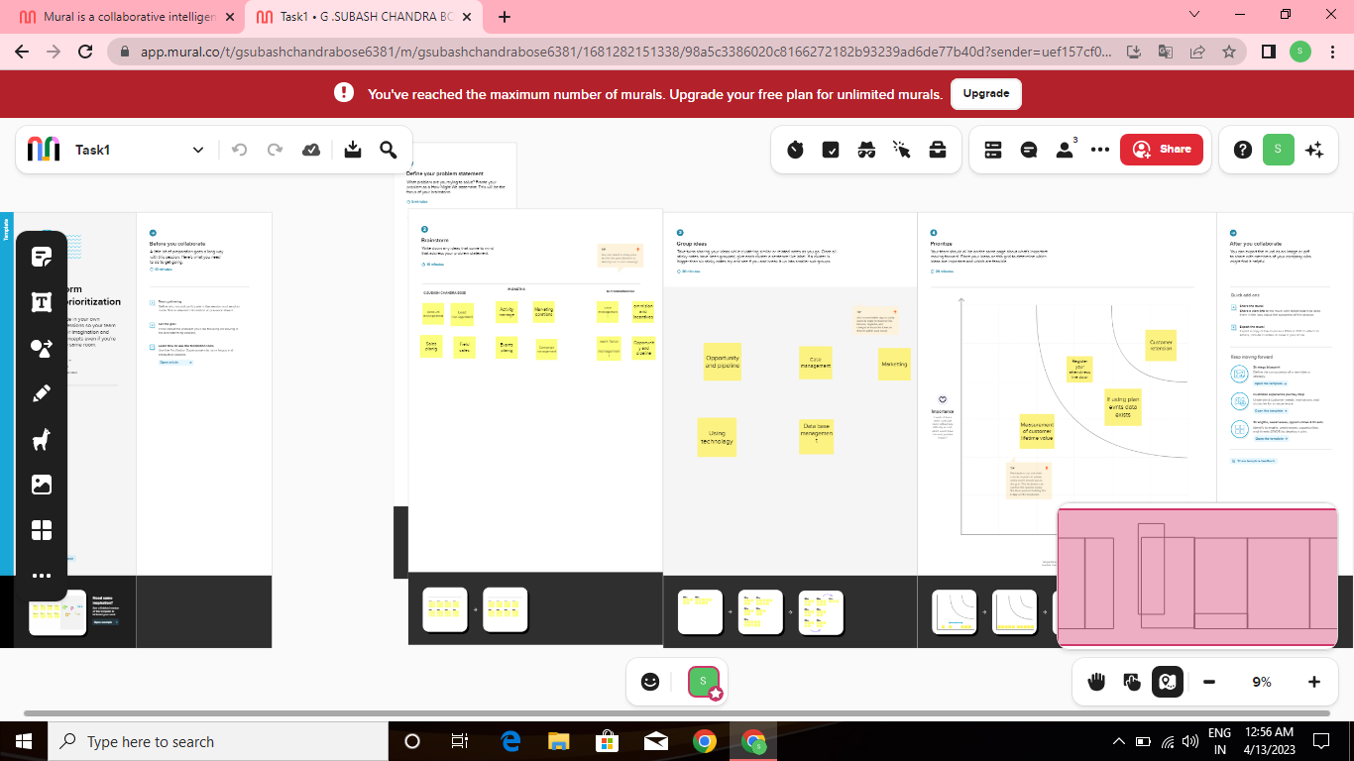**RESULT**

* 1. Data Model

|  |  |  |
| --- | --- | --- |
| **Object name** | **Field label** | **Data type** |
| **School object** | Address | Text Area |
| Number of students | Roll-up summary |
| **Student object** | Phone number | Phone |
| Results | Pick list |

* 1. **ACTIVITY&SCREENSHOT**

Screenshot (6)

# TRAILHEADPROFILEPUBLICURL

Team leader -<https://trailblazer.me/id/ssubash24>

Team Member1 - [https://trailblazer.me/id/smohan578](https://trailblazer.me/id/smohan578%20)

Team Member2 - <https://trailblazer.me/id/tqueen18>

# ADVANTAGES&DISADVANTAGES

## Advantages:

* Track potential leads
* Handle student enquiries
* Streamline teacher evaluations
* MIS reports
* Enrich student lifecycle management
* Build long lasting alumni relations
* Monitor fee payments & remainders
* Manage admissions

## Disadvantages

* Lack of communication
* Lack of organization wide use
* Lack of technology integration
* Cost
* Set clear objectives
* Deployment type
* Training
* Plan out integration needs in advance

# APPLICATIONS

* The use of CRM in education industry is important for many reasons. A CRM system can help educational organization s effectively manage and track leads, resulting in improved enrolment numbers.
* Using a CRM system provides educational organization with the data they need to make informed decisions about recruitment ,marketing, and other areas.
* It also allows you to improve student engagement by trackingstudentinteractionsandprovidingpersonalisedcommunication.
* A CRM system is an essential tool for any educationalorganizationtoimproveenrolments,leadmanagement,communicationandstudentengagement.

# CONCLUSION

From the above discussion it is clear that every educational system must adopt CRM system for the record breaking enrollments and for managing their account as well.

# FUTURESCOPE

**ss**

The goal of the future of CRM is to make integrated sales, marketing, service and commerce possible for all companies. The project has a very vast scope in future.