# Objective

Objective of this project is to make sure when web page is developed, it must be accessible. Team needs to consider various groups of people with disabilities and make content accessible to all. Information and services should be available to everyone whether customer is disable or not, accessibility is the law.

# Background

Nearly 20% (around 1.5Billion) people in the world have some sort of disability. 71% of disabled users don’t use website or application simply because digital content is not accessible. Last year, more then 2000 websites accessibility lawsuits were filed by plaintiffs because they were not ADA (American Disability Act) complaint.

American with disability act (ADA) covers equal and fair treatment to disable users. All websites that fall under the category of ‘Public Accommodations’ – i.e. businesses that are open to the general public – will need to comply with Title III of the ADA. Section 508 of the Rehabilitation Act of 1973 ([29 U.S.C § 794 d](http://www.gpo.gov/fdsys/pkg/USCODE-2011-title29/html/USCODE-2011-title29-chap16-subchapV-sec794d.htm)) requires federal agencies in the United States to ensure that their electronic and information technology – including websites, web applications, software, and digital documents – is accessible to everyone

# Interview Questions

1. **What are challenges for deaf users while accessing web pages ?**

Barriers that people who are deaf may encounter on the Web can include:

* lack of captions or transcripts of audio on the Web, including webcasts
* lack of content-related images in pages full of text, which can slow comprehension for people whose first language may be a sign language instead of a written/spoken language
* requirements for voice input on Web sites

1. **What are issues for blind people to use websites?**

Some challenges are as follows:

* images that do not have alternative text
* complex images (e.g., graphs or charts) that are not adequately described
* video that is not described in text or audio
* tables that do not make sense when read serially (in a cell-by-cell or "linearized" mode)
* frames that do not have "NOFRAME" alternatives, or that do not have meaningful names
* forms that cannot be tabbed through in a logical sequence or that are poorly labelled
* browsers and authoring tools that lack keyboard support for all commands
* browsers and authoring tools that do not use standard applications programmer interfaces for the operating system they are based in
* non-standard document formats that may be difficult for their screen reader to interpret

1. **What are barriers for users with low vision while accessing websites?**

* Web pages with absolute font sizes that do not change (enlarge or reduce) easily
* Web pages that, because of inconsistent layout, are difficult to navigate when enlarged, due to loss of surrounding context
* Web pages, or images on Web pages, that have poor contrast, and whose contrast cannot be easily changed through user override of author style sheets
* text presented as images, which prevents wrapping to the next line when enlarged
* also, many of the barriers listed for blindness, above, depending on the type and extent of visual limitation

1. **What are challenges for users with motor disabilities?**

People with this disability has limitation while moving body parts for example they have hard time using mouse or keyboard.

Barriers that people with motor disabilities affecting the hands or arms may encounter include:

* time-limited response options on Web pages
* browsers and authoring tools that do not support keyboard alternatives for mouse commands
* forms that cannot be tabbed through in a logical order

1. **What are issues with user having seizure disorders?**

Some individuals with seizure disorders, including people with some types of epilepsy, are triggered by visual flickering or audio signals at a certain frequency.

* use of visual or audio frequencies (animations, blinking text, or certain frequencies of audio) that can trigger seizures.

1. **What are issues with colorblind users while accessing web pages ?**

They have issue distinguishing colors. For example, most colorblind people cannot distinguish between color green and red, some cannot distinguish between blue and yellow while some are completely color blind.

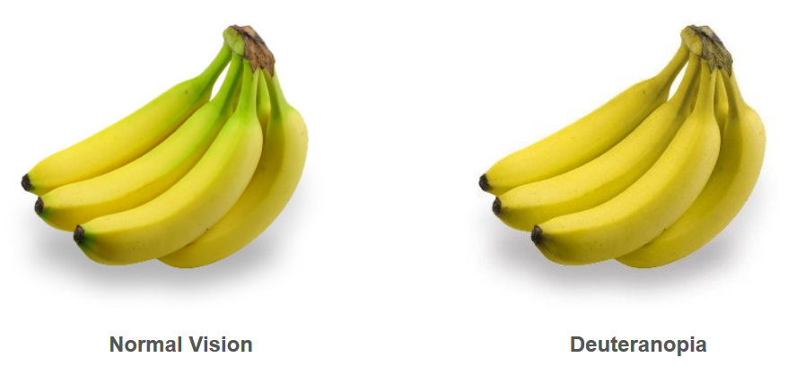

1. **Barriers that people with color blindness may encounter on the Web can include:**

* color that is used as a unique marker to emphasize text on a Web site
* text that inadequately contrasts with background color or patterns
* browsers that do not support user override of authors' style sheets

1. **Why are color contract issues important in websites?**

Color contract issue between text and background affects users ability to perceive information.

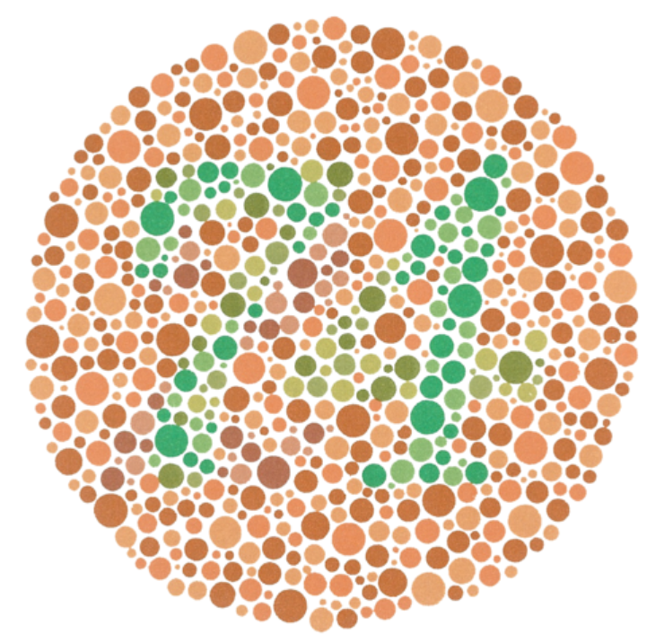

If you can see the number 74 in the main image above, you may have normal colour vision, and if you can see 21, you may have a red green color vision deficiency.

## Problems Statement:

We share digital information or provide digital services to reach out to as many users as possible. Unfortunately, certain people with disabilities cannot get that information or services we want to provide. This is against our mission &/or vision. Information or services should be accessible to all irrespective to their physical or medical condition.

# Persona

User is a disable individual who wants to access web sites to get information. Because of lack of accessibility in that web page. User has hard time getting information s/he needs. User is disappointed and sad because s/he is not able to get information s/he needs.

# Affinity Mapping DEAF

COLOR BLIND

lack of content-related images in pages full of text.

Only color is used as a unique marker to emphasize text on a Web site.

BLIND

images that do not have alternative text

lack of captions or transcripts of audio on the Web, including webcasts

complex images (e.g., graphs or charts) that are not adequately described.

text that inadequately contrasts with background color or patterns

MOTOR DISABILITIES

time-limited response options on Web pages.

LOW VISION

tables that do not make sense when read serially (in a cell-by-cell or "linearized" mode)

tools that do not support keyboard alternatives for mouse

Web pages with absolute font sizes that do not change.

frames that do not have "NOFRAME" alternatives, or that do not have meaningful names

difficult to navigate when enlarged, due to loss of surrounding context

browsers and authoring tools that lack keyboard support for all commands

# SEIZURE

forms that cannot be tabbed through in a logical sequence or that are poorly labelled.

Web pages, or images on Web pages, that have poor contrast

# 

use of visual or audio frequencies that can trigger seizures

text presented as images, which prevents wrapping to the next line when enlarged

# HMW Statement

Digital Accessibility is important for disable individual to get information they need whether it is digital services or content. Disability can be temporary or permanent, so it includes wide range of people. During interview I was able to talk with six people with different disabilities. While addressing accessibility issue we need to address for different accessibility groups. For example, problem for blind people are different from problems for deaf people. Improving accessibility is not feature, it is the law.

. Step1 Notes

### Critical data from interview questions

1. People with colorblind have issues differentiating colors.
2. Because of poor color contrast ratio between background and text color, people with low vision have hard time getting information.
3. People with hearing impairments have hard time hearing audio or video clip in websites.
4. People with seizure have hard time if web pages have animation, blinking text, bright images etc.
5. Image with alternate text and descriptive hyperlink will be helpful for users who use screen reader to visit webpage.
6. Content with logical order with appropriate heading helps to focus for users who use keyboard.
7. Avoid using very bright content or flash videos in page.

## Step2 Ideas

### Establish connection

Different disable groups have common problem. If content is not accessible it is very challenging for disable individual to get information they need while trying to get digital information or services. Different disable groups problems should be addressed differently.

## Step3 Sketch



Use Caption or transcript for any audio

Header1 …

Header2 …

Header3…

Use Headers appropriately.

Use label properly & Organize content with logical order.



Use Alt text for images



Avoid Flash content



Consider Color Contract Ratio with background.



Make sure digital content is accessible with keyboard.

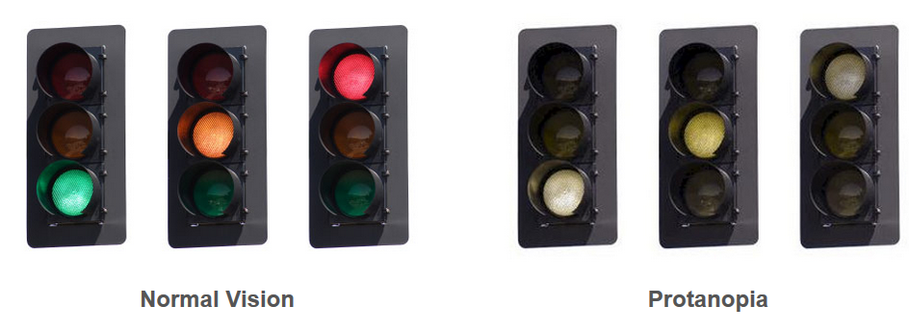 Consider colors for color blind users

Do not use color only form important information.

Search in [Google](https://www.google.com/)

Use descriptive name for hyperlinks

# Features

1. For audio or video use caption or transcripts.
2. Images should have alternate text.
3. Give unique and descriptive names for hyperlinks.
4. Tables should be used to display data not just as layout.
5. Form elements should be able to be tabbed through in logical order with appropriate label.
6. Web pages should be accessible using keyboard only.
7. Make sure there is proper color contract ratio with content and background.
8. Try avoiding very bright content or content with flash.
9. Use headers appropriately to structure content on page.
10. Do not use color to inform users, use appropriate text with it.
11. Complex images like graphs and charts should have proper description.
12. Try to avoid time limited response from users.
13. When page is zoomed, content should be zoomed with same proportion without breaking.
14. Do not present text as image.
15. Do not use complex language on web sites.
16. Try using graphics to share information as an alternate method.
17. Avoid automatic media and navigation.

# MVP

1. For audio or video use caption or transcripts.
2. Images should have alternate text.
3. Give unique and descriptive names for hyperlinks.
4. Tables should be used to display data not just as layout.
5. Form elements should be able to be tabbed through in logical order with appropriate label.
6. Web pages should be accessible using keyboard only.
7. Make sure there is proper color contract ratio with content and background.
8. Try avoiding very bright content or content with flash.
9. Use headers appropriately to structure content on page.

# Task Analysis

* Disable user needs to access information to address critical and time sensitive issue.
* Disable user visit web sites.
  + User has Hearing problem, user needs caption or transcripts for audio or video content.
  + User is colorblind, do not use color only to share information.
  + User with seizure, do not use video or audio frequencies that can trigger seizure.
  + User with motor disability:
    - Make sure web page is accessible only with keyboard.
    - Content should be organized in logical order with appropriate headings.
  + Do not include time limited response.
  + For blind users:
    - Use alt text for images.
    - Use table to display data not to display as layout.
    - Form fields should have appropriate label and organized properly.
    - Use appropriate description for hyperlink.
  + For user with low vision:
    - Make sure contents zoom appropriately without loosing any information.
    - Maintain appropriate color contract of content with background.

Yes

Accessible, User was able to get information needed.

caption or transcripts for audio or video

No

Alternate texts are used for images

Yes

No

Organized and Keyboard accessible content.

Yes

Yes

There is appropriate color contract ratio with background.

No

Yes

Meaningful Names are given to hyperlinks.

No

Yes

Short time sensitive input is requested

Yes

No

Yes

Yes

No

No

Only Color is used to share information

High Audio or video Frequencies

Not Accessible, User Could not get information needed.

# Wireframe and Prototype

Please check [Wireframe & Prototype in Figma](https://www.figma.com/file/MgfHNNpYCLh7NgMj5VTSE2/Untitled?node-id=0%3A1)

# Story Arc

**Introduction**: Digital accessibility is important to share information &/or services for all including disable users to reach out to more users.

**Incident**: Disable individuals have issue with getting information they need because of lack of accessibility.

**Raising Action**: There are some instances of lawsuit action because of accessibility issue.

**Climax**: There are laws to make digital content & services accessible.

**Resolution**: We have technologies and best practices in place that need to be addressed at early phase of project. If possible, all disable groups should be addressed.

**Conclusion**: We must consider accessibility while developing digital content or services.

# Mood Board for Web page accessibility

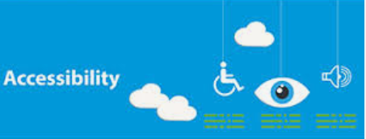

# Moods into styles

* Background color: 000080 (Navy blue)
* Primary color: 0000FF (Blue)
* Secondary color: #8ADEF8 (Sky Blue)
* System color: 808080 (Grey)
* Font color: FFFFFF (white), 0B5C1A(Green)
* Font weight: 100 for body 900 for header
* Font style: Roboto, Itim, TimesNewRoman, SpeakPro

Reference:

<https://www.w3.org/WAI/EO/Drafts/PWD-Use-Web/20040701.html>

<https://fuzzymath.com/resources/web-accessibility-checklist/>

<https://webaccess.berkeley.edu/resources/tips/web-accessibility>

[How People with Disabilities Use the Web | Web Accessibility Initiative (WAI) | W3C](https://www.w3.org/WAI/people-use-web/)

<https://www.indeed.com/career-advice/career-development/how-to-write-a-problem-statement>

<https://monsido.com/blog/digital-accessibility>