Project Report Template

1. INTRODUCTION
   1. Overview

Recruiting assistant for HR Managers

1.2 Purpose

Maintains accurate and up-to-date human resource files, records and documentation

1. Problem Definition & Design Thinking

2.1 Empathy Map

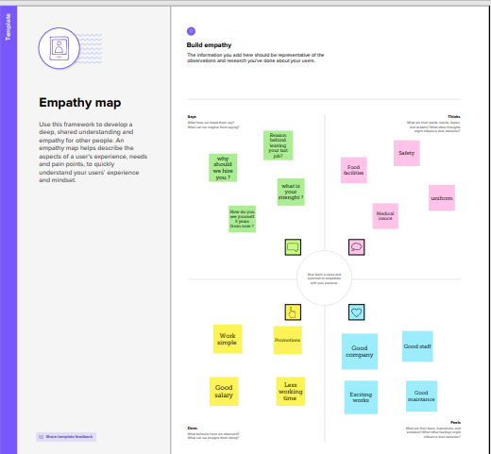

2.2 Ideation& Brainstorming Map

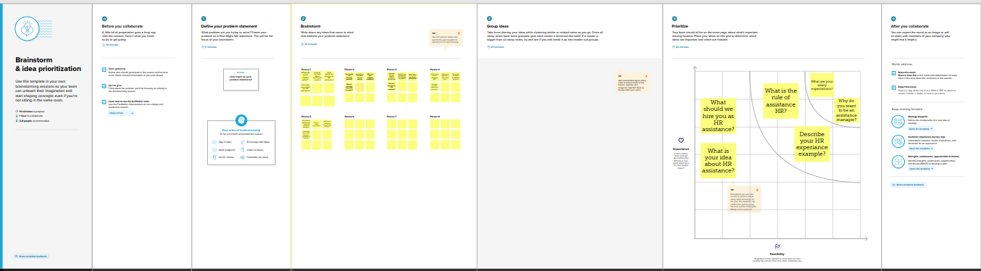

3. RESULT

3.1 Data Model

|  |  |
| --- | --- |
| Object name | Fields in the object |
| Creation of developer account | |  |  | | --- | --- | | Field label | Data type | | Review | Auto-number | | Job posting site | Text | |
| Package installation | |  |  | | --- | --- | | Field label | Data type | | Status | Picklist | | Technical site | Checkbox | |

3.2 Activity & Screenshot

1. **Creation of developer account;**

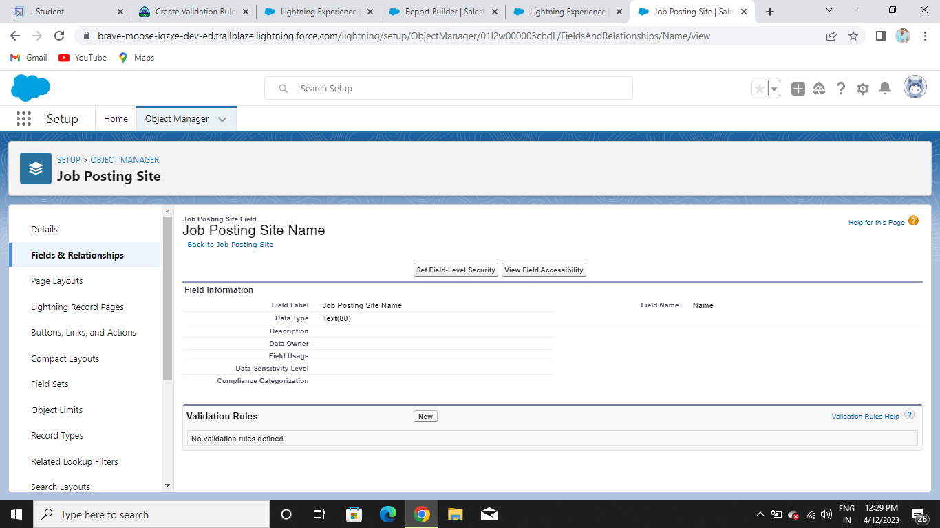

1. **Package Installation;**

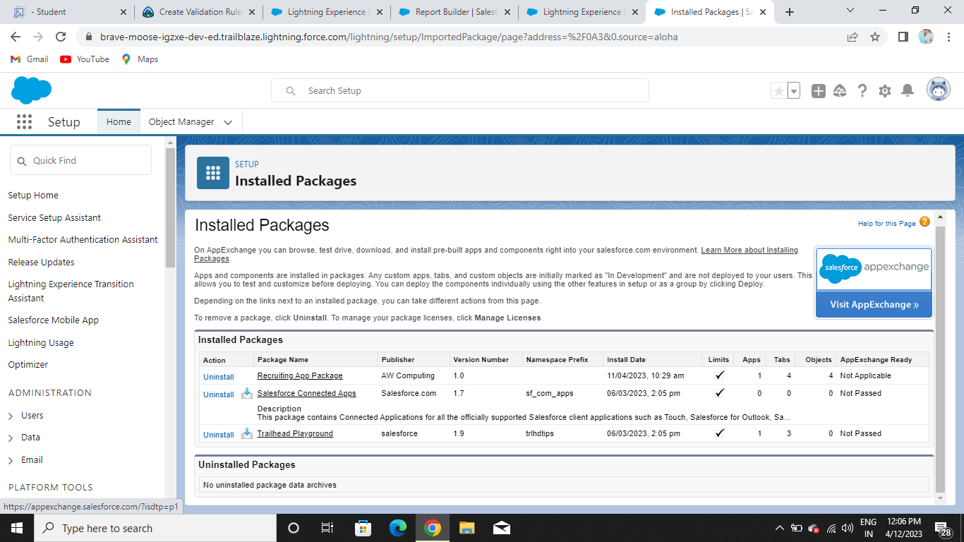

1. **Object**

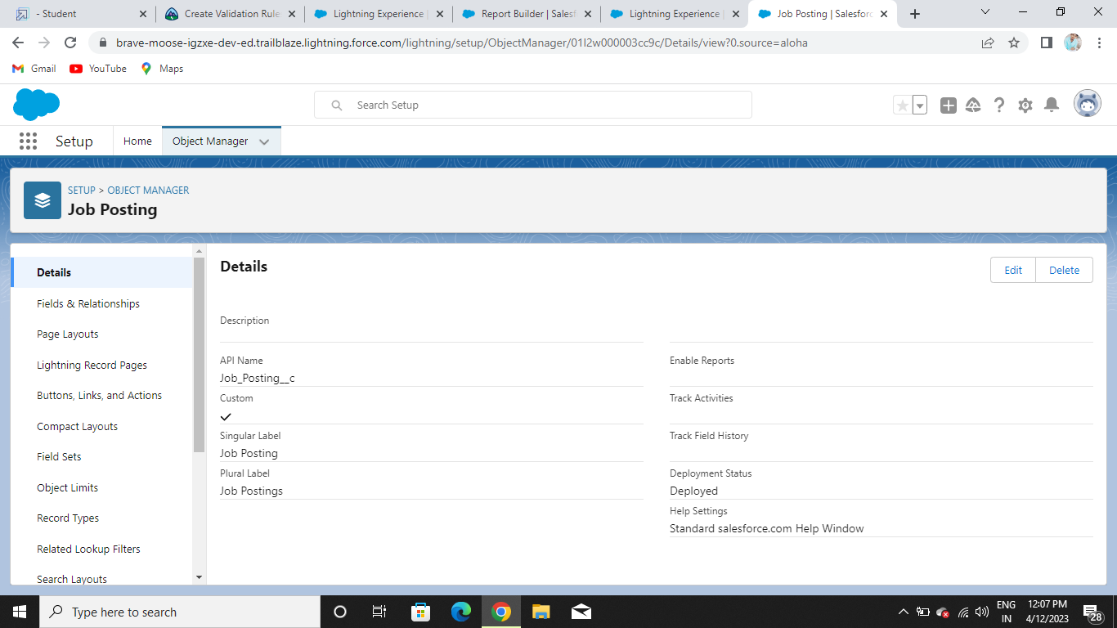

1. **Tabs**

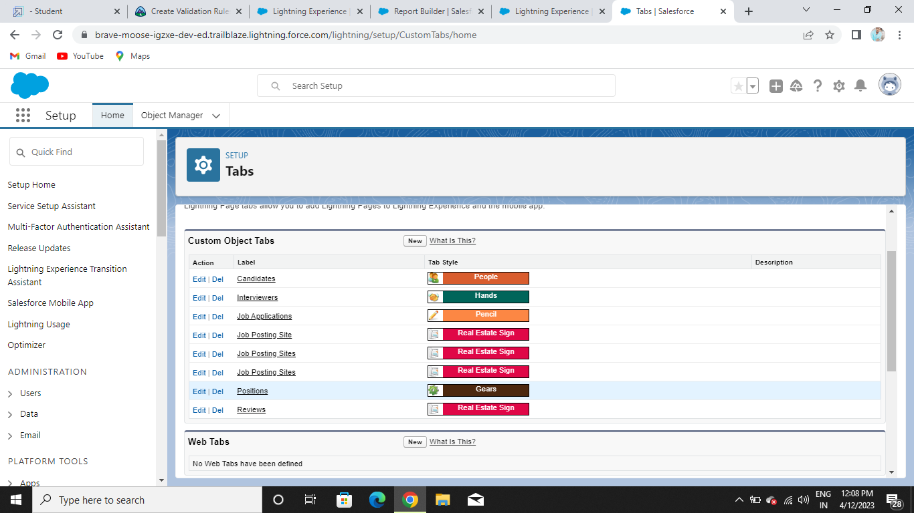

1. **Fields**

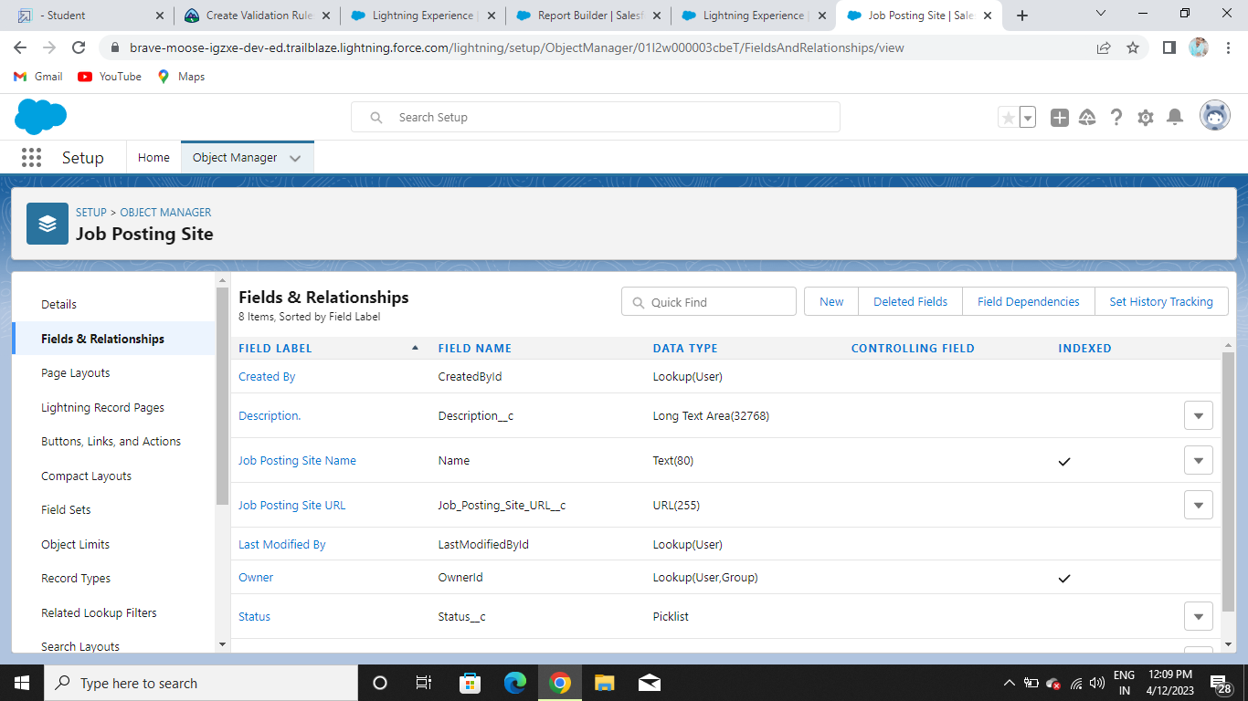

1. **Junction Object**

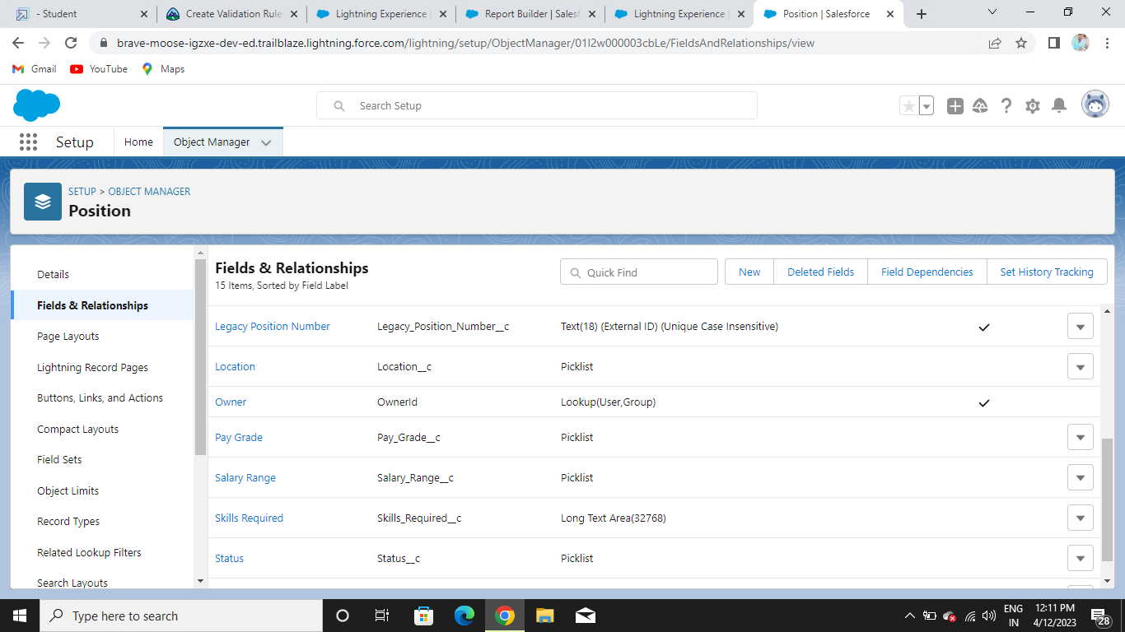

1. **Page Layout**

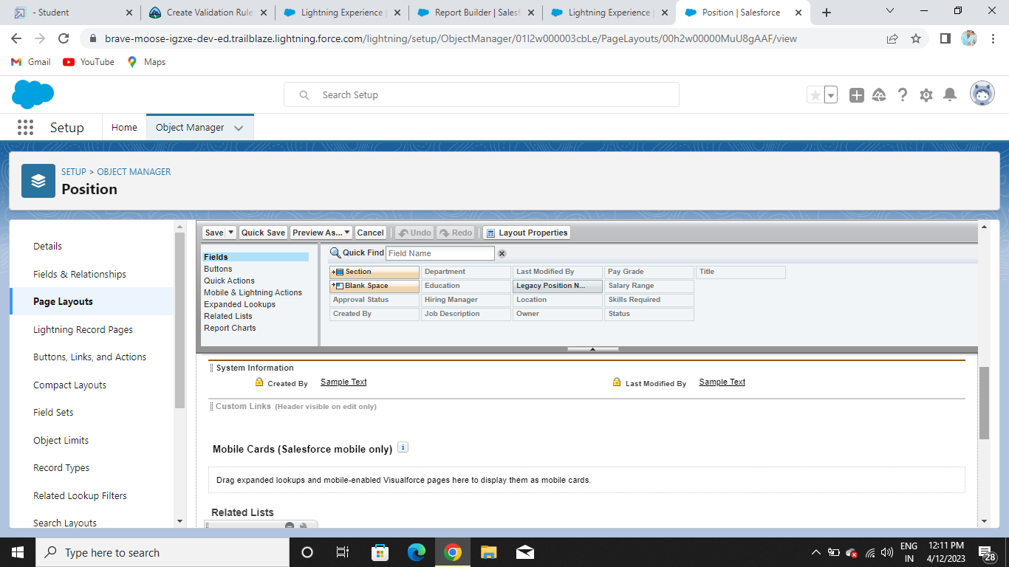

1. **Validation Rules**

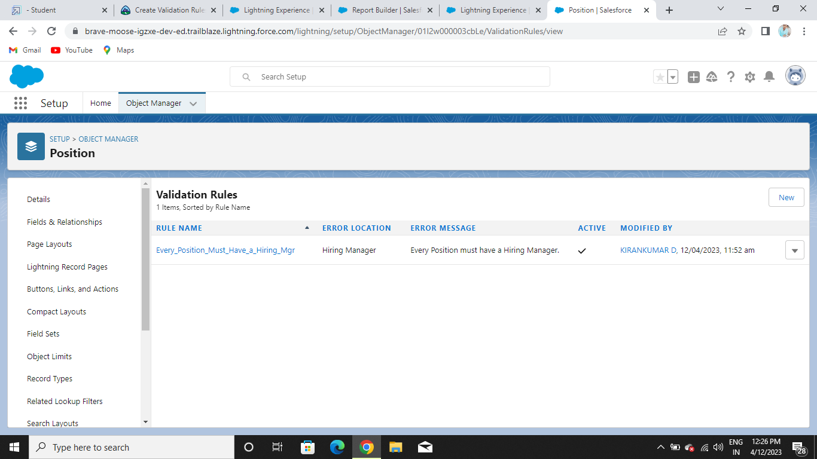

1. **Profile**

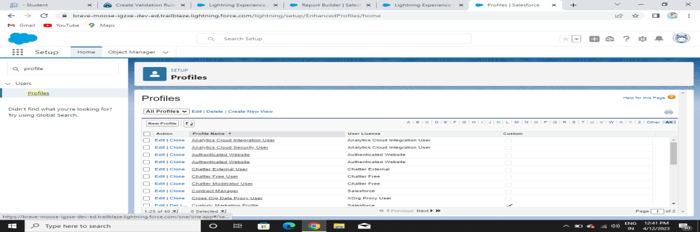

1. **User**

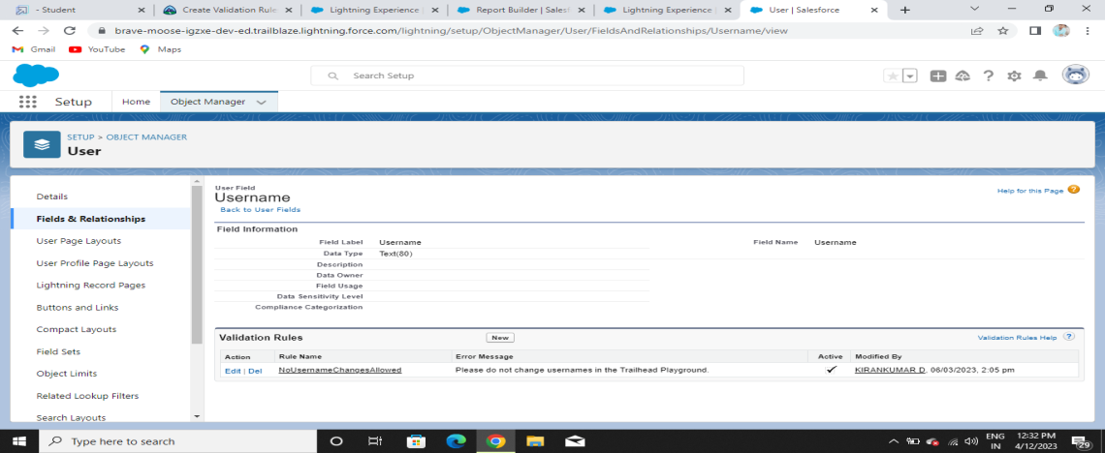

1. **Permission set**

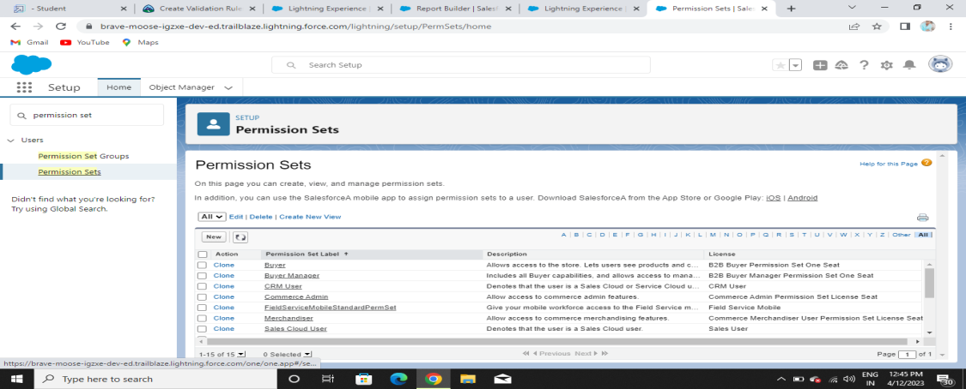

1. **Reports**

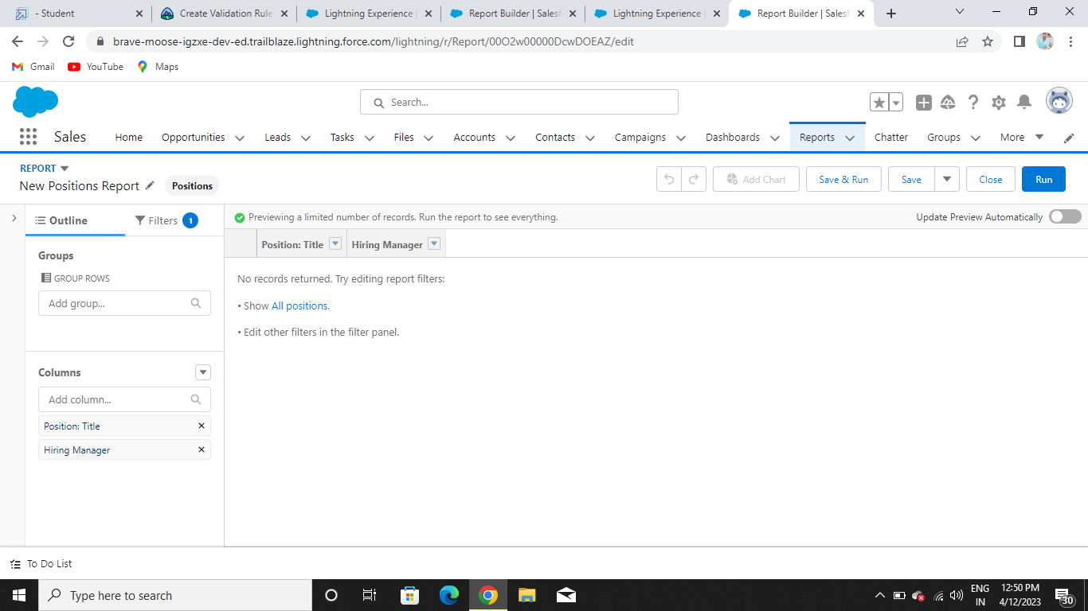

4

**4 . Trailhead Profile Public URL**

**Team lead - KIRANKUMAR D:** **https://trailblazer.me/id/kkirankumarkd**

**Team Member1- SUBASH S:** **https://trailblazer.me/id/subas176**

**Team Member2- SONIYA K:** **https://trailblazer.me/id/ktms-2**

**Team Member3- SARATHKUMAR H**

**Team Member4- LAVANYA S**

**5. ADVANTAGES & DISADVANTAGE**

ADVANTAGES:

They often help manage job trainings where employees can learn transferable skills .as HR assistant, you might help provide employees with performance reviews that offer valuable information about their work.

DISADVANTAGES:

A disadvantage of adding a human resources department is that it requires you to relinquish control regarding how your business operates.

**6. APPLICATIONS**

*Employees benefits

*Human resources compliance

*Organizational structure

*Employee training and development

*Recruiting and staffing employees

**7. CONCLUSION**

In the conclusion of ASSISTANT HR MANAGER . The final remedy or justification is usually given.

**8. FUTURE SCOPE**

HR professionals can aim to learn about the technologies trends and operational changes shaping the future of business.