AIR QUALITY MONITORING USING

INTERNET OF THINGS

TEAM MEMBER

960321106032: Subash S.K
Phase-2 Document Submission

Project: Air Quality Monitoring

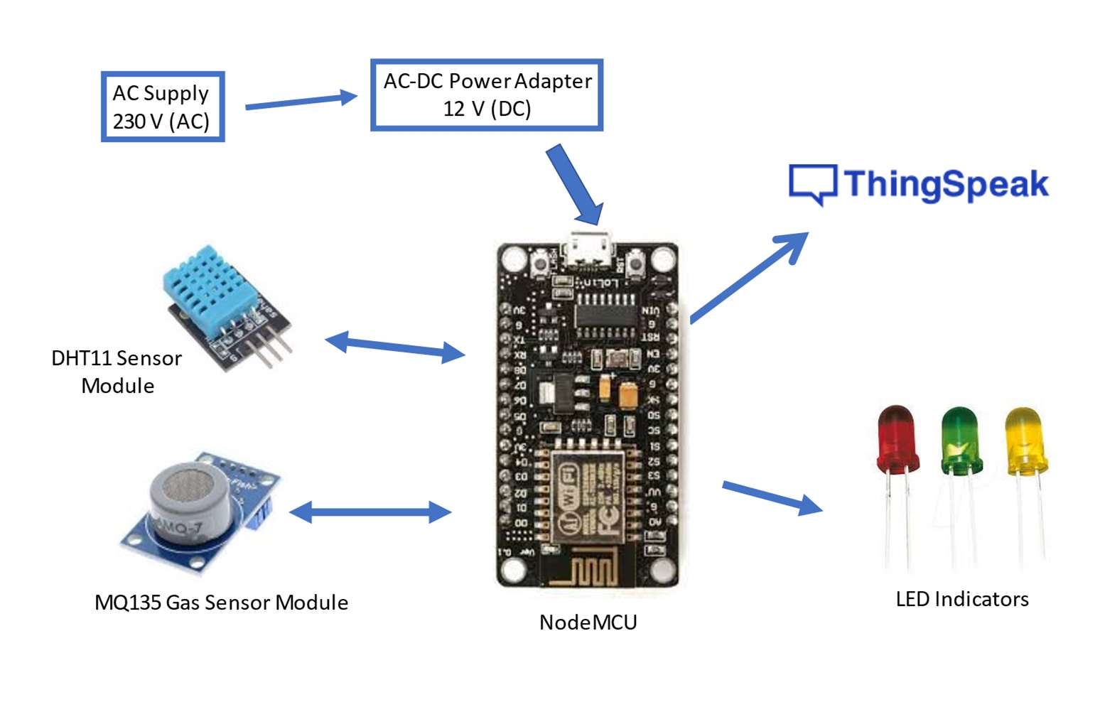

Figure: IoT based Air Quality Monitoring
Introduction:

- Air Quality Monitoring: Continuous measurement of criteria air pollutants and other relevant pollutants provides valuable data for assessing the overall air quality in a region. This information is crucial for regulatory agencies and environmental organizations in formulating policies and strategies to improve air quality

- Indoor Air Quality Monitoring: Monitoring indoor air quality is essential for maintaining a healthy and productive indoor environment, especially in workplaces, homes, and public buildings. It helps identify sources of indoor pollution and ensures that indoor air meets health and safety standards.

- Clean Room Airborne Molecular Contamination Monitoring: Industries like semiconductor manufacturing and pharmaceuticals require extremely clean environments to prevent contamination. Monitoring molecular contaminants in clean rooms is critical for ensuring product quality and safety.

- Quality Control: Air quality data can be used for quality control purposes in industries where air quality affects product quality. For instance, in food production, maintaining air quality standards is vital to prevent contamination and ensure product safety.

- Stationary Emission Monitoring: Monitoring emissions from stationary sources, such as industrial facilities, power plants, and refineries, helps track compliance with emissions regulations. It enables companies to manage and reduce their environmental footprint while meeting regulatory requirements.

Content for Project Phase2 :

Consider incorporating predictive modeling to forecast air quality trends based on historical data.

Predictive Modeling of Air Quality:

- Research Objective: To understand the impact of pollutant concentration on air quality and how this relationship changed during the COVID-19 lockdown. It uses various machine learning and statistical modeling techniques to achieve this goal.

- Linear Regression (LM): The study starts with linear regression to initially analyze the relationship between pollutant concentration and air quality. Linear regression assumes a linear relationship between the dependent and independent variables.

- Non-Linear Time Series Analysis: Explores non-linear relationships among air quality determinants using non-linear time series models, including tree-based models, artificial neural networks, and support vector regression.

- Tree-Based Models: Decision Trees, Random Forest, and XGBoost are employed to capture patterns in the data over time and predict future values. These models use decision nodes and independent variables' significance to create rules during training.

- Artificial Neural Networks (ANN): ANN is used for predictive modeling of air quality, with input, hidden, and output layers. The number of neurons and layers, as well as connection strengths (weights) and activation functions, are experimentally determined. Backpropagation and gradient descent are used for training.

- Support Vector Regression (SVR): SVR is utilized to map non-linear relationships between predictors and generalize predictions for unseen instances. A Gaussian kernel with a radial basis function is employed to minimize the loss function during training.

- COVID-19 Impact: Investigates how the relationship between pollutants and air quality changed during the COVID-19 lockdown. It uses the models developed to predict air quality before and during the pandemic to understand these changes.

- National Air Quality Index (AQI): The predicted pollutant concentrations are used to determine the national air quality index, following the guidelines of the Central Pollution Control Board (CPCB).
Components Used:
- Hardware Components:
1. NodeMCU V3
2. DHT11 Sensor Module
3. MQ-135 Gas Sensor Module
4. Veroboard(KS100)
5. Breadboard
6. Connecting Wires
7. AC-DC Adapters
8. LEDs emitting green, yellow and red colours
9. Resistors
- Software Components:
1. ThinkSpeak Cloud
2. Arduino IDE
Working Procedures:
NodeMCU plays the main controlling role in this project. It has been programmed in a manner, such that, it senses the sensory signals from the sensors and shows the quality level via led indicators. The DHT11 sensor module is used to measure the temperature and the humidity of the surroundings.With the help of the MQ-135 gas sensor module, air quality is measured in ppm. These data are fed to the ThinkSpeak cloud over the internet. We have also provided LED indicators to indicate the safety levels.

STEP 1:Firstly, the calibration ofthe MQ-135 gas sensor module is done. The sensor is set to preheat for 24 minutes. Then the software code is uploaded to the NodeMCU followed by the hardware circuit to calibrate the sensor has been performed.
STEP 2:Then, the DHT11 sensor is set to preheat for 10 minutes.
STEP 3:The result of calibration found in STEP 1 is used to configure the final working code.
STEP 4: The final working code is then uploaded to the NodeMCU.

STEP 5:Finally, the complete hardware circuit is implemented. The software codes and the hardware circuits are described in the following chapters.

Hardware Model to Preheat DHT11 Sensor Module :
As discussed earlier, we need to preheat the DHT11 sensor so that it can work accurately.
The following steps were performed to preheat the DHT11 sensor module:
STEP 1 : The Vcc pin of the DHT11 sensor module was connected with the VU pin of NodeMCU.
STEP 2 : The Gnd pin of the DHT11 sensor module was connected with the Gnd pin of
NodeMCU.
STEP 3 : The NodeMCU is powered with a 12V DC via AC-DC adapter for 20 minutes.
STEP 4 : The setup was then disconnected.

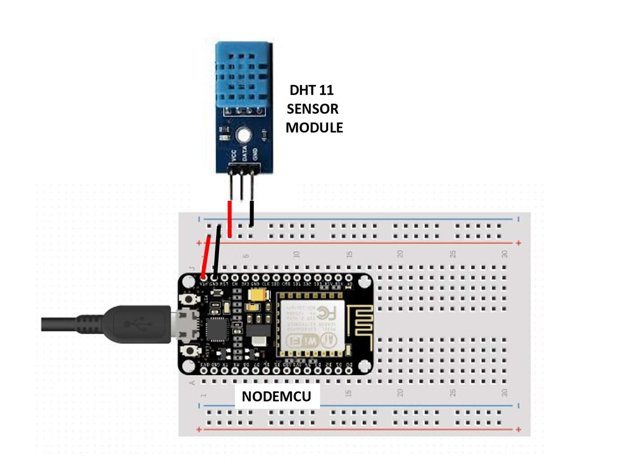

Figure:Circuit Diagram to Preheat the DHT11 sensor module

Hardware Model to Preheat and Calibrate MQ-135 Gas Sensor Module:
The following steps were performed to preheat the MQ-135 gas sensor module:
STEP 1 : The Vcc pin of the MQ-135 gas sensor module was connected with the VU pin of NodeMCU.
STEP 2 : The Gnd pin of the MQ-135 gas sensor module was connected with the Gnd pin of NodeMCU.
STEP 3 : The NodeMCU is powered with a 12V DC via AC-DC adapter for a day.
STEP 4 : The setup was then disconnected.

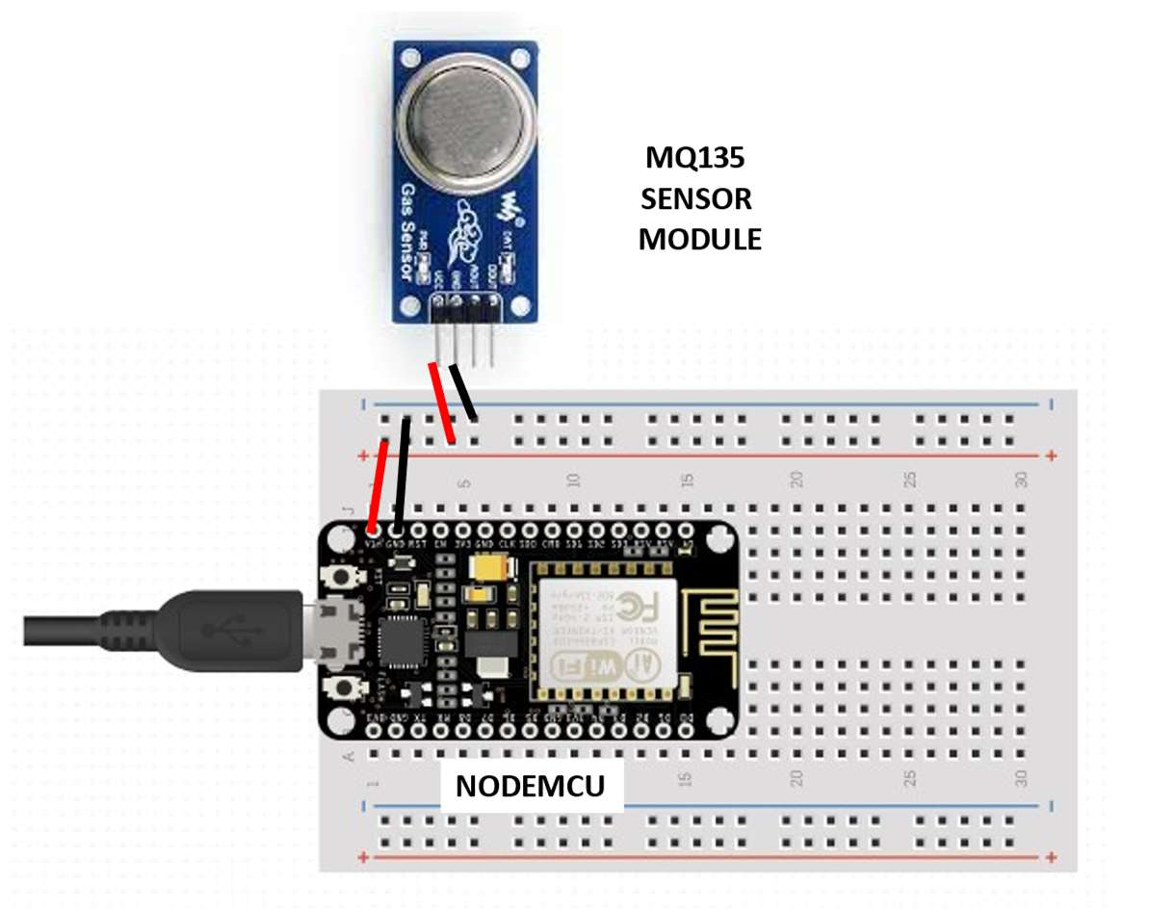

Figure: Circuit Diagram to Preheat the MQ-135 Gas sensor module

The following steps were performed to calibrate the MQ-135 gas sensor module:
STEP 1 : The Vcc pin of the MQ-135 gas sensor module was connected with the VU pin of NodeMCU.
STEP 2 : The Gnd pin of the MQ-135 gas sensor module was connected with the Gnd pin of NodeMCU.
STEP 3 : The analog DATA pin of the MQ-135 gas sensor module was connected with the
A0 Pin of the NodeMCU.
STEP 4 : The software code to calibrate the sensor is then uploaded to the NodeMCU and the value of R0in fresh air is collected from the serial monitor of the Arduino IDE.
STEP 5 : The setup was then disconnected.

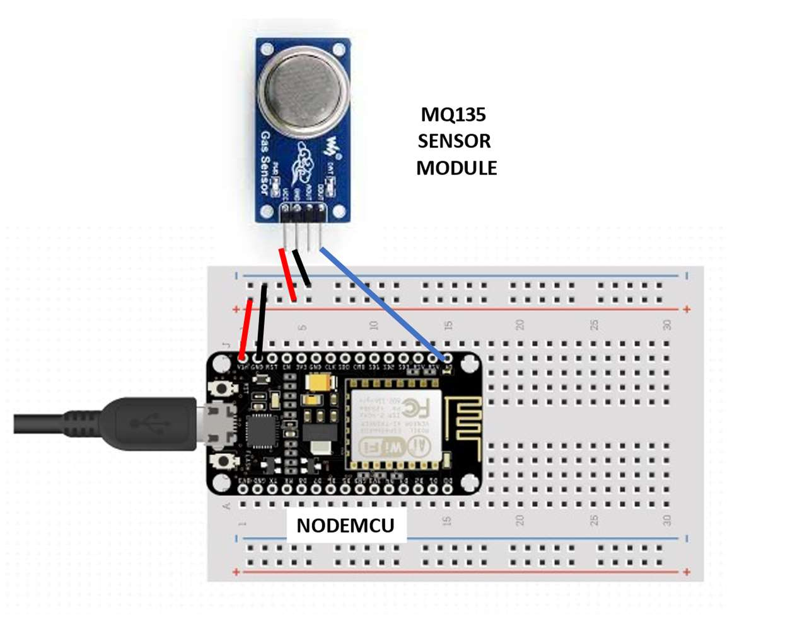

Figure: Circuit Diagram to Calibrate the MQ-135 Gas sensor module

Final Hardware Model :
The following steps were performed to execute the project
STEP 1 : The Vcc pin of the MQ-135 gas sensor module and DHT11 sensor module was connected via Veroboard with an adapter delivering around 5V.
STEP 2 : The Gnd pin of the MQ-135 gas sensor module, DHT11 sensor module and the cathode of the LED indicators was connected via Veroboard with the Gnd pin of the NodeMCU.
STEP 3 : The analog DATA pin of the MQ-135 gas sensor module was connected with the A0 Pin of the NodeMCU.
STEP 4 : The DATA pin of the DHT11 sensor module was connected with the D0 pin of the NodeMCU.
STEP 5 : The anode of the three LED indicators (green, yellow, and red) were connected to the D2, D3, and D4 pins of the NodeMCU respectively.
STEP 6 : The software code to execute the project was then uploaded to the NodeMCU.
STEP 7 : The setup was then powered with 9V DC via AC-DC adapter. It can be now turned ON/OFF as per the requirements.

and Turn OFF the
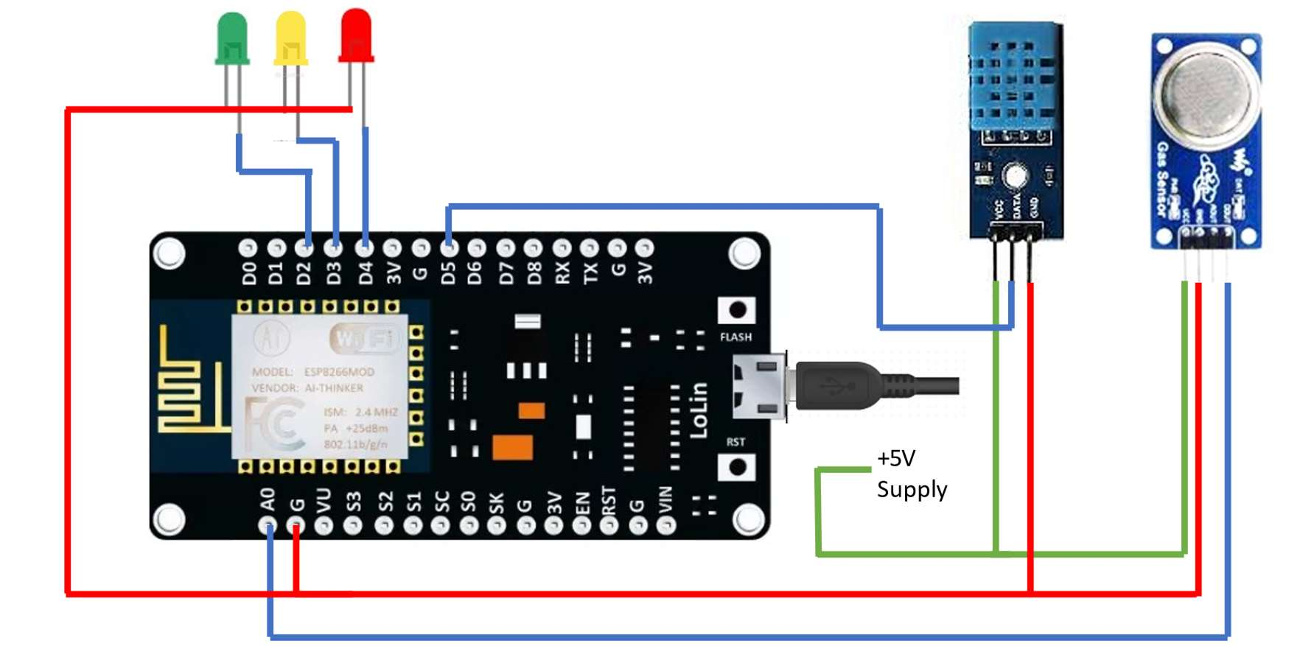

Figure: Circuit Diagram
Conclusion:
- To evaluate the Air Quality Index (AQI) and pollutant concentrations before and during the COVID-19 lockdown in major Indian cities. This is relevant as the pandemic and lockdown measures had a significant impact on human activity and, potentially, air quality.Time-series data on various pollutants, including PM2.5, PM10, NO, NO2, NOX, NH3, CO, SO2, O3, Benzene, Toluene, and Xylene, from major stations in Delhi, Hyderabad, and Kolkata. This data is publicly available and represents a comprehensive dataset for analysis.
- Cluster analysis to group pollutants based on their concentration levels. This approach can help identify which pollutants tend to co-occur and potentially have a combined impact on air quality. Comparing these clusters before and during the lockdown can reveal changes in pollution patterns.
- The limitations of existing prediction models for forecasting AQI during the lockdown period. Developing and validating machine learning-based models with minimal prediction errors and high accuracy. This can be crucial for more reliable air quality forecasting in the future.
- The integration of smart pollution monitoring systems, IoT, machine learning, and cloud computing for real-time monitoring of pollutant variations. This approach can enhance data collection and analysis for better decision-making.
- Integrating Google Mobility data with pollution monitoring systems to understand the relationship between human activities and air quality variations. This can provide valuable insights into the impact of specific events on air quality.

