Objects and its internal representation in javascript

Subashan Raj T S

Javascript is an object oriented programming language so everything in it is object. A javascript object is a real world entity like it has state and behavior. For example car is an object and it has mode and color as state, and it has behavior like acceleration and brake.objects are important data types in javascript But it is different from primitive data types like integer, float, long, sting, etc. these primitive data types can have one value but objects is a collection of these primitive data types in the form of “Key : Value” pairs. These keys can be variables and functions and are called methods and properties.

Objects and Properties

A javascript object has properties associated with it. A property can be explained as a variable that is attached to an object. Object properties are the same as ordinary javascript variables. The property of an object represents the characteristics of an object. You can access the properties by simple dot notation.

ObjectName.propertyName

Lets see for example how many values are stored in an object.

Var car = { Make:”Mercedes”, Model:”C-class”, Color:”white”, Fuel:”Diesel”}

The **name:value** pairs are called **properties**.

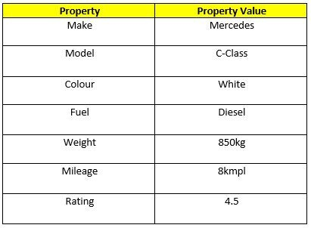

The properties can usually be changed,added and deleted.

The syntax for adding a property

Objectname:ObjectProperty = property value

The syntax for Deleting a property

Delete ObjectName.ObjectProperty

The syntax for accessing a property

objectName.property // Car.Make

//or

objectName["property”] // Car["Make"]

//or

objectName[expression] // x = "Make"; Car[x]

Objects in javascript can be created using a three ways

* Using object literal
* Using constructor
* Using keyword new

Object literal

It is one of the easiest way to create object in javascript simply define the **name:value** pairs inside a curly braces for example

Var car = { Make:”Mercedes”, Model:”C-class”, Color:”white”, Fuel:”Diesel”}

Constructor

Constructor is a function, with the help of a new keyword constructor function allows us to create a multiple objects.

For example

Function Vehicle(name, maker){

this.name = name;

this.maker = maker;

}

Let car1 = new Vehicle(‘ Fiesta’, ‘Ford’);

Let car2 = new Vehicle(‘ Tata’, ‘Nexon’’);

console.log(car1.name); //Output: Fiesta

console.log(car2.name); //Output: Tata

Keyword New

The following example also creates a new JavaScript object with three properties:

var person = new Object();

person.firstName = “John”;

person.lastName = “Doe”;

person.age = 50;

Page break image