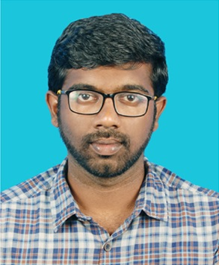
T.S.SUBASHAN RAJ
9/2, kumara vadivel lane, Thenkarai,
Periyakulam,
Theni. 625 601.
Mobile - 8668045218
Mail - subash32926@gmail.com Linked-In - linkedin.com/in/subashanraj

Professional Summary
Seeking a challenging position to explore my skills in the software field that offers professional growth. Detail-oriented, organized and meticulous employee. Works at fast pace to meet tight deadlines. Enthusiastic team player ready to contribute to company success.

Technical Skills
· Languages: Java-script, Node JS, Express, Python, Django.
· Platforms: Windows XP/ 7/8/8.1/10, Linux, Ubuntu, Mac OS.
· Web Design: HTML, CSS, React, Bootstrap.
· Database: MySQL, MongoDB.

Work Experience
I had 3.5 years’ experience as system management officer in JRR CIVIL TECH (P) Ltd. Worked in a role of network maintenance and have well versed in MS Office.

Areas of Interest
- Web Development.
- Data Analytics.
Projects
As a part of my Full stack development course in Guvi Geeks I have done “Zen student management system” project, which is to facilitate mentors to view student profile, attendance, courses, assessment, and also to assign tasks. Additionally the data can be sorted and filtered.
Front-end – Html, CSS, Reactjs. Back-end – express, Node. Database – mongo DB

Certification & Workshop
. September 2022 - Done certification in MERN Full stack development in GUVI GEEKS.
. April 2019 - Done certification in RPA level 1 -foundation training in UIPath
. Attended workshop on android app development in IIT Chennai.

Academic Details
COURSE | COLLEGE/SCHOOL | YEAR | CGPA/PERCENTAGE
B.E(Computer science  and engineering) | KUMARAGURU COLLEGE OF TECHNOLOGY  COIMBATORE. | 2012 - 2016 | 5.73*
HSC | VIDYAA VIKAS BOYS HR, SEC, SCHOOL  THIRUCHENGODE. | 2012 | 71.2%
SSLC | SANTINIKETAN MATRICULATION SCHOOL  THENI. | 2010 | 81%

Achievements & Curricular Activities
. Won a medal in National level karate tournament.
. Won medals in Badminton inter-club tournaments.

Personal Abilities
- Ability to make sound decisions, Good communication and organizing skills, Make people to understand the situation quickly, Pragmatic.

Extra-Curricular Activities & Hobbies
Won many prizes in school level oratory and essay competitions.
Sports & Games: Badminton, Cricket, Basketball, Carom.

Place: Periyakulam, Theni.
Date: 18.09.2022

