EXL Application – High Level Architecture Document (HLD)

1. Overview
The EXL Application is hosted on Amazon Web Services (AWS) and is designed to provide a scalable, secure, and highly available platform for processing data received from external systems and web users. The architecture leverages AWS managed services including compute, container orchestration, database services, monitoring, and storage.
The system enables secure file transfers through SFTP and web-based interactions, processes workloads within the AWS environment, and stores data in a managed relational database and object storage.

2. High Level Architecture Diagram
The following diagram illustrates the high level architecture of the EXL Application environment.
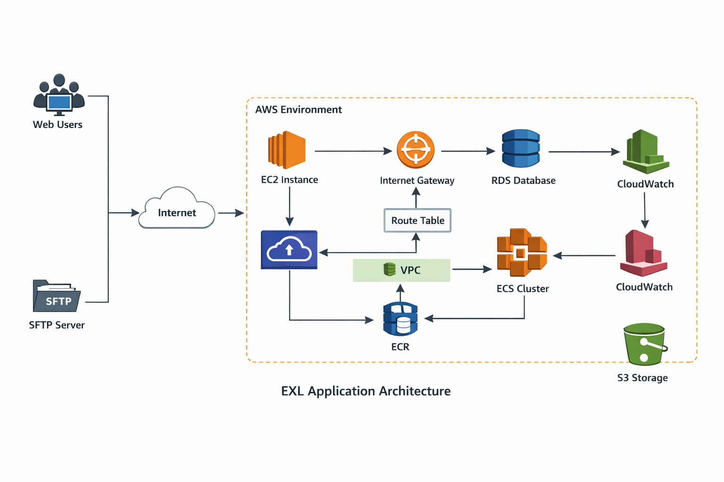
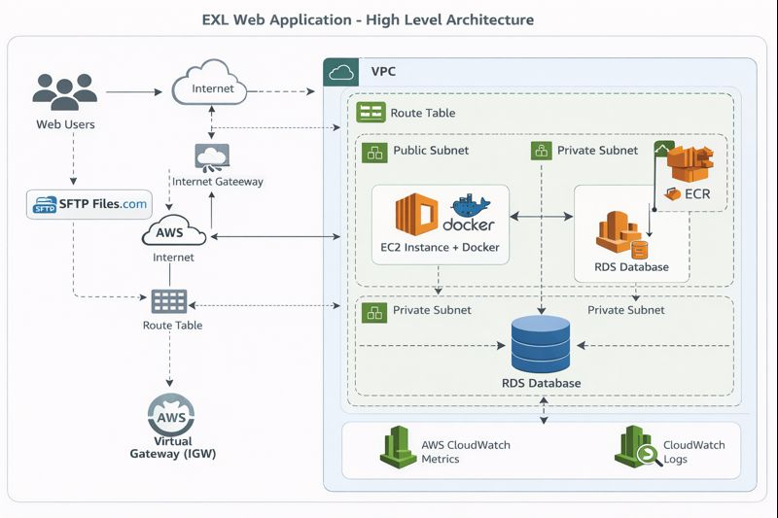
3. Architecture Summary
The EXL application architecture follows a cloud-based layered design consisting of:
- User Access Layer
- Network Layer
- Compute Layer
- Container Platform
- Data Layer
- Monitoring and Logging Layer
- Storage Layer
Data flows from external users and systems through the internet into the AWS environment where application services process and store the information securely.
4. High Level Architecture Flow
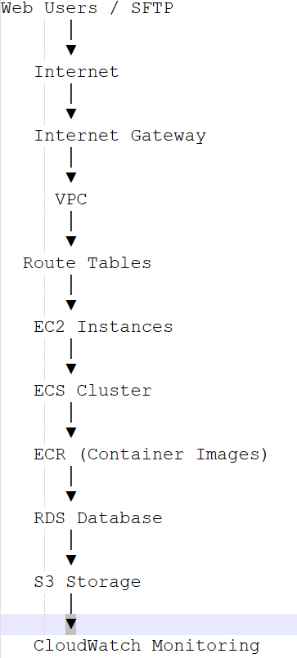

5. AWS Components Description
5.1 Web Users
External users interact with the EXL application through secure internet connectivity. These users access the application services hosted within the AWS environment.
5.2 SFTP Server
An SFTP server is used for secure file transfers between external systems and the EXL platform. Files uploaded through SFTP are processed by the application components running in AWS.

5.3 Internet
All incoming traffic from web users and SFTP systems enters the AWS environment via the public internet.
5.4 Internet Gateway
The Internet Gateway enables communication between resources within the VPC and external networks. It allows inbound and outbound internet connectivity for the application components.
5.5 Virtual Private Cloud (VPC)
The application infrastructure is deployed inside a dedicated AWS VPC which provides network isolation and security. The VPC contains the networking components required for routing traffic within the environment.
Key responsibilities:
- Network isolation
- Subnet segmentation
- Secure communication between services
5.6 Route Tables
Route tables define how traffic flows between the internet gateway, subnets, and internal services within the VPC. They ensure proper routing of inbound and outbound traffic.
5.7 Amazon EC2
Amazon EC2 instances provide the compute layer for the application. These instances host application services and facilitate communication with container workloads and supporting infrastructure.
Responsibilities:
- Application runtime environment
- Integration services
- Processing application logic

5.8 Amazon ECS (Elastic Container Service)
Amazon ECS is used for container orchestration. The application workloads are deployed as containers within the ECS cluster to provide scalability and efficient resource utilization.
Key capabilities:
- Containerized application deployment
- Auto scaling support
- High availability
5.9 Amazon ECR (Elastic Container Registry)
Amazon ECR is used as a container image repository. It stores Docker images required to deploy the application containers within ECS.
Key responsibilities:
- Secure container image storage
- Integration with ECS deployment pipeline
5.10 Amazon RDS
Amazon RDS is used as the relational database service for the EXL application. It stores application data, transactional information, and metadata.
Key features:
- Managed database service
- Automated backups
- High availability
- Database monitoring
5.11 Amazon S3
Amazon S3 is used for object storage within the architecture.
Use cases include:
- File storage
- Data archiving
- Backup storage
- Processing outputs
5.12 Amazon CloudWatch
Amazon CloudWatch provides monitoring and logging capabilities for the entire application infrastructure.
It enables:
- Performance monitoring
- Log collection
- Alerting and alarms
- Operational insights

6. Security Considerations
The architecture follows AWS security best practices including:
- Network isolation using VPC
- Controlled access using security groups
- Secure file transfer via SFTP
- IAM role-based access control
- Encrypted data storage
- Monitoring through CloudWatch

6. Backup and Data Protection
The following mechanisms are used for data protection:
- Automated database backups through Amazon RDS
- Snapshot-based backup of EC2 instances
- Data retention using Amazon S3
- Monitoring and alerting using CloudWatch

7. Monitoring and Logging
Monitoring and logging capabilities are implemented using Amazon CloudWatch to ensure system reliability and operational visibility.
The monitoring framework includes:
- Application performance monitoring
- Infrastructure metrics tracking
- Log aggregation
- Alerting and notifications

8. Benefits of the Architecture
The EXL application architecture provides several benefits:
- Scalability through containerized workloads
- High availability using managed AWS services
- Secure networking using VPC and IAM
- Operational visibility with CloudWatch
- Reliable storage through S3 and RDS

9. Conclusion
The EXL Application architecture leverages AWS managed services to deliver a secure, scalable, and resilient platform for data processing and application services. The design ensures secure access, reliable data storage, and efficient application deployment through containerized infrastructure.

