Feedbacks for Employer Account: -

1.   
After job posted, there’s no pop out or indication of job - successfully posted.

(It brings me back to the default job posting page.)

Would be good if can have the following: (examples)

Example 1:

Example 2:

2.

**After I clicked into candidate profile for summary:**

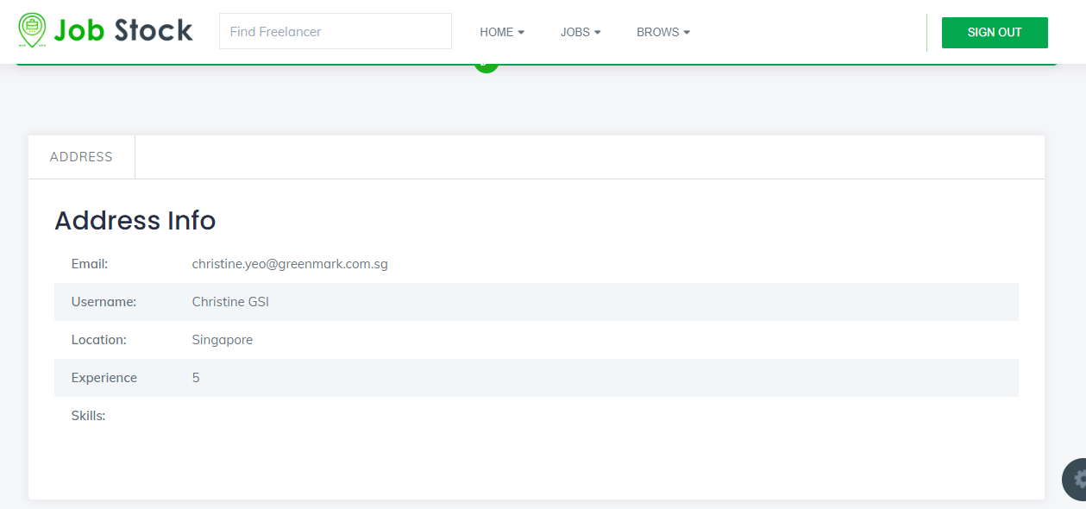

**For example (from anther platform):**

For application, it doesn’t indicate the following:

* Which job posting/ position the candidate applied to
* When did the candidate applied
* Candidate current position
* Candidate account last active date

3.

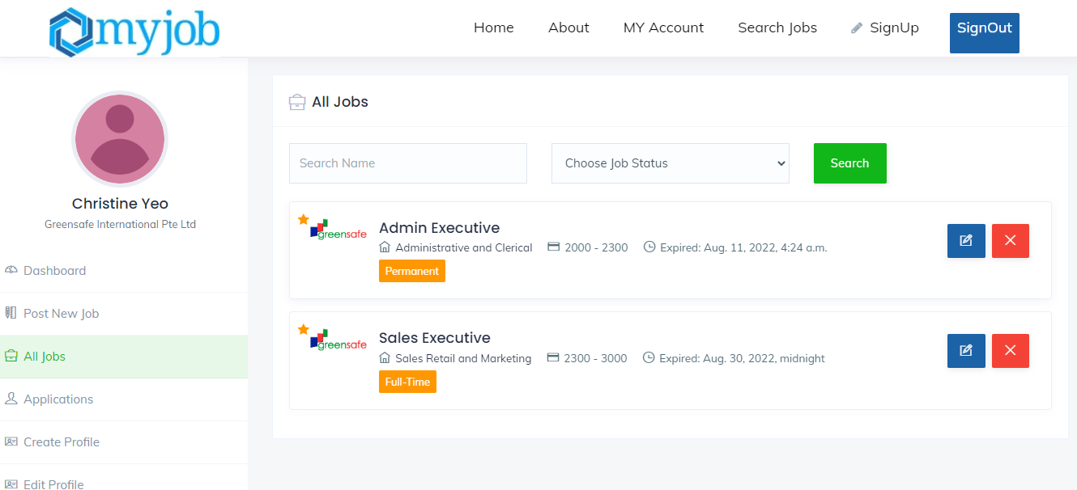

Under jobs, cannot see applicant(s) information. (e.g. Number of applicants)

**From other job portal:**

* Able to see total number of applicants