**MYJOB Portal Review (EMPLOYER JOB POSTING)**

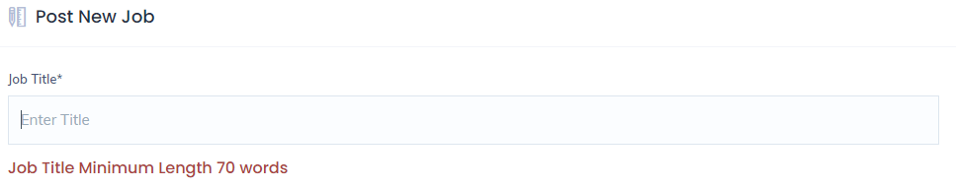

|  |
| --- |
| **Comments** |
| **This should be Job title maximum capped length 70 words instead of minimum.**  **Job titles usually are “short” and difficult to meet the minimum length of words 70.**  **Eg. Sales Executive** |

|  |
| --- |
| **Comments** |
| **Under the Job description, it indicate “about company” instead of “Responsibilities & Requirements”** |

|  |
| --- |
| **Comments** |
| **Error settings (can’t type more than 200 words)** |

3.

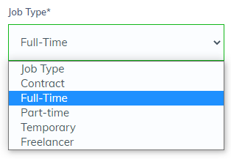

|  |
| --- |
| **Comments** |
| **Add on: Permanent** |

4.

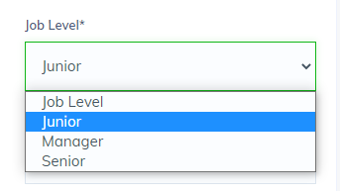

|  |
| --- |
| **Comments** |
| **Add on: Executive** |

5.

|  |
| --- |
| **Comments** |
| **Add on: More Language Options – Chinese etc.** |
| **Add on: a few language selection instead of just 1.**  **(Example: refer to pic below abstract from another portal)** |



6.

|  |
| --- |
| **Comments** |
| **Cannot delete job posting** |

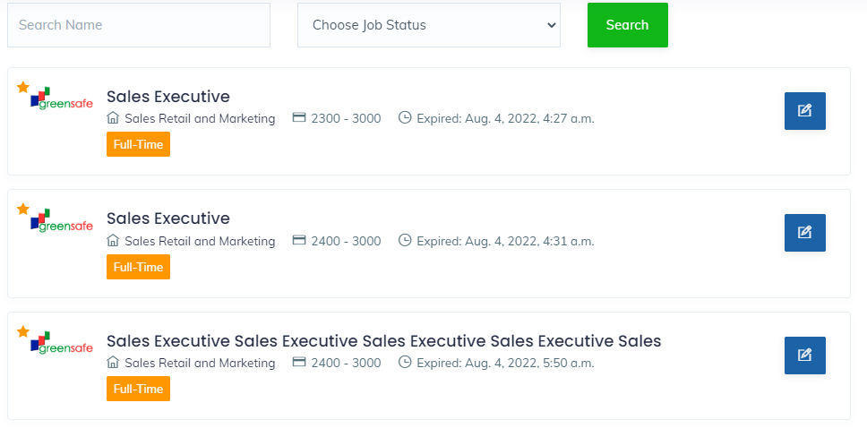

**7.**

|  |
| --- |
| **Comments** |
| **Can’t see applicant’s current position unless I download the resume. If the summary can have their current job title would be good.**  **For the years of experiences, under jobseeker account it’s reflected as Months but now that I am viewing it from employer account, it reflected as years.** |