Preliminary Whisper Benchmark
Speaker S01 | Laptop CPU | English prompts
A controlled initial comparison of six Faster-Whisper models for a conversational social-robot speech pipeline. Results are preliminary and represent one speaker in a quiet environment.

01 Test conditions
Item | Details
Speaker | S01
Prompts | 10 controlled prompts
Models | tiny, tiny.en, base, base.en, small, small.en
Total transcriptions | 60
Environment | Quiet home environment
Hardware | Laptop CPU; INT8 computation
Audio input | ReSpeaker; 16 kHz; channel 0

02 Model comparison
Model | Language | Exact prompts | WER | Mean inference
tiny | Multilingual | 5/10 | 7.32% | 0.311 s
tiny.en | English only | 6/10 | 8.13% | 0.258 s
base | Multilingual | 8/10 | 1.63% | 0.486 s
base.en | English only | 8/10 | 1.63% | 0.457 s
small | Multilingual | 10/10 | 0.00% | 1.410 s
small.en | English only | 9/10 | 0.81% | 1.417 s
Mean inference time measures only Whisper transcription processing. It excludes speaking duration, model loading, OpenAI processing and Piper speech generation.

Lower WER and lower inference time are better. Exact prompts represent transcriptions that match the reference after lowercase conversion and removal of punctuation differences.

03 Visual comparison
Word Error Rate (Lower is Better)
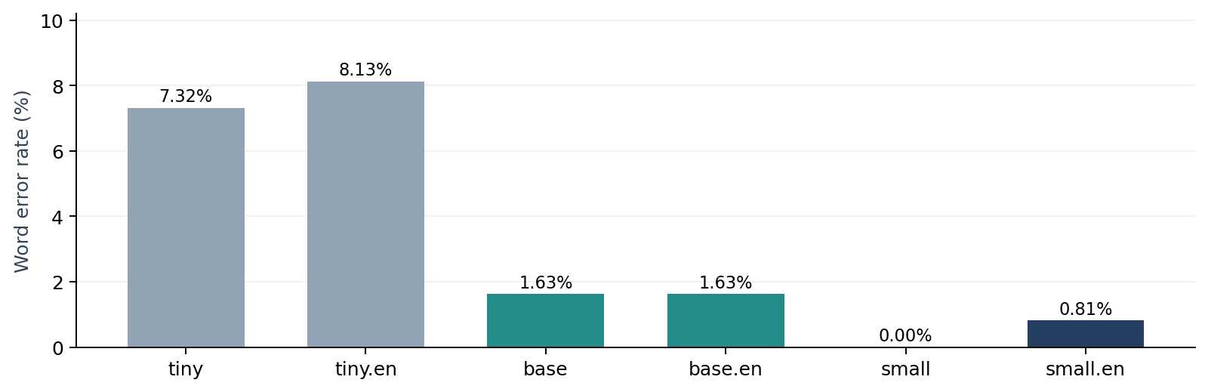
Mean Whisper Inference Time (Lower is Better)
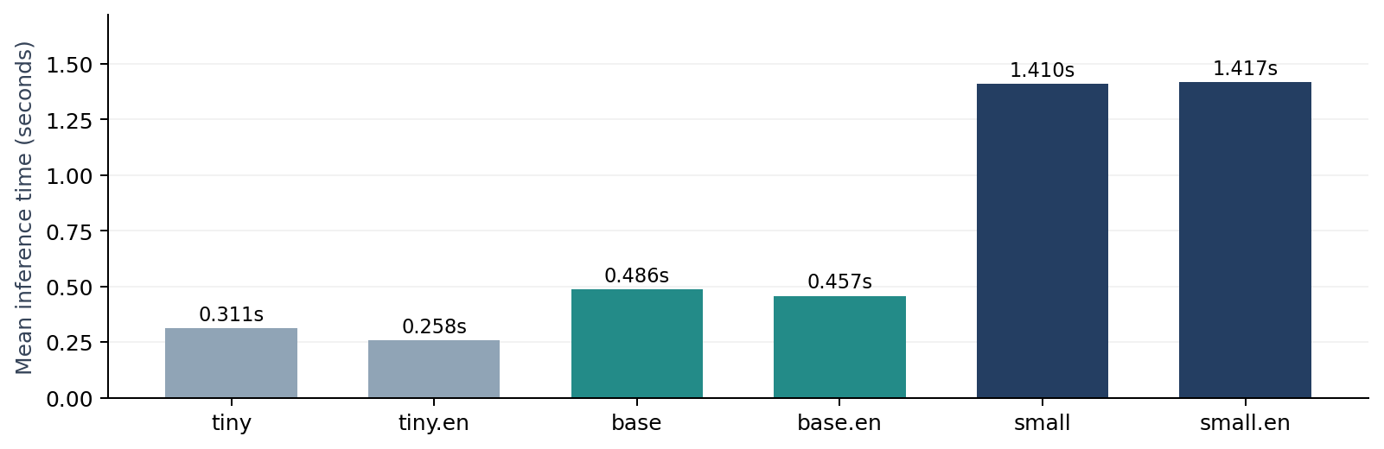

04 Interpretation
- Fastest: tiny.en (0.258 s mean), but its transcription errors make it less reliable on this speaker’s prompts.
- Balanced candidates: base and base.en achieved 1.63% WER at approximately 0.46–0.49 s mean inference.
- Most accurate: multilingual small achieved 0.00% WER, but its mean inference time (1.410 s) was approximately 2.9× that of base.
- Multilingual base remains a practical preliminary candidate because future multilingual support is planned.

05 Preliminary conclusion
Recommended candidate for the next stage: multilingual base. It offers a promising initial balance of English transcription accuracy, CPU processing speed, and multilingual capability. This is not a final model selection.

06 Manual meaning-preservation review
Non-exact transcriptions were manually classified as acceptable when the original meaning remained usable for the conversational robot. Meaning-changing errors were classified as not acceptable.
Model | Acceptable prompts | Acceptable rate
tiny | 9/10 | 90%
tiny.en | 8/10 | 80%
base | 9/10 | 90%
base.en | 9/10 | 90%
small | 10/10 | 100%
small.en | 10/10 | 100%
Meaning-changing errors: “gaze detection” was recognized as “gas detection” by tiny and base variants; tiny.en recognized “social robot” as “social properties”; and base.en recognized “speech recognition” as “speech examination.” Minor article or pronoun changes were accepted when the intended request remained clear.

07 Remaining evaluation
- Additional speakers S02 and S03
- Background-noise experiments
- Jetson GPU performance and live-streaming latency
- Final accuracy–latency comparison and model selection

