OpenAI Model Benchmark for Social-Robot Conversation

1. Objective
This experiment compared four OpenAI models for a conversational social robot. The objective was to identify:
- A fast model for simple questions.
- A stronger model for medium and complex questions.
- Models that generate concise answers suitable for Piper speech synthesis.

2. Experimental Method
Item | Details
Models | gpt-6-luna, gpt-6.1-terra, gpt-6.1-sol, gpt-6-astra
Questions | 9 controlled questions
Categories | 3 short, 3 medium and 3 complex
Repetitions | 3 per question and model
Total requests | 108
Successful requests | 108
API failures | 0
Reasoning effort | Low
Maximum output | 400 tokens
Response instruction | Maximum three short sentences suitable for spoken interaction
The same questions and instructions were sent to every model. Response time measured the complete time between sending the API request and receiving the answer. This measurement includes API processing and network delay.
A four-request smoke test was conducted before the full experiment to confirm model access, answer generation, timing, token logging and CSV storage. Smoke-test timings were excluded from the final comparison.

3. Evaluation Metrics
- Median response time: the middle response time after sorting the measurements. Lower is better.
- Mean response time: the average response time. It can be strongly affected by unusual delays.
- Input tokens: the question and system instructions sent to the model.
- Output tokens: the answer generated by the model.
- Quality score: a manual score from 1 to 5 based on correctness, completeness and clarity.
- Speech suitability: whether the answer was concise and natural enough for spoken robot interaction.
The median was prioritized because two requests experienced unusually long delays, which distorted the mean.

4. Response-Time Results
Model | Short median | Medium median | Complex median | Overall median
gpt-6-luna | 1.536 s | 1.841 s | 3.174 s | 1.881 s
gpt-6.1-terra | 1.636 s | 1.842 s | 2.868 s | 2.214 s
gpt-6.1-sol | 2.149 s | 2.764 s | 4.913 s | 3.210 s
gpt-6-astra | 2.867 s | 3.172 s | 4.719 s | 3.236 s

Response Time by Question Complexity
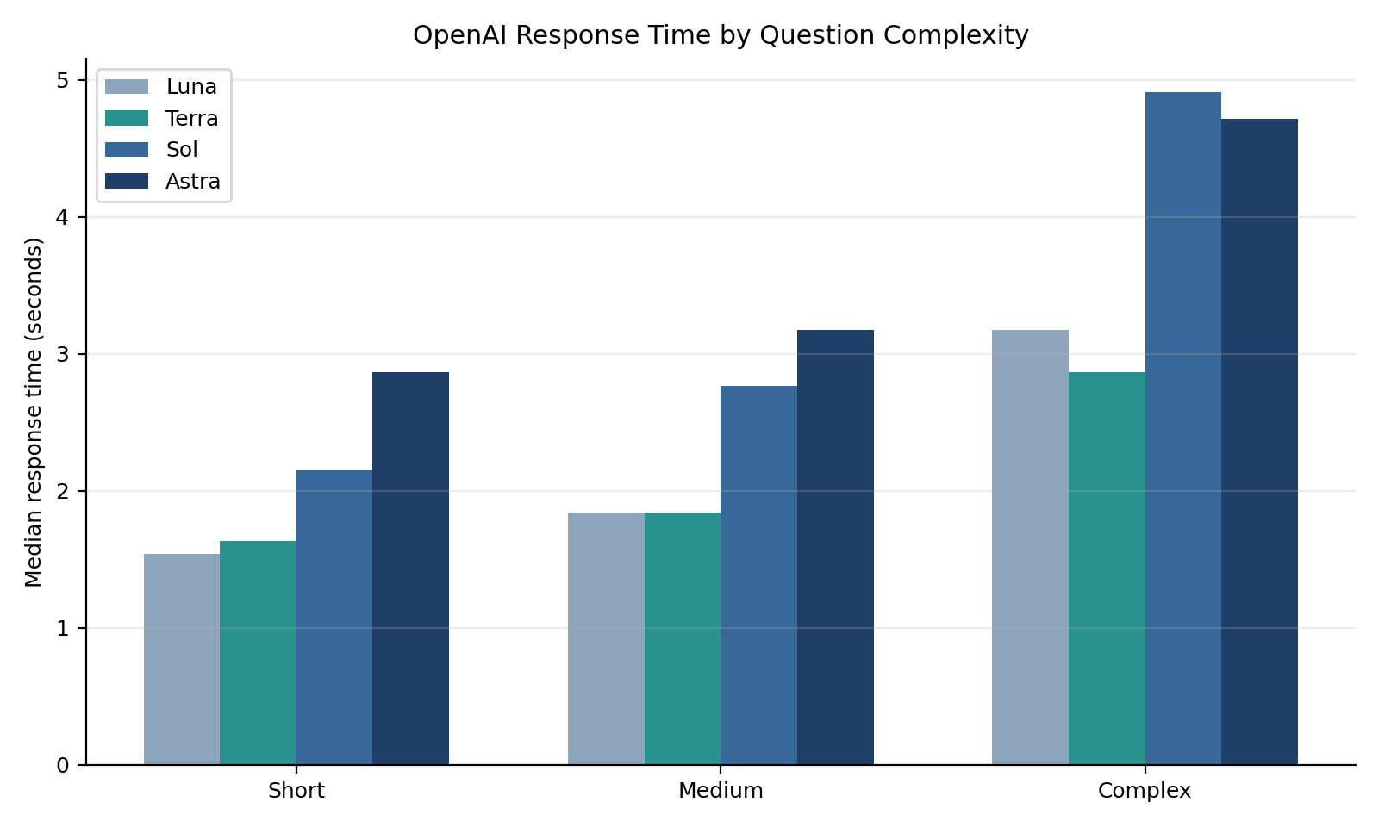
Interpretation: Luna was fastest overall and for short questions. Terra was almost as fast for short and medium questions and produced the fastest median for complex questions.

5. Token Usage and Reliability
Model | Successful requests | Mean input tokens | Mean output tokens | Maximum delay | Requests over 10 s
gpt-6-luna | 27/27 | 55.9 | 69.5 | 25.969 s | 1
gpt-6.1-terra | 27/27 | 55.9 | 46.7 | 4.093 s | 0
gpt-6.1-sol | 27/27 | 55.9 | 64.6 | 5.951 s | 0
gpt-6-astra | 27/27 | 55.9 | 60.3 | 603.917 s | 1
All models received the same average input because identical questions and instructions were used. Terra generated the shortest answers, which is beneficial because shorter responses reduce Piper playback duration.
Luna had one 25.969-second delay. Astra had one 603.917-second delay. Both requests eventually succeeded. These delays may have resulted from temporary API, server or network conditions. They were retained as reliability observations.

Input Length versus Response Time
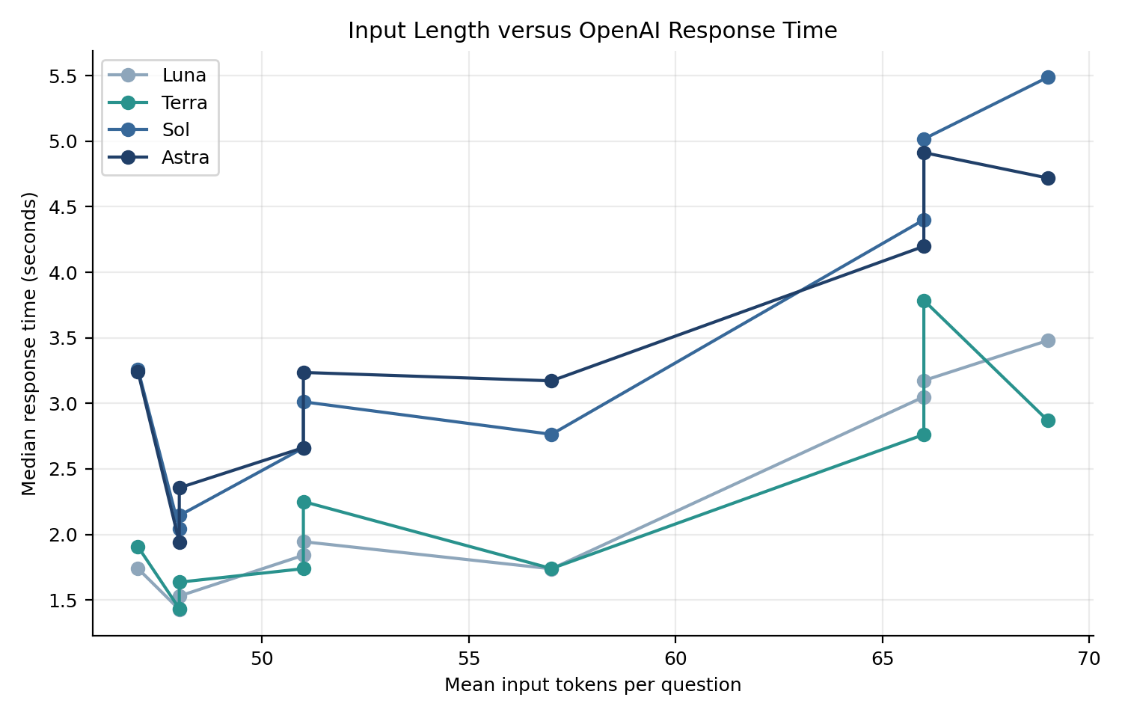
The input-token value includes both the question and the common instructions. Per-question median latency was used to reduce the influence of isolated extreme delays.

6. Manual Quality and Speech Suitability
Quality was scored from 1 to 5:
- 5: correct, complete, clear and highly suitable.
- 4: good, with a minor omission or unnecessary detail.
- 3: mostly correct but missing important information or too verbose.
- 2: significant problems.
- 1: incorrect or unusable.
Speech suitability was recorded separately. “Yes” indicates a clear, direct response of approximately 60 words or fewer.

Each cell below shows:
Quality score / Suitable for speech
Question | Luna | Terra | Sol | Astra
Q01 | 5 / Yes | 5 / Yes | 5 / Yes | 5 / Yes
Q02 | 5 / Yes | 5 / Yes | 5 / Yes | 5 / Yes
Q03 | 5 / Yes | 5 / Yes | 5 / Yes | 5 / Yes
Q04 | 5 / Yes | 5 / Yes | 5 / Yes | 5 / Yes
Q05 | 5 / Yes | 5 / Yes | 5 / Yes | 5 / Yes
Q06 | 4 / Yes | 5 / Yes | 5 / Yes | 5 / Yes
Q07 | 4 / No | 5 / Yes | 4 / No | 4 / No
Q08 | 4 / No | 4 / Yes | 4 / No | 4 / No
Q09 | 4 / No | 5 / Yes | 4 / No | 4 / No

Overall Manual Evaluation
Model | Mean quality | Speech-suitable questions
gpt-6-luna | 4.56/5 | 6/9
gpt-6.1-terra | 4.89/5 | 9/9
gpt-6.1-sol | 4.67/5 | 6/9
gpt-6-astra | 4.67/5 | 6/9

Quality versus Response Time
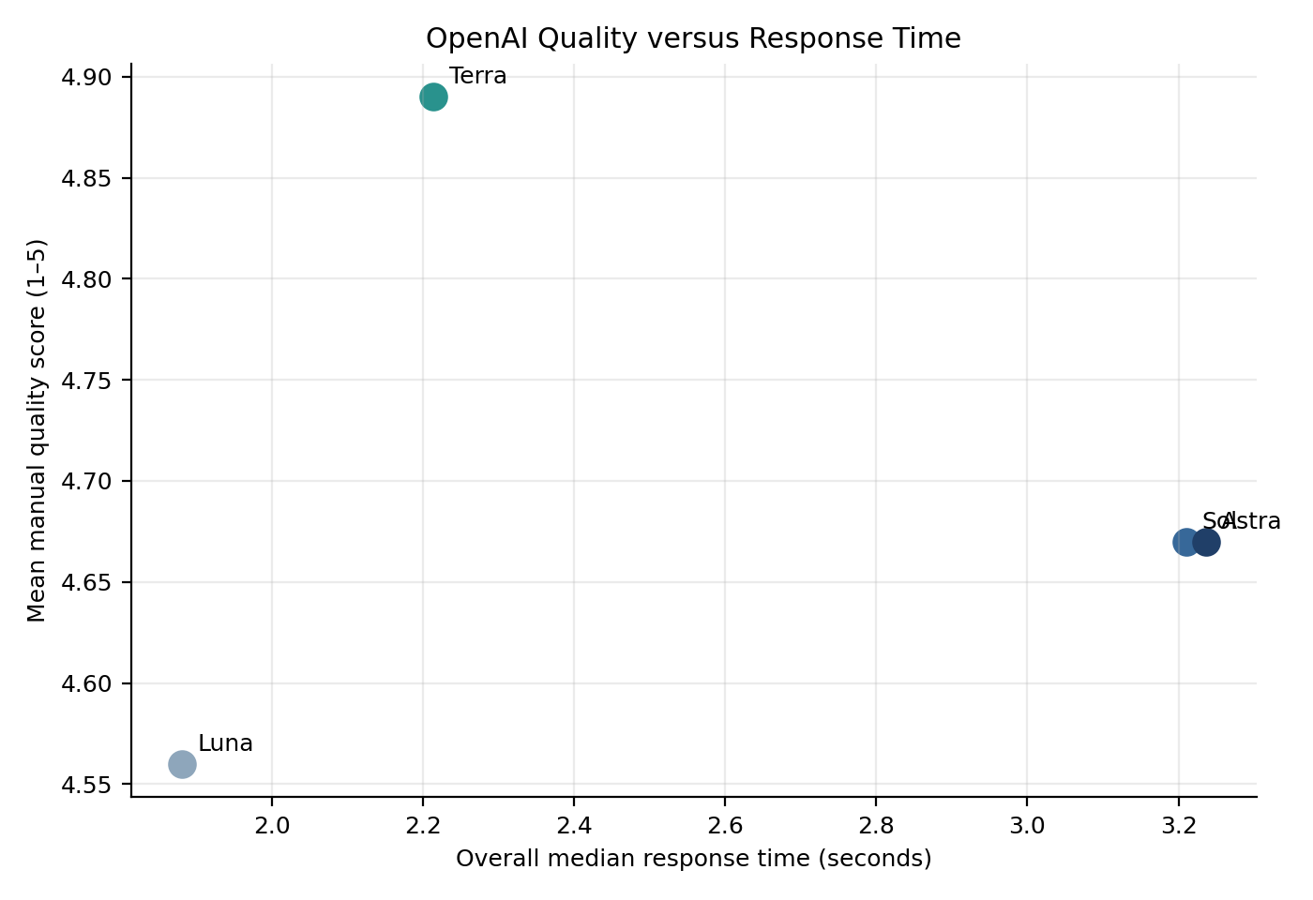

Suitability for Spoken Robot Responses
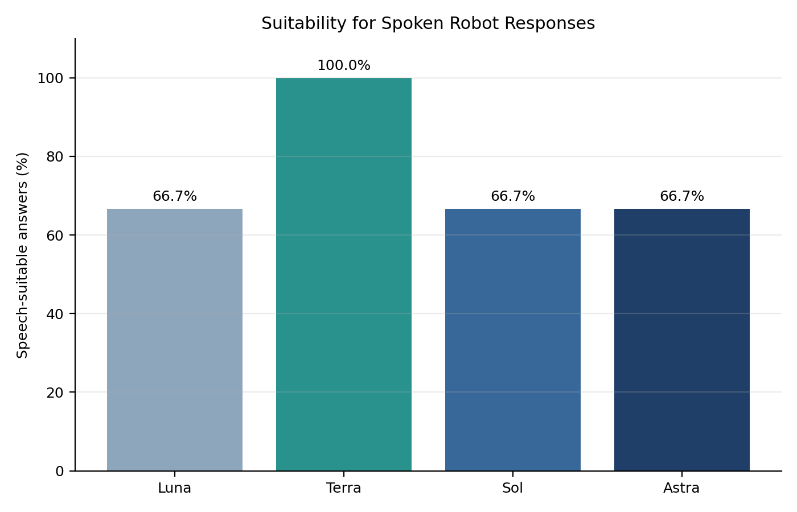
Terra achieved the highest manual quality score and was the only model whose answers were considered suitable for speech across all nine questions.

7. Interpretation
- Luna provided the lowest overall median response time.
- Terra was only 0.333 seconds slower overall than Luna.
- Terra achieved the highest quality score and shortest average output.
- Terra produced speech-suitable answers for all questions.
- Sol and Astra produced detailed answers but were slower and often unnecessarily long for spoken interaction.
- Sol and Astra did not provide a sufficient advantage for this controlled social-robot question set.
- Median latency was more representative than mean latency because of the isolated Luna and Astra delays.

8. Recommended Dynamic Model Routing
Based on the current experiment:
Simple question
→ gpt-6-luna
→ fastest response
Medium or complex question
→ gpt-6.1-terra
→ higher quality and concise spoken response
The initial implementation should classify questions by length and complexity. The final routing threshold should be evaluated using additional questions and complete speech-to-speech testing.

9. Preliminary Model Decision
- Fast model: gpt-6-luna
- Best overall model: gpt-6.1-terra
- Recommended model for medium and complex spoken responses: gpt-6.1-terra
Terra provides the best current balance between response time, answer quality, reliability and spoken-response suitability.

10. Limitations
- Only nine controlled questions were tested.
- Tests were performed during one experimental session.
- API and internet conditions may vary over time.
- Quality assessment was manual and therefore partly subjective.
- The experiment measured text API performance only.
- Whisper transcription and Piper synthesis were excluded.
- Multi-turn conversation and memory were not evaluated.
- Model aliases may change as the API is updated.

11. Conclusion
The benchmark successfully compared four OpenAI models across 108 requests. Luna was fastest overall, while Terra achieved the best combination of quality, concise output and stable latency. The current evidence supports using Luna for simple questions and Terra for medium and complex questions. The next implementation stage is dynamic model selection followed by complete speech-to-speech latency testing.

