**Automation Project:**

**Environment Required:**

**1.Android Studio.**

**2.Appium for Desktop.**

**3.Java.**

**4.Android Mobile.**

**5.Install all the Apk provided - in the android mobile.**

**Code:**

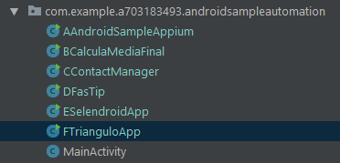

I have done Automation for 6 APK provided in the mail.

1. AndroidSampleApp

2. CalculateMediaFinal.

3. ContactManager

4. FasTip.

5. SelendroidApp.

6. FTrianguloApp

**How to run the file?**

**1.open AndroidSampleAutomation project and Import the gradle file into android studio and will take some time load the index.**

**2. when all files are imported, please open the package as shown above: com.example. a703183493.androidsampleautomation.**

**3.Meanwhile open Appium:**

**Start the server:**

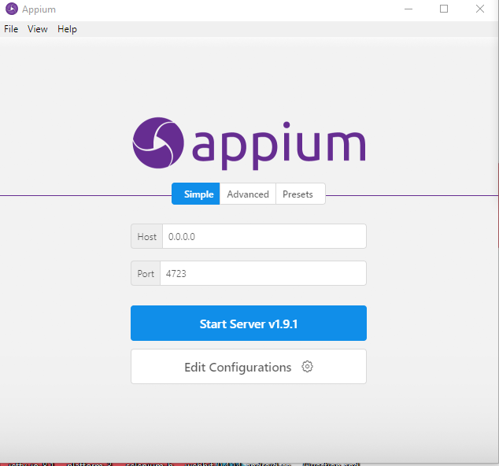

**4. start inspector session:**

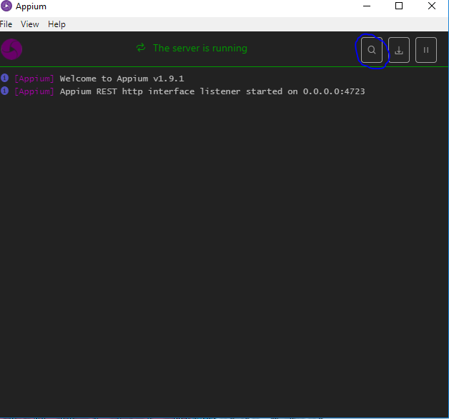

**5.Goto Desired Capabilities and create the JSON Representation:**

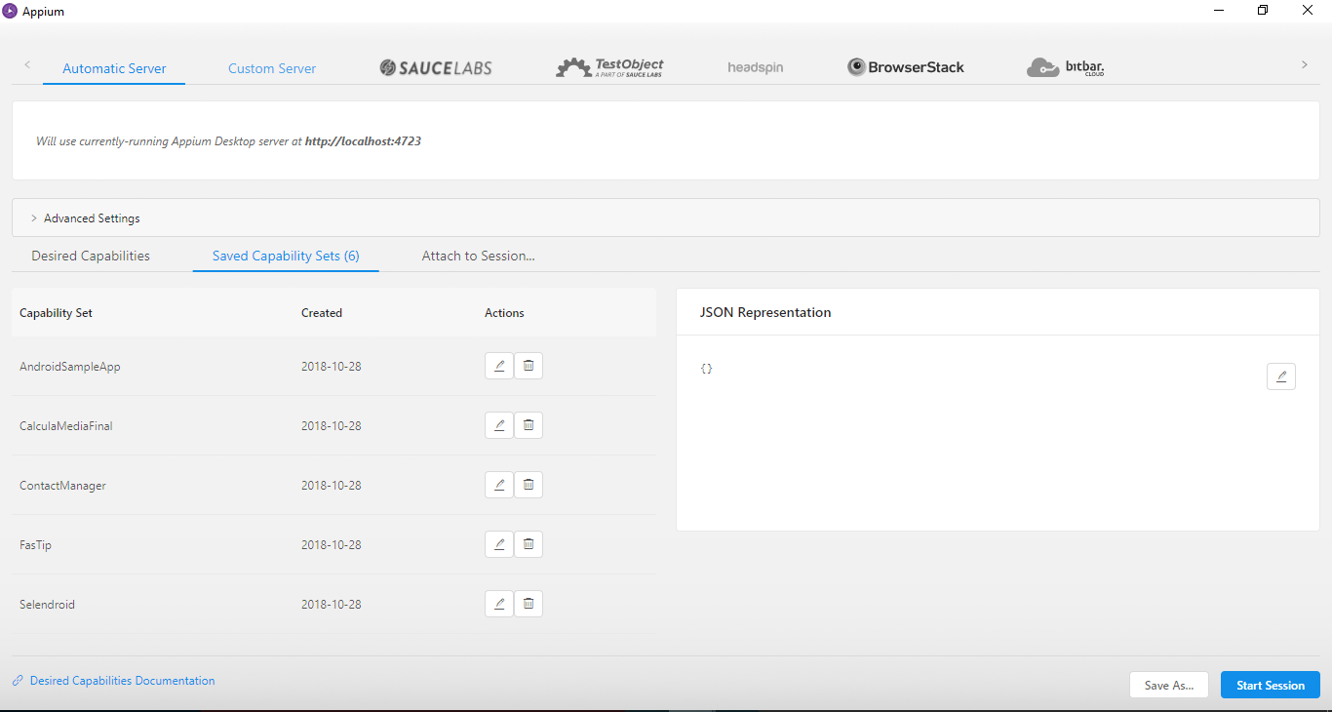

*{  
 "deviceName": "Motorola",  
 "udid": "ZY22364MT7",  
 "VERSION": "7.1.1",  
 "automationName": "uiautomator2",  
 "platformName": "Android",  
 "appPackage": "io.selendroid.testapp",  
 "appActivity": "HomeScreenActivity"  
 }*

Here device name and UDID will change according to the device, please replace with your android device name and UDID

In *appPackage: provide the package name*

*In appActivity provide the Root Activity of the application*

**6.After providing the details of the capabilities start the session**

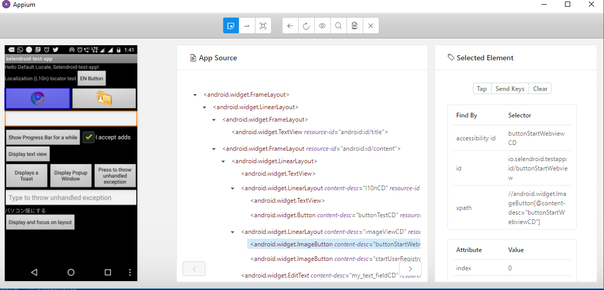

7.**Now open Android Studio** and in our application, go to the package: **com.example. a703183493.androidsampleautomation.**

**Select any of the below class,**



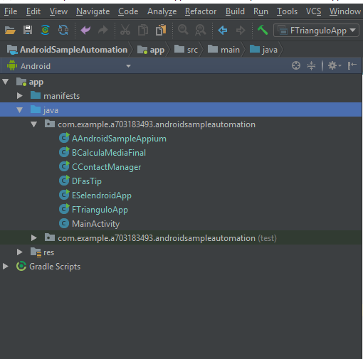

**8.Do right click and run the class file – automation will start**

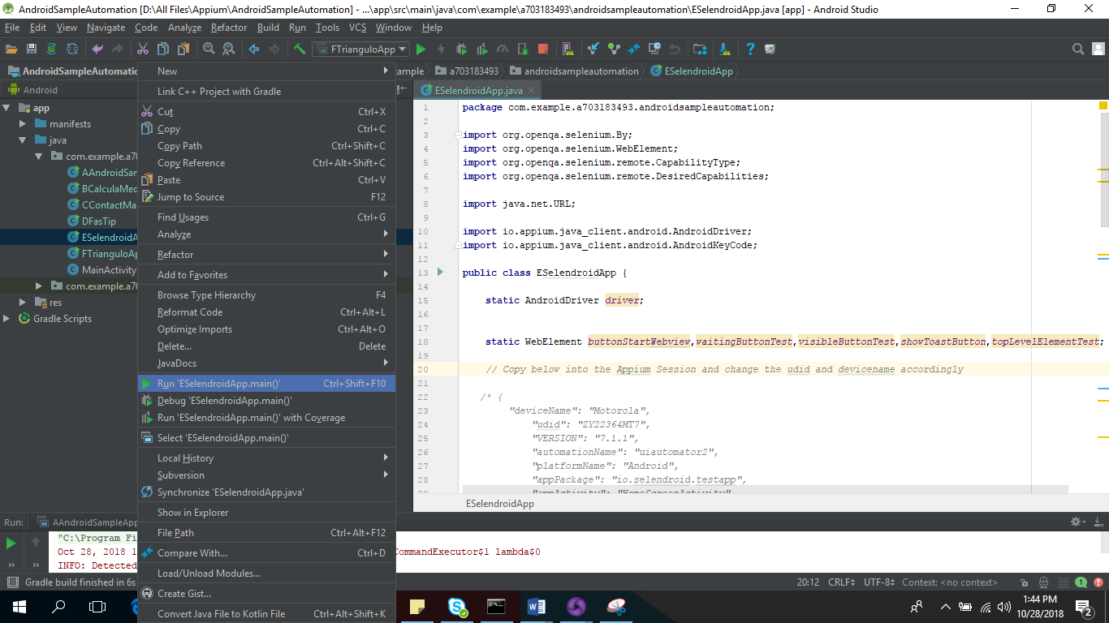

JSON FORMAT FOR ALL APK TO BE USED IN APPIUM IS GIVEN BELOW:

Please change the UDID and Device Name according to your mobile.

1. AndroidSampleApp

*{  
 "deviceName": "Motorola",  
 "udid": "ZY22364MT7",  
 "VERSION": "7.1.1",  
 "automationName": "uiautomator2",  
 "platformName": "Android",  
 "appPackage": "com.vbanthia.androidsampleapp",  
 "appActivity": "com.vbanthia.androidsampleapp.MainActivity"  
 }*/*

*2.*CalculateMediaFinal

*/* {  
 "deviceName": "Motorola",  
 "udid": "ZY22364MT7",  
 "VERSION": "7.1.1",  
 "automationName": "uiautomator2",  
 "platformName": "Android",  
 "appPackage": "com.exemplo.calculamediafinal",  
 "appActivity": "com.exemplo.calculamediafinal.MediaActivity"  
 }*/*

*3.* ContactManager

*{  
 "deviceName": "Motorola",  
 "udid": "ZY22364MT7",  
 "VERSION": "7.1.1",  
 "automationName": "uiautomator2",  
 "platformName": "Android",  
 "appPackage": "com.example.android.contactmanager",  
 "appActivity": "ContactManager"  
}*

*4.* FasTip

*{  
 "deviceName": "Motorola",  
 "udid": "ZY22364MT7",  
 "VERSION": "7.1.1",  
 "automationName": "uiautomator2",  
 "platformName": "Android",  
 "appPackage": "org.traeg.fastip",  
 "appActivity": "org.traeg.fastip.MainActivity"  
 }*

*5.* SelendroidApp

*{  
 "deviceName": "Motorola",  
 "udid": "ZY22364MT7",  
 "VERSION": "7.1.1",  
 "automationName": "uiautomator2",  
 "platformName": "Android",  
 "appPackage": "io.selendroid.testapp",  
 "appActivity": "HomeScreenActivity"  
 }*

*6.* FTrianguloApp

*/* {  
 "deviceName": "Motorola",  
 "udid": "ZY22364MT7",  
 "VERSION": "7.1.1",  
 "automationName": "uiautomator2",  
 "platformName": "Android",  
 "appPackage": "com.eliasnogueira.trianguloapp",  
 "appActivity": "com.eliasnogueira.trianguloapp.MainActivity"  
}*/*