RULE-BASED EVENT DETECTION IN SURVEILLANCE
WHO IS IT ???
COLOR HISTOGRAM BASED IDENTITY TRACKER

G. Vejey Subash
CS07D004

RULE-BASED EVENT DETECTION IN SURVEILLANCE
WHO IS IT??? – COLOR HISTOGRAM BASED IDENTITY TRACKER

In recent years, automated surveillance has gained much attention. It is of utmost importance to know what is happening around in house front, public places and everywhere. Possible threats and suspicious activities have to be detected in order to prevent vandalism. Continuous monitoring of a place of interest is needed and this involves deploying a human to watch videos all day long, which is really a daunting task. So there is a need to assist him in monitoring people. Although it is much difficult to fully automate without human intervention, certain simple questions like “How many people are there in the scene?” , “What is the identity of each person?” , “Were this person been here before?” , “If so when is the last time he was here?” and “ With whom has he interacted?“ can be answered to assist security personnel. An attempt to develop a system for people monitoring in public places has been tried with a view to answer these vital questions.

First the foreground is extracted using the background subtraction method. The blobs are extracted from the background and only the blobs, which are above an experimentally tested threshold, are considered for further processing. Tracking of objects is achieved by using the color distribution histogram models where each person is visually interpreted as a color histogram model based on the pixel color of the blob. This is stored as a model and the blobs coming in from successive frames are checked for similarity. If there is a high match, the blob is assigned to the corresponding model and if that blob does not match with any models available then it is stored as a separate model. This process is repeated for all frames in the live feed. Thus tracking of objects in the scene i.e., maintaining correspondence between blobs of two frames is achieved using color histograms.

The identity tracker module identifies the blobs and tracks it across all frames. This module helps in solving the issues like correspondence of blobs between frames. The algorithm below gives the process flow of the identity tracker module. Tracking is done through the color histogram model that is created on the fly in real time. The histogram model of the blob establishes the correspondence of the blobs in consecutive frames. The centroid of the blob is computed and is stored across all frames for offline processing providing object’s trajectory. This histogram model even address the issue of tracking even under occlusion provided atleast half of the object is visible. When the person enters the scene after some time he is correctly identified. So this histogram approach helps in establishing motion correspondence as well as tracking under occlusion.
The algorithm of the identity tracker is given below:
Input: Blobs with bounding box from motion detection module
Output: Tracked blobs with its trajectory
- Compute histogram of the blob.
- Correlate with the histograms of all the models available.
- Find the maximum value of the correlation results.
- If maximum value is less than a threshold
Add a new model to the available list with this histogram of the blob.
Else mark the blob as belonging to the corresponding model having maximum correlation value.
- Compute the centroid of the blob and keep track of the blobs’ trajectory.
- Get the next frames’ blob from motion detector.

Tracking refers to the process of keeping track of the objects in scene i.e., establishing the correspondence of the blobs in successive frames. The tracking here is done by the color histogram model.

Histogram Modeling of blobs
Histogram. The color histogram h of image I is defined for IЄ[m] such that h_{I}(c_{i}) gives for any pixel in I , the probability that the color of the pixel is c_{i} .

Histogram refers to the distribution of the colours in the blob i.e., how many times does a colour appear in the scene. After the motion detector detects the motion and extracts the foreground and turns into a blob, the frequency of colour distribution of the blob i.e., its histogram is computed and stored into a model for further analysis.
In this method, the histogram model method is affected by some parameters such as the number of bins taken and the method of similarity check used. A true image with 24 bit RGB has got 16 million colours in it with red channel accounting for 256 variations similarly green and blue each varying from 0 to 255. So totally 256*256*256 equalling 16777216 colours which is 16 million approximately. The human eye cannot distinguish all these 16 million colours. This is an advantage for choosing the number of bins. It is practically impossible to take all 16 million colours as bins and checking for similarity. So the reduction of bins is required for effective computation. The following formula reduces the number of bins.
Histogram_{index} = ( red / 32 ) + 8 * ( green / 32 ) + 64 * ( blue / 32 )
where the histogram_{index} is the index value of the histogram bin. It gives the colour of the pixel.
Illustration of grouping of colours: An example where a white pixel and a black pixel is taken. As the white pixel has got all red, green and blue components are all 255, so the value of the histogram index becomes this,
Histogram_{index} = ( 255 / 32 ) + 8 * ( 255 / 32 ) + 64 * ( 255 / 32 ) equals 511.
When a black pixel is taken, its red, green and blue are all 0, so the histogram index value is 0. So the value varies from 0 to 511 totalling 512 bins. This implies that in red, green and blue components, say 32 combinations of colours are grouped into one colour. 32*32*32 colours are grouped as one colour and assigned a bin in the histogram. So the 16 million colours have been reduced to just 512 colours.

Working methodology
The objective of the human tracking is to label and track each individual consistently throughout the video sequence. The first problem to be solved when tracking people is detecting them. For detection of humans, background subtraction method is used. Although the idea behind background subtraction is simple, the problem is very challenging. Changes in illumination conditions, movements of tree branches waving in the wind, camera noise, shadows or reflections can all affect the detection performance. After this process, the system expects each isolated person to be segmented into an isolated blob. Thus it assumes that in an indoor environment each detected blob will correspond to a person. For instance, if there is a part of the body that has been segmented into a different blob after the background subtraction stage, and this blob has not been removed during the thresholding process, the system will fail and detect that blob corresponding to a part of the body as a new person. It is also assumed that when a person enters the scene he/she will be isolated. If two or more people enter together and are segmented into the same blob by the background subtraction algorithm, the system will treat them as though they were a single person until they split. At this point the system will begin to keep track of each individual separately, assigning the label of the group to one of the components of the group and new labels for the rest.
As soon as a person enters the scene, a model for that person is generated and stored. A model consists of histogram information of how the colours are distributed in the image. In the next frame, another model is built for each of the foreground blobs that are detected by the motion detector module. Then the similarity measure between all the histograms of the stored models and all the blobs in the current frame are calculated using one of the distance measures given below.
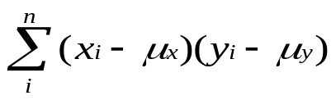
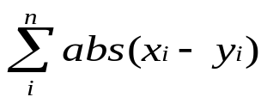
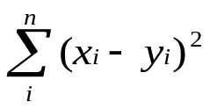
where n is the required number of bins
Using one of these distance measures given in equations, the similarity check is done and the most similar blobs are matched as long as the similarity measure is above a certain threshold. However, if a blob in the current frame is at a significant distance from all the stored models, a new model is initialized. The fixing of threshold in any operation in images is still a mystery to the researchers. A local threshold and a global threshold can be fixed to fix this problem but the only way to address this issue is by experimentally fixing the threshold. Once the matching stage is completed, all the models are updated using this equation below.
Once the matching and updating of the models are done the next frame is processed and the process continues till the system is stopped.

Issues encountered

The issues encountered in this module are as follows:
Fixing of thresholds in the similarity check with the histograms of the current blob to that of the available models.
Persons occluding each other in the scene cannot be distinguished, as only one whole blob will be obtained from the motion detection module.
Persons wearing same colour of clothing cannot be discriminated efficiently. So looking for an algorithm that takes spatial information along with the colour information.
Entry and exit of persons in the scene are solved by establishing a criterion where only the blob is take into consideration only when it is fully visible in the scene.

Experimentation & Analysis
The experiments were done on the system configured with 2.4GHz AMD Turion64 processor with 1GB RAM and programmed with C++ using Intel’s open source image library OpenCV. The test sequences consist of four persons with different clothing at an indoor environment. The color histogram model correctly identifies the people as different persons entering the scene. Various histogram correlation distance measures been tested with these sequences and the results are attached with this section and the effect of the histogram bin sizes are also discussed. Basically, more the number of bins, the sparser the array and it will provide wide range of diversity in colour. But it will increase the computation. So there is a trade-off between the computational complexity and the accuracy of the colour dispersion into bins.

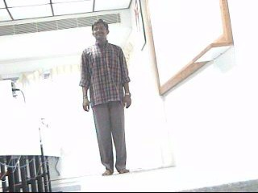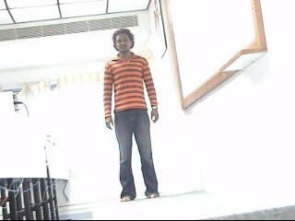
(a) (b)
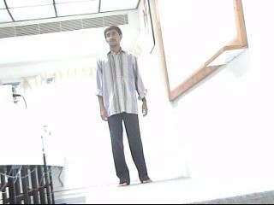
(c) (d)
Four persons used in the test sequence (a) Arjun (b) Subash (c) Vasanth (d) Jayaram

The test sequence consists of 1800 frames that have four people entering and leaving the scene in random fashion. The system needs to correctly identify the person and label him as the correct person who has already entered the scene or is new to the scene. The four persons are vasanth, arjun, jayaram and subash. The system needs to label them as what they are. From the experiments conducted it is observed that the persons are correctly identified and the false positives are really low. Only 5% false positives are present with these four persons. The following table gives the idea of how each person appearance is closer to each other. The numbers in the cells indicate the level of closeness i.e., similarity. Higher the number in the cell, higher is the similarity. The values of the cells in the table are obtained by correlating the histograms of the blob with that of available model.

Blob / Model | Subash | Vasanth | Arjun | Jayaram
Subash | 13.25 | 9.69 | 6.2 | 3.38
Vasanth | 8.8 | 12.08 | 5.12 | 2.78
Arjun | 5.88 | 4.95 | 11.99 | 5.8
Jayaram | 3.57 | 2.88 | 5.86 | 11.58
Confusion matrix of the Correlation sum of the histograms

Models | Colour of the model
1 | Red
2 | Black
3 | White
4 | Green
5 | Yellow
6 | Cyan
7 | Magenta
Lookup table for colouring of the models

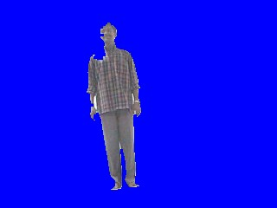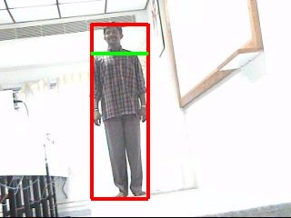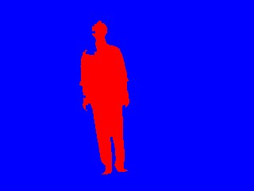 1(a) 1(b) 1(c)
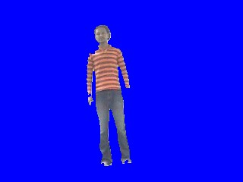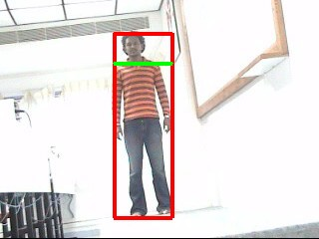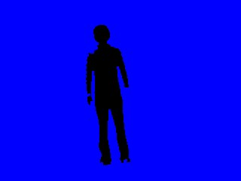 2(a) 2(b) 2(c)
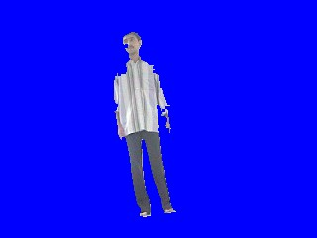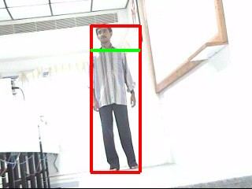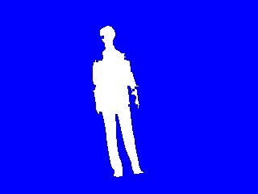 3(a) 3(b) 3(c)
Results of the identity tracker. The first column gives the colour blob detected from the motion detection module. The second column gives the bounding box enclosing the blob in red and the head tracker with a green horizontal line. The third column shows the output of the identity tracker where each person is different from each other. The different colours used are from the lookup table used for colouring the blob and it is mainly used for visual appeal and ease of understanding.

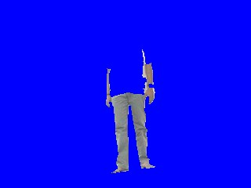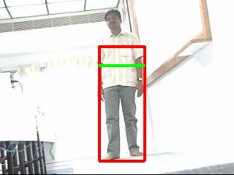
(a) (b) (c)
Error in identity detection due to the effect of the background. (a) Model (b) Blob detected due to the effect of background as he is wearing a shirt with the same colour as that of background. (c) Consequences of wrong blob detection in the bounding box stage with head tracker (green line) showing his chest as the head.

From the table, it is also observed that the maximum similarity is obtained when histogram is self-correlated with itself. The figure above shows the tracked results in the test sequence using the color histogram model. The different colours used in the last column of the figure shows the different identities of the person. The following lookup table is made for each model stored in the knowledge base. When the first person enters the scene he will be coloured in red and whenever he re-appears in the scene, he will be coloured the same colour. And the next new person is identified and coloured as black and so on. To illustrate, only seven colours of the models are shown in the lookup table. There are very few scenarios where the algorithm fails miserably in identifying the right person. One such figure shows this scenario. This is an effect of the accuracy of the blob detected in the motion detector module. When the blob is detected in a crude sense, the results of this algorithm also become miserable. This shows the importance of the pre-processing stage.

Conclusion & Future Work

Various issues were encountered during this module and some of the issues were addressed fully and some partially. Thresholding of the similarity check is one of the main problems in this module while correlation is done. An empirical way of fixing the thresholds is tried out and it is known that it is not the best way. The entry and the exit of persons are taken care of by assuming the blob needs to be processed only when it is away from the image boundary fully. In spite of all these issues, this module works satisfactorily when people come with different clothing. When feature like shape of the contour is taken along with the color information, the system will improve in efficiency and it discriminates the people wearing same dress.

References
[1] Balcells-Capellades .M, DeMenthon .Dand Doermann .D, “An appearance based approach for consistent labeling of humans and objects in video” in Pattern Analysis and Applications, pages 1433-7541, November 2004. (BASE PAPER)
[2] LIU Ya, AI Haizho, XU Guangyou, “Moving Object Detection and Tracking Based on Background Subtraction”, 2001.
[3] Masanori Yamaday, Kazuyuki Ebihara, and Jun Ohya , “A New Robust Real-time Method for Extracting Human Silhouettes from Color Images” in Proceedings of the Third International Conference on Automatic Face and Gesture Recognition (FG'98), April 1998.
[4] Ahmed Elgammal, David Harwood and Larry Davis, “Non-parametric model for background subtraction” in 6th European Conference on Computer Vision (ECCV 2000), Dublin, Ireland, pages 751–767. Springer Verlag, 2000.
[5] Douglas Ayers and Mubarak Shah, “Monitoring Human Behavior from video taken in an Office Environment”, School of Electrical Engineering and Computer Science, University of Central Florida, Orlando, Florida, February 2005.

