**WEEK 8 GIT**

**HOL -3**

Construct a branch, do some changes in the branch, and merge it with master (or trunk)

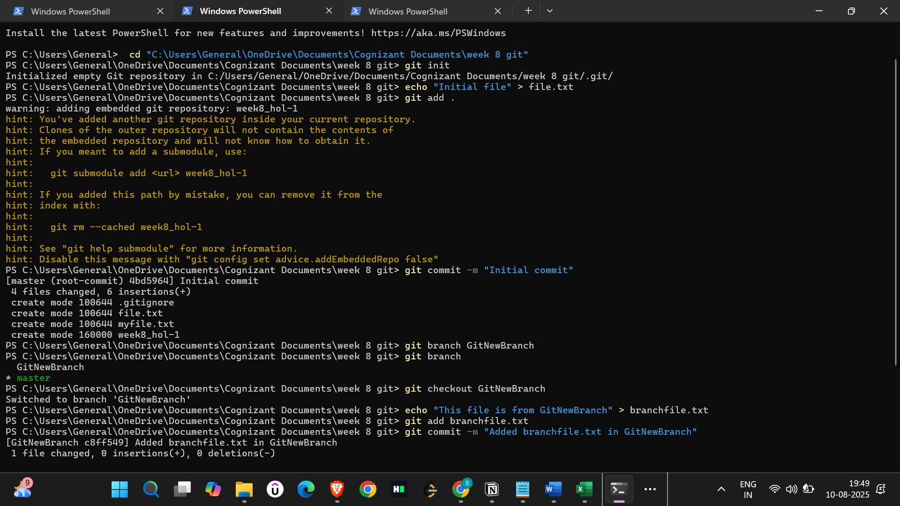

**Branching**

1. Create a new branch

git branch GitNewBranch

2. List all branches

git branch

* master

GitNewBranch

3. Switch to the new branch

git checkout GitNewBranch

4. Add a new file in this branch

echo "This file is from GitNewBranch" > branchfile.txt

git add branchfile.txt

git commit -m "Added branchfile.txt in GitNewBranch"

5. Check status

git status

**Merging**

1. Switch back to master

git checkout master

2. View differences between master and GitNewBranch

git diff GitNewBranch

3. Merge the branch into master

git merge GitNewBranch

4. View merge history

git log --oneline --graph --decorate

5. Delete the merged branch

git branch -d GitNewBranch

6. Final check

git status

