E-Commerce Conversion Rate Analysis
Data Analytics Internship Project | Task 4
Prepared by: Subashini S
Tools: Python, Pandas, Matplotlib, Seaborn
Data period: 2025-01-01 to 2025-12-31

1. Introduction
Conversion rate is one of the most important health metrics of an online store. It shows how many website visitors finally become paying customers. This project analyses the complete shopping funnel (visitors, product views, add to cart and purchases) to find where customers are lost and which segments perform best.

Objectives
- Build the sales funnel and measure drop-off at every stage.
- Calculate the overall conversion rate = purchases / visitors x 100.
- Analyse monthly and weekly conversion trends.
- Compare conversion across traffic channels, devices and days of the week.
- Give practical business recommendations.

2. Dataset and Methodology
The dataset (ecommerce_data.csv) contains 5,475 records. Each record is one day for one traffic channel and one device. Columns: date, channel, device, visitors, product_views, add_to_cart, purchases and revenue. The data is simulated with realistic patterns (festive-season uplift, lower mobile conversion) using generate_data.py, so it can be replaced with a real store export in the same format.

Steps followed
- Data cleaning: removed duplicates and nulls, validated that each funnel stage is not larger than the previous stage.
- Aggregation: totals by month, week, channel, device and day of week.
- Metrics: view rate, add-to-cart rate, purchase rate (of carts), overall conversion rate and average order value.
- Visualisation with Matplotlib and Seaborn.
- Insight generation directly from the computed numbers.

3. Sales Funnel Analysis
Stage | Count | Rate
Visitors | 16,44,057 | 100%
Product Views | 9,79,159 | 59.56% of visitors
Add to Cart | 1,96,964 | 20.12% of views
Purchases | 69,877 | 35.48% of carts

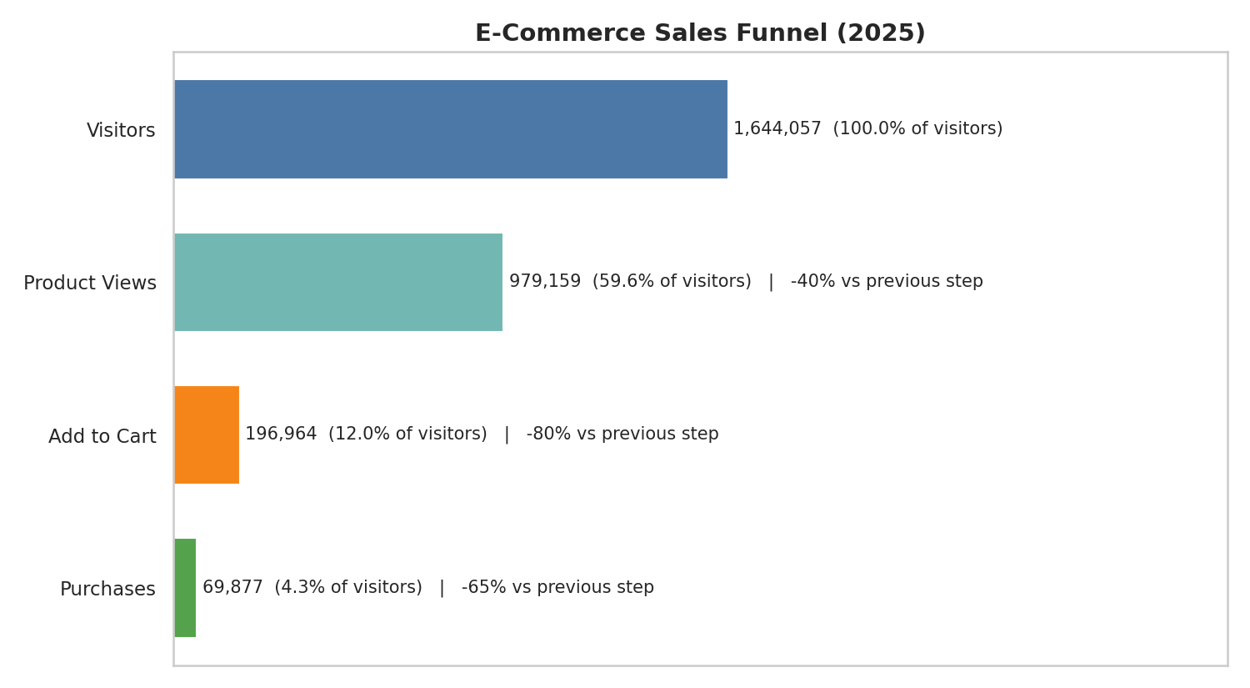
Figure 1: Sales funnel
The overall conversion rate is 4.25%. The largest loss happens at the step "Product View -> Add to Cart", where 79.88% of users do not continue. In addition, 64.52% of carts are abandoned before purchase. Total revenue is Rs. 18,52,48,721 with an average order value of Rs. 2,651.

4. Monthly and Weekly Conversion
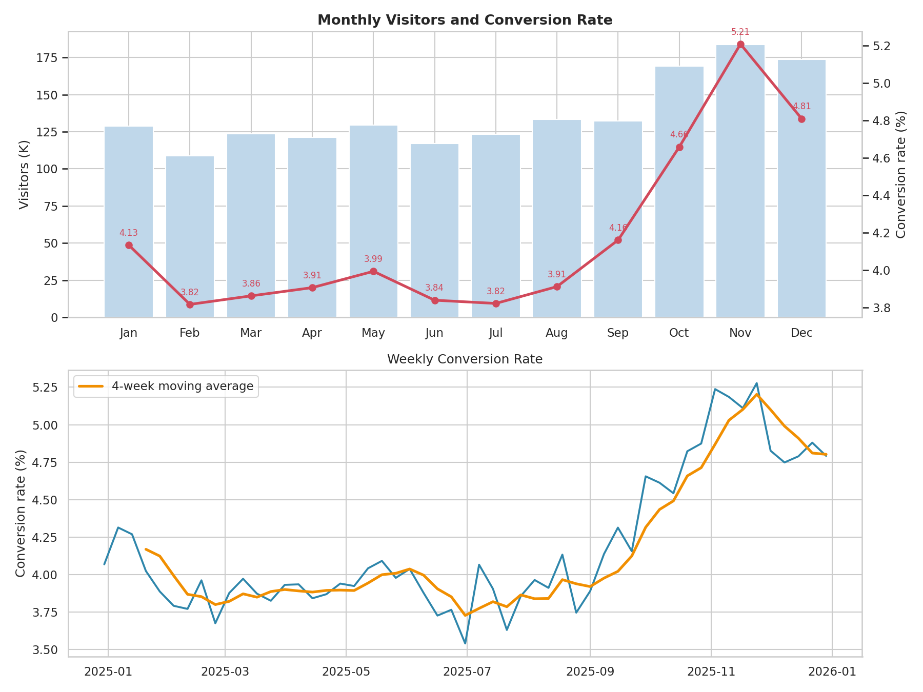
Figure 2: Monthly visitors with conversion rate, and weekly trend
Conversion peaks in November (5.21%) and is lowest in February (3.82%). Traffic and conversion both rise from October, which matches the festive shopping season, so campaigns and stock should be planned around it.

5. Channel, Device and Day Analysis
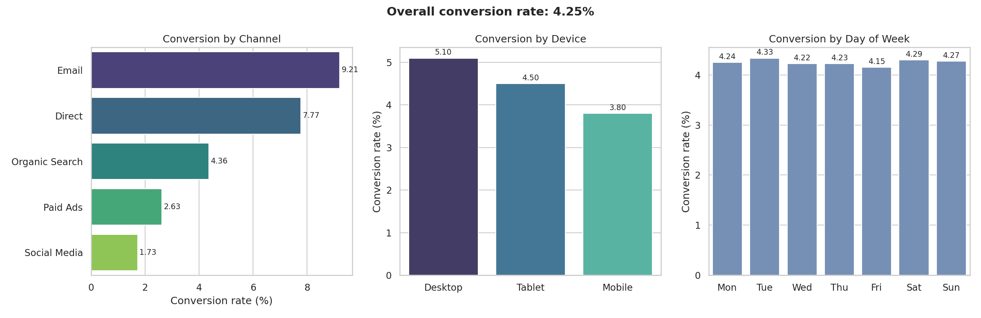
Figure 3: Conversion rate by channel, device and day of week

By traffic channel
Channel | Visitors | Purchases | Conversion % | Revenue (Rs.)
Email | 1,42,295 | 13,106 | 9.21 | 3,48,24,134
Direct | 2,43,768 | 18,932 | 7.77 | 4,99,09,590
Organic Search | 4,86,220 | 21,203 | 4.36 | 5,62,58,946
Paid Ads | 3,66,372 | 9,622 | 2.63 | 2,54,65,799
Social Media | 4,05,402 | 7,014 | 1.73 | 1,87,90,252

By device
Device | Visitors | Purchases | Conversion % | Avg order (Rs.)
Desktop | 5,09,811 | 25,980 | 5.10 | 3,088
Tablet | 1,15,433 | 5,190 | 4.50 | 2,381
Mobile | 10,18,813 | 38,707 | 3.80 | 2,394

Email converts best (9.21%) while Social Media converts lowest (1.73%). Desktop users convert best and Mobile users convert lowest, although mobile brings 62% of all visitors, so improving the mobile experience has the largest potential impact. Day of week has almost no effect (gap only 0.18 pts between Friday and Tuesday); weekday vs weekend is not a lever.

6. Key Insights
- Overall conversion rate is 4.25%.
- Biggest funnel leak: Product View -> Add to Cart (79.88% drop).
- Cart abandonment is 64.52%.
- Email is the best converting channel; Social Media is the weakest.
- November is the strongest month; February is the weakest.
- Mobile has the lowest conversion despite the largest traffic share.

7. Business Recommendations
- Reduce cart abandonment with reminder emails, guest checkout and showing shipping cost early.
- Improve mobile page speed and simplify the mobile checkout.
- Move marketing budget toward high-converting channels such as Email; review landing pages and targeting for Social Media.
- Improve product pages (better images, reviews, clear pricing) to lift the view-to-cart step.
- Plan festive campaigns and inventory ahead of November and run offers in slow months such as February.
- Run A/B tests on the weakest funnel step and track the change in conversion rate.

8. Conclusion
The analysis shows a 4.25% overall conversion rate with clear opportunities in cart abandonment, mobile experience and channel mix. The same code can be applied to a real store's data by replacing ecommerce_data.csv, and the reports and charts will update automatically.
Note: the dataset used here is simulated for demonstration, so the specific numbers should not be treated as real business results.

